SCHEDULE ONE
BENDIGO-OPHIR GOLD PROJECT
COMMON CONDITIONS WHICH APPLY TO ALL OF THE RESOURCE CONSENTS WITHIN THE JURISDICTION OF THE CENTRAL OTAGO DISTRICT COUNCIL AND OTAGO REGIONAL COUNCIL
Notes: The ‘comment’ column has been provided for guidance and interpretation purposes only and is not proposed to form part of the consent conditions.
Cross references to other conditions are highlighted in yellow wash for ease of finding and checking the accuracy of those cross references when the conditions are finalised. In some instances, a short description of the condition being cross referenced is also provided in square brackets.
Contents
General 1
Interpretation 1
Hours of operation 5
Company Liaison Officer 5
Complaints Procedure 5
Annual Work Programme 6
Annual Monitoring and Compliance Report 7
Management and Monitoring Plans 8
Publicly Available Management Plans and Monitoring Reports 11
Tangata Whenua 11
Accidental Discovery Protocol 14
Landscape and Ecological Rehabilitation 15
BOGP Biodiversity and heritage enhancement Fund 25
Mine Rehabilitation and Closure 26
Bond 27
Review of conditions 30
administration 30

General
No. | Condition | Comment
 | The activities authorised by the consents must be undertaken in general accordance with the information contained in the Substantive Application Report prepared by Mitchell Daysh Limited dated 31 October 2025 and supporting technical documents submitted by Matakanui Gold Limited (“the Consent Holder”) to the Environmental Protection Authority ("EPA") in support of its application for authorisation of the Bendigo-Ophir Gold Project (“BOPG”) under the Fast-track Approvals Act 2024 (“Act”).
 | In the event of any conflict or discrepancy between the documents referred to above and the conditions of the consents, the conditions prevail.

Interpretation
Acronyms and Abbreviations
Acronyms and abbreviations used in these conditions have the following meanings:
Act | Fast-track Approvals Act 2024
AEP | Annual Exceedance Probability
AQMP | Air Quality Management Plan
ARAMP | Ardgour Restoration Area Management Plan
BOGP | Bendigo-Ophir Gold Project
BOMP | Biodiversity Outcome Monitoring Plan
BPO | Best Practicable Option
CODC | Central Otago District Council
Cushionfield ARP | Applied Research Plan for the conservation, management, rehabilitation and expansion of cushionfield
DDF | Direct Disturbance Footprint
DOC | Department of Conservation
ELF | Engineered Landform
EPA | Environmental Protection Authority
GPS | Global Positioning System
HAIL | Hazardous Activities and Industries List
HIMP | Habitat Impact Management Plan
HSW-HS | Health and Safety at Work (Hazardous Substances) Regulations
LERMP | Landscape and Ecological Rehabilitation Management Plan
LINZ | Toitū Te Whenua Land Information New Zealand
LUC | Land Use Consent
masl | Metres above sea level
MGL | Matakanui Gold Limited
NTU | Nephelometric Turbidity Unit (the standard unit of measurement for turbidity, which quantifies the cloudiness of a fluid caused by suspended particles, such as those in water)
NZTM | New Zealand Transverse Mercator
ORC | Otago Regional Council
RL | Reduced Level
RMA | Resource Management Act 1991
RPMP | Otago Regional Pest Management Plan 2019-2029 (Otago Regional Council, 2019)
SEQE | Suitably Experienced and Qualified Ecologist
SQEP | Suitably Qualified and Experienced Person
SH | State Highway
SNA | Significant Natural Area
SSESCP | Site Specific Erosion and Sediment Control Plan
TIMP | Terrestrial Invertebrate Management Plan
TSF | Tailings Storage Facility
TSP | Total Suspended Particulate
WTP | Water Treatment Plant

 | Defined Terms
 | For the purposes of the consents and all associated conditions:  - Any reference to “the consents” means the resource consents granted under the Fast-track Approvals Act 2024 for BOGP activities within the jurisdiction of CODC and ORC under the RMA.  - The “Project Site” mean the areas identified on Plan 1 - Project Overview Plan annexed as part of Attachment 1 – Plans to these conditions covering 568 hectares. The project site includes:  - The areas within which mining operations will occur including open pits, an underground mine, the TSF, ELFs, processing plant, haul roads and supporting / ancillary activities and infrastructure;  - Two bores on the Bendigo Terrace and associated pipelines for the supply of fresh water;  - An upgrade to the intersection of SH8 and Ardgour Road; and  - The construction of Ardgour Rise – a new road to maintain public access between Ardgour Terrace and Thomsons Saddle.  - The “BOGP Consent Area” means the entire Bendigo-Ophir Gold Project including exploration activities, mining operations within the project site, and all associated ancillary, monitoring, mitigation, off-setting and compensation activities and supporting infrastructure and activities within, and in the vicinity of, the Project Site as shown on Plan 2 – BOGP Consent Area annexed as part of Attachment 1 – Plans to these conditions. For the avoidance of doubt, the BOGP Consent Area includes the areas that are the subject of Concessions within Public Conservation Land.  - “Exploration” means any activity undertaken for the purpose of identifying mineral deposits or occurrences and evaluating the feasibility of mining particular deposits or occurrences of 1 or more minerals; and includes any drilling, dredging, or excavations (whether surface or subsurface) that are reasonably necessary to determine the nature and size of a mineral deposit or occurrence; and to “explore” has a corresponding meaning.  - “Mining operations” means operations in connection with mining, exploring, or prospecting for any Crown owned mineral and includes, when carried out at or near the site where the mining, exploration, or prospecting is undertaken:  - the extraction, transport, treatment, processing, and separation of any mineral or chemical substance from the mineral; and  - the construction, maintenance, and operation of any works, structures, and other land improvements, and of any related machinery and equipment connected with the operations; and  - the removal of overburden by mechanical or other means, and the stacking, deposit, storage, and treatment of any substance considered to contain any mineral; and  - the deposit or discharge of any mineral, material, debris, tailings, refuse, or wastewater produced from or consequent on the operations; and  - the doing of all lawful acts incidental or conducive to the operations.  - “Supporting infrastructure and activities” means any infrastructure and/or activities established or undertaken for the purpose of facilitating mining operations, including buildings, structures, security fencing, use and maintenance of access tracks and roads, installation of pipelines, culverts, windrows, channels, silt ponds, sediment traps, monitoring equipment, communications towers, temporary generators and refuelling activities.  - “Commencement date” and “commencement of the consents” means the date on which the decision is issued under section 88 of the Fast-track Approvals Act 2024 or any later date on which the last of any appeals brought under section 99 are determined.  - “First exercised” means that date on which the activities authorised by any consent are first undertaken, either in whole or in part.  - “The Councils” means Central Otago District Council (“CODC”) and Otago Regional Council (“ORC”).  - “Active closure” means the period of time when all mining activities are completed and rehabilitation activities are in progress (including profiling to final landforms, decommissioning of infrastructure, construction of water treatment facilities and capping of the ELFs and TSF)  - “Passive closure” means the period of time when final site closure arrangements are in place and the active WTP (or PTS) continues to operate, with ongoing site monitoring to ensure it is a long-term stable landform. | Note that the location of the various activities comprising the BOGP are subject to Condition C1 requiring activities to be in “general accordance” with the documentation supporting the application.  Definition as per the Crown Minerals Act 1991.  Definition as per (a) and (b) of the definition in the Crown Minerals Act 1991.  Mining operations can only occur within the project site as shown on Plan 1 subject to Condition C1 requiring activities to be in “general accordance” with the documentation supporting the application.  Supporting infrastructure and activities can occur both within the project site (Plan 1) and the wider BOGP Consent Area as shown on Plan 2 subject to Condition C1 requiring activities to be in “general accordance” with the documentation supporting the application.  An appeal does not automatically stay commencement - ORC understands the applicant is asking the panel to provide for a later commencement date in the event of an appeal or appeals. The reference to High Court appeals could be reinstated here if the applicant seeks ‘automatic’ commencement after that stage.  Consider adding definition of “first exercised” as relevant to the bond conditions and certification of plans and to the lapse date.  Consider adding definition(s) of “closure”. The terms “closure”, “at closure”, “during closure”, and “post-closure” are used variably throughout the application and proposed consent conditions. Recommend adding definitions for active and passive closure phases to dispel the idea that closure of the mine is a defined single point in time.

Hours of operation
The hours of operation for the BOGP are 24 hours a day, 7 days a week provided that:
- No surface blasting in open pits shall occur before 10 am and no later than 9 pm; and
- The aggregate pits must not be operated beyond 7.30 am to 6.30 pm Monday to Saturday, except when needed to respond to any emergency situations or undertake any emergency works within the Project Site.

Company Liaison Officer
Prior to the exercise of the consents, the Consent Holder must appoint a person (the “Company Liaison Officer”) to be the primary point of contact between the Consent Holder, iwi, the community and the Councils.
The Consent Holder may replace the Company Liaison Officer from time to time but must maintain a Company Liaison Officer for the duration of the mining operations undertaken pursuant to the consents.
The name of the current Company Liaison Officer, together with the phone number and email address they can be contacted at, must be available on the Consent Holder’s website prior to the exercise of the consents and up-to-date details must remain on the website for the duration of mining operations authorised by the consents.

Complaints Procedure
The Consent Holder must investigate and respond to any complaints as soon as practicable after receipt. The Consent Holder must maintain and keep a Complaints Register for any complaints received in relation to activities authorised by these consents. As a minimum, the register must record the following:
- The name of the complainant (if known / revealed);
- The date, time, and details of the complaint;
- The incident that resulted in the complaint, if known, including its location;
- The wind direction and wind speed at the time of the complaint (if the complaint relates to a discharge to air or the emission of noise);
- Any corrective action taken by the Consent Holder in response to the complaint, including timing of that corrective action;
- Communication with the complainant in response to the complaint; and
- Recommendations to update any relevant procedures or management plans to prevent any recurrence of problems.
The Complaints Register must be made available to the Councils on request or as otherwise specified in specific resource consent conditions for the Bendigo-Ophir Gold Project. A summary of any complaints received in the previous 12 months and any action taken to address the complaints must be included in the Annual Monitoring and Compliance Report required by Common Condition C12 (Schedule One).

Annual Work Programme
By 31 July of each year that the consents are exercised, the Consent Holder must provide in writing to the Councils an Annual Work Programme for the following year commencing on 1 September (for information purposes). The Annual Work Programme must include:
a. A summary of the site establishment and/or mining operations proposed for the following year;
b. A description of the proposed sequencing of works and the environmental procedures to be adopted to manage the works; and
c. Details of the proposed progressive rehabilitation and revegetation of active mining areas.

Annual Monitoring and Compliance Report
By 30 November of each year that the consents are exercised, the Consent Holder must provide in writing to the Councils an Annual Monitoring and Compliance Report which must include the following:
- The extent to which the Annual Work Programme for the previous year has been achieved;
- The results of all monitoring required by the conditions of the consents for the BOGP;
- A report summarising the activities of the Iwi Advisory Group and any other engagement undertaken with iwi in the previous year (suitably redacted to address confidentiality obligations between the Consent Holder and the parties it is engaging with)
- A summary of the complaints register from the previous 12 months and any action taken to address the complaints as required by Conditions C9 and C10.
- An Annual Ecological Monitoring Report setting out the results of all the monitoring and reporting required by the conditions attached to the Land Use Consent for the BOGP (within the jurisdiction of CODC) relating to ecological matters.
- Blasting Summary Report as required by Condition 22 of the CODC Land Use Consent.
- A log for each water take bore drilled during that calendar year;
- A list of any decommissioned bores, including their logs.
- A register of ponds and reservoirs located in the project site as required by Condition 24 of the ORC General Conditions (Schedule Two);
- Instream Works Aquatic Ecology monitoring as required by Condition 23 of the ORC General Conditions (Schedule Two);
- A register of the tailings storage locations in the project site as set out in Condition 33 of the ORC General Conditions (Schedule Two);
- Documentation demonstrating that the TSF has complied with the specifications as set out in Condition 27 of the ORC General Conditions (Schedule Two);
- All work undertaken on each individual ELF for the previous year as set out in Condition 53 of the ORC General Conditions (Schedule Two);
- Annual Surface Water and Groundwater Monitoring Report as required by Condition 15 of the ORC General Conditions (Schedule Two) including the volume of water taken from the Bendigo Aquifer as required by Condition 8 of Water Permit [insert Consent Number];
- and
- The air quality monitoring report required by Condition 84 of the ORC General Conditions (Schedule Two).

Management and Monitoring Plans
CX1 | The Consent Holder must follow the process set out below for any plans, documents, designs, or specifications (hereafter referred to in this condition as ‘documents’) requiring written certification from the Otago Regional Council and Central Otago District Council:  - Documents requiring written certification must be submitted to the Otago Regional Council and Central Otago District Council in electronic form to compliance@orc.govt.nz and [insert CODC email], or in hard copy form if requested, within the timeframe specified in the relevant condition;  - Works to which the documents relate must not commence until the Consent Holder has received certification from the Otago Regional Council and Central Otago District Council;  - If the response from Otago Regional Council and / or Central Otago District Council is that it / they are not able to certify the documents, the reasons and recommendations are to be provided in writing and the Consent Holder must consider the Otago Regional Council / Central Otago District Council’s reasons and recommendations and resubmit amended documents for written certification;  - If provided for in conditions, certified documents may be amended at the request of the Consent Holder subject to written recertification undertaken in accordance with parts (a) to (c) of this condition, with references in those clauses to certification to be read as recertification.  Advice note: The written certification process is confined to confirming that the documents adequately give effect to the relevant condition(s). | ORC comment:  ORC suggests that a condition describing the certification process is necessary, and suggests this wording as a starting point.
 | Where an activity authorised by this consent is addressed in one or more of the following management plans / documents, they form part of this consent, and the Consent Holder must undertake the activity in general accordance with the most recently certified version of that management plan / document:  - Noise and Vibration Management Plan;  - Project Traffic Management Plan;  - Archaeological Management Plan;  - Soil Management Plan;  - Hazardous Substances Management Plan;  - Ecological Management Plan Framework;  - Habitat Impact Management Plan;  - Avifauna Management Plan;  - Lizard Management Plan;  - Terrestrial Invertebrate Management Plan;  - Landscape and Ecological Rehabilitation Management Plan;  - Ardgour Restoration Area Management Plan;  - Matakanui Sanctuary Management Plan;  - Mammalian Pest Management Plan;  - Biosecurity and Plant Pest Management Plan;  - Biodiversity Outcome Monitoring Plan;  - Air Quality Management Plan;  - Erosion and Sediment Control Management Plan;  - Engineered Landform Management Plan;  - Tailings Management Plan;  - Pond and Reservoir Management Plan;  - Water Management Plan; and  - Freshwater Ecology Management and Monitoring Plan.  Advice Note: Consent conditions setting out the objectives and environmental outcomes that must be achieved in relation to each of the management plans / documents listed above are set out in:  - these Common Conditions, where they are applicable to both Otago Regional Council and Central Otago District Council, or  - In the Land Use Consent within Central Otago District Council’s jurisdiction, where they relate solely to territorial authority functions; or  - the various resource consents within ORC’s jurisdiction, where they relate solely to regional council functions.. | ORC does not agree that it is appropriate for management plans to be certified by the panel.  ORC comment:  All of the ecology management plans manage effects that arise as a consequence of activities requiring regional resource consents (in addition to district council consent) and therefore should be certified by both councils.
 | The Consent Holder must ensure that a copy of the latest version of each management plan / document referred to in Common Condition C13 (Schedule One), including any certified amendments, is available onsite at all times and that each copy is updated within 5 working days of any amendments being certified.
 | In the event of any conflict or discrepancy between a management plan / document and the conditions of the consents, the conditions prevail.
 | Amendments to Management Plans / Documents
The Consent Holder may propose amendments to any of the management plans / documents referred to in Common Condition C13 (Schedule One) at any time (including any Site-Specific Erosion and Sediment Control Plans prepared in accordance with the Erosion and Sediment Control Management Plan (“SSESCP”)).
Advice Note: Any conditions of the consents that need to be amended (to be consistent with any proposed amendments to management plans / documents) will need to be the subject of an application under s.127 of the RMA at the same time as any request to amend the management plans / documents.
 | Any proposed amendments to any plan must be submitted to the relevant Consent Authority (see Conditions C18– C21 below) for certification in accordance with Condition CX1. Any works associated with the amendments must not commence until certification has occurred, provided that this condition shall not apply to minor and/or administrative changes which can occur without the need for certification (and the relevant Council being advised of those amendments in writing within 5 working days). | Examples of minor / administrative changes would include updating the name and contact details of key personnel.  ORC comment:  Regarding certification, the changes are suggested to make it clear that councils are not required to certify any amended plans (because conditions can’t bind the councils); rather, the consent holder is required to submit the amended plans for certification. Councils may or may not agree to certify the plans  Strike-through of the last sentence reflects earlier removal of expectation that panel would provide first certification of management plans.
 | Any proposed amendments to the following management plans / documents which are subject to Condition C16 and C17 [above] are to be provided to the Central Otago District Council for certification:  - Noise and Vibration Management Plan.  - Project Traffic Management Plan.  - Soil Management Plan.  - Hazardous Substances Management Plan. | ORC comment:  Ecological management plans are also relevant to ORC and are moved to condition C20
 | Any proposed amendments to the following management plans / documents which are subject to Condition C17 and C18 [above] are to be provided to the Otago Regional Council for certification:  - Erosion and Sediment Control Management Plan (including any SSESCPs).  - Water Management Plan.  - Tailings Management Plan.  - Pond and Reservoir Management Plan.  - Engineered Landform Management Plan.  - Air Quality Management Plan.  - Freshwater Ecology Management and Monitoring Plan. | ORC comment:  Added missing plan
 | Any proposed amendments to the following management plans / documents which are subject to Condition C17 and C18 [above] are to be provided to the Central Otago District Council and the Otago Regional Council for certification:  - Landscape and Ecological Rehabilitation Management Plan.  - Ecological Management Plan Framework.  - Habitat Impact Management Plan.  - Avifauna Management Plan.  - Lizard Management Plan.  - Terrestrial Invertebrate Management Plan.  - Ardgour Restoration Area Management Plan.  - Matakanui Sanctuary Management Plan.  - Mammalian Pest Management Plan.  - Biosecurity and Plant Pest Management Plan.  - Biodiversity Outcome Monitoring Plan.  - Ground Control Management Plan(s). | This condition uses plurals in the event that other management plans / documents are added to the list.  ORC comment:  Ground control management plans for all open pit mines and the underground mines are required.
 |  | ORC does not agree to any ‘deemed to be certified condition’ on the basis that deemed certification undermines the purpose of the certification process, which is to ensure that ensure that all requirements of the consent conditions will continue to be met if the amendments to the management plan are made. Given the scale and complexity of this project, and the complicated and convoluted inter-dependencies of the management plans, prescribing a fixed timeframe for the certification process is not appropriate.

Publicly Available Management Plans and Monitoring Reports
The following documents required by the consents must be made publicly available by being posted on the Consent Holder’s website as follows:
- Management plans referred to in Common Condition C13 (Schedule One) must be posted within 20 working days of the date of commencement of the consents; and
- The Annual Monitoring and Compliance Report must be posted within 5 working days of it being accepted by the Councils.
Advice Note: Only the current versions of the management plans and monitoring reports are required to be displayed on the Consent Holder’s website.

Tangata Whenua
Iwi Advisory Group
Within 3 months of commencement of the consents the Consent Holder must invite the following parties to participate as members of an Iwi Advisory Group (comprising one representative from each of the following groups) to assist the Consent Holder to undertake the functions set out in Condition C25:
- Te Rūnanga o Moeraki;
- Kāti Huirapa Rūnaka ki Puketeraki;
- Te Rūnanga o Ōtākou;
- Hokonui Rūnanga; and
- Any other group invited by the Consent Holder.
The functions of the Iwi Advisory Group are to:
- Facilitate engagement and long-term working relationships between the Consent Holder and tangata whenua in respect of the BOGP, and the management, mitigation, offsetting and compensation, and monitoring of environmental effects;
- Identify and create opportunities for social, economic and environmental enhancement through enhancement of the cultural values and interests as they relate to the project; and
- Provide other cultural advice to the Consent Holder as may be required.
 | The Consent Holder must invite the Iwi Advisory Group to hold meetings with the Consent Holder at quarterly intervals for the first two years following the commencement of this consent, reducing to yearly thereafter, or at any other frequency as may be agreed by the Iwi Advisory Group and the Consent Holder.
The Consent Holder’s obligations in respect of the Iwi Advisory Group are to:
- Provide a venue for the Iwi Advisory Group meetings at the Consent Holder’s cost;
- Meet the reasonable costs of all appointed iwi representatives associated with them attending Iwi Advisory Group meetings and undertaking the functions of the Iwi Advisory Group;
- Resource any other reasonable needs or costs associated with the functioning of the Iwi Advisory Group;
- Record the main points arising from each meeting of the Iwi Advisory Group and provide a copy of that record to all tangata whenua members of the Iwi Advisory Group within 10 working days following each meeting;
- Consider and, if requested by tangata whenua members of the Iwi Advisory Group, provide a written or other appropriate response to, all recommendations made by the Iwi Advisory Group;
- To make available any staff members or independent experts engaged by the Consent Holder to meet with the Iwi Advisory Group where reasonably required, with the costs of the experts’ attendances and any necessary preparation to be met by the Consent Holder;
- Subject to any operational or health and safety constraints, provide ongoing opportunities for tangata whenua to walk the project site before works commence and for visits to the project site over the life of the operations; and
- Consider and, if requested, respond to the outcomes of any cultural monitoring undertaken by tangata whenua.
 | As part of the Annual Monitoring and Compliance Report required by Condition C12, the Consent Holder must prepare a report summarising the activities of the Iwi Advisory Group and any other engagement undertaken with iwi in the previous year (suitably redacted to address confidentiality obligations between the Consent Holder and the parties it is engaging with).
Cultural Awareness Programme
 | The Consent Holder must prepare a Cultural Awareness Programme and ensure that it is provided to the Consent Holder’s staff and contractors working in the BOGP mining operations as part of site induction. The purpose of the Cultural Awareness Programme is to ensure that staff and contractors are aware of, and understand their obligations in relation to:  - aspects of the Project Site and the wider BOGP Consent Area that are of particular importance to iwi including archaeological sites, streams, indigenous vegetation and fauna; and  - the Accidental Discovery Protocol required by Condition C32.  The Cultural Awareness Programme must be reviewed and updated, as necessary, every two years. | ORC seeks clarification on why a cultural awareness programme would only be applicable to staff and full-time contractors. In the absence of an explanation, ORC considers that the largest risk of breaching any appropriate behaviour / appropriate activity standard that may be set in the cultural awareness programme would arise from persons who are less familiar with the site i.e. short-term or one-off contractors.  All contractors will require a site induction of some description (for H&S reasons at a minimum) and ORC does not consider it onerous for the induction process to include provision of the Cultural Awareness Programme.
 | Subject to their agreement, the Cultural Awareness Programme must be prepared with input from one or more representatives of the Iwi Advisory Group. The Consent Holder must be solely responsible for all reasonable costs associated with the preparation of the Cultural Awareness Programme.
 | The Consent Holder must keep a record of when the Cultural Awareness Programme has been delivered to its staff and contractors.
Karakia
 | Prior to the commencement of mining operations for the BOGP in the Project Site, the iwi groups listed in Condition C23 must be offered by the Consent Holder the opportunity to conduct a karakia.

Accidental Discovery Protocol
In the event that any previously unidentified archaeological site, feature or artifact is located when exercising the consents, the following procedures must be undertaken by the Consent Holder:
a. All work must cease, and where practicable machinery shutdown, within 20 m of the discovery;
b. The Consent Holder must notify the Heritage New Zealand Regional Archaeologist;
c. If the site appears to be of Māori origin, the Consent Holder must also notify the tangata whenua entities listed in (d) below of the discovery and ensure site access to enable appropriate cultural procedures and tikanga to be undertaken (as long as all statutory requirements under the Heritage New Zealand Pouhere Taonga Act 2014 and the Protected Objects Act 1975 have been met);
d. The tangata whenua entities referred to in (c) are:
- Te Rūnanga o Moeraki;
- Kāti Huirapa Rūnaka ki Puketeraki;
- Te Rūnanga o Ōtākou;
- Hokonui Rūnanga; and
- Any other group invited by the Consent Holder;
e. If human remains (koiwi tangata) are discovered, the Consent Holder must also advise the New Zealand Police; and
f. Works affecting the discovery must not recommence until Heritage New Zealand provides written approval or an archaeological authority has been obtained. Such authorisations must be provided to the Councils.
Except where it relates to koiwi, this condition only applies to those areas not subject to an archaeological authority obtained under the Fast-track Approvals Act 2024 or Heritage New Zealand Pouhere Taonga Act 2014.
Advice Note: The Heritage New Zealand Pouhere Taonga Act 2014 provides for the recording, protection, and preservation of archaeological sites whether registered or not. As such, any land use activity likely to damage, modify or destroy any pre-1900 archaeological site (whether recorded or unrecorded) will require an archaeological authority from Heritage New Zealand for the work to lawfully proceed. This applies to all sites, regardless of whether a building or resource consent has been granted or not.
The Consent Holder shall ensure that all staff and contractors involved in any form of earthworks or excavation associated with the BOGP complete a training programme as part of site induction to ensure they are familiar with the requirements of, and importance of adhering to, the Accidental Discovery Protocol set out in Condition C32 prior to them being involved in undertaking any earthworks or excavation.

Landscape and Ecological Rehabilitation
 | Landscape and Ecological Rehabilitation Management Plan  Advice Note: The Landscape and Ecological Rehabilitation Management Plan is a key document which sets out the proposed management of effects of the BOGP on the landscape and ecology within the Project Site. A range of other management plans, address specific aspects of the ecology associated with the Project Site (and the mitigation of those effects within the wider BOGP Consent Area) and are set out in under separate headings below | Reasons as above – ecological effects within jurisdiction of both ORC and CODC
 | The Consent Holder must implement the Landscape and Ecological Rehabilitation Management Plan (“LERMP”) certified by both Otago Regional Council and Central Otago District Council and which forms part of the consents.  The primary objective of the LERMP is to enable the modified mined landscape to be re-integrated into the Dunstan Mountains Outstanding Natural Landscape. This includes enabling natural systems to be re-established and ensuring rehabilitated landforms can be absorbed within a broader connected mosaic of native revegetation which reflects the legible transition between the south and north Dunstan Mountains, west of Thomsons Saddle. | This plan needs to be updated to include a primary ecological objective, not just a landscape objective.
The rehabilitation strategy in the LERMP must be guided by the following overarching landscape objectives that include public access:
- Recognise and protect backdrop and skyline integrity when shaping mine elements within the context of an ONL;
- Ensure rehabilitated and closure landforms (including habitat rock stacks) remain responsive to the underlying ONL context;
- Create safe, stable engineered landforms with high erosion resistance;
- Address heritage place loss through maintaining public vehicle access over Dunstan mountains during and following mining via Ardgour Rise Road (replacing Thomson Gorge Road);
- Identify and respond to cultural values including mana whenua;
- Provide for wetland and riparian values; and
- Reinstate public recreation access to Rise and Shine Creek valley and through the natural low point of Thomson Saddle at closure for walking.
The rehabilitation strategy in the LERMP must be guided by the following overarching rehabilitation objectives:
- Create landforms and land covers that reflect coarse, heterogeneous mosaics characteristic of native-dominated Central Otago ecosystems;
- Enhance ecological values and resilience across Mine Regeneration Zones (MRZ);
- Support native plants, invertebrates, birds and lizards, including nationally threatened, at-risk, or socially/culturally important species. Rehabilitation includes objectives for the establishment and maintenance of infrastructure;
- Retain or repurpose selected built infrastructure post-mining where beneficial (such as parts of gravel pits and plant areas which do not detract from the underlying landscape);
- Maintain or establish light-vehicle tracks for ongoing ecological management; and
- Provide truck access, storage, and turn-around areas for decades until water treatment facilities and passive wetlands are decommissioned.
To achieve the objectives of the LERMP set out in Conditions C35 to C37, the LERMP must include, as a minimum:
- Landscape and rehabilitation objectives (as per Conditions C35 and C36 above);
- Rehabilitation strategy, including specific strategies for key elements of the mine, and how rehabilitation will integrate with operational parts of the mine, and rehabilitation zones, Contingency Zones and Mine Regeneration Zones (MRZ);
- Timeframes and sequence;
- Landscape Management Units directing the nature of rehabilitation following completion of mining activity;
- MRZ directing rehabilitation of the adjoining landscape context within which mining activity occurs;
- Measures for vegetation protection, salvage, removal, stockpiling and reuse, landform modification, drainage and hydrology, root zone reinstatement, revegetation and pest control; and
- Monitoring programme and review of rehabilitation performance.
 | The LERMP must seek to achieve the following outcomes for key elements of the BOGP:  a. Engineered Landforms (Shepherd’s ELF, Western ELF, SREX ELF):  - To progressively finish the final contours to create a range of contours and aspects that blend in as much as possible with the adjacent landforms;  - To ensure edges with natural landforms blend as much as possible, avoiding linear features and vertical cuts over 2m height;  - To establish sufficient depths and heterogeneity of root zones to support rehabilitation with native revegetation, with the Western ELF creating slopes, aspects and soils to support revegetation trials and lizard habitats including cushionfield, spring annual herbs and tussocks; and  - To establish coarse heterogeneous mosaic of vegetation covers on the final landform as soon as possible to visually assimilate within surrounding landcover for sediment and erosion control purposes.  - Shepherd’s ELF final surface must be intensively scalloped to a minimum 50 cm depth and covered with 1 m to 2 m depth of weathered brown rock and 10 to 50 cm of soil. At least 50% of the south to east facing slopes and at least 25% of the north east to north west facing slopes shall have root zones at least 2 m depth. A broad low-biomass fire buffer must be established along the top of the ELF.  - SRX ELF landform must have slopes to a maximum of 1:3 vertical to horizontal with special consideration for future public access.  - The methods used to achieve the landscape and ecological rehabilitation outcomes for the ELFs, described in parts (a) to (f) of this condition, must not undermine the water quantity and quality outcomes for the ELFs as required by Condition X and Y of the Scheule 2 General Conditions which apply to all of the Resource Consents within the jurisdiction of the Otago Regional Council. In the event of an incompatibility between the landscape / ecological outcomes and the water quality outcomes, the water quality outcomes prevail.  b. Permanent Open Pits:  - To minimise or otherwise remedy the extent to which permanent open pits remain visible from beyond the Dunstan Mountains;  - To backfill the CIT Open Pit to resemble the pre-mining landforms to the extent possible and support the permanent reestablishment of native vegetation mosaic that includes native spring annual herbs and cushionfields;  - To finish the final contours of the RAS and SRX Open Pits to facilitate the permanent establishment of native vegetation wherever practicable. This shall include placing root zones a minimum of 20 metres along the edges of pit benches where they contact natural ground and along haul roads into the resultant pit lakes; and  - To implement biosecurity and pest control to prevent plant pest species and mammalian pests from affecting the establishment of native vegetation.  c. Tailings Storage Facility:  - To cap the final landform of the Tailings Storage Facility with suitable material once operations have ceased and tailings material has dried;  - To facilitate the permanent establishment of wetland and riparian native vegetation and habitats by constructing swales to receive and transport water across the TSF to constructed wetlands planted with [specified appropriate plants] at a minimum density of 7500 plants/ha; and  - To implement biosecurity and pest control to prevent plant pest species and mammalian pests from adversely affecting the establishment of native vegetation establishment.  d. Haul Roads:  - To treat all areas other than a 4m maximum width of running surface required for permanent access tracks;  - To break linear features including relocating windrows and filling against cuts that are more than 2 m height;  - To recontour and distribute overburden to reflect the surrounding landform; and  - To use spot-ripping and mounding to at least 0.5 m depth before covering with at least 0.5 m depth of root zone over at least 60% of the surface.  e. Processing Plant:  - To remove plant, including foundations and associated infrastructure;  - To establish revitalised native riparian margins to Shepherds Creek in accordance with the Freshwater Ecology Management and Monitoring Plan;  - To establish wetlands covering at least 0.5 ha and at least 0.5 ha of tall forest species;  - To implement pest control to prevent plant pest species and mammalian pests from adversely affecting the establishment and growth of native riparian vegetation;  - To complete final contours of earthworks to the south of the Processing Plant by ripping and recontouring with overburden and soils to blend into the adjacent landform; and  - To establish [provide specific details] vegetative cover on the final landform as soon as possible to support integration within the surrounding land cover.  f. Soil Stockpiles:  - During storage/extraction, to maintain stockpile contours and to establish vegetative cover that integrate the stockpile into the surrounding landscape; and  - During rehabilitation of, stockpiles, recontour and replace at least 0.5 m depth of root zones to reflect the surrounding landform and support native revegetation.  Advice Note: Conditions X2-XZ below include conditions relating to each of the management plans focusing on specific aspects of the terrestrial ecology of the BOGP Consent Area. The General Conditions relating to all of the resource consents within the jurisdiction of ORC include conditions relating the Water Management Plan and the Freshwater Ecology Management and Monitoring Plan which addresses aquatic ecology. | ORC comment:  The ELFs are also managed by the ELF Management Plan to achieve the landscape and ecological outcomes of the LERMP as well as the water quality outcomes set by the Water Management Plan.  In the event of any incompatibility of outcomes, ORC considers that the water quality outcomes should be prioritised over the landscape / ecological outcomes.  Changes to numbering scheme suggested to avoid situation where there are multiple clause (a), clause (b), etc.  Condition C38(c)(ii) should specify what plants need to be planted.  Condition C38(d)(i) unclear what ‘treat’ means in this context.  Condition (e)(vi) should specify appropriate vegetation cover type
 | The Consent Holder must undertake ecological rehabilitation progressively over approximately 480 ha of habitat within the DDF (excluding the majority of the permanent pit lakes and pit walls, and permanent infrastructure), to deliver outcomes that are consistent with Plan 3 and to comply with the standards and limits in the LERMP as follows:  - Re-establish indigenous swamp/marsh wetland communities over 7.5 ha, comprising at least 2 ha of swamp wetlands (with at least 0.5 ha of open water), 4 ha of marshlands, and three smaller swamp/marsh wetland communities of ~0.5 ha each. The Ardgour Terrace wetland will be constructed with >0.4 ha of direct transfer wetland sods that include Carex kaloides in year 1 that includes at least 24 kowhai trees. The lower Shepherds Valley will be constructed with direct transfer sods, salvaged individual plants and nursery-raised seedlings before the end of year 3;  - Deploy rock stacks and create rock rubble pits across the DDF in accordance with the requirements of Condition 63 of the CODC Land Use Consent. Ensure a minimum 5% rock cover measured within 24 months of revegetation, with the exception of wetlands and pit lakes;  - Rehabilitate terrestrial vegetation so that at 35 years following commencement of the consents the extents in the following table are achieved as a minimum:  - Establish the nationally or regionally Threatened, At-Risk plant species in accordance with Appendix E.7 of the LERMP;  - Establish Cushionfield in accordance with Condition 109 of the CODC Land Use Consent regarding the Applied Research Plan for the Conservation, Management, Rehabilitation and Expansion of Cushionfield, and the outcomes therein;  - Establish vegetation on the haul roads entering both pit lakes by establishing minimum 30 cm depth of favourable root zone along at least 50 m of haul road centred on the intersection with the predicted lake edge; and place 10-25% rock and boulder cover across this zone to provide habitat features and deter vehicle access;  - Rehabilitate mined areas progressively as final landforms become available in accordance with the LERMP, including:  - Phase 1: The northern and western slopes of the Western ELF must include at least 5ha of trial slopes for cushionfields and spring annuals, by the end of year 3. The remainder of the Western ELF surface must be completed with trial slopes comprised of tussock and shrublands within and around habitat rock stacks and rubble pits;  - Phase 2: Areas of Shepherds ELF, SRX ELF and SRX Pit, CIT Backfill, SRX haul road, topsoil stockpiles and the temporary construction workers accommodation must be rehabilitated as final landforms become available. The temporary construction workers accommodation area must be cultivatable to at least 30cm depth and maintain a kg/ha of pasture productivity without irrigation equivalent to that of adjacent areas;  - Phase 3: Rehabilitation of the TSF, Shepherd’s ELF, main haul roads, RAS pit and associated stockpiles shall be completed as part of mine closure;  - Nursery-sourced native plants must be eco-sourced primarily within the DDF and MRZ of the BOGP with at least 25% sourced from outside the Dunstan Ecological District but within the Central Otago Ecological region;  - Remove benching in all landforms other than pit walls, and place root zones on haul roads into pits to 1m below the expected water height, with root zones placed over at least the outer 20 m of all pit wall contacts with natural ground to 4 m depth at base of the batter, and minimum root zones depths over minimum areas for ELF; and  - Separate salvage and stockpiling of organic-enriched wetland soils and use for re-establishing wetlands, SHRX soil not to be used outside SRX area (to contain elevated arsenic (i.e. 70 ppm or above)). | ORC comment:  Condition 39(d) is an example of a problematic condition in terms of the ability of the consent holder to propose an amendment to a management plan for councils to certify. Refer Section X of s53 comments for discussion.  As written, the outcome for each species is not measurable.  C39(j) intent of condition is unclear, and reads like it should be split into two conditions (one for wetland soils and one for soils high in arsenic)
  Habitat Type to be Rehabilitated | Areal Extent (at Year 35)
  Indigenous tussockland | 222 hectares that contains at least 20% tussock cover
  Indigenous woody scrubland | 230 hectares
  Taramea herbfield and shrubland | 2 hectares
 | The Consent Holder must ensure that the Landscape Management Units in the DDF (described in Appendix A and Figure 4 of the LERMP) are delivered to include the following:  - Tailings Storage Facility (TSF): the embankment must be naturalised to remove linear features while providing for a permanent vehicle access track, and a variable depth of root zone used to:  - Create swales to receive and transport water across the TSF to constructed wetlands planted at a minimum 7,500 plants/ha that include Carex kaloides;  - Support a heterogeneous mosaic of native vegetation heights that include Olearia lineata and O. bullata; and  - Support at least 50 habitat rock stacks and temporary diversion drains;  - Shepherds ELF: the landform must be shaped to create specific slopes and aspects to designed to support at least 15ha of cushionfield and spring annual herbs, as informed by the ARP. The final surface must be intensively scalloped to a minimum 50 cm and covered with 1 m to 2 m depth, weathered brown rock and 10 cm to 50 cm stripped soils before establishing at least 1,500 nursery plants/ha and translocated tussocks. A broad low-biomass fire buffer must be established and maintained along the top of the ELF to connect with and complement the wider fire buffer network;  - Western ELF: the landform must be constructed within the first 2 years;  - SRX ELF: the landform must have slopes to a maximum of 1:3 Vertical: Horizontal, using methods adapted from the Western ELF with special consideration of future public safety and access;  - Permanent Pits: must have plants and root zones on the haul roads where lake emergent vegetation will naturally establish and areas where kowhai will be planted in fire-resistant pockets, and minimum 20 m of benches contacting natural ground where edges are enriched with relocated native plants and reduced cover of non-native plants (LERMP Appendix C);  - Soil stockpiles: must be reinstated to similar contours to pre-mining while minimising erosion risk; and  - Haul roads: must be rehabilitated by treating all areas other than a maximum 4 m wide running surface required for permanent access tracks. Rehabilitation must break linear features including relocating windrows and filling against cuts more than 2 m high. | ORC comment:  Figure 4 of the LERMP appears to be the correct reference for LMU delineation
 | Root zones and microtopography within the DDF must be established per the LERMP (Appendix D) to underpin vegetation success and include:  - TSF: cover must be a minimum 1 m protective cap of weathered rock and minimum 0.2 m soils with habitat rock stacks placed where cover is at least 1.5 m depth;  - Shepherd’s ELF: root zones must be at least 2 m depth covering >50% of south to east slopes and at least 25% of north-east to north-west slopes;  - Pit benches: must have a wedged root zone from 10 cm to 400 cm thick placed during construction along at least the outer 20 m of pit benches to support natural regeneration, and haul roads must have a minimum 2 m-deep root zone;  - Soil stockpiles: must be rehabilitated using at least 0.5 m of root zone;  - Haul roads: must be spot-ripped and mounded to at least 0.5 m depth to create adjacent water shedding and harvesting areas and covered with at least 0.5 cm of root zone over at least 60% of the surface; and  - Wetlands: must be created using direct transfer sods and stripped and/or stockpiled organic-enriched soils where possible. | Condition relates to individual features as specified in LERMP Appendix A (Rehabilitation by Mine Landscape Management Units) and Appendix D (Root Zones)
Mine Regeneration Zone Management
 | As part of the offsetting and compensation programme, the Consent Holder will maintain and enhance at least 889 ha of Mine Regeneration Zones (MRZs) surrounding the Project Site, which will be ecologically enhanced as part of the offsets/compensation package for the project for a minimum of 35 years.
 | The objective of the four Mine Regeneration Zone (“MRZ”) Management Units is to protect and enhance indigenous ecosystems to provide increased flow and diversity of indigenous plants and animal propagules into the DDF and protect against fire by establishing fire buffers. This is essential to rehabilitation success within the adjacent DDF and will be achieved through native enrichment planting, removal of all cattle and horses, livestock management, mammalian pest control, and ecological pest plant control, as detailed in the LERMP.  - The individual objectives for each MRZ Management Unit along with Rehabilitation and closure strategies are described in LERMP Appendix A and are as follows:  - MRZ A objectives: Native regeneration on the northern side of main ELF and TSF while protecting Shepherds Creek headwaters, seepages, and riparian zones; and connectivity and taramea enhancement, including connecting the high-elevation Ardgour Conservation Area to the low-elevation Ardgour Sanctuary, and establishment of snow tussock areas, creating biodiversity halo that benefits both areas and extends into mined zones;  - MRZ B1 objectives: Protect and enhance cushionfield, native spring annual herbs, and associated invertebrates as dominant components of vegetation mosaic; with a secondary objective to provide increased flow and diversity of native propagules across and into Western ELF;  - MRZ B2 objectives: primary objective is to protect (buffer) MRZ B1 (cushionfield) and secondary objective is to enhance ecological values of currently degraded ecosystem and provide increased flow and diversity of native propagules across and into RAS pit and Shepherds ELF; and  - MRZ B3 objectives: enhance ecological values of currently degraded ecosystem and provide increased flow and diversity of native propagules across and into SRX pit and SRX ELF, soil stockpiles, Shepherds ELF and TSF; and also to protect and enhance Jean Creek's riparian zones and seepages, and ephemeral streams and seepages that will flow onto southern side of TSF at closure.  - Specific actions associated with each MRZs must include:  - Kowhai protection within at least 12 rabbit-proof enclosures - each enclosure will be up to 1,000 m2 and planted with more than 20 kowhai of diverse genetics and at least 25 plants of 6 other browse intolerant species (Appendix E2 Table 3.1);  - Enrichment planting of nursery-raised seedlings into suitable microsites at minimum densities of 1,500 plants/ha for exotic pasture and 500 native plants/ha for all other vegetation types except native dominant scrubland where at least 250 plants/ha must be planted. The species must include those listed in Appendix E3 Table 3.1 and Appendix E7 of the LERMP;  - At least 5,000 snow tussocks planted at 0.8 to 1.2 m spacing over 10 years over 10 ha in MRZ-A, interplanted in year 3 with tree and shrub species in protective guards;  - At least 2,000 riparian forest trees into exotic pasture; and  - At least 25 individuals of each of the following species established in each of 5 successive years into MRZ and DDF: Veronica buchananii, V. hectorii subsp demissa, V. pimeleoides pimeleoides, Carmaechaelia monroi, Coprosma brunnea, C. cheesemanii, Gaultheria antipoda, G. depressa, Helichrysum aff. crassifolius, and Olearia cymbifolia.  - Targets for MRZ by ha of ecosystem. The exotic pasture cover is a maximum; the area of mixed depleted herbfield and grassland, wetland and native dominant scrubland are minimums.  MRZ A B1 B2 B3  Total area 436.58 6.187 30.49 354.76  Exotic Pasture (EP) 110.29 5.11 2.08 7.59  Mixed depleted herbfield & grassland 1.86 50.35 3.34 32.09  Native dominant tussockland* 23.6 0 2.15 107.16  Native herbfield and shrubland 15.93 0 0 59.58  Mixed native tussock shrubland/EP 171.27 9.63 12.27 148  Mixed scrubland 15.4 2.10 10.62 40  Native dominant scrubland 98.22 0 0.02 27.20  Wetland 0 0 0 0 | ORC comment:  Renumbering to avoid having multiple of the same clauses in one condition.  Condition C43(a)(iii) LERMP delineates primary and secondary objectives for MRZ B2 so those are replicated in the condition.  Condition C43(b)(i) appears to incorrectly reference a table and figure (see G.07A s11.6)
Reporting
The Consent Holder must engage a suitably qualified and experienced ecologist and landscape architect to prepare an annual BOGP Landscape and Ecological Rehabilitation Monitoring Report, which is to form part of the Annual Monitoring and Compliance Report required by Common Condition C12 (Schedule One), that covers activities addressed in the LERMP for the previous year.
The purpose of the monitoring is to:
- Recognise trends early to allow optimisation (e.g. identifying favourable micro-sites or successful rates of seed for short-term erosion control that allows native establishment)
- Address pest problems when first observed (e.g. removing plant pest seedlings while young or controlling browsing mammals)
- Manage changeable climatic conditions (e.g. delaying planting in drought years or applying more intensive erosion control practices in very dry years).
The BOGP Landscape and Ecological Rehabilitation Monitoring Report must include:
a. A description of the works and other actions completed by the Consent Holder in the previous twelve months;
b. Where aspects of the LERMP have not been implemented in accordance with expected timeframes, the reasons why, and the measures that have been taken by the Consent Holder to address the shortcoming;
c. An assessment of the effectiveness of the LERMP in achieving their objectives and performance indicators. Where the report identifies that the performance indicators have not been achieved or maintained the Report must include:
i. The reasons why the performance indicators have not yet been achieved; and
ii. Specific measures that have already been implemented, or are required to be implemented to address the failure to achieve performance indicators;
d. Details of any amendments needed for the LERMP or any other related management plan.

BOGP Biodiversity and heritage enhancement Fund
 | From the third anniversary of the commencement of the consents or six months after commercial production is declared, whichever occurs later, the Consent Holder must provide an annual payment of $500,000 + GST for every year in which gold is produced up to a maximum of 10 years to the Alexandra Office of the Department of Conservation. The purpose of the annual payment is to enable the Department of Conservation to support the protection and enhancement of cushionfield habitat (or other threatened or at-risk species or ecosystems) outside of the BOGP Consent Area within the Dunstan Ecological District and to enhance heritage values outside of the BOGP Consent Area within Central Otago.  Advice Note: It will be up to the Department of Conservation to determine the priorities for the expenditure of the money provided in accordance the condition above. While the conditions of the consents cannot bind or direct the actions of a third party, it is anticipated that the Department of Conservation will provide advice on an annual basis as to what the money has been spent on and the ecological and heritage benefits that have been achieved and/or that are anticipated. | This condition is proffered on an Augier basis.

Mine Rehabilitation and Closure
Mine Closure Plan
 | At least 12 months prior to the cessation of mining operations, the Consent Holder must submit an updated Mine Closure Plan to CODC and ORC for certification.
 | The Mine Closure Plan required by Condition C47, must ensure that the rehabilitation and closure activities for the BOGP are undertaken so that the following objectives / closure outcomes are achieved within the timeframes stated in consent conditions or, if no specific timeframe is explicitly set out in a condition, prior to the expiry of the relevant consents:  - Safety hazards have been appropriately managed, and effective controls are in place;  - Key heritage values have been protected during closure implementation;  - All infrastructure not required to support post mining land use(s) has been removed and appropriately disposed;  - Contamination caused by the operation is appropriately remediated or managed;  - The final landform is geotechnically stable;  - Disturbed areas have been appropriately revegetated in accordance with consent conditions;  - Water quality and hydrological function meet parameters specified in consent conditions, and the final landform integrates appropriate surface water management controls;  - Pit lakes have developed in line with modelled parameters, as demonstrated through model calibration;  - Details of any ongoing management, maintenance, monitoring, and reporting required by any other consent conditions or proposed by the Consent Holder to ensure post-closure compliance with all compliance standards and other management plans;  - A strategy has been implemented that manages impacts of mine closure on the workforce; and  - Closure implementation, enables the relinquishment of tenure and associated obligations held by MGL. | ORC comment:  ORC does not understand what part (k) of this condition means. Applicant to please explain purpose and implications of this condition.
 | The Mine Closure Plan required under Condition C47 must set out the details of the actions, methods, and monitoring programmes to ensure the requirements of Condition C48 are satisfied.
 | Once certified by the Councils, the Consent Holder must implement the Mine Closure Plan.

Bond
Rehabilitation Bond
 | Prior to the first exercise of the consents, the Consent Holder must provide and maintain, at all times, jointly in favour of the Councils a rehabilitation bond to:  a. Secure compliance with all the conditions of the consents and to enable any adverse effects on the environment resulting from the Consent Holder’s activities, whether authorised by a resource consent or not to be avoided, remedied, mitigated, offset or compensated for;  b. Secure the completion of rehabilitation and closure in accordance with the conditions of the consents and in accordance with any Mine Closure Plan to be certified by the Councils prior to the cessation of mining operations;  c. Ensure the performance of any monitoring obligations of the Consent Holder under the consents; and  d. Enable the Councils to undertake monitoring and management of the project site until the objectives and closure outcomes set out in Condition C48 are achieved.  - Enable the Councils to monitor for and deal with any adverse effect on the environment that may arise from the exercise of the consent whether during or after the expiry or surrender of this consent.  - Enable the Councils, in the event of the bond being called upon, to purchase Industrial and Special Risk Insurance and Public Liability Insurance with the sum insured to be commensurate to the nature and scale of works required to be undertaken by Councils to achieve the outcomes set in consent conditions, if the bond was called in the following 12 months. | ORC comment:  For (a) – the bond must be in place prior to starting any works subject to this bond i.e. before commencing any activities authorised by these consents.  For (b) – although mine closure outcomes are pre-determined, the certified mine closure plan won’t be in place for the entire duration of active mining.  For (d) – to reflect that closure cannot occur until the closure outcomes are achieved.  New (e) – to reflect risk that adverse effects directly resulting from the exercise of these consents only manifest after consents expire or are surrendered.  New (f) – to reflect the risk absorbed by councils if they call in the bond and have to undertake works that are fundamentally different in nature and scale to core council functions.
 | The rehabilitation bond must be in a form approved by the Councils and must, subject to Conditions C53-C61, be on the terms and conditions required by the Councils.
 | Section 109(1) of the Resource Management Act 1991 must apply to the rehabilitation bond, and the rehabilitation bond must be registered under the Land Transfer Act 2017 by the Consent Holder at its expense against the Records of Title of the properties annexed as Attachment 2 to these conditions.
 | Unless the rehabilitation bond is a cash bond, the performance of all of the conditions of the bond must be guaranteed by a guarantor acceptable to the Councils. The guarantor must bind itself to pay for the carrying out and completion of all works required to satisfy any condition in the event of any default of the Consent Holder, or any occurrence of any adverse environmental effect requiring remedy.
 | The amount of the rehabilitation bond must be fixed annually by the Councils, following the receipt of a report by a suitably qualified and experienced independent assessor recommended by the Consent Holder and approved by the Councils. The amount of the rehabilitation bond must be sufficient to cover the estimated costs (including contingencies) of meeting the requirements of C51, taking into account:  - The methodology set out in the Lane Associates Limited report “Bendigo-Ophir Gold Project Bond Introduction” dated 27 May 2025;  - The Annual Works Programme required by Common Condition C11 (Schedule One);  - The Landscape and Ecological Rehabilitation Management Plan;  - The Mine Closure Plan;  - Ecological Management Plan Framework;  - Habitat Impact Management Plan;  - Avifauna Management Plan;  - Lizard Management Plan;  - Terrestrial Invertebrate Management Plan;  - Ardgour Restoration Area Management Plan;  - Matakanui Sanctuary Management Plan;  - Mammalian Pest Management Plan;  - Biosecurity and Plant Pest Management Plan;  - Biodiversity Outcome Monitoring Plan;  - Air Quality Management Plan;  - Erosion and Sediment Control Management Plan;  - Engineered Landform Management Plan;  - Tailings Management Plan;  - Pond and Reservoir Management Plan;  - Water Management Plan; and  - Freshwater Ecology Management and Monitoring Plan; and  - Any bonded works that have been completed in the previous 12 months.  The amount of the rehabilitation bond must be advised in writing to the Consent Holder at least one month prior to the review date. | ORC comment:  Clarification that councils fix the amount, not the assessor.  Added in other relevant management plans.  ORC is not sure what ‘the review date’ is. Presumably it is a date some fixed period prior to the anniversary of the setting of the previous year’s bond, but this should be clarified.
 | The amount of the rehabilitation bond to achieve the purposes set out in Condition C51 include:  a. The estimated costs (including any contingencies necessary) of rehabilitation and closure in accordance with the conditions of this consent, on completion of the mining operations proposed for the next year and described in the Rehabilitation and Closure Plan;  b. Any further sum which the Councils consider necessary to allow for remedying any adverse effect on the environment that may arise from the exercise of this consent;  c. The estimated costs of monitoring, in accordance with the monitoring conditions of this consent until completion of closure of the site; and  d. Any further sum which the Councils consider necessary for monitoring any adverse effect on the environment that may arise from the exercise of this consent including monitoring anything which is done to avoid, remedy, or mitigate an adverse effect. | ORC comments:  ORC is not sure how this condition C56 is intended to operate with C51 and C55. This could be clarified.
Should the Consent Holder not agree with the amount of the rehabilitation bond fixed by the Councils then the matter must be referred to arbitration in accordance with the provisions of the Arbitration Act 1996.
Arbitration must be commenced by written notice by the Consent Holder to each of the Councils advising that the amount of the rehabilitation bond is disputed, and such notice is to be given by the Consent Holder within two weeks of receipt of notification of the amount of the rehabilitation bond.
If the parties cannot agree upon an arbitrator within a week of receiving the notice from the Consent Holder, then an arbitrator must be appointed by the President of the Institute of Professional Engineers of New Zealand. Such arbitrator must give an award in writing within 30 days after his or her appointment, unless the Consent Holder and the Councils agree that time must be extended. The parties must bear their own costs in connection with the arbitration.
In all other respects, the provisions of the Arbitration Act 1996 must apply. Pending the outcome of that arbitration and subject to Condition C58, the existing bond must continue in force. That sum must be adjusted in accordance with the arbitration determination.
 | If, for any reason other than default of the Councils, the decision of the arbitrator is not made available by the 30th day referred to above, then the amount of the bond must be the sum fixed by the Councils, until such time as the arbitrator does make their decision. At that stage the new amount must apply. The Consent Holder must not exercise this consent if the variation of the existing bond or new bond is not provided in accordance with this condition.
 | The rehabilitation bond may be varied, cancelled, or renewed at any time by agreement between the Consent Holder and the Councils provided that cancellation will not be agreed to unless a further or new rehabilitation bond acceptable to the Councils is available to replace immediately that which is to be cancelled (subject however to the condition below as to release of the rehabilitation bond on the completion of closure of the site to the Councils' satisfaction).
The Councils must release the remaining rehabilitation bond on the completion and/or achievement of the objectives and outcomes set out in the Mine Closure Plan.
The bond must otherwise not expire until at least 20 years after the expiry of this consent.
 | All costs (including the costs of the Councils) relating to the rehabilitation bond must be paid by the Consent Holder.

Review of conditions
 | The Councils may, in accordance with Sections 128 and 129 of the Resource Management Act 1991, serve notice on the Consent Holder of its intention to review the conditions of the consents during the period of three months either side of the date of granting of this consent each year, or within two months of any enforcement action taken by the Council(s) in relation to the exercise of the consents, or on receiving monitoring results, for the purpose of:  - Determining whether the conditions of the consents are adequate to deal with any adverse effect on the environment which may arise from the exercise of the consent and which it is appropriate to deal with at a later stage, or which becomes evident after the date of commencement of the consent;  - To address any adverse effects on the environment which have arisen as a result of the exercise of the consents that were not anticipated at the time of commencement of the consent; or  - To review the adequacy of, necessity for, and frequency of any of the monitoring programmes or management plans that are part of the conditions of the consents.  - Ensuring the conditions of this consent are consistent with any National Environmental Standards, relevant regional plans, and/or the Otago Regional Policy Statement; and/or  Any review under this condition must, in addition to the matters set out in the Resource Management Act 1991. | ORC comment:  FTAA s96 and schedule 5 clause 31 clearly leaves ORC with its standard RMA powers over a consent granted in the RMA.  ORC also notes that a council can’t impose a condition on review that compromises the implementation of the consent.

administration
The Consent Holder must pay to the Councils all actual and reasonable charges arising from the monitoring of the conditions of the consents and any other administrative charges fixed in accordance with Section 36 of the Act, or any charge prescribed in accordance with regulations made under Section 360 of the Act.
The Councils may also charge the Consent Holder for the reasonable costs associated with any technical experts that the Councils need to engage to assist with the review of documentation or to provide technical advice in relation to resource management issues associated with the operation of the BOGP.
CX2 | Where information is required to be provided to the Otago Regional Council in the conditions of these consents this is provided in writing to compliance@orc.govt.nz

Attachment 1

Plans

Plan 1 - Project Overview Plan

Plan 2 – BOGP Consent Area

Plan 3 – Ecological Rehabilitation and Enhancement Area

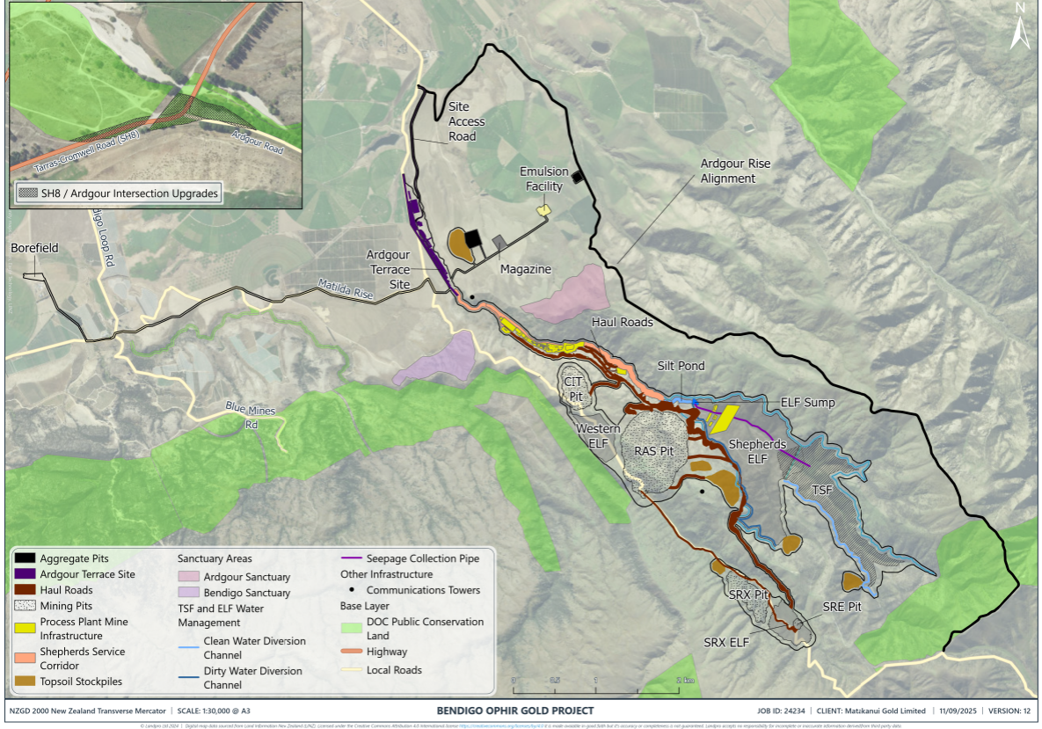

Plan 1 - Project Overview Plan

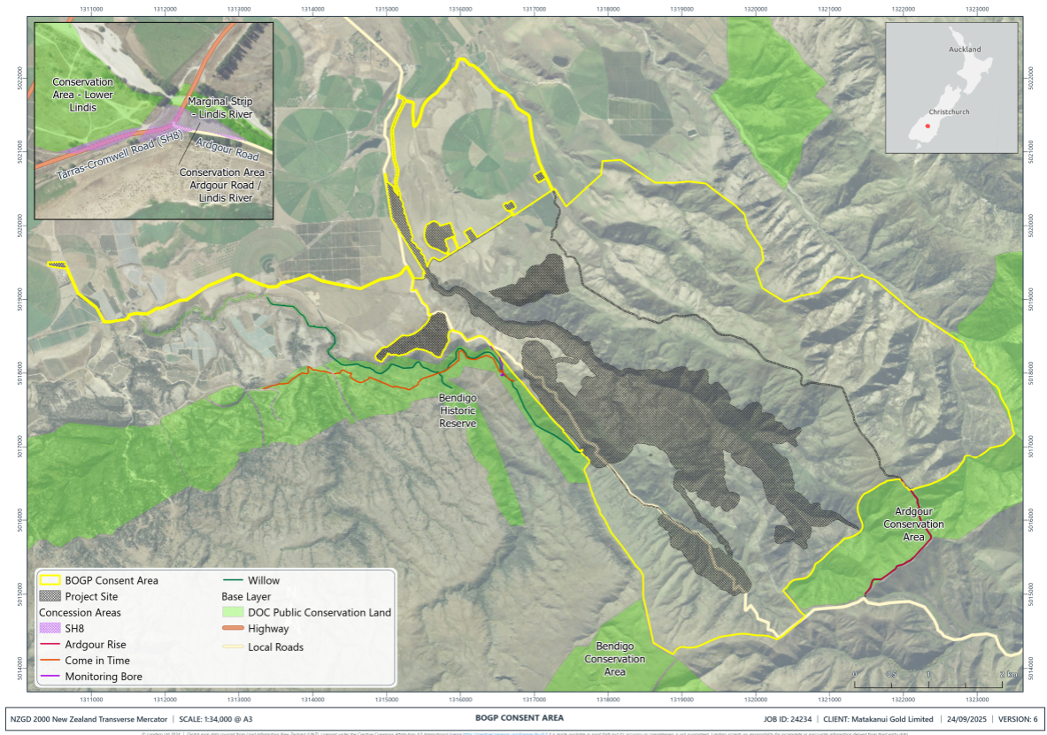

Plan 2 – BOGP Consent Area

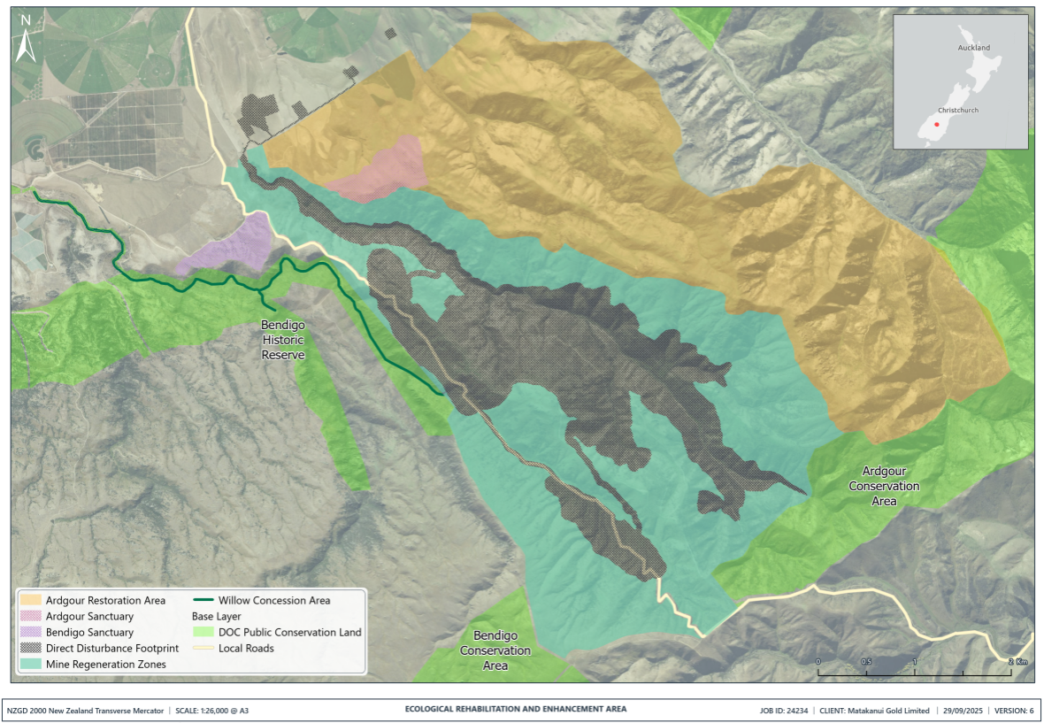

Plan 3 – Ecological Rehabilitation and Enhancement Area

Attachment 2

Records of Title against which the Bond is to be Registered

