Macraes Phase 4 Project – Proposed District Council Land Use Consent Conditions
Condition
Activities
Pursuant to the Resource Management Act 1991, the Waitaki District Council and Dunedin City District Council grants its consent to Oceana Gold (New Zealand) Limited for gold mining operations involving:
- The extraction of minerals and overburden by mechanical means from the expanded open pits shown as Coronation Pit, Golden Bar Pit, and Innes Mills Pit on Maps 1-3, respectively, attached to and forming part of this consent;
- The transport, treatment and processing of minerals extracted from the expanded Coronation Pit, Golden Bar Pit, and Innes Mills Pit;
- The stacking, deposit and storage of substances considered to contain any mineral from the expanded Coronation Pit, Golden Bar Pit, and Innes Mills Pit;
- The deposit of waste rock produced by the expanded Coronation Pit within the Coronation North Pit, Coronation Waste Rock Stack, Coronation North Waste Rock Stack and Trimbells Waste Rock Stack shown on Map 1 annexed;
- The excavation of waste rock from the Northern Gully Waste Rock Stack;
- The deposit of waste rock produced by the expanded Golden Bar pit at the expanded Golden Bar Waste Rock Stack shown on Map 3 annexed;
- The deposit of waste rock produced by the operation centred on the following grid references: Frasers East Waste Rock Stack (NZTM 1402258E 4972772N), Frasers West Waste Rock Stack (NZTM 1400757E 4970734N), and Frasers South Waste Rock Stack (NZTM 1402065E 4971366N);
- The deposit of waste rock from the operation into the open pits as shown on Maps 1-3 annexed;
- The construction and maintenance of the Frasers Tailings Storage Facility, which includes the Frasers Backfill embankment, centred at NZTM 1398891E 4973180N, and as shown on Map 5 annexed; and the deposition or discharge of tailings, process water and associated by-products from the Macraes ore Processing Plant into the tailings storage facility;
- The re-establishment, maintenance and use of a haul road from Golden Bar Pit to the ore Processing Plant;
- The maintenance and use of a haul road from Coronation North Pit to the ore Processing Plant;
- The use of two haul road crossings (approximately centred at grid reference NZTM 1397100E 4975800N Horse Flat Road and NZT 1398200E 4974200N Golden Point Road);
- The use and storage of diesel, explosives and associated detonation materials;
- The construction and use of temporary buildings;
- The de-commissioning, rehabilitation, de-construction or dismantling of the mine and of any structures and works resulting from activities set out in paragraphs a-j above;
- The realignment of part of Golden Bar Road as shown on Map 4 annexed;
- The construction, operation and maintenance of silt ponds and erosion and sediment control facilities necessary for controlling runoff from the mining operation;
- The formation of pit lakes in Coronation Pit, Coronation North Pit, Frasers Pit, Innes Mills Pit, Golden Point/Round Hill Pit and Golden Bar Pit;
- Activities to offset and compensate for the adverse effects of the above activities.
The duration of this consent shall be 35 years.
DEFINITONS
"Act" means the Resource Management Act 1991, and includes all amendments to the Act, and any enactments made in substitution for the Act
"Project Overview and Annual Work and Rehabilitation Plan" means the Project Overview and Annual Work and Rehabilitation Plan required by Condition 3.
"Building" means any temporary or permanent structure.
"Building Work" means work for or in connection with the construction, alteration, operation, demolition or removal of a building and includes site work.
"Councils" means the Waitaki District Council and the Dunedin City Council and includes its successors, and also includes any person to whom the consent authorities delegate or transfer any of its functions, powers and duties as a consent authority under the Act.
“Disturbed Land” means any land where the soil has been removed or modified and includes any waste rock stacks, or any other structures that have not been rehabilitated with soil and vegetation;
"Exploration" means any activity undertaken for the purpose of identifying mineral deposits or occurrences and evaluating the feasibility of mining particular deposits or occurrences of one or more minerals; and includes any drilling, dredging, or excavations (whether surface or subsurface) that are reasonably necessary to determine the nature and size of a mineral deposit or occurrence; and "to explore" has a corresponding meaning.
“Heavy Vehicle” means a vehicle with a gross vehicle mass of more than 3,500 kilograms.
"Landscape Architect" means a professional member of the New Zealand Institute of Landscape Architects Inc or equivalent body.
"Life of the Macraes Gold Project" means the period ending when all mining operations at Macraes cease.
“Macraes Ecological District” means the area described by the Department of Conservation (James Bibby), 1997: Macraes ecological district: survey report for the Protected Natural Areas Programme, ISBN 0478019254, 9780478019254 and as also defined in McEwen, W.M. (1987): Ecological regions and districts of New Zealand, incorporating third revised edition in four 1:500 000 maps (Part 4). New Zealand Biological Resources Centre publication No. 5. 125p + maps.
"Mining" means to take, win, or extract, by whatever means, a mineral existing in its natural state in land, or a chemical substance from that mineral, for the purpose of obtaining the mineral or chemical substance; but does not include prospecting or exploration; and "to mine" has a corresponding meaning.
"Mining Operations" means operations in connection with mining, exploring, or prospecting for any mineral, gold, including –
- The extraction, transport, treatment, processing, and separation of any gold mineral; and
- The construction, maintenance, and operation of any works, structures, and other land improvements, and of any machinery, and equipment, connected with such operations; and
- The removal of overburden by mechanical or other means, and the stacking, deposit, storage, and treatment of any substance considered to contain any mineral; and
- The deposit or discharge of any mineral, material, debris, tailings, refuse, or wastewater produced from or consequent on, any such operations; and
- The doing of all lawful acts incidental or conducive to any such operations – when carried out at or near the site where the mining, exploration, or prospecting is carried out.
"ORC" means the Otago Regional Council and includes its successors, and also includes any person to whom the council delegates or transfers any of its functions, powers and duties under the Act
"Prospecting" means any activity undertaken for the purpose of identifying land likely to contain exploitable mineral deposits or occurrences; and includes:
- Geological, geochemical, and geophysical surveys;
- The taking of samples by hand or hand held methods; and
- Aerial Surveys, -
and "to prospect" has a corresponding meaning.
"Site work" means work on a building site, including earthworks, preparatory to or associated with the construction, alteration, demolition or removal of a building.
"Structure" includes a dam and a waste rock stack.
"Supporting documents" means the supporting documents listed as Appendices 1-33 attached to the application date 28 March 2024 (Updated 18 February 2024), and also includes all other material (including statements of evidence and submissions) provided by the applicant to the consent authorities in support of the application for the consent.
"Rehabilitation objectives and terms" means the rehabilitation, objectives and terms set out in Condition 4.
"Works" includes any excavation, drilling and includes a road.
General Conditions
  - This consent shall be exercised substantially in accordance with the Macraes Phase 4 Project application for resource consent lodged to, and receipted by, the Councils on 2nd April 2024, including the Assessment of Environmental Effects and all Supporting Documents (which are deemed to be incorporated in, and form part of this consent), except to the extent that any condition in this consent is inconsistent with such material. If there is an inconsistency the conditions and terms of this consent shall prevail.
  - Pursuant to Section 125(1) of the Resource Management Act 1991 this consent shall lapse on the expiry of five years after the date of issue of the consent unless the consent is given effect to before the end of that period or upon application in terms of Section 125 (1) (b) of the Act, the Councils may grant a longer period of time.
  - The Consent Holder shall notify the Councils in writing of the first exercise of this consent.
  - In the event of any non-compliance with the conditions of this consent, the Consent Holder shall notify the Councils within 24 hours of the non-compliance being detected. Within five working days the Consent Holder shall provide written notification to the Councils providing details of the non-compliance. This notification will at a minimum include an explanation of the cause of the non-compliance, the steps taken to remedy the situation and steps taken to avoid any future occurrence of the non-compliance.
  - The Councils may, in accordance with sections 128 and 129 of the Resource Management Act 1991, serve notice on the Consent Holder of its intention to review the conditions in the last week of March in any year:
for the purposes of
- Dealing with any adverse effect on the environment (including cultural values) which may arise from the exercise of this consent and which is appropriate to deal with at a later stage, or which become evident after the date of commencement of the consent; and
- Ensuring the conditions of this consent are appropriate.
  - Prior to the expiry of this consent, the Consent Holder shall ensure that all rehabilitation and everything necessary to comply with the conditions of this consent has been completed.
Advice Note: in addition to the fees payable for the processing of this application, where further site inspections are required to monitor compliance with any of the conditions, the Councils may render an account to the Consent Holder for additional monitoring fees at the rate prescribed in the Annual Plan on the basis of time involved.
2. Location of Various Mining Activities
  - The Innes Mills Pit, Coronation Pit, Golden Bar Pit and associated waste rock storage areas, Frasers Tailings Storage Facility, realignment of Golden Bar Road and other ancillary mine features connected with the Macraes operation shall not materially exceed those footprints shown on the maps annexed. The corridor for the deviation of Golden Bar Road is shown on Map 4 annexed.
3. Project Overview and Annual Work and Rehabilitation Plan
  - The Consent Holder shall submit a Project Overview and Annual Work and Rehabilitation Plan to the Councils by 31 March each year that will cover the upcoming year (1 July to 30 June). The Consent Holder may, at any time, submit to the Councils an amended Project Overview and Annual Work and Rehabilitation Plan. The Project Overview and Annual Work and Rehabilitation Plan shall include, but not be limited to:
- A description and timeline of intended mining activities for the duration of mining operations including a plan showing the location and contours of all existing and proposed structures at completion of mining;
- A description (including sequence, method and form) of mining operations, monitoring and reporting carried out in the last 12 months;
- A detailed description (including sequence, method and form) of all mining operations, monitoring and reporting, not covered by a separate management plan intended to be carried out in the next 12 months;
- An explanation of any departure in the last 12 months from the previous Project Overview and Annual Work and Rehabilitation Plan;
- Plans showing the contours (at 5 metre intervals) and footprints of all works and structures and any proposed changes at the end of the next 12 months;
- A description and analysis of any unexpected adverse effects on the environment that have arisen as a result of the exercise of the consent in the last 12 months and the steps taken to deal with it and the results of those steps;
- A description and analysis of any non-compliance with any conditions of consent that have occurred in the last 12 months and the steps that were taken to deal with it and the results of those steps;
- A full report describing and evaluating the mitigation measures used in the last 12 months and any that are proposed to be implemented in the next 12 months. This should detail where further mitigation is proposed or has been undertaken as a result of a non-compliance event and/or any adverse effects on the environment;
- A summary description of all Management Plans and Manuals required under this land use consent and any resource consents issued by ORC and details of any review or amendment of any of the Management Plans or Manuals;
- An overview of the monitoring and reporting programme for the previous 12 months and any changes proposed for the next 12 months;
- A detailed section on rehabilitation including, but not limited to the following
- The total area of disturbed land in the mine site, yet to receive rehabilitation and indicative rehabilitation dates for various areas of the mine site;
- The area of additional disturbed land in the coming year that will require future rehabilitation;
- The area of disturbed land rehabilitated in the previous year;
- The area of disturbed land proposed to be rehabilitated in the coming year;
- A description of rehabilitation planned for the life of mine at the site;
- A description of proposed rehabilitation methods for any area, including proposed topsoil to be stripped and stockpiled, surface pre-treatment and re-use of topsoil on finished areas in the next 12 months;
- The details of the location, design (including shape form and contour) and construction of all permanent structures;
- Drainage details for any disturbed land and recently rehabilitated areas;
- Details of any vegetation to be used as part of rehabilitation for the next 12 month period; and
- Detailed results of any revegetation trials.
- A description of any rehabilitation problems encountered and the steps being taken to resolve these problems;
- An up to date and detailed calculation of the cost of dealing with any adverse effects on the environment arising or which may arise from the exercise of this consent;
- An up to date and detailed calculation of the costs of complying with all rehabilitation conditions of this consent;
- An up to date and detailed calculation of the costs of any monitoring required by the conditions of this consent;
- A contingency closure plan describing in detail the steps that would need to be taken if mining operations stopped in the next 12 months in accordance with Condition 23; and
- Any other information required by any other condition of this consent and any related consent.
  - Each year the Consent Holder shall provide the Chair of Macraes Community Incorporated, Kāti Huirapa Rūnaka ki Puketeraki, Te Rūnanga o Ōtākou and Te Rūnanga o Moeraki with a copy of each Project Overview and Annual Work and Rehabilitation Plan.
  - The Project Overview and Annual Work and Rehabilitation Plan for this consent may be combined with any Project Overview and Annual Work and Rehabilitation Plan required by any other consent held by the Consent Holder for mining operations at Macraes Flat.
  - The Consent Holder shall provide the Councils with any further information, or report, which the Councils may request after considering any Project Overview and Annual Work and Rehabilitation Plan. This information or report shall be provided in the time and manner required by the Councils.
  - The Consent Holder shall exercise this consent in accordance with the Project Overview and Annual Work and Rehabilitation Plan.
  - The Consent Holder shall design and construct all permanent earthworks to the form shown in the Project Overview and Annual Work and Rehabilitation Plan.
Rehabilitation
  - The rehabilitation objectives to be achieved by the Consent Holder are:
- To ensure short and long term stability of all structures and works and their surrounds;
- To avoid maintenance after completion of rehabilitation requirements;
- To protect soil from erosion and to protect water from contaminants affected by mining operations;
- To stabilise and rehabilitate the banks and surrounds of any waterbodies;
- To return land as closely as possible to its original condition, including any exotic pastoral and indigenous species appropriate to the area; and
- To visually integrate finished structures, land-forms and vegetation into the surrounding landscape so they appear to be naturally occurring features; and,
- To control invasive environmental weeds, including wilding conifers, in the Disturbed Land for the Life of the Macraes Gold Project.
Earth Shaping and Visual
  - The Consent Holder shall locate, form and shape all earthworks so that their profiles, contours, skylines and transitions closely resemble and blend with the surrounding natural landforms. If earthworks cannot be fully naturalised, the Consent Holder shall minimise the extent of their visibility and maximise their integration into the surroundings.
  - The Consent Holder shall use a Landscape Architect in the planning and design of all permanent earthworks and structures.
Waste Rock Stacks
  - The Consent Holder shall design and construct the waste rock stacks in accordance with the following principles:
- Slopes shall be suitably concave or convex in cross-profile to match nearby natural slopes;
- Slope gradients shall be no steeper than nearby natural surfaces
- Transitions between natural and formed surfaces shall be rounded and naturalised;
- Contours should be curvilinear in plan form, in keeping with original natural contours in that area;
- The skyline shall be variable and curved, simulating natural skylines;
- New landforms shall be aligned and located so they seem to continue, not cut across, existing landscape patterns; and
- Silt ponds shall be removed and the site rehabilitated or be converted to stock water drinking ponds following completion of mining operations and rehabilitation
  - Where practicable the waste rock shall be backfilled into pits in order to minimise the size of waste rock stacks.
Soil
  - The Consent Holder shall, as far as practicable, stockpile soil from any disturbed land, unless the soil is required to be left in place to protect water and soil values.
  - All salvaged soil shall be used on disturbed land for rehabilitation purposes.
Revegetation
  - The Consent Holder shall in accordance with the rehabilitation objectives, undertake progressive rehabilitation of disturbed land as operational activities allow. It shall be revegetated with:
- Exotic pastoral species; or
- Tussock species which are as far as practicable sourced from the Macraes Ecological District;
- Shelter trees provided the following are not planted:
  - Lodgepole pine (Pinus contorta)
  - Scots pine (Pinus sylvestris)
  - Corsican pine (Pinus nigra)
  - Dwarf mountain pine (Pinus uncinate)
  - Mountain pine (Pinus mugo)
  - Douglas fir (Pseudotsuga menziesii)
  - All larches (Larix species)
  - All alders (Alnus species)
  - All willows (Salix species)
  - Sycamore (Acer pseudoplatanus)
- Indigenous species which are as far as practicable sourced from the Macraes Ecological District.
Details of area, density and methods of planting shall be set out in the Ecological Management Plan required under Condition 18.
  - The outcomes of the monitoring carried out in accordance with condition 4.11(e) shall be reported in the Annual Ecology Report required under Condition 19.1.
  - The Consent Holder shall maintain vegetation cover on revegetated land until the expiry of this consent and ensure that the vegetation, including any vegetation established on disturbed land, shall be self-sustaining after expiry.
Soil and Vegetation Monitoring
  - At three yearly intervals, the Consent Holder shall complete a review of all soil and pasture on land that has been rehabilitated. The first review shall be no later than the third anniversary of the commencement of this consent. The review shall include, but not be limited to, the following:
- Monitoring for ground cover, species components, plant nutrition status, soil organic matter and concentrations of exchangeable nutrients in the soil;
- Analysis and interpretation of the monitoring results by a suitably qualified soil or agricultural scientist;
- Evaluation of the vegetation and its potential to be self-sustaining for pastoral farming after mining ceases; and
- Any necessary recommendations for future rehabilitation, including plant species or varieties to be used, cultivation and seeding methods to be introduced, or fertilisers to be used.
A copy of the review will be forwarded to the Councils and Department of Conservation within three months of the review being completed.
Site Decommissioning and Closure
  - The Consent Holder shall submit to the Councils a Site Decommissioning Plan, not less than 12 months before completion of the operations.
  - The Site Decommissioning Plan shall be prepared in consultation with takata whenua, Macraes Community Development Trust and Macraes Community Incorporated.
  - The Site Decommissioning Plan shall include but not be limited to:
- A plan(s) showing the final design and intended contours (at 5 metre intervals) of all permanent structures and works, including but not limited to, waste rock stacks, permanent earthworks, tailings storage facilities, dam embankments, water storage reservoirs, pit lakes, water bodies, roads or other works which under this consent or any related consent are authorised or required to remain after the relevant consents expire;
- A summary of rehabilitation completed to date, and details of rehabilitation required to fulfil the conditions of this consent and any related consents;
- Details on infrastructure to be decommissioned, such infrastructure may include buildings, plant, and equipment;
- Details of specific infrastructure to remain on-site post-closure. Such infrastructure may include buildings, plant, equipment and any monitoring structures required by this consent and any related consent to remain after the expiry of the consents;
- Details of management, any ongoing maintenance, monitoring and reporting proposed by the Consent Holder to ensure post-closure activities are carried out in accordance with the conditions of this consent;
- Details on the decommissioning of any infrastructure associated with existing art works, heritage sites, tracks and interpretation signage;
- Details of measures to protect public safety, including any fencing yet to be completed;
- Peer-reviewed findings of a geotechnical assessment undertaken for the purpose of determining appropriate exclusion zones around the open pits.
- The costs of complying with (a)-(f) above.
  - The Consent Holder shall remove all buildings, plant and equipment (whether attached to the land or not) listed in the Site Decommissioning Plan for removal. This condition does not apply to:
- Any waste rock stacks, permanent earthworks, tailings storage facility, silt ponds, waterbody, road or other works and any associated plant and equipment which under this or any other resource consent is permitted or required to remain after decommissioning or after this consent expires;
- Any structure which cannot be safely removed following reasonable attempts to do so;
- Any monitoring structure required by this or any other resource consent to remain after the expiry of this consent.
Cultural Matters
  - [Placeholder]
OceanaGold is yet to receive a final Cultural Impact Assessment for the Macraes Phase 4 Project. On receipt of the final Cultural Impact Assessment, OceanaGold will consider whether any specific conditions are required to address matter raised.
Complaints
  - The Consent Holder shall maintain a record of any complaints received regarding their operation. The register shall include, but not be limited to:
- The date, time, location and nature of the complaint;
- The name, phone number, and address of the complainant, unless the complainant elects not to supply this information;
- Action taken by Consent Holder to remedy the situation and any policies or methods put in place to avoid or mitigate the problem occurring again.
  - The register of complaints shall be incorporated into the Project Overview and Annual Work and Rehabilitation Plan required by Condition 3 of this consent and provided to the Councils on request.
8. Blasting and Vibration
  - The Consent Holder shall ensure that blasting practices minimise air and ground borne vibration. Fly-rock shall be minimised and all blasting procedures shall be carried out so as to ensure the safety of employees and the public. No blasting shall occur when the weather is unsuitable.
  - The location and time of blasting shall be posted daily at all the main mine entrances and advised to employees by daily email.
  - Blasting shall be restricted to within the following hours:
Monday to Friday 9.00am to 5.30pm
Saturday and Sunday 10.00am to 4.30pm
  - Details of blasting method, strength of the blast and time of blast shall be entered into a record kept for that purpose and shall be available to the Councils on request. This information shall also be included in the monitoring report, required under Condition 10.
  - Vibration due to blasting or any other activity associated with the mining operation, when measured at any point within the notional boundary of any dwelling not owned by the Consent Holder, or subject to an agreement with the Consent Holder, school or church outside the Macraes Mining Project Mineral Zone as defined by the Waitaki District Plan, deemed operative on 23 August 2010 shall not exceed a peak particle velocity measured in the frequency range 3-12 Hz of 5 mm/sec provided this level may be exceeded on up to 5% of the total number of blasts over a period of 12 months. The level shall not exceed 10 mm/sec at any time.
Advice Note: The notional boundary is defined as a line 20 metres from the exterior wall of any rural dwelling or the legal boundary where this is closer to the dwelling.
  - Airblast overpressure from blasting associated with the mining operation, when measured at any point within the notional boundary of any dwelling not owned by the Consent Holder, or subject to an agreement with the Consent Holder, school or church outside the Macraes Mining Project Mineral Zone as defined by the Waitaki District Plan, deemed operative on 23 August 2010 shall not exceed a peak non-frequency-weighted (Linear or flat) level of 115 decibels (dB), provided this level may be exceeded on up to 5% of the total number of blasts over a period of 12 months. The level shall not exceed 120 dB (Linear peak) at any time. For the purpose of this consent, C-frequency-weighting may be considered equivalent to the Linear or Flat-frequency-weighting.
  - The Consent Holder shall not conduct blasting within the vicinity of the Macraes Road or Golden Bar Road in a manner that constitutes a danger to life or property. If the Waitaki District Council considers it necessary to temporarily close the Macraes Road or Golden Bar Road to allow blasting to take place, it may permit the Consent Holder to temporarily close the road, provided that the Consent Holder:
- Keeps the time of closure as short as possible; and
- Does not allow the time of closure to exceed a maximum of 15 minutes in any continuous period of 60 minutes, except where an emergency situation arises in respect of the safety of the public or project personnel.
In the event of such temporary closure the Consent Holder shall:
- Ensure appropriate barriers are erected and ensure such number of persons as may be necessary are stationed at Macraes Road or Golden Bar Road to prevent access by the public to that part of the road that shall be closed; and
- Hold current public liability insurance to indemnify any member of the public affected.
- Postpone any blasting in order to reopen the Macraes Road or Golden Bar Road to allow the passage of vehicles for emergency purposes.
9. Noise
Noise Limits
  - The Consent Holder shall ensure that all construction and operation activities associated with the mining operations are designed and conducted so that the following noise limits are not exceeded at the locations specified in Condition 9.2:
- On any day between 7 am to 9 pm (daytime): 50 dBA Leq; and
- On any day between 9.00 pm to 7.00am the following day (night-time): 40dBA Leq; and/or 70 dBA Lmax.
Measurement Locations
  - Noise measurements shall be taken at any point within Macraes Village; or at, the notional boundary of any dwelling not owned by the Consent Holder, or subject to an agreement with the Consent Holder.
Advice Note: The notional boundary is defined as a line 20 metres from the exterior wall of any rural dwelling or the legal boundary where this is closer to the dwelling.
Measurement and Assessment
  - All noise measurements referred to in Conditions 9.1 and 9.2 above shall be measured in accordance with the provisions of NZS 6801:2008 Acoustics: Measurement of Environmental Sound, and shall be assessed in accordance with the provisions of NZS 6802:2008 Acoustics: Environmental Noise.
10. Monitoring of Noise, Airblast and Vibration
  - Prior to exercise of this consent, the Consent Holder shall prepare a Noise, Airblast and Vibration Monitoring Plan. The plan shall include but not be limited to:
- Details of the monitoring locations, the frequency of monitoring and the method of measurement and assessment in accordance with Conditions 8.4, 8.5, 9.1 and 9.2;
- Procedures for recording blasting method, strength of the blast and time of blast; and
- Procedures for addressing non-compliant results and notification of the Councils.
  - The Noise, Airblast and Vibration Monitoring Plan for this consent may be combined with any other Noise, Airblast and Vibration Monitoring Plan required by any other consent held by the Consent Holder for mining operations at Macraes Flat.
  - The Consent Holder shall exercise this consent in accordance with the Noise, Airblast and Vibration Monitoring Plan. The Consent Holder shall review the plan annually and, if necessary, update it. Confirmation of the review shall be included in the Project Overview and Annual Work and Rehabilitation Plan. The Councils shall be provided with any updates of the plan within one month of any update occurring.
  - The Consent Holder shall produce a report each year summarising the results of the Noise, Airblast and Vibration Monitoring. The report shall be included in the Project Overview and Annual Work and Rehabilitation Programme.
  - All measurements from the monitoring programmes shall be recorded and shall be made available to the Councils on request.
11. Lighting
  - All flood lighting luminaires that could potentially cause a glare nuisance or a traffic hazard shall be fitted with shields and, as far as is practicable, orientated so that the principal output is directed away from residences and traffic.
12. Waste Rock Stacks and Waste Rock Backfills
  - Waste rock stacks and waste rock pit backfills shall be designed in accordance with industry best-practice, and to withstand a 1-in-2500 annual-exceedance-probability earthquake without catastrophic failure, noting that some deformation is allowable provided the structure retains a state of long-term stability post event.
  - A design report shall be prepared for each new waste rock stack and waste rock pit backfill by a suitably qualified geotechnical engineer or engineering geologist and this report provided to the Council prior to the commencement of construction of the structure. The report shall include details of the geotechnical model, loading assumptions, credible failure modes, and key design and construction requirements, and shall include an evaluation of the long-term stability for closure.
  - The Golden Bar Waste Rock Stack must not materially exceed a height of 610 mRL
13. Tailings Storage Facilities
  - The Consent Holder shall ensure that Stage 2 of the Frasers Tailings Storage Facility is designed and constructed in accordance with sound engineering practice.
  - The Consent Holder shall engage a suitably qualified engineer to design Stage 2 of the Frasers Tailings Storage Facility. A design report shall be prepared for the Frasers Tailings Storage Facility and this report provided to the Waitaki District Council prior to the commencement of construction of the Stage 2 impoundment. The report shall include details of the foundation conditions, material properties, groundwater, seepage and construction requirements, and shall include evaluation of the long-term stability and performance of the impoundment.
14. Final Pit Lakes
  - The pit lakes shall, at all times, have sufficient freeboard to fully contain seiche waves that may be induced by landslides and earthquakes.
  - No less than twelve months prior to commencement of filling the pit lakes, the Consent Holder shall provide the Councils with a Closure Manual for the following pit lakes: Golden Bar, Coronation, Coronation North (if applicable), and Frasers - Innes Mills Pit Lakes. The manual shall include, but not be limited to:
- Details of how Condition 14.1 shall be achieved and how compliance with Condition 14.1 is to be demonstrated over the term of this consent.
- Details of the lake filling, including but not limited to mean flow-rates, location of inflows and, where applicable, the quality of the discharge; and
- Details of the long-term pit wall stability.
  - The Consent Holder shall exercise this consent in accordance with the Closure Manual. The Consent Holder shall review the manual annually and if necessary update it. Confirmation of the review shall be included in the Project Overview and Annual Work and Rehabilitation Plan. The Consent Holder shall provide the Councils with any updates of the plan within one month of any update occurring.
15. Roading
Coronation Roading
  - The consent holder shall provide unformed legal public access of a width not less than 15m that generally follows the blue line, and orange line north of Horse Flat Road shown on the map titled “Macraes Gold Project Coronation Area Roading” annexed.
  - The consent holder shall provide unformed pedestrian access that generally follows the yellow dashed line south of Horse Flat Road shown on the map titled “Macraes Gold Project Coronation Area Roading” annexed.
  - Within 12 months of all stages of Coronation Pit, Coronation North Pit, Coronation WRS, Coronation North WRS and Trimbells WRS excavation and rehabilitation ceasing, the Consent Holder shall reinstate for public use that part of Golden Point Road south of Horse Flat Road shown on the map titled “Macraes Gold Project Coronation Area Roading” annexed.
  - To achieve the reinstatement of that part of Golden Point Road under Condition 15.3 the following work must be completed:
- The haul road shall be decommissioned, and replaced with a public road that has a minimum road reserve of 15 metres in width, and a carriageway of 5 metres in width;
- The public road shall be formed to a minimum 150 mm sub-base and a base course of 100mm AP4O with a wearing course of AP2O;
- The road shall also be delineated and marked to a public road standard;
- Design and construction details shall be lodged with the Waitaki District Council for its approval.
  - Within 6 months of completion of mining operations associated with all stages of Coronation North and Coronation Pits and rehabilitation of the project areas to the point of decommissioning silt ponds, the consent holder shall define and take steps to vest to the respective Councils (and make lawfully available to the Councils pending completion of vesting) a legal road of no less than 20 m wide that approximately follows the purple line shown as “Post Mining Matheson Road” on the map titled “Macraes Gold Project Coronation Area Roading” annexed (as a replacement for the unformed Matheson Road). Depending on the extent of pit excavations, the road may be modified to be south or southwest of the purple line. The grade of Matheson Road shall be no more than 1 Vertical, 6 Horizontal at any location of the alignment. Prior to vesting, the road shall be graded to a standard enabling it to be used as a fine weather track for four wheel drive vehicles. The consent holder shall not have any ongoing responsibility to maintain the track or any form of public access along this unformed road as a consequence of this grading.
  - Where the road under Condition 15.5 crosses Trimbells waste rock stack, the Consent Holder shall design the road to avoid the road being scoured out or eroded. The detailed design shall be forwarded to the Compliance Manager at the Dunedin City Council.
  - Within 6 months of completion of mining operations associated with all stages of Coronation North and Coronation Pits ceasing and rehabilitation of the project areas to the point of decommissioning silt ponds, the consent holder shall define and take steps to vest to the Waitaki District Council (and make lawfully available to the Council pending completion of vesting) a legal road of no less than 20 metres wide that approximately follows the Coronation haul road alignment (as indicatively shown marked in orange as “Post Mining Golden Point Road” on the map titled “Macraes Gold Project Coronation Area Roading” annexed) between Horse Flat Road and Matheson Road (as a replacement for the unformed Golden Point Road). Prior to vesting, the road shall be graded to a standard enabling it to be used as a fine weather track for four wheel drive vehicles. The consent holder shall not have any ongoing responsibility to maintain the track or any form of public access along this unformed road as a consequence of this grading.
Advice Note: All road stopping, temporary road closures and vesting of new road reserve is to be completed under the relevant statutes.
Road Stability
  - Prior to the exercise of this consent, the Consent Holder must assess the existing Factor of Safety for Macraes Road and Golden Bar Road in the vicinity of Innes Mills Pit and Golden Bar Pit to identify any areas where the existing Factor of Safety is less than 1.5.
  - The Consent Holder must ensure that the activities authorised by this consent do not cause the Factor of Safety of Macraes Road or Golden Bar Road to reduce below 1.5 or below the Factor of Safety identified by the assessment carried out in accordance with Condition 15.8, whichever is the lesser.
  - Where the assessment carried out in accordance with Condition 15.8 identifies an existing Factor of Safety of less than 1.0, the Consent Holder must prepare and submit to the Waitaki District Council a Ground Stability Management Plan (GSMP) within 6 months of the first exercise of this consent. The purpose of the GSMP is to manage stability of public roads potentially affected by the activities authorised by this consent.
  - The GSMP required by condition 15.10 must include, at a minimum, the following information:
  - Provision of a Factor of Safety, developed using an Industry Standard methodology for the relevant public road;
  - Methodology for determining the Factor of Safety including the assessed failure mode(s);
  - A monitoring program for the specific slope potentially affecting the public road which may include prisms and deformation markers, and inspections (walkover and drive over). The nature and scale of the monitoring program will be developed with regard to the Factor of Safety and the assessed risk;
  - Triggers for action, based on rainfall and demonstrated ground movement determined through deformation curves;
  - A response plan when monitoring reaches trigger levels. The response plan will include specific actions to be undertaken, timeframes for response and roles and responsibilities for undertaking actions;
  - A review period for the GSMP based on frequency and in the event of specific trigger levels being breached;
  - Reporting requirements in the case that movement triggers are exceeded, including but not limited to the following information:
    - Who is to prepare the report and within what timeframe of a trigger exceedance;
    - Factors which may explain why the movement trigger was exceeded;
    - Recommended actions to minimise recurring or ongoing instability;
    - Recommended changes to the monitoring if required;
    - Any revisions on the current applicable factor of safety and Risk Assessment, if required;
    - Recommended actions to restore appropriate stability to the road realignment if required;
    - Any other necessary actions to achieve the purpose of the GSMP;
    - Timeframe for provision of the report to Waitaki District Council;
  - A description of the methods and principles to avoid ground movement and otherwise ensure the road is geotechnically safe and fit for purpose;
  - Details of the proposed monitoring network to be established, including the location and installation schedule for monitoring stations and instrumentation to be used at each station.
  - A description of the stability parameters and milestones that should be reached and at which point the GSMP and all of its requirements will no longer apply.
  - Any other information or procedure that is recommended by the geotechnical engineer, or a suitably qualified and experienced peer reviewer in order to achieve the purpose of the GSMP.
  - The GSMP must be certified in writing by a suitably qualified and experienced geotechnical engineer as meeting the requirements of condition 2.4 and the consent holder shall provide this certification and the GSMP to Waitaki District Council.
16. Golden Bar Road Realignment
  - The realignment of Golden Bar Road shall be constructed within the corridor identified on Map 4 attached to and forming part of this consent and shall be designed and constructed in accordance with the conditions identified in this section.
Maintenance of Public Right-of-way
  - During the Golden Bar Road realignment construction, the Consent Holder shall ensure that public vehicle and pedestrian access along existing roads is maintained within the existing legal road reserve on a carriageway at all times, except that the roads may be temporarily closed from time to time for the purpose of mine blasting. All works on or in close proximity to open public roads shall be managed in accordance with the NZTA Code of Practice for Temporary Traffic Management.
Land for New Public Roads
  - All land to be vested as road reserve for new roads shall be transferred to Waitaki District Council by the Consent Holder at no cost to Waitaki District Council. If any actual and reasonable costs are incurred by Waitaki District Council in facilitating the vesting of the road, such as survey, legal and consulting costs, these costs shall be paid in full by the Consent Holder.
Road Closures
  - The Consent Holder shall request the Waitaki District Council to initiate road stopping procedures in relation to all public roads to be stopped. All actual and reasonable costs including survey, legal and other consulting fees, and all of Waitaki District Council’s direct costs associated with the closure procedures shall be paid in full to the Waitaki District Council by the Consent Holder.
If any roads within the Dunedin City Council control need to be stopped, the Consent Holder shall request the Dunedin City Council to initiate road stopping procedures in relation to all public roads to be stopped. All actual and reasonable costs including survey, legal and other consulting fees, and all of Dunedin City Council’s direct costs associated with the closure procedures shall be paid in full to the Dunedin City Council by the Consent Holder.
Disposal of land under closed roads
  - All road reserve land comprised as closed road shall be transferred from the Council or the Councils to the Consent Holder as the owner of adjacent land. All land created by road closure shall immediately be amalgamated with the adjoining land.
  - The Consent Holder shall ensure that all existing parcels of land have frontage to a legal road at the completion of the amalgamations.
  - All actual and reasonable costs, including survey, legal, consulting fees and costs and disbursements incurred by the Council in disposing of the land under the closed roads shall be paid in full to the respective Council by the Consent Holder.
Stability Requirements for Golden Bar Road Realignment
  - Fill material shall be placed and compacted to a minimum standard in accordance with TNZ F/1:1997 “Specification for earthworks construction” and Council requirements, and in accordance with previously established construction precedent for the public roads within the mine site.
Preparation and Certification of Designs for Road Works
  - The Consent Holder shall ensure a producer statement (PS1) is completed that confirms that the road design meets industry design criteria, including but not limited to:
- TNZ F/1:1997 "Specification for earthworks construction" for general earthworks;
- Austroads "Guide to Road Design" (2009) and "NZ supplement to the 2004 Austroads Pavement Design Guide" for pavement design;
- Granular Pavement Layers: TNZ B/02:2005. Specification for Construction for Unbound. Granular Pavement Layers; and
- TNZ P/3: 1995: Specification for First Coat Sealing.
Where any one of the documents set out in clauses (a)-(e) above are superseded by a new document prior to provision of the PS1 to Waitaki District Council, the new document or part thereof shall only apply with the express agreement in writing by the Waitaki District Council Roading Manager.
Inspection and Certification Works
  - An inspection report shall be supplied to the Council at three monthly intervals during the road construction work, and at the conclusion of the maintenance periods defined in these conditions.
  - The Consent Holder will meet on site with a Waitaki District Council representative monthly during construction to discuss compliance matters and inspect the road alignment works, unless Waitaki District Council states in writing that this is unnecessary in that month. The outcomes of this meeting will be recorded in minutes and provided to Waitaki District Council.
  - The Consent Holder shall provide a producer statement (PS4) to the Waitaki District Council confirming that the constructed road meets the PS1 prepared in accordance with condition 16.9.
  - A Schedule 1B "Contractor's Certification Upon Completion of Land Development/Subdivision" and a Schedule 1C "Certificate Upon Completion of Land Development/Subdivision" from NZS 4404:2010 shall be completed and presented to Council at the completion of works.
Advice Note: It is recommended that construction work be inspected and certified as being constructed in compliance with the design by a Chartered Professional Engineer with specific experience in road construction.
Road Construction and Maintenance Standards
  - The realigned section of Golden Bar Road authorised by this consent shall be designed, constructed and maintained as required by the following conditions 16.15 to 16.33 inclusive.
Pavement Design
  - The Consent Holder shall ensure that the design life of the realigned section of Golden Bar Road authorised by this consent is sufficient to ensure that the road is capable of sustaining the anticipated traffic load for 25 years.
  - The minimum actual pavement design life achieved on the realigned road shall be 10 years based on the AADT with 10% heavy vehicles for sealed roads, and 10 years based on AADT with 20% heavy vehicles for unsealed roads.
  - The pavement design of the road shall be in accordance with Austroads "Guide to Road Design" (2009) and "NZ supplement to the 2004 Austroads pavement design guide".
Where the document set out in this condition is superseded by a new document prior to provision of the PS1 to the Council, the new document or part thereof shall only apply with the express agreement in writing by the Waitaki District Council Roading Manager.
  - All road pavement construction is to be in accordance with NZTA B/2 "Construction of Unbound Granular Pavement Layers". All construction testing is to be submitted to the Council before sealing of pavement on the realigned road commences.
  - The Consent Holder shall, prior to opening the realigned section of road for public vehicular and pedestrian use, undertake roughness testing in accordance with TNZ TM 7003 v1 "Roughness Requirement for Finished Pavement Construction". Should the tests fall outside the roughness parameters then the Consent Holder shall, at its cost, undertake the necessary remedial works to bring the pavement back into specification prior to vestment of the pavement.
Advice Note: This condition does not prevent the Consent Holder from opening any unsealed section of the new realignment with the agreement of Waitaki District Council, should this be required for operational reasons.
Geometric Standards
  - The geometric design of all new public roads and intersections shall be in accordance with Austroads "Guide to Road Design" (2009).
Private Vehicle Access Design
  - On sealed roads all access ways shall be constructed in accordance with the Waitaki District Council Standard vehicle entrance specification, including any drainage and concrete headwalls.
Safety Audit
  - The Consent Holder shall commission an independent safety audit by a suitably qualified and experienced person on the as built design and submit the safety audit report to Waitaki District Council within 1 month of practical completion of road construction or a longer time frame if agreed to in writing by the Waitaki District Council.
Day-to-Day Maintenance
  - The day-to-day maintenance of Golden Bar Road between Macraes Road and the Golden Bar Haul Road by the Frasers South Waste Rock Stack as shown on Map A and Map B2 of resource consent 201.2011.235 (including snow clearance, frost gritting, road clearing and vehicle recovery) will be the responsibility of the Consent Holder at its cost during the mine operation and for a period of six months after the decommissioning of the ore processing plant at the mine site carried out in accordance with the Site Decommissioning Plan prepared under Condition 5.1 of resource consent 201.2011.235.
  - Any deficiencies in the day-day maintenance of the road surface will be repaired by the Consent Holder until the timeframe described in condition 16.25 has elapsed. The response time of the repairs carried out and standard of repair required will be undertaken as outlined in the Waitaki District Council current Road Maintenance Contract, unless otherwise agreed to by the Waitaki District Council Roading Manager.
Structural Maintenance Period
  - Subject to condition 16.29, for a period of four years after the decommissioning of the ore processing plant at the mine site in accordance with the Site Decommissioning Plan prepared under Condition 5.1, the Consent Holder shall remain responsible, at its own cost, for the drainage and structural condition of all new or reconstructed road formations where these cross over previously mined areas or tailings deposits and/or are within 500m of an excavated mine pit.
  - Subject to condition 16.29, for a period of 12 months after the decommissioning of the ore processing plant at the mine site in accordance with the Site Decommissioning Plan prepared under Condition 5.1 of resource consent 201.2011.235, the Consent Holder shall remain responsible, at its own cost, for the drainage and structural condition of all new or reconstructed road formations, other than those covered by condition 16.25 of this consent.
  - The Consent Holder must undertake annual inspections of the road structural condition and drainage. The Consent Holder shall notify Waitaki District Council not less than three weeks before the inspection is to be carried out. Inspection reports and notifications will be e-mailed to Waitaki District Council Roading Manager within 3 months of the inspection being carried out.
  - Any part of the road including structural, bridge or drainage aspects that do not meet the standards for a local road set out in the One Network Road Classification prepared by the New Zealand Transport Agency will be repaired or rectified by the Consent Holder at its own cost within two months of identification of the deficiency, or a longer time frame if approved in writing by the Waitaki District Council Roading Manager.
  - Prior to the Council accepting the road at the end of the structural maintenance periods described in conditions 16.25 and 16.26 above, the Council may provide the Consent Holder with details of any standards for a local road set out in the One Network Road Classification prepared by the New Zealand Transport Agency that were identified as requiring rectifying in the inspections required by 16.27 that are yet to be remedied and the Consent Holder, upon receiving such details, shall carry out the works so that the road meets the standards for a local road set out in the One Network Road Classification prepared by the New Zealand Transport Agency.
Advice Note: The Council shall only accept responsibility for the road upon being satisfied that any deficiencies which have been identified in inspections carried out pursuant to condition 16.30 are remedied by the Consent Holder so that the road meets the standards for a local road set out in the One Network Road Classification prepared by the New Zealand Transport Agency.
Maintenance Standards
  - The Consent Holder shall, until such time as the Council agrees to accept the roads for maintenance, will maintain the roads affected by this consent to the standards for a local road set out in the One Network Road Classification prepared by the New Zealand Transport Agency.
General Roading
  - The Consent Holder, at its own cost, shall ensure that the roading maintenance, carried out by the Consent Holder or by a contractor engaged by the Consent Holder, shall:
- Carry out road maintenance to the specifications as identified in Council’s Road Maintenance Contract current at the time of repair or other specifications only with the express agreement in writing by the Waitaki District Council Roading Manager.
- Install, maintain and replace all work to the specifications identified in Council’s Road Maintenance Contract current at the time of repair or other specification only with the express agreement in writing by the Waitaki District Council Roading Manager.
  - The Consent Holder shall complete all pavement markings in accordance with TNZ P/12 Specification for Painted Pavement Markings unless any alternative is with the express agreement of the Waitaki District Council Roading Manager.
  - No tree planting by the Consent Holder shall be positioned such that when the trees grow, they will shade the Golden Bar Road alignment between the hours of 1000 and 1400 on the shortest day of the year.
17. Heritage
  - Prior to the removal of any part of the historic fenceline at Coronation Pit Stage 6 identified in Map 7 attached to this consent, the Consent Holder must record the extent and features of the fenceline to a Level III Standard as per HNZPT, “Investigation and Recording of Buildings and Standing Structures” (Archaeological guidelines series no. 1, 2018).
Advice note: An archaeological authority from Heritage New Zealand Pouhere Taonga will be required before removal of any part of the historic fenceline can proceed.
  - The Consent Holder must not remove any part of the historic fenceline except where necessary to provide for the Coronation Pit Extension. This may include up to 50m either side of the Coronation Pit Extension. The consent holder must restrain the remaining parts of the historic fenceline.
  - If the Consent Holder
- Discovers koiwi tangata (human skeletal remains), or Māori artefact material, the Consent Holder shall without delay:
- Notify the Councils, Tangata whenua and Heritage New Zealand Pouhere Taonga and in the case of skeletal remains, the New Zealand Police.
- Stop work within the immediate vicinity of the discovery to allow a site inspection by Heritage New Zealand Pouhere Taonga and the appropriate runanga and their advisors, who shall determine whether the discovery is likely to be extensive; if a thorough site investigation is required and whether an Archaeological Authority is required.
- Any koiwi tangata discovered shall be handled and removed by tribal elders responsible for the tikanga (custom) appropriate to its removal or preservation.
- Discovers any feature or archaeological material that predates 1900, or heritage material, or disturbs a previously unidentified archaeological or heritage site, the Consent Holder shall without delay:
- Cease work immediately at that place and within 20m around the site;
- Shut down all machinery, secure the area, and advise the Site Manager;
- Secure the site and notify the Heritage New Zealand Regional Archaeologist and the Councils. Further assessment by an archaeologist may be required;
- If the site is of Māori origin, notify the Heritage New Zealand Regional Archaeologist, the Councils and the appropriate iwi groups or kaitiaki representative of the discovery and ensure site access to enable appropriate cultural procedures and tikanga to be undertaken, as long as all statutory requirements under legislation are met (Heritage New Zealand Pouhere Taonga Act 2014, Protected Objects Act 1975). Heritage New Zealand will determine if an archaeological authority under the Heritage New Zealand Pouhere Taonga Act 2014 is required for works to continue; and
- Recommence site work following consultation with the Councils, Heritage New Zealand and iwi, provided that any relevant statutory permissions have been obtained.
Advice Note: An archaeological authority from Heritage New Zealand Pouhere Taonga may be required before work can proceed.
  - Following a discovery described in Condition 17.3, site work shall recommence following consultation with the Councils, Heritage New Zealand Pouhere Taonga, Tangata whenua, and in the case of skeletal remains, the NZ Police, provided that any relevant statutory permissions have been obtained.
18. Ecological Management Plan
  - Prior to the exercise of this consent, the Consent Holder shall engage a suitably qualified and experienced ecologist to prepare and submit to the Councils an Ecological Management Plan (“EMP”) for certification. The purpose of the EMP is to manage the actual and potential adverse effects on the Threatened, At Risk and Locally Uncommon species and general ecological values being affected by the Macraes Phase 4 Project.
Advice Note: The EMP may be combined with any EMP required by any other consent held by the Consent Holder for mining operations at Macraes Flat.
  - The EMP shall:
- Include sections covering the following matters:
  - vegetation and threatened plant management;
  - avifauna management;
  - aquatic biota management; and
  - management of other indigenous biodiversity
- Have the following objective:
  - To avoid, remedy, mitigate, offset or compensate the effects of the Macraes Phase 4 Project on threatened, at risk and locally uncommon plants and vegetation types, indigenous birds, indigenous invertebrates, resident lizard populations, and aquatic fauna.
- Detail the methods by which the objective set out in this condition shall be achieved, including:
  - Ecological management during construction and operation of the Macraes Phase 4 Project including to give effect to conditions 20.1 to 20.4;
  - Rehabilitation requirements to give effect to conditions 21.1 to 21.2;
  - Offsetting and compensation requirements including the management of such sites to give effect conditions 22.1 to 22.17;
  - Details relating to the salvage, propagation and transplanting of the indigenous plant species identified in conditions 24.1 to 24.4;
  - Management of effects on lizards including to give effect to conditions 25.1 to 25.4;
  - Management of any habitat restoration;
  - Weed and predator control;
  - Ecological monitoring and ongoing management requirements and,
  - Fencing design and method of construction for the offset/compensation areas.
- The Consent Holder shall implement the programme of activities specified in the EMP.
  - Where offsetting and compensation is proposed as part of the EMP the Consent Holder shall ensure it achieves the following outcomes:
- Any offset is applied so that the ecological values being achieved are the same or similar to those being lost. Any compensation together with the offset will achieve positive biological diversity outcomes;
- The positive ecological outcomes of the offset are designed and implemented to last at least as long as the duration of the consent, and as far as is practicable in perpetuity;
- The offset and compensation will achieve biological diversity outcomes beyond results that would have occurred if the offset was not implemented; and
- The delay between the loss of biological diversity through the proposal and the gain or maturation of the offset’s biological diversity outcomes is minimised.
    - The Councils will use their best endeavours to certify the EMP within 10 working days of receipt, noting that expert input may be required before certification can be provided. If the Council is unable to certify the EMP within 10 working days, it must notify the Consent Holder and advise a revised timeframe. Regardless, the Councils must use their best endeavours to certify the EMP as soon as possible after the 10 working day period and within a total of 20 working days of receipt.
    - Provided that the Consent Holder has not been advised of a revised timeframe under Condition 18.4(a), the Councils shall, no later than 10 Working Days of receipt of the EMP, confirm in writing to the Consent Holder that the management plan is either certified or declined, or shall request that the Consent Holder incorporate changes suggested by the Councils. If a revised timeframe has been advised, confirmation of a decision shall be made by the Councils in accordance with that timeframe (applying best endeavours to reach a decision within 10 working days from receipt of the EMP).
    - If 10 workings days have passed since the EMP has been provided to the Council, and the Council has not advised the Consent Holder of a revised timeframe under Condition 18.4(a), or certified or declined to certify the EMP in accordance with Condition 18.4(b), then the EMP shall be deemed to be certified and the Consent Holder may commence works in accordance with the EMP as provided.
  - Prior to submitting the final EMP to the Councils for certification, a copy of the draft EMP must be provided to the Department of Conservation and Kāti Huirapa ki Puketeraki, Te Rūnanga o Otakou; Te Rūnanga o Moeraki, with an invitation to provide feedback within 10 working days. The Consent Holder must ensure that all written feedback on the draft EMP received from Department of Conservation and Kāti Huirapa ki Puketeraki, Te Rūnanga o Otakou; Te Rūnanga o Moeraki within the 10 working day timeframe is provided to the Councils when the EMP is submitted for certification, along with a clear explanation of where any comment made on the draft EMP has or has not been incorporated into the EMP and, if not incorporated, the reasons why.
  - The Consent Holder may request subsequent changes to the certified EMP by submitting the amendments in writing to the Councils for certification. Any changes to the EMP shall remain consistent with the objectives and functions of the EMP as specified in condition 18.2, and no changes shall take effect until certified by the Councils. Condition 18.4 applies to any amendments submitted by the Consent Holder.
19. Ecological Monitoring Report (EMR)
  - The Consent Holder shall engage a suitably experienced and qualified ecologist(s) to prepare an annual Macraes Phase 4 Project Ecological Monitoring Report (EMR). The EMR shall include:
- A description of the works and other actions completed by the Consent Holder in the previous twelve months in order meet the purpose and objectives of the EMP; and
- An evaluation of the progress of:
  - Rehabilitation implementation as required by conditions 21.1 to 21.2;
  - Offsetting and compensation implementation as required by conditions 22.1 to 22.12;
  - Transplanting of indigenous plant species identified in condition 24.1; and
  - Actions required by the Lizard Management Plan in accordance with conditions 25.1 – 25.5
- A description of the methods to be implemented in the following 12 months in order to meet the purpose and objectives of the EMP.
  - The Consent Holder shall provide the Councils, Kāti Huirapa ki Puketeraki, Te Rūnanga o Otakou; Te Rūnanga o Moeraki; and the Department of Conservation with a copy of the report by no later than 31 July each year. The report may be combined with any EMP report required by any other consent held by the Consent Holder for mining operations at Macraes Flat.
20. Ecological Management During Construction and Operation
  - Land disturbance undertaken by the Consent Holder must adhere to a Ground Nesting Bird Protocol. The Ground Nesting Bird Protocol must be developed by a suitable qualified and experienced ecologist with the objective of avoiding disturbance of indigenous ground nesting birds. A copy of the Ground Nesting Bird Protocol must be provided to the Councils as part of the EMP required by Condition 18.1.
  - The Consent Holder shall take practical measures to ensure that the areas of indigenous vegetation requiring disturbance to give effect to this consent are minimised where possible. This shall include the following protocols:
    - Using survey markers to clearly mark out areas to be cleared prior to land disturbance commencing;
    - Using survey markers to clearly mark out areas of higher ecological value within 100m of the areas to be cleared or disturbed prior to land disturbance commencing. Such areas must be identified in the EMP required by Condition 18.1;
    - Only clearing authorised areas as they are required; and
    - Avoiding driving vehicles and machinery outside of established tracks or areas that are authorised by this consent to be cleared.
  - If Orocrambus sophistes is confirmed in pre-development surveys to be present at the site of the Golden Bar Waste Rock Stack, the Consent Holder must undertake the following to protect the resident Orocrambus sophistes:
    - Only remove tussock from the site of the Golden Bar Waste Rock Stack Extension during summer;
    - Stockpile any tussock removed from the site of the Golden Bar Waste Rock Stack Extension in addition to soils within an area of existing undisturbed tussock grassland; and
    - Use all of the stockpiled tussock specified in (b) to rehabilitate the Golden Bar Waste Rock Stack in accordance with condition 21.1.
  - Within 12 months of the works authorised by this consent commencing, the Consent Holder shall engage an appropriately qualified ecologist to undertake an inspection of the area around any disturbed land authorised by this consent for new weed species. The Consent Holder must engage and appropriately qualified ecologist to repeat the inspection every 6 months for two years and annually thereafter for the duration of this consent. Any new environmental weeds that are discovered in the area must be subject to OceanaGold’s annual environmental weed control operation.
21. Ecological Rehabilitation Requirements
  - The Consent Holder shall in accordance with the rehabilitation objectives specified in condition 4.1, rehabilitate at least 35 ha of the 48 ha extension of the Golden Bar WRS to 80% cover of narrow-leaved tussock grassland by planting subdivided or nursery grown narrow-leaved tussock plants within an area which shall include a 20 m buffer from the WRS base to facilitate recruitment by other species from adjacent undisturbed tussock grassland.
  - The Consent Holder shall fence the area specified in condition 21.1 to exclude stock.
22. Ecological Offsetting and Compensation Requirements
Offset and Compensation Areas
  - Prior to undertaking any clearance of indigenous vegetation at the site of the Coronation Stage 6 Pit Extension, the Consent Holder must set aside:
- an area of land capable of containing ephemeral wetland(s) covering a combined area of at least 0.3 ha known as the Ephemeral Wetland Creation Site at or near the location as shown on the Map 1 annexed to this consent for the purpose of providing ecological offsetting for ephemeral wetland values.
- an area of land containing at least 1.5 ha of suitable lizard habitat that can be enclosed by a predator proof fence or otherwise predator controlled;
- an area of land containing at least 0.5 ha of riparian and wetland vegetation mosaic;
- an area of land containing at least 6 ha of existing tussock grassland that is currently at approximately 15% tussock cover that is capable of having average tussock cover increased to 50%.
The exact size and location of the area shall be finalised during preparation of the management plans required by Condition 22.12 and shall be in accordance with the outcomes set out in Conditions 22.4, 22.6, 22.8, and 22.10 (as applicable). Two or more of the above areas may be combined.
  - Prior to undertaking any clearance of indigenous vegetation at the site of the Innes Mills Pit Extension or the Golden Bar Road Realignment, the Consent Holder must set aside:
- an area of land at capable of containing a wetland covering at least 0.1 ha known as the Wetland Offset Site at or near the location shown on the Map 1 annexed to this consent for the purpose of providing ecological offsetting for wetland values.
- an area of land containing at least 6 ha of suitable lizard habitat that can be enclosed by a predator proof fence or otherwise predator controlled;
- an area of land containing at least 1 ha of riparian and wetland vegetation mosaic;
- an area of land containing at least 6 ha of existing tussock grassland that is currently at approximately 15% tussock cover that is capable of having average tussock cover increased to 50%.
The exact size and location of the area shall be finalised during preparation of the management plans required by Condition 22.12 and shall be in accordance with the outcomes set out in Conditions 22.4, 22.6, 22.8, and 22.10 (as applicable). Two or more of the above areas may be combined.
  - Prior to undertaking any clearance of indigenous vegetation at the site of the Golden Bar Pit Extension or the Golden Bar Waste Rock Stack Extension, the Consent Holder must set aside:
- an area of land containing at least 27.7 ha of suitable lizard habitat that can be enclosed by a predator proof fence or otherwise predator controlled;
- an area of land containing at least 1.8 ha of riparian and wetland vegetation mosaic;
- an area of land containing at least 31 ha of existing tussock grassland that is currently at approximately 15% tussock cover that is capable of having average tussock cover increased to 50%.
The exact size and location of the area shall be finalised during preparation of the management plans required by Condition 22.12 and shall be in accordance with the outcomes set out in Conditions 22.4, 22.6, 22.8, and 22.10 (as applicable). Two or more of the above areas may be combined.
Management Requirements for Offset and Compensation Areas
  - The Consent Holder must manage the area identified in Condition 22.1(a) (the Ephemeral Wetland Creation Site) to achieve the following outcomes:
    - Establish ephemeral wetlands which will become self-sustaining; and
    - To increase the overall extent and value of ephemeral wetlands within the Macraes Ecological District.
  - To achieve the outcomes specified in Condition 22.4 the Consent Holder must, as a minimum:
    - Excavate gently sloping concave scrapes in the bedrock of approximately 1m depth below existing ground level, with two excavated to a deeper depth;
    - Fill the excavations specified in (a) with peat material to a depth of approximately 10cm below existing ground level;
    - Carry out seeding of the peat base described in (b) with ephemeral wetland and wetland plant species to form a near continuous cover of native plant community;
    - Fence off the ephemeral wetlands constructed within the Ephemeral Wetland Creation Site with fencing of an appropriate specification to exclude cattle whilst maintaining access for sheep; and
    - Enable grazing of the Ephemeral Wetland Creation Site by sheep or otherwise undertake weed control to prevent short-statue native plant communities being overtopped by weeds.
  - The Consent Holder must manage the area identified in Condition 22.2(a) (the Wetland Offset Site) to achieve the following outcomes:
    - Establish a wetland which will become self-sustaining; and
    - To increase the overall extent and value of wetlands within the Macraes Ecological District.
  - In order to achieve the outcomes specified in Condition 22.6 the Consent Holder must, as a minimum:
    - Planting out at least 0.1 ha of indigenous wetland plant species at the Wetland Offset Site;
    - Fence off the Wetland Offset Site with fencing of an appropriate specification to exclude cattle whilst maintaining access for sheep; and
    - Enable grazing of the Wetland Offset Site by sheep or otherwise undertake weed control to prevent short-statue native plant communities being overtopped by weeds.
  - The Consent Holder must manage the areas identified Conditions 22.1(b), 22.2(b), and 22.3(a) (Lizard Habitat Enhancement Areas) to achieve the following outcomes:
    - Protect and enhance lizard habitat;
    - Provide for the translocation of lizards from within the project footprint.
  - In order to achieve the outcomes specified in condition 22.8 the Consent Holder shall:
    - Fence the Lizard Habitat Enhancement Areas to exclude stock;
    - Install predator proof fencing or otherwise undertake predator control to exclude mammalian predators;
    - Prepare and implement a Predator Control Plan with the objective of eradicating target pest animals from the area(s).
  - The Consent Holder must manage the areas identified under Conditions 22.1(c) – (d), 22.2(c) – (d), and 22.3(b) – (c) (Vegetation Enhancement Areas) to achieve the following outcomes:
    - Allow the natural succession of the indigenous vegetation communities within the Vegetation Enhancement Areas; and
    - Increase the ecological diversity and ecological importance of the Vegetation Enhancement Areas.
  - In order to achieve the outcomes specified in condition 22.10 the Consent Holder shall:
    - Fence the Vegetation Enhancement Area to exclude stock;
    - Plant out at least 0.5ha of new shrubland, comprising at least five different indigenous shrub species in the area that shall achieve 75% canopy cover within 10 years;
    - Undertake control of woody weeds within the shrubland area referred to in (b) and within 200m of this area;
    - Include at least 12 ha of riparian vegetation;
    - Remove gorse from the area described in (g) and establishing safeguards against invasion of woody weed species within this habitat.
Offset and Compensation Management Plans
  - As part of the EMP required by condition 18 the Consent Holder shall engage an appropriately qualified and experienced Ecologist(s) to prepare the following management plans:
    - An Ecological Enhancement Area Management Plan (EEAMP) for the areas referred to in Conditions 22.1(b) – (d), 22.2(b) – (d), and 22.3(a) – (c);
    - An Offset Plan for the Ephemeral Wetland Creation Site specified in condition 22.1(a); and
    - An Offset Plan for the Wetland Creation Site specified in condition 22.2(a).
  - The objective of each Plan referred to in Condition 22.12 is to set out the detailed offsetting, compensation, and monitoring measures that will be practically implemented at the areas identified in Conditions 22.1 – 22.3 to achieve the outcomes specified under conditions 22.4, 22.6, 22.8, and 22.10, respectively. The Plans required by Condition 22.12 must include, as a minimum (as applicable to the relevant site):
- A description of the offset, the calculation basis, locations and management activities by which enhancements will be generated;
- Details regarding the financial cost of the offset work and its subsequent maintenance and how these will be secured in the long term in order to secure the financial delivery of the Plan.
- A monitoring programme to assess the degree to which enhancement targets are being achieved and the ability to adjust biodiversity management to ensure that gains will be achieved and maintained for the long term;
- The roles and responsibilities of those carrying out the work, and the governance and management structures relating to the operation of the offsetting site(s)
- Reporting of monitoring results and a process for undertaking actions if offsetting or enhancement targets are not being achieved as anticipated.
- With regard to the Ecological Enhancement Area Management Plan, the incorporation of research programmes in order to:
  - form a better understanding of the response of resident invertebrate communities to changes in tussockland habitat; and
  - if Orocrambus sophistes is present, form a better understanding of the distribution, habitat and food plants of Orocrambus sophistes in both the Golden Bar and local area to enable the creation or enhancement of suitable habitat in the Murphys Ecological Enhancement Area or other suitably protected site.
  - Upon certification of the Plans prepared in accordance with Condition 22.12 and not later than six months following the commencement of any onsite works the Consent Holder shall confirm in writing to the Councils that it has commenced implementing the Plan at the appropriate.
  - Three years following the implementation of each certified Plan identified in Condition 22.12 the Consent Holder shall engage a suitably qualified and experienced ecologist to conduct a review of each offset and compensation area that has been established to determine that all offsetting and compensation actions have been undertaken in accordance with Conditions 22.5, 22.7, 22.9, and 22.11 (as applicable).
The purpose of this review shall be to ensure that these actions are achieving or show clear evidence towards achieving the outcomes specified in Conditions 22.4, 22.6, 22.8, and 22.10 (as applicable). Should any monitoring result show that the expected outcomes will not be realised, the Consent Holder shall implement a programme of corrective actions to achieve the expected outcomes.
  - As a result of the reviews undertaken in accordance with Condition 22.15 the Consent Holder may request subsequent changes to the certified Plan by submitting the amendments in writing to the Councils. Any amendments shall be such that the Offset Plan will continue to achieve outcomes specified under Conditions 22.4, 22.6, 22.8, and 22.10 (as applicable) and the requirements of Condition 22.13. No changes may take effect until the Councils have certified that the plan will continue to achieve the relevant objectives. Condition 18.4 applies to any amendments submitted by the Consent Holder as part of an updated EMP.
  - Within 6 months of completing construction of the Coronation Pit Lake Spillway, the consent holder must fence off 100 m of gully bottom extending from the spillway downstream to the current stock fence using standard stock fencing situated at least 5 m from gully bottom.
23. Offsetting sites – Land Protection and Long Term Requirements
  - Within 24 months of the exercise of this consent, the Consent Holder must register a covenant (or other suitable legal protection mechanism) in perpetuity against the relevant land titles for the areas identified in Conditions 22.1 – 22.3. The conservation purposes of the covenant shall be as described at Conditions 22.4 – 22.11 (as applicable) and any covenant shall retain the right of access to the Councils for monitoring and compliance purposes. The survey and legal costs associated with creating the covenants in registrable form shall be borne by the consent holder. Copies of the titles shall be provided to the Councils upon completion of the covenant registration.
24. Plant Rescue
  - Prior to mining the Golden Bar Pit Extension or depositing waste rock into the Golden Bar Waste Rock Stack Extension, the Consent Holder shall, using a suitably qualified person or persons, fund and carry out measures for the translocation of seeds, cuttings or other cultivation material from the following plant species located within the impacted footprint (“salvage species”):
- The Declining desert broom Carmichaelia petriei from the c. 100 shrubs in the Golden Bar Pit and Waste Rock Stack footprint to establish 500 individuals at a location fenced to exclude stock;
- The Naturally Uncommon wetland rush Juncus distegus from the c. 6 individuals in the Golden Bar Waste Rock Stack footprint to establish 50 individuals at a location fenced to exclude stock;
- The Data Deficient shrub Melicytus aff. alpinus from 20 individuals in the Golden Bar Waste Rock Stack footprint to form a component of shrubland containing at least 40 individuals at a location fenced to exclude stock;
  - The propagation material taken from the plants listed in Condition 24.1 (a) - (c) will be established as self-sustaining and viable plants in suitable habitat within the Vegetation Enhancement Areas identified in Condition 22.3(c) of this consent.
  - The Consent Holder shall monitor the success of all plantings carried out under the requirements of (a) - (c) of Condition 24.1 annually for three years following planting and shall detail the plantings carried out and the “success” of the plantings in its annual EMR. In this context, success means the successful survival and growth of the plant species so that they may form potentially viable populations and shall be monitored by recording the survival and growth of individual plants and noting any flowering and recruitment of new individuals. Success shall be demonstrated by at least 75% of established plants surviving, and at least 50% of transplants increasing in size compared with their establishment.
  - Prior to constructing the Coronation Pit Lake spillway, the Consent Holder shall use a suitably qualified person or persons, fund and carry out measures for the translocation of the c. 300 plants Naturally Uncommon Declining mountain daisy Celmisia hookeri to a stock fenced area adjacent to the proposed Coronation Pit Lake spillway.
25. Lizard Management Plan
  - As part of preparing the EMP the Consent Holder shall engage an appropriately qualified and experienced person to prepare a Lizard Management Plan (LMP).
  - The purpose of the LMP is to, as far as is practicable, plan and implement actions to avoid, remedy and/or mitigate the actual and potential effects of the Macraes Phase 4 Project on the lizard values present within the project footprint. Offsetting and compensation will be employed to address residual adverse effects. The Lizard Management Plan shall demonstrate consistency with;
    - The requirements of any permit or approvals issued under any other legislation for the Macraes Phase 4 Project site (Wildlife Act Authorisation or permit); and
    - The draft Lizard Management Strategy: OceanaGold Operations, Macraes Flat prepared by LizardExpertNZ, dated 2022 and any final version or subsequent updates to that strategy.
  - The LMP required by condition 25.1 of this consent shall include:
- A description of the measures to be taken by the Consent Holder to adequately avoid, remedy, mitigate or compensate for effects on lizard species present within the Macraes Phase 4 Project site; and
- A description of the monitoring and reporting requirements required to ensure the intended outcomes of the LMP are being met.
The actions described in the LMP to satisfy the requirements of (a) and (b) will be in general accordance with those outlined in the draft LMP included as Appendix 18 of the Macraes Phase 4 Resource Consent Application and Assessment of Environmental Effects, dated 28 March 2024, and any other permit or approval obtained under the Wildlife Act 1953 or other relevant legislation. If there are any inconsistencies between the draft LMP and the conditions of any permit or approval obtained under the Wildlife Act 1953 or other relevant legislation, the Consent Holder shall prioritise consistency of the final LMP with those approvals.
  - Within two years of first exercise of this consent the Consent Holder shall engage a suitably qualified person to update the Lizard Management Strategy: OceanaGold Operations, Macraes Flat to incorporate the lizard information relating to the Macraes Phase 4 Project and shall provide it to the Councils. Any recommendations within the Lizard Management Strategy shall be incorporated into the overarching EMP and implemented by the Consent Holder.
26. Fencing, barriers and marking
  - Stock-proof fencing shall be used to keep livestock away from all working areas.
  - On the completion of mining operations, the Consent Holder shall ensure that all fences and barriers, required to restrict people and/or stock for safety purposes, are installed and maintained. This shall include fences and barriers to be installed and maintained around any pit or tailings storage facility.
27. Management of Hazardous Substances
  - The Consent Holder shall ensure that all fuels and oils used at the site are contained in appropriately bunded facilities and that all fuel/oil dispensers are fitted with non-return valves.
  - Refuelling, lubrication and any mechanical repairs shall be undertaken in a manner that provides sufficient mitigation measures to ensure that no spillages onto the land surface or into water occur.
28. Bonds
Obligations to be secured
  - The Consent Holder shall provide and maintain in favour of the Councils one or more bonds to secure:
- The performance and completion of rehabilitation in accordance with the conditions of this consent; and
- The carrying out of the monitoring required by the conditions of this consent; and
- The remediation of any adverse effect on the environment that may arise from the exercise of this consent; and
- Compliance with conditions 28.13 - 28.17 of this consent.
Advice note: The bond is not intended to include the cost of general road maintenance or rectifying any deficiency caused by lack of maintenance of public roading beyond the maintenance periods identified by this consent. The Consent Holder is required to carry out road inspections, monitoring and maintenance under conditions 16.28, 16.29, 16.30, 16.31 and 16.32 of this consent, until four years after the closure of the processing plant, at which time maintenance will no longer be a Consent Holder responsibility.
When bonds to be provided
  - Before the commencement of this consent, the Consent Holder shall provide to the Councils one or more bonds required by Condition 28.1
Form of bond
  - Subject to the other provisions of this condition, any bond shall be in the form and on the terms and conditions approved by the Councils.
Surety
  - Any bond shall be given or guaranteed by a surety acceptable to the Councils.
  - The surety shall bind itself to pay for the carrying out and completion of the conditions of consent which are the subject of the bond on default by the Consent Holder or the occurrence of any adverse environment effect requiring remedy during or after the expiry of this consent.
Amount
  - The amount of each bond shall be fixed annually by the Councils which will take into account any calculations and other matters submitted by the Consent Holder relevant to the determination of the amount to be bonded in the Project Overview and Annual Work and Rehabilitation Plan, or otherwise.
  - The amount of the bond(s) shall include:
- The estimated costs of complete rehabilitation in accordance with conditions of consent on the completion of the mining operations proposed for the next year and described in the Project Overview and Annual Work and Rehabilitation Plan.
- The estimated costs of:
- Monitoring in accordance with the monitoring conditions of the consent;
- Monitoring for and of any adverse effect of the activity authorised by this consent which may become apparent during or after expiry of this consent;
- Monitoring any rehabilitation required by this consent.
- Any further sum which the consent authority considers necessary for monitoring and dealing with any adverse effects on the environment that may arise from the exercise of the consent whether during or after the expiry of this consent.
  - The amount shall be calculated for the duration of this consent and for a period of 20 years after its expiry.
  - If, on review, the total amount of bond to be provided by the Consent Holder is greater or less than the sum secured by the current bond(s), the Consent Holder, surety and the Councils may, in writing, vary the amount of the bond(s).
General
  - While the liability of the surety is limited to the amount of the bond(s), the liability of the Consent Holder is unlimited.
  - Any bond may be varied, cancelled, or renewed at any time by written agreement between the Consent Holder, surety and Councils.
Costs
  - The costs (including the costs of the consent authority) of providing, maintaining, varying and reviewing any bond shall be paid by the Consent Holder.
Bonding on expiry or surrender of this consent
  - For a period of 20 years from the expiry or surrender of this consent the Consent Holder shall provide in favour of the Councils one or more bonds.
  - The amount of the bond to be provided under Condition 28.13 shall include the amount (if any) considered by the Councils necessary for:
- Completing rehabilitation in accordance with the conditions of this consent.
- Monitoring for and of any adverse effect on the environment that may arise from the exercise of the consent.
- Monitoring any measures taken to prevent, remedy or mitigate any adverse effect on the environment that may arise from the exercise of this consent.
- Dealing with any adverse effect on the environment which may become apparent after the surrender or expiry of this consent.
- Contingencies
  - Without limitation, the amount secured by the bond given under Condition 28.13 may include provision to deal with structural instability or failure, land and water contamination, and the failure of rehabilitation in terms of the rehabilitation objectives and conditions of this consent. Costs shall include costs of investigating, preventing, remedying or mitigating any adverse effect.
  - The bond(s) required by Condition 28.13 must be provided on the earlier of:
- 12 months before the expiry of this consent;
- Three months before the surrender of this consent.
  - Conditions 28.3, 28.4, 28.5, 28.8, 28.9, 28.10 and 28.11 apply to the bond(s) required by Condition 28.13.
29. Public Liability Insurance
  - The Consent Holder shall effect and keep current public liability insurance for an amount not more than twenty million dollars. The amount shall be determined by the Councils in consultation with the Consent Holder.
  - The indemnity expressed in the insurance policy shall be sufficiently wide in its coverage so as to include claims arising from damage caused by structural failure, or damage resulting from fire or explosion and all fire fighting costs resulting from the Consent Holder’s operations in respect of the land and from any accidental or otherwise spillage of any chemical or reagent and/or resulting clean up and restoration costs and the costs of mitigation of those events.
  - The Consent Holder shall on request provide the Councils a copy of the insurance policy and the receipt evidencing payment of the premium in respect of any such policy.
  - The Consent Holder shall also indemnify the Councils against any claim arising from the public use of public roads for the time being under control of the Consent Holder.
30. Closure of Operations
  - The Consent Holder shall annually supply to the Council a contingency plan for the early closure of the mine, as part of the Project Overview and Annual Work and Rehabilitation Programme. This contingency plan shall be updated annually. The plan shall address the objectives listed in Condition 4 and include:
- An evaluation of the residual risk of the operation with regard to the neighbouring community and environment; and
- A plan for the long term management of the site, in particular the area of open pits or consequent lakes and include details of on-going maintenance and monitoring requirements and restrictions on future use.
- Describe in detail what needs to be done to:
  - Decommission the mine site in accordance with this consent;
  - Rehabilitate the mine site in accordance with this consent;
  - Comply with other conditions relevant to cessation of mining; and
  - The costs needed to comply with (i)-(iii).

Map 1 – Coronation Mining Area
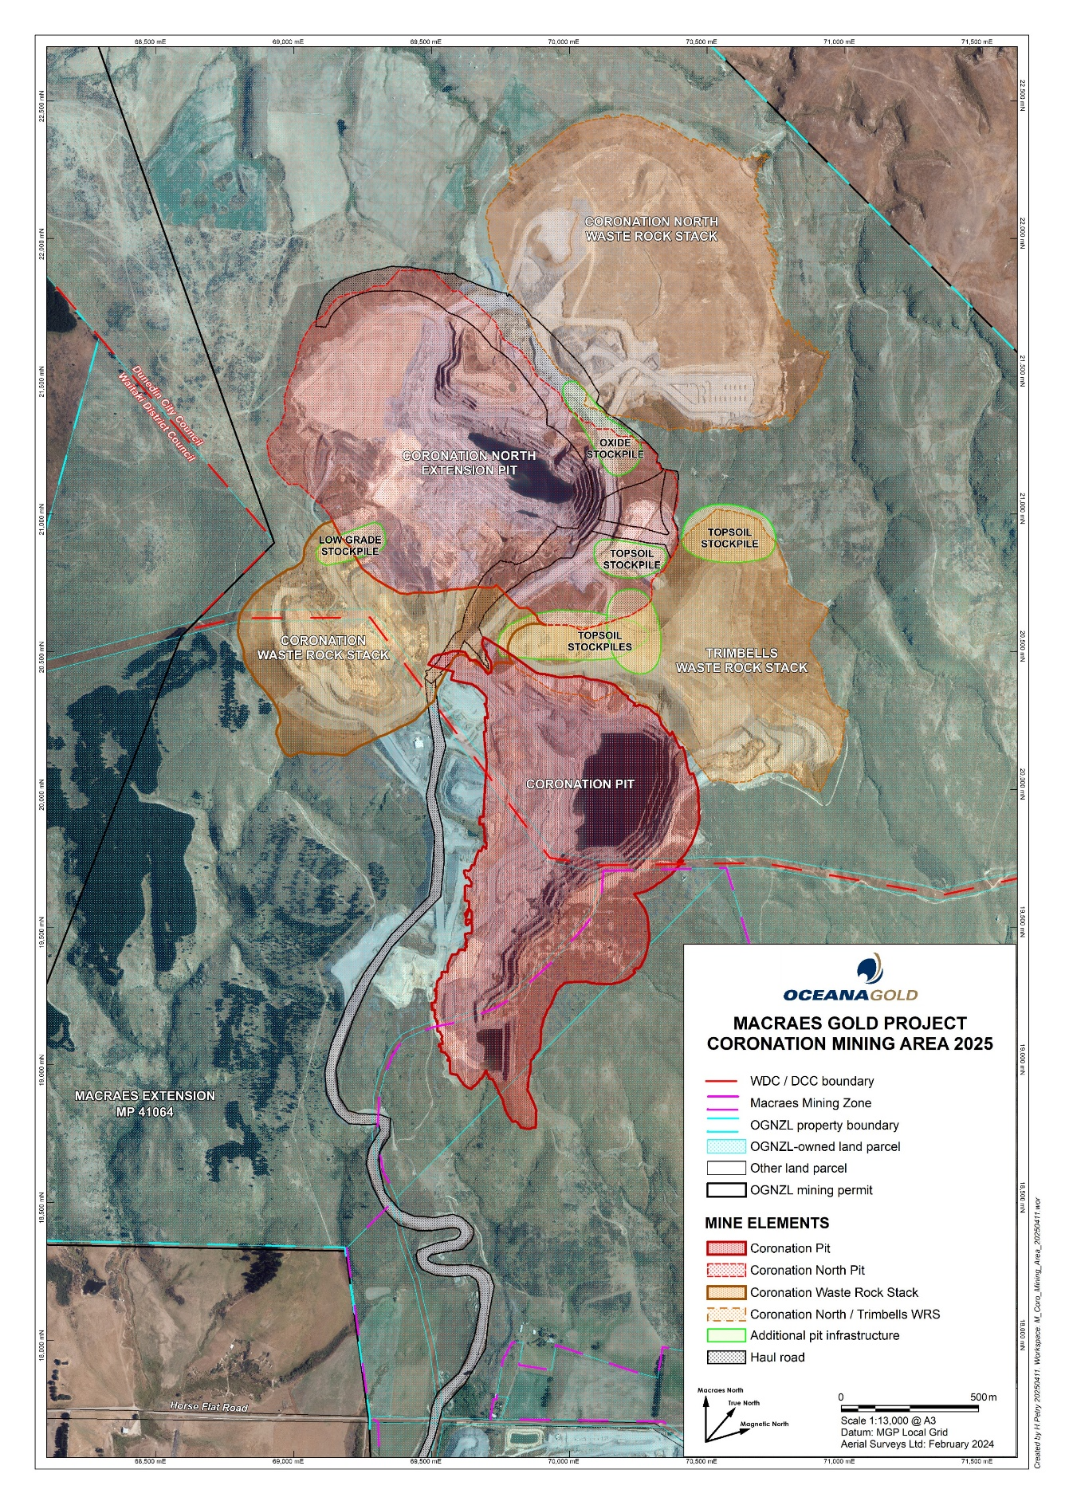

Map 2 – Innes Mills Pit
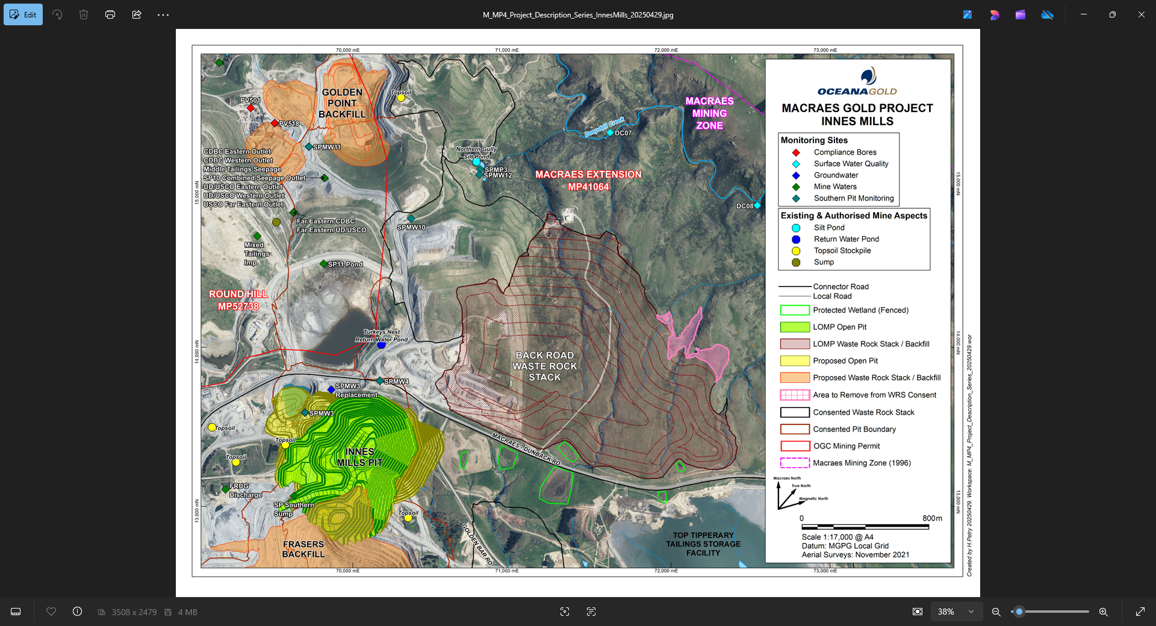

Map 3 – Golden Bar Mining Area
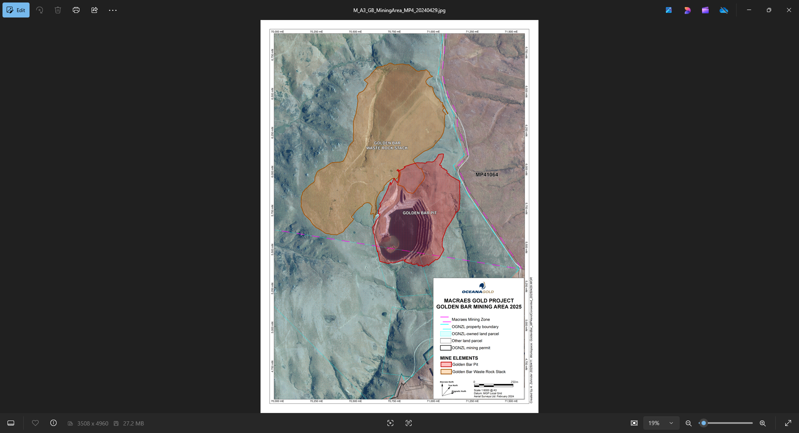

Map 4 – Golden Bar Road Realignment
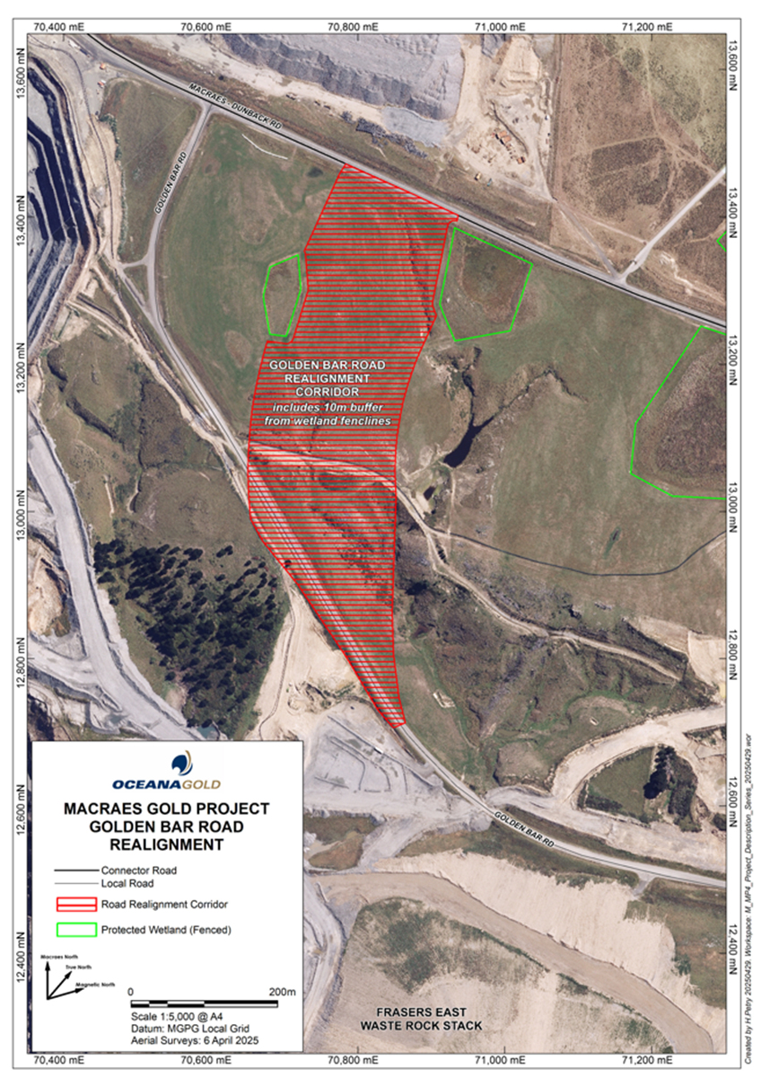

Map 5 – Frasers Tailings Storage Facility
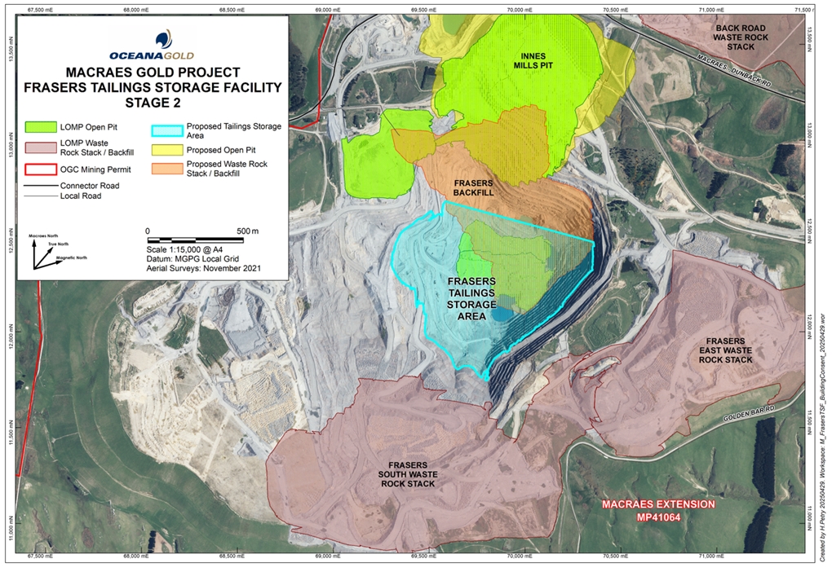

Map 6 – Coronation Area Roading
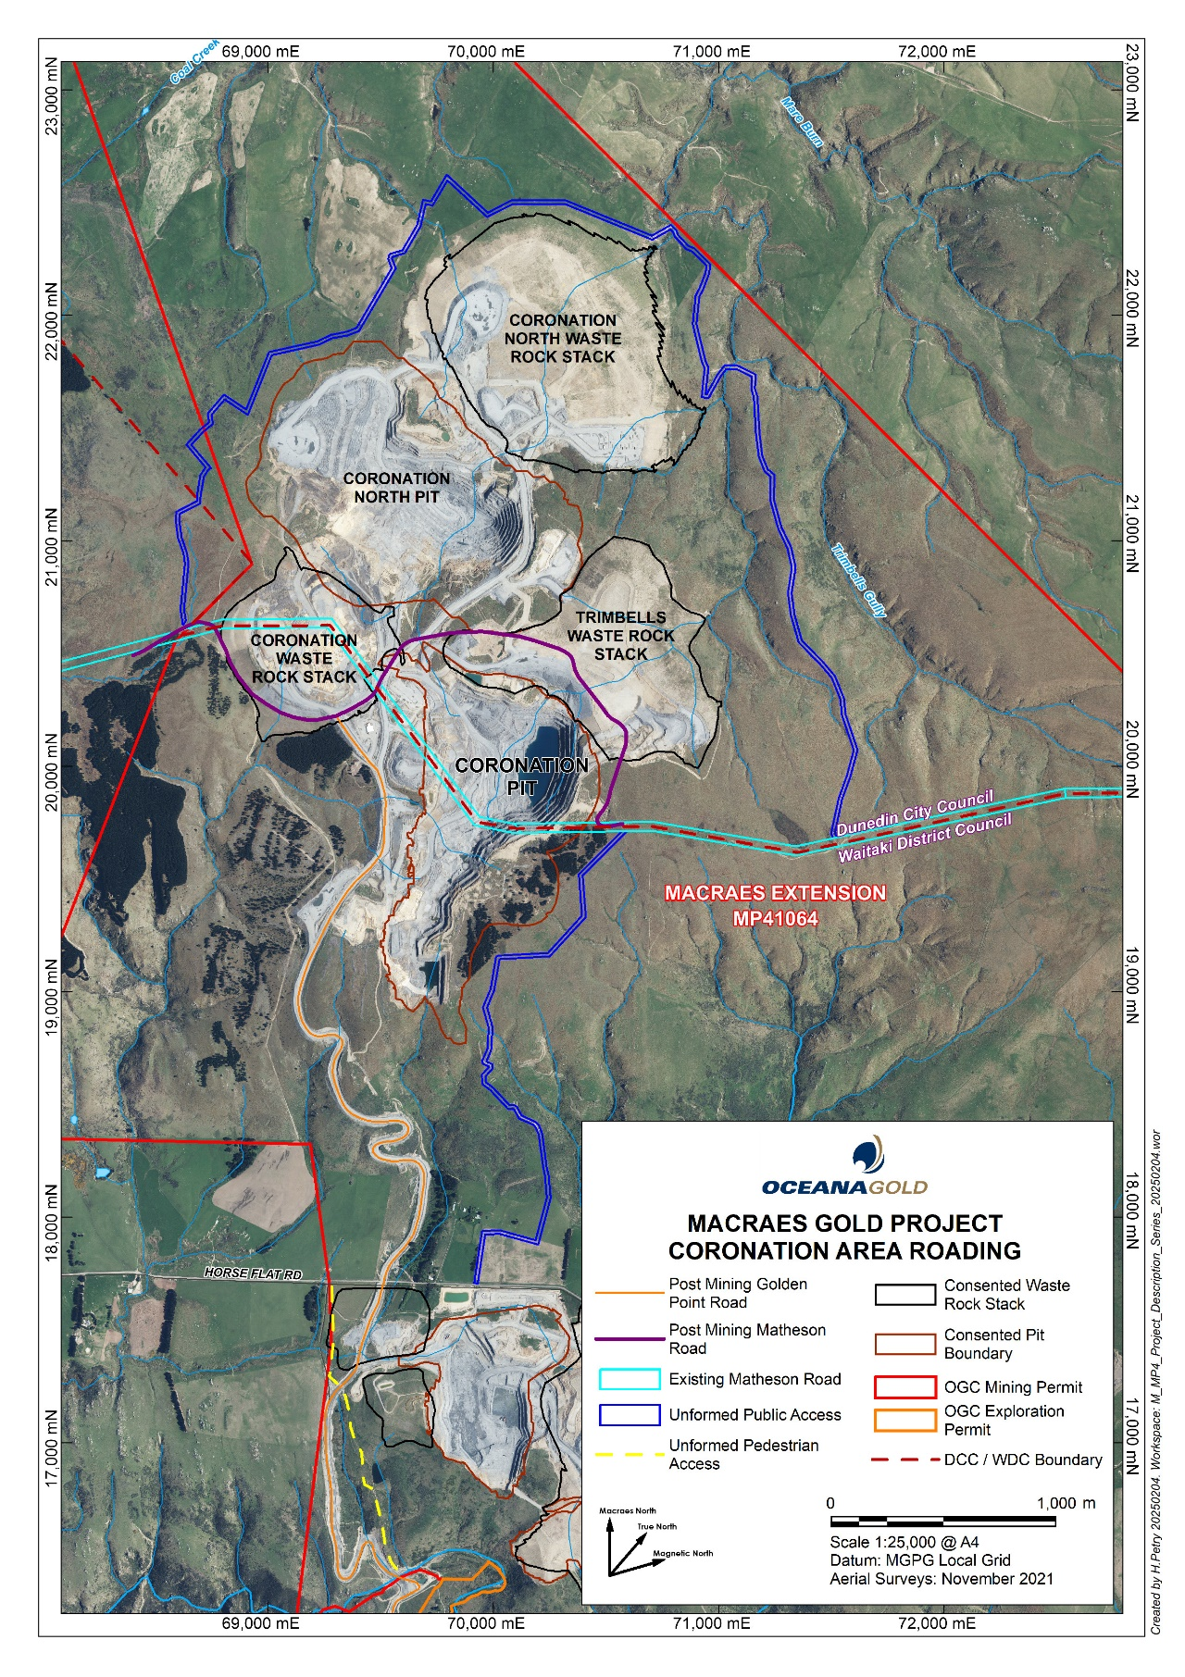
Map 6 - Macraes Gold Project Coronation Area Roading

Map 7 – Historic Fenceline
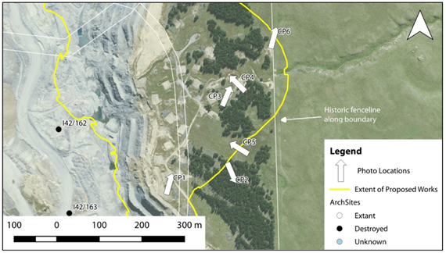
Map 7 – Historic Fenceline at Coronation Stage 6 Pit Extension

Map 8 – Murphys Ecological Enhancement Area
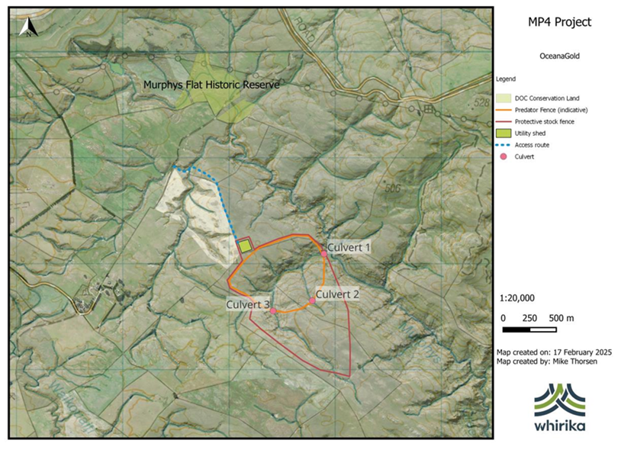
Map 8 – Approximate location of the Murphys Ecological Enhancement Area

Map 9 – Ephemeral Wetland Creation Site
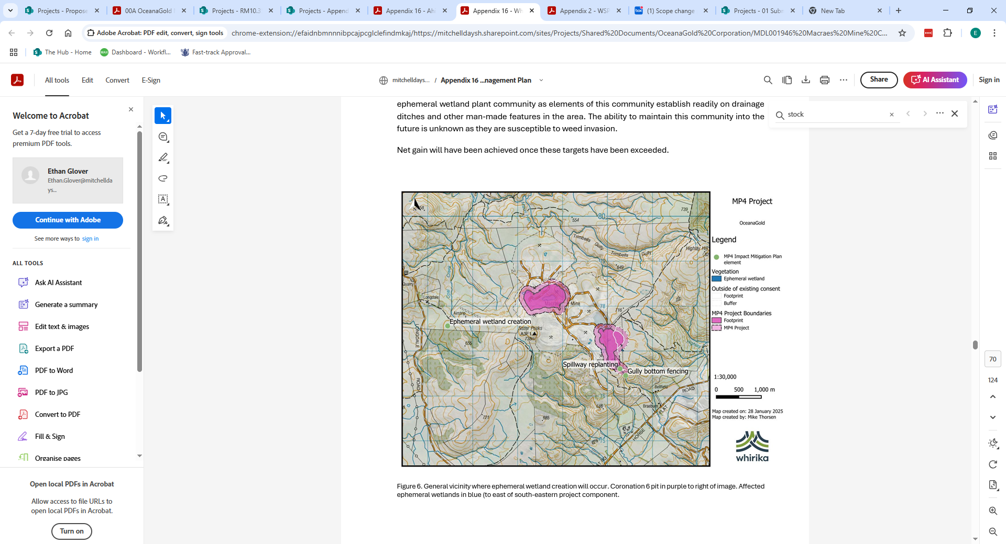

Map 9 – Approximate Location of the Ephemeral Wetland Creation Site

Map 10 – Wetland Offset Site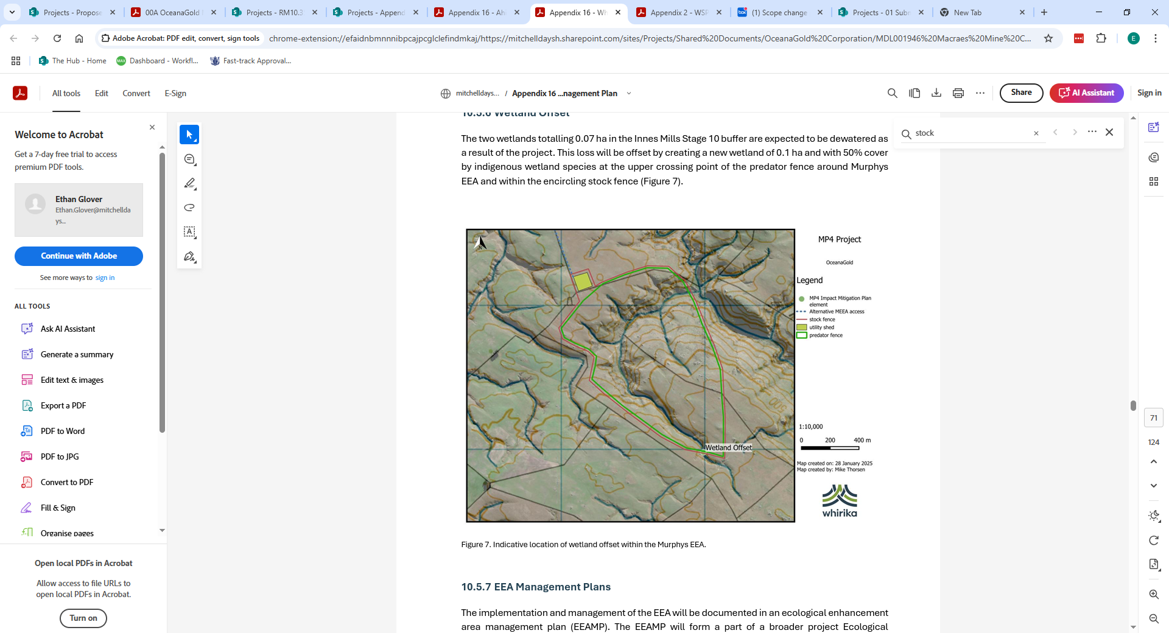
Map 10 – Approximate location of the Wetland Offset Site

