Air Discharge Permits
Consent numbers correspond to those listed in Table 4.2 of the Assessment of Environmental Effects.
New consents and conditions are denoted by blue highlight.
Use document headings to navigate between consents and corresponding appendices.

RM10.351.52.V4
Condition Number | Proposed Conditions
RM10.351.52.V4
Discharge Permit (to air)
To discharge contaminants to air for the purpose of carrying out mining activities and post mining rehabilitation
For a term expiring: 31 August 2032
Location of consent activity: Macraes Gold Project, Macraes Flat
Legal description of consent activity: Various
Map Reference: Within a three kilometre radius of NZTM 2000 E1400484 N4973117
Specific Conditions
1 | This consent shall be exercised in conjunction with Discharge Permit 96785 and Discharge Permit 2006.689.
2 | For the purpose of this consent, the “Macraes Gold Project site” is that property owned by the Consent Holder as identified on Appendix I attached.
3 | This consent will be exercised substantially in accordance with:  - the Macraes Phase III Assessment of Environmental Effects dated 2 May 2011 and Appendix 31, Beca Infrastructure Ltd, Assessment of Environmental Effects of Air Discharges, 7 April 2011, and  - with the Frasers Co-Disposal Project application and associated Appendix C dated 3 February 2023, and  - the Continuity Consents Project Assessment of Environmental Effects, 15 December 2023 and associated plans and appendices and responses to further information requests, and  - the Macraes Phase 4 Project Resource Consent Application and Assessment of Environmental Effects, including Appendices 1 – 33, prepared by Mitchell Daysh Limited, dated 28 March 2024 (Updated 18 February 2025), and the response to s92(1) Request for Further Information, dated 15 October 2024, and the response to s92(1) Request for Further Information, dated 5 February 2025.  except to the extent that any condition in this consent is inconsistent with such material. If there is an inconsistency the conditions and terms of this consent prevail.  If there are any inconsistencies between the above information and the conditions of this consent, the conditions of this consent prevail.
4 | This consent authorises the discharge of contaminants to air from the Macraes Gold Project site, other than where the discharge of contaminants to air in that area is authorised by Discharge Permit 96785 or Discharge Permit 2006.689, Discharge Permit RM12.378.15, Discharge Permit RM16.138.19, Discharge Permit RM20.024.12, or Discharge Permit RM24.184.30.
5 | There shall be no visible dust beyond the boundary of the Macraes Gold Project site that, in the opinion of an enforcement officer, is offensive or objectionable to such an extent that it has an adverse effect on the environment.
Performance Monitoring
6 | Insoluble dust deposition rates at sites DG07, DG11, DG20 and DG21, as shown on Appendix I attached, must not exceed 3 grams per square metre per 30 days (g/m²/30 days) of insoluble dust above background more than twice in any calendar year. Compliance with this condition shall be demonstrated by the monitoring required in Condition 11 of this consent.
6(a) | - The consent holder must continuously monitor real time suspended particulate matter for a period of at least 12 months following the commencement of works under this consent. The monitor must be located at the DG11 monitoring site shown in Appendix I.  - The monitoring instrument must be a nephelometer with controlled heated inlet or similar equipment that provides continuous real-time data to a website with alerts sent to the consent holder when trigger levels are reached. The instrument must be regularly serviced and calibrated. The equipment design and operating specifications must be agreed in writing with the Consent Authority.  - Total suspended particulate matter must be continuously measured and reported as 1-hour and 24- hour averages. The results must be compared to trigger levels of 250 μg/m³ (1-hour average) and 80 μg/m³ (24-hour average). Any exceedance of these levels must result in an alert message being immediately sent to the consent holder.  - Wind speed and direction must be continuously measured at the monitoring site to assist in the interpretation of monitoring data.  - After the completion of at least 12 months of monitoring and following review of the data by a suitably qualified expert, total suspended particulate monitoring may be amended or suspended if such agreement is provided in writing by the Consent Authority.
6(b) | - If Total Suspended Particulate matter concentrations measured in accordance with condition 6(a) exceed the alert trigger values set out in condition 6(a)(c) the consent holder must review dust sources and dust control measures onsite. If the exceedance is likely to have been caused or contributed to by onsite activities, then the consent holder shall revise its dust control management and/or implement additional dust control measures. Such measures may include but not be limited to, reducing vehicle speeds, ceasing overburden stripping and bund construction activities and increasing the quantity of water used as a dust suppressant. Any additional measures shall continue until the monitoring undertaken in accordance with condition 6(a) indicates that Total Suspended Particulate levels have reached at or below 150 μg/m³ (1 hour average) for a continuous period of 48 hours.  - If the trigger levels set out in condition 6(a)(c) are exceeded again within a 7 day period and are likely to have been caused or contributed to by onsite activities, the need for any ongoing management must be reviewed and if required must be specified in the Dust Management Plan required by conditions 15 and 16.
6(c) | The consent holder must provide written notice of any recorded exceedance, that is likely to have been caused or contributed to by onsite activities, of the trigger values specified in Condition 6(a)(c) to the consent authority within 10 working days of that exceedance. The notice must specify the additional dust control measures undertaken to reduce concentrations to below the trigger values.
7 | Insoluble dust deposition rates at sites DG02 and DG15, as shown on Appendix I attached, must not exceed 3 grams per square metre per 30 days (g/m²/30 days) of insoluble dust above background. Compliance with this condition will be demonstrated by the monitoring required in Condition 11 of this consent.
8 | Background concentrations will be calculated by averaging the insoluble dust deposition rates at sites DG09, DG10 and DG24DG17 as shown on Appendix I attached.
9 | Twenty-four hour average total suspended particulate at site DG15, as shown on Appendix I attached, must not exceed 120μg/m³. Compliance with this condition will be demonstrated by the monitoring required in Condition 12 of this consent.
10 | In the event of any exceedance of those limits specified in Conditions 6, 7 and 9 of this consent, the Consent Holder must undertake an immediate review of the cause of the exceedance. A report detailing the findings of this review shall be provided to the Consent Authority within 1 month of the non-compliant result(s) being received. If it is shown that activities within the Macraes Gold Project site were the cause of the exceedance, then dust mitigation measures within the Macraes Gold Project shall be reviewed by an independent consultant engaged in consultation with the Consent Authority. The independent consultant shall provide a report summarising the cause of the exceedance and recommending measures to improve dust mitigation at the Macraes Gold Project site so that the exceedance does not occur again. This report shall be provided to the Consent Authority within 2 months of the non-compliant result(s) being received.
11 | The consent holder shall monitor dust deposition rates at monthly intervals in accordance with draft ISO Standard ISO/SIS 4222.2 (“Air Quality Measurement of Atmospheric Dustfall – Horizontal Deposit Gauge Method” 1980), or another method approved in writing by the Consent Authority. The monitoring shall be undertaken at the sites shown on Appendix I attached.
12 | - The consent holder shall monitor real time total suspended particulate concentrations at site DG15 as shown on Appendix I attached. The monitoring shall be undertaken using a nephelometer, or other instrument as agreed in writing by the Consent Authority. The instrument shall be sited in accordance with AS/NZS 3580.1.1:2007.  - The consent holder shall monitor total suspended particulate at monitoring site DG15 as shown on Appendix I in accordance with Australian Standard AS/NZS3580.9.3:2003 (Determination of suspended particulate matter - Total Suspended Particulates [TSP] - High Volume Sampler Gravimetric Method), or another method approved by the Consent Authority. Twenty-four hour measurements must be taken every six days March to October inclusive, and every three days November to February inclusive, for a minimum period of twelve months or for however long is required to ensure that adequate data is collected to achieve the objectives of Condition 12(d).  - Parameters to be recorded shall include, but not be limited to:  - Hourly average TSP concentrations as measured by the instrument installed in accordance with Condition 12(a) of this consent;  - 24-hour average TSP concentrations as measured by the instruments installed in accordance with Conditions 12(a) and 12(b).  - The instruments installed in accordance with Conditions 12(a) and 12(b) shall be operated concurrently for a period of no less then twelve months to ensure that twelve months of coincident data is collected. A correlation between the data shall be established by an independent consultant engaged in consultation with the Consent Authority. A report detailing this investigation shall be provided to the Consent Authority within two months of the data being collected.
12A | - The results of total suspended particulate matter monitoring undertaken in accordance with Condition 12 must be compared to trigger levels of 250μg/m³ (1-hour average) and 80μg/m³ (24-hour average). Any exceedance of these levels that is deemed to be caused by dust from mining activities must result in a trigger alert message being immediately sent to the Consent Holder.  - The procedure for determining whether an exceedance of the trigger levels referred to in Condition 12A(a) is deemed to be caused by dust from mining activities must be set out in the Dust Management Plan required by Condition 16 of this consent and shall include consideration of wind speed, wind direction and humidity, as a means of filtering non-mining related exceedances.  - On receipt of a trigger alert message referred to in Condition 12A(a), the Consent Holder must implement additional dust control measures as set out in the Dust Management Plan required by Condition 16 of this consent.  - If a trigger alert message is received again within a 7-day period of a response being actioned in accordance with Condition 12A(c), the need for further dust management must be reviewed and if required must be specified in the Dust Management Plan via the review procedure outlined in Condition 17.  - A record of trigger alert messages and responses must be included in the annual report required by Condition 18 of this consent.
13 | - Meteorological conditions shall be continuously monitored and recorded at site DG03 as shown on Appendix I attached. As a minimum, the meteorological data collected shall include wind speed, wind direction, temperature and rainfall. Sufficient information shall also be measured to allow an estimate of atmospheric stability. These estimates shall be obtained from measurements of solar radiation and temperature at two heights above ground level, or other parameters as approved by the Consent Authority.  - Meteorological conditions shall be continuously monitored and recorded at site DG15 as shown on Appendix I attached. As a minimum, the meteorological data collected shall include wind speed, wind direction, humidity, temperature and rainfall.
14 | The consent holder shall keep a daily record of water used for dust suppression. These records shall be made available to the Consent Authority on request.
15 | Results of all monitoring undertaken in accordance with this consent shall be reported to the Consent Authority on a quarterly basis. The format of the report shall be agreed upon in consultation with the Consent Authority.
16 | Prior to the exercise of this consent, the consent holder shall submit a Dust Management Plan to the Consent Authority. The Dust Management Plan shall include, but not be limited to, the following:  - A description of potential dust sources and the factors influencing dust generation;  - Dust mitigation measures and procedures including, but not limited to:  - Minimising the areas of disturbed ground;  - Watering, with water trucks and fixed sprinklers;  - Avoiding as far as possible, ground disturbance when wind may cause dust nuisance;  - Taking wind conditions into account in planning and carrying out work to minimise dust dispersion;  - Ensuring materials being moved are kept in a coarse state;  - Covering materials; and  - Replanting disturbed ground as soon as possible, including temporary planting if necessary.  - A description of dust monitoring equipment and procedures, including methods of analysis and details of the method used for the calculation of background dust concentration should values from one or all of the background sites be unavailable;  - Procedures for managing and addressing air quality or odour related complaints; and  - Key responsibilities, consultation and reporting, including details of the annual review and independent consultant used as required by Condition 18 of this consent.
17 | The consent holder shall review the Dust Management Plan annually taking into account the following:  - The outcomes of reviews completed in accordance with Condition 10 and 18 of this consent; and  - Whether management practices are resulting in compliance with the conditions of this consent.  Confirmation of the review and any revisions will be included in the Project Overview and Annual Work and Rehabilitation Plan for the Macraes Gold Project site. The consent holder shall provide the Consent Authority with any updates of the Dust Management Plan within one month of any update occurring.
18 | An independent consultant, engaged by the Consent Holder in consultation with the Consent Authority, shall undertake an annual review and assessment of all dust monitoring data. The reviewer’s report shall include:  - The name, qualifications, and experience of the reviewer;  - The methods used and the investigations undertaken for the review;  - Interpretation of the monitoring data reviewed;  - An assessment of the quality of the monitoring data;  - An assessment of the monitoring regime;  - A description and evaluation of each of the dust mitigation measures used by the consent holder;  - Recommendations on whether:  - The monitoring of dust is adequate or should be changed, and if changed the changes that are recommended;  - The dust mitigation measures used by the consent holder are adequate, or should be changed, and the changes that are recommended; and  - Any changes should be made to the conditions of this consent; and  - Any other matters that the reviewer considers should be drawn to the attention of the consent holder or the Consent Authority.
19 | The annual report required by Condition 18 shall be provided to the Consent Authority by 30 April each year.
20 | In the event of any non compliance with the conditions of this consent, the consent holder shall notify the Consent Authority within 24 hours of the non compliance being detected. Within five working days the consent holder shall provide written notification to the Consent Authority providing details of the non-compliance. This notification will at a minimum include an explanation of the cause of the non compliance, the steps taken to remedy the situation and steps taken to mitigate any future occurrence of the non compliance.
21 | The consent holder shall pay to the Consent Authority, the costs for monitoring, enforcing and administering this consent as agreed upon between the consent holder and the Consent Authority pursuant to Section 36 of the Resource Management Act 1991.
22 | The consent holder shall maintain a record of any complaints received regarding their operation. The register shall include, but not be limited to:  - name and location of site where the problem is experienced;  - nature of the problem;  - date and time problem occurred, and when reported;  - action taken by consent holder to remedy the situation and any policies or methods put in place to avoid or mitigate the problem occurring again.  The register of complaints shall be incorporated into the Project Overview and Annual Work and Rehabilitation Plan.
General
23 | The Consent Authority may, within 6 months of receipt of the Cultural Impact Assessment prepared by Kai Tahu ki Otago on behalf of Te Runanga o Moeraki and Kāti Huirapa Rūnaka ki Puketeraki, commissioned in 2011, serve notice of its intention to review the conditions of this consent for the purpose of amending or adding conditions to address mitigation of the effect(s) of the exercise of this consent on cultural values and associations. All costs associated with any such review shall be borne by the consent holder.
24 | - The consent holder shall provide and maintain in favour of the Consent Authority one or more bonds to secure:  - The performance and completion of rehabilitation in accordance with the conditions of this consent; and  - The carrying out of the monitoring required by the conditions of this consent; and  - The remediation of any adverse effect on the environment that may arise from the exercise of this consent.  - Compliance with Conditions 24(m) to 24(q) of this consent.  - Before the first exercise of this consent, the consent holder shall provide to the Consent Authority one or more bonds required by Condition 24(a).  - Subject to the other provisions of this consent, any bond shall be in the form and on the terms and conditions approved by the Consent Authority.  - Any bond shall be given or guaranteed by a surety acceptable to the Consent Authority.  - The surety shall bind itself to pay for the carrying out and completion of the conditions of consent which are the subject of the bond on default by the consent holder or the occurrence of any adverse environment effect requiring remedy; during or after the expiry of this consent.  - The amount of each bond shall be fixed annually by the Consent Authority which will take into account any calculations and other matters submitted by the consent holder relevant to the determination of the amount to be bonded in the Project Overview and Annual Work and Rehabilitation Plan, or otherwise.  - The amount of the bond(s) shall include:  - The estimated costs of complete rehabilitation in accordance with the conditions of consent on the completion of the mining operations proposed for the next year and described in the Project Overview and Annual Work and Rehabilitation Plan.  - The estimated costs of:  - Monitoring in accordance with the monitoring conditions of the consent;  - Monitoring for and of any adverse effect of the activity authorised by this consent which may become apparent during or after expiry of this consent;  - Monitoring any rehabilitation required by this consent.  - Any further sum which the Consent Authority considers necessary for monitoring and dealing with any adverse effect on the environment that may arise from the exercise of the consent whether during or after the expiry of this consent.  - The amount shall be calculated for the duration of this consent and for a period of 20 years after its expiry.  - If, on review, the total amount of bond to be provided by the consent holder is greater or less than the sum secured by the current bond(s), the consent holder, surety and the Consent Authority may, in writing, vary the amount of the bond(s).  - While the liability of the surety is limited to the amount of the bond(s), the liability of the consent holder is unlimited.  - Any bond may be varied, cancelled, or renewed at any time by written agreement between the consent holder, surety and Consent Authority.  - The costs (including the costs of the Consent Authority) of providing, maintaining, varying and reviewing any bond shall be paid by the consent holder.  - For a period of 20 years from the expiry or surrender of this consent the consent holder shall provide in favour of the Consent Authority one or more bonds.  - The amount of the bond to be provided under Condition 24(m) shall include the amount (if any) considered by the Consent Authority necessary for:  - Completing rehabilitation in accordance with the conditions of this consent.  - Monitoring for and of any adverse effect on the environment that may arise from the exercise of the consent.  - Monitoring any measures taken to prevent, remedy or mitigate any adverse effect on the environment that may arise from the exercise of this consent.  - Dealing with any adverse effect on the environment which may become apparent after the surrender or expiry of this consent.  - Contingencies.  - Without limitation, the amount secured by the bond given under Condition 24(m) may include provision to deal with structural instability or failure, land and water contamination, and the failure of rehabilitation in terms of the rehabilitation objectives and conditions of this consent. Costs shall include costs of investigating, preventing, remedying or mitigating any adverse effect.  - The bond(s) required by Condition 24(m) must be provided on the earlier of:  - 12 months before the expiry of this consent.  - Three months before the surrender of this consent.  - Conditions 24(c), (d), (e), (h), (i), (j) and (k) apply to the bond(s) required by Condition 24(m).
25 | The Consent Authority may, in accordance with Sections 128 and 129 of the Resource Management Act 1991, serve notice on the consent holder of its intention to review the conditions of this consent within three months of each anniversary of the commencement of this consent, for the purpose of:  - determining whether the conditions of this consent are adequate to deal with any adverse effect on the environment which may arise from the exercise of the consent and which it is appropriate to deal with at a later stage, or which become evident after the date of commencement of the consent; or  - ensuring the conditions of this consent are consistent with any National Environmental Standards; or  - requiring the consent holder to adopt the best practicable option, in order to remove or reduce any adverse effect on the environment arising as a result of the exercise of this consent.

Appendix I – RM10.351.52
[Replace the plan on left with the plan on right]
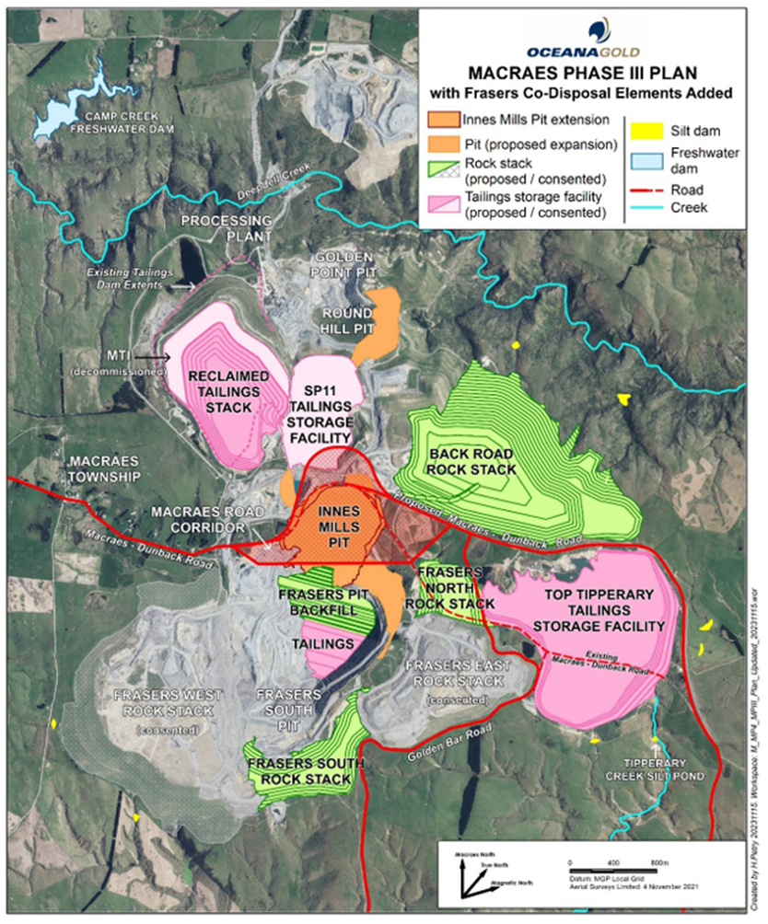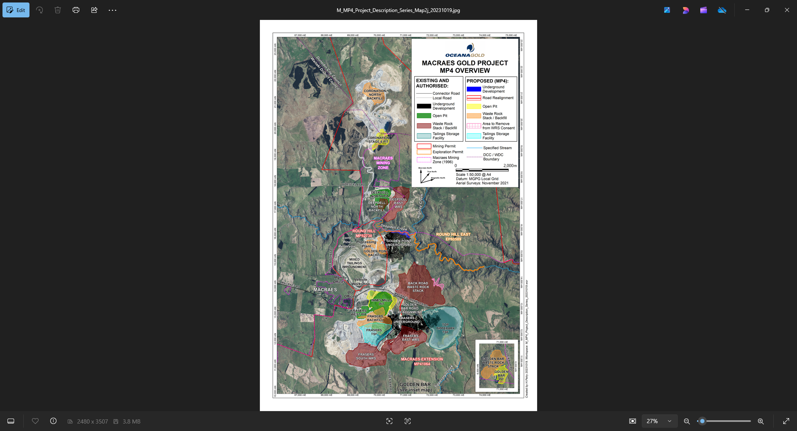

RM12.378.15.V1
Condition Number | Proposed Conditions
RM12.378.15.V1
Discharge Permit (to air)
To discharge contaminants from mining operations and post mining rehabilitation to air for the purpose of undertaking mining operations
For a term expiring: 31 August 2032
Location of consent activity: Macraes Gold Project, approximately 6.5 kilometres to the northwest of the intersection of Macraes Road and Red Bank Road, Macraes Flat.
Legal description of consent activity: Pt Section 2 Blk V Highlay SD, Pt Section 2 Blk VII Highlay SD, Section 2 Blk VII Highlay SD, Pt Secs 11 and 12 Blk VII Highlay SD, Road Reserve
Map Reference: Within a 1 kilometre radius of NZTM2000 1395770 E 4977492 N
Specific Conditions
1 | This consent shall be exercised in conjunction with Discharge Permit 96785, Discharge Permit 2006.689, Discharge Permit RM10.351.52, Discharge Permit RM16.138.19, Discharge Permit 24.184.30 and any subsequent variations to these permits.
2 | This consent authorises the discharge of contaminants to air from the Coronation Waste Rock Stack, Coronation Pit and associated haul roads, as shown on Appendix I attached.
3 | There shall be no visible dust beyond the boundary of the Macraes Gold Project site that, in the opinion of an enforcement officer, is offensive or objectionable to such an extent that it has an adverse effect on the environment, including the human environment.
Performance Monitoring
4 | Insoluble dust deposition rates at sites DG07, DG20, DG21, DG22 and DG253, as shown on Appendix I and Appendix II attached, must not exceed 3 grams per square metre per 30 days (g/m²/30 days) of insoluble dust above background more than twice in any calendar year. Compliance with this condition shall be demonstrated by the monitoring required in Condition 9 of this consent.
5 | Insoluble dust deposition rates at sites DG02 and DG15, as shown on Appendix I and Appendix II attached, must not exceed 3 grams per square metre per 30 days (g/m²/30 days) of insoluble dust above background. Compliance with this condition will be demonstrated by the monitoring required in Condition 9 of this consent.
6 | Background concentrations will be calculated by averaging the insoluble dust deposition rates at sites DG09, DG10 and DG24 as shown on Appendix I and Appendix II attached.
7 | Twenty-four hour average total suspended particulate at site DG15, as shown on Appendix I attached, must not exceed 120μg/m³. Compliance with this condition will be demonstrated by the monitoring required in Condition 10 of this consent.
8 | In the event of any exceedance of those limits specified in Conditions 4, 5 and 7 of this consent, the Consent Holder must undertake an immediate review of the cause of the exceedance. A report detailing the findings of this review shall be provided to the Consent Authority within 1 month of the non-compliant result(s) being received. If it is shown that activities within the Macraes Gold Project site were the cause of the exceedance, then dust mitigation measures within the Macraes Gold Project shall be reviewed by an independent consultant engaged in consultation with the Consent Authority. The independent consultant shall provide a report summarising the cause of the exceedance and recommending measures to improve dust mitigation at the Macraes Gold Project site so that the exceedance does not occur again. This report shall be provided to the Consent Authority within 2 months of the non-compliant result(s) being received.
9 | The consent holder shall monitor dust deposition rates at monthly intervals in accordance with draft ISO Standard ISO/DIS 4222.2 (“Air Quality Measurement of Atmospheric Dustfall – Horizontal Deposit Gauge Method” 1980), or another method approved in writing by the Consent Authority. The monitoring shall be undertaken at the sites shown on Appendix I and Appendix II attached.
10 | - The consent holder shall monitor real time total suspended particulate concentrations at site DG15 as shown on Appendix I attached. The monitoring shall be undertaken using a nephelometer, or other instrument as agreed in writing by the Consent Authority. The instrument shall be sited in accordance with AS/NZS 3580.1.1:2007 (Methods for Sampling and Analysis of Ambient Air – Guide to Siting Air Monitoring Equipment).  - The consent holder shall monitor total suspended particulate at monitoring site DG15 as shown on Appendix I in accordance with Australian Standard AS/NZS3580.9.3:2003 (Determination of suspended particulate matter - Total Suspended Particulates [TSP] - High Volume Sampler Gravimetric Method), or another method approved by the Consent Authority. Twenty-four hour measurements must be taken every six days March to October inclusive, and every three days November to February inclusive, for a minimum period of twelve months or for however long is required to ensure that adequate data is collected to achieve the objectives of Condition 10(d).  - Parameters to be recorded shall include, but not be limited to:  - Hourly average TSP concentrations as measured by the instrument installed in accordance with Condition 10(a) of this consent;  - 24-hour average TSP concentrations as measured by the instruments installed in accordance with Conditions 10(a) and 10(b).  - The instruments installed in accordance with Conditions 10(a) and 10(b) shall be operated concurrently for a period of no less then twelve months to ensure that twelve months of coincident data is collected. A correlation between the data shall be established by an independent consultant engaged in consultation with the Consent Authority. A report detailing this investigation shall be provided to the Consent Authority within two months of the data being collected.
10A | - The consent holder must continuously monitor real time suspended particulate matter at the DG07 monitoring site shown in Appendix I or another site otherwise agreed in writing by the Consent Authority.  - The monitoring instrument must be a nephelometer with controlled heated inlet or similar equipment that provides continuous real-time data to a website with alerts sent to the consent holder when trigger levels are reached. The instrument must be regularly serviced and calibrated. The equipment design and operating specifications must be agreed in writing with the Consent Authority.  - The results of total suspended particulate matter monitoring undertaken in accordance with Condition 10A(a) must be compared to trigger levels of 250μg/m3 (1-hour average) and 80μg/m3 (24-hour average). Any exceedance of these levels that is deemed to be caused by dust from mining activities must result in a trigger alert message being immediately sent to the Consent Holder.  - The procedure for determining whether an exceedance of the trigger levels referred to in Condition 10A(c) is deemed to be caused by dust from mining activities must be set out in the Dust Management Plan required by Condition 14 of this consent and shall include consideration of wind speed, wind direction and humidity, as a means of filtering non-mining related exceedances.  - On receipt of a trigger alert message referred to in Condition 10A(c), the Consent Holder must implement additional dust control measures as set out in the Dust Management Plan required by Condition 14 of this consent.  - If a trigger alert message is received again within a 7-day period of a response being actioned in accordance with Condition 10A(e), the need for further dust management must be reviewed and if required must be specified in the Dust Management Plan via the review procedure outlined in Condition 15.  - A record of trigger alert messages and responses must be included in the annual report required by Condition 16 of this consent.
11 | - Meteorological conditions shall be continuously monitored and recorded at site DG03 as shown on Appendix I attached. As a minimum, the meteorological data collected shall include wind speed, wind direction, temperature and rainfall. Sufficient information shall also be measured to allow an estimate of atmospheric stability. These estimates shall be obtained from measurements of solar radiation and temperature at two heights above ground level, or other parameters as approved by the Consent Authority.  - Meteorological conditions shall be continuously monitored and recorded at site DG15 as shown on Appendix I attached. As a minimum, the meteorological data collected shall include wind speed, wind direction, humidity, temperature and rainfall.
12 | The consent holder shall keep a daily record of water used for dust suppression. These records shall be made available to the Consent Authority on request.
13 | Results of all monitoring undertaken in accordance with this consent shall be reported to the Consent Authority on a quarterly basis. The format of the report shall be agreed upon in consultation with the Consent Authority.
14 | Prior to the exercise of this consent, the consent holder shall submit a Dust Management Plan to the Consent Authority. The Dust Management Plan shall include, but not be limited to, the following:  - A description of potential dust sources and the factors influencing dust generation;  - Dust mitigation measures and procedures including, but not limited to:  - Minimising the areas of disturbed ground;  - Watering, with water trucks and fixed sprinklers;  - Avoiding as far as possible, ground disturbance when wind may cause dust nuisance;  - Taking wind conditions into account in planning and carrying out work to minimise dust dispersion;  - Ensuring materials being moved are kept in a coarse state;  - Covering materials; and  - Replanting disturbed ground as soon as possible, including temporary planting if necessary.  - A description of dust monitoring equipment and procedures, including methods of analysis and details of the method used for the calculation of background dust concentration should values from one or all of the background sites be unavailable;  - Procedures for managing and addressing air quality or odour related complaints; and  - Key responsibilities, consultation and reporting, including details of the annual review and independent consultant used as required by Condition 1816 of this consent.
15 | The consent holder shall review the Dust Management Plan annually taking into account the following:  - The outcomes of reviews completed in accordance with Conditions 8 and 16 of this consent; and  - Whether management practices are resulting in compliance with the conditions of this consent.  Confirmation of the review and any revisions will be included in the Project Overview and Annual Work and Rehabilitation Plan for the Macraes Gold Project site. The consent holder shall provide the Consent Authority with any updates of the Dust Management Plan within one month of any update occurring.
16 | An independent consultant, engaged by the Consent Holder in consultation with the Consent Authority, shall undertake an annual review and assessment of all dust monitoring data. The reviewer’s report shall include:  - The name, qualifications, and experience of the reviewer;  - The methods used and the investigations undertaken for the review;  - Interpretation of the monitoring data reviewed;  - An assessment of the quality of the monitoring data;  - An assessment of the monitoring regime;  - A description and evaluation of each of the dust mitigation measures used by the consent holder;  - Recommendations on whether:  - The monitoring of dust is adequate or should be changed, and if changed the changes that are recommended;  - The dust mitigation measures used by the consent holder are adequate, or should be changed, and the changes that are recommended; and  - Any changes should be made to the conditions of this consent; and  - Any other matters that the reviewer considers should be drawn to the attention of the consent holder or the Consent Authority.
17 | The annual report required by Condition 1816 shall be provided to the Consent Authority by 30 April each year.
18 | In the event of any non compliance with the conditions of this consent, the consent holder shall notify the Consent Authority within 24 hours of the non compliance being detected. Within five working days the consent holder shall provide written notification to the Consent Authority providing details of the non-compliance. This notification will at a minimum include an explanation of the cause of the non compliance, the steps taken to remedy the situation and steps taken to mitigate any future occurrence of the non compliance.
19 | The consent holder shall maintain a record of any complaints received regarding their operation. The register shall include, but not be limited to:  - name and location of site where the problem is experienced;  - nature of the problem;  - date and time problem occurred, and when reported;  - action taken by consent holder to remedy the situation and any policies or methods put in place to avoid or mitigate the problem occurring again.  The register of complaints shall be incorporated into the Project Overview and Annual Work and Rehabilitation Plan.
General
20 | The Consent Authority may, within 6 months of receipt of the Coronation Project Addendum to the MPIII Cultural Impact Assessment prepared by Kai Tahu ki Otago on behalf of Te Runanga o Moeraki, Te Runanga o Otakou and Kati Huirapa Runaka ki Puketeraki, commissioned in 2013, serve notice of its intention to review the conditions of this consent for the purpose of amending or adding conditions to address mitigation of the effect(s) of the exercise of this consent on cultural values and associations. All costs associated with such review shall be borne by the consent holder.
21 | - The consent holder shall provide and maintain in favour of the Consent Authority one or more bonds to secure:  - The performance and completion of rehabilitation in accordance with the conditions of this consent; and  - The carrying out of the monitoring required by the conditions of this consent; and  - The remediation of any adverse effect on the environment that may arise from the exercise of this consent.  - Compliance with Conditions 21(m) to 21(q) of this consent.  - Before the first exercise of this consent, the consent holder shall provide to the Consent Authority one or more bonds required by Condition 21(a).  - Subject to the other provisions of this consent, any bond shall be in the form and on the terms and conditions approved by the Consent Authority.  - Any bond shall be given or guaranteed by a surety acceptable to the Consent Authority.  - The surety shall bind itself to pay for the carrying out and completion of the conditions of consent which are the subject of the bond on default by the consent holder or the occurrence of any adverse environment effect requiring remedy; during or after the expiry of this consent.  - The amount of each bond shall be fixed annually by the Consent Authority which will take into account any calculations and other matters submitted by the consent holder relevant to the determination of the amount to be bonded in the Project Overview and Annual Work and Rehabilitation Plan, or otherwise.  - The amount of the bond(s) shall include:  - The estimated costs of complete rehabilitation in accordance with the conditions of consent on the completion of the mining operations proposed for the next year and described in the Project Overview and Annual Work and Rehabilitation Plan.  - The estimated costs of:  - Monitoring in accordance with the monitoring conditions of the consent;  - Monitoring for and of any adverse effect of the activity authorised by this consent which may become apparent during or after expiry of this consent;  - Monitoring any rehabilitation required by this consent.  - Any further sum which the Consent Authority considers necessary for monitoring and dealing with any adverse effect on the environment that may arise from the exercise of the consent whether during or after the expiry of this consent.  - The amount shall be calculated for the duration of this consent and for a period of 20 years after its expiry.  - If, on review, the total amount of bond to be provided by the consent holder is greater or less than the sum secured by the current bond(s), the consent holder, surety and the Consent Authority may, in writing, vary the amount of the bond(s).  - While the liability of the surety is limited to the amount of the bond(s), the liability of the consent holder is unlimited.  - Any bond may be varied, cancelled, or renewed at any time by written agreement between the consent holder, surety and Consent Authority.  - The costs (including the costs of the Consent Authority) of providing, maintaining, varying and reviewing any bond shall be paid by the consent holder.  - For a period of 20 years from the expiry or surrender of this consent the consent holder shall provide in favour of the Consent Authority one or more bonds.  - The amount of the bond to be provided under Condition 21(m) shall include the amount (if any) considered by the Consent Authority necessary for:  - Completing rehabilitation in accordance with the conditions of this consent.  - Monitoring for and of any adverse effect on the environment that may arise from the exercise of the consent.  - Monitoring any measures taken to prevent, remedy or mitigate any adverse effect on the environment that may arise from the exercise of this consent.  - Dealing with any adverse effect on the environment which may become apparent after the surrender or expiry of this consent.  - Contingencies.  - Without limitation, the amount secured by the bond given under Condition 21(m) may include provision to deal with structural instability or failure, land and water contamination, and the failure of rehabilitation in terms of the rehabilitation objectives and conditions of this consent. Costs shall include costs of investigating, preventing, remedying or mitigating any adverse effect.  - The bond(s) required by Condition 21(m) must be provided on the earlier of:  - 12 months before the expiry of this consent.  - Three months before the surrender of this consent.  - Conditions 21(c), (d), (e), (h), (i), (j) and (k) apply to the bond(s) required by Condition 21(m).
22 | The Consent Authority may, in accordance with Sections 128 and 129 of the Resource Management Act 1991, serve notice on the consent holder of its intention to review the conditions of this consent within three months of each anniversary of the commencement of this consent, for the purpose of:  - determining whether the conditions of this consent are adequate to deal with any adverse effect on the environment which may arise from the exercise of the consent and which it is appropriate to deal with at a later stage, or which become evident after the date of commencement of the consent; or  - ensuring the conditions of this consent are consistent with any National Environmental Standards; or  - requiring the consent holder to adopt the best practicable option, in order to remove or reduce any adverse effect on the environment arising as a result of the exercise of this consent.

Appendix I – RM12.378.15
[Replace the plan on left with the plan on right]
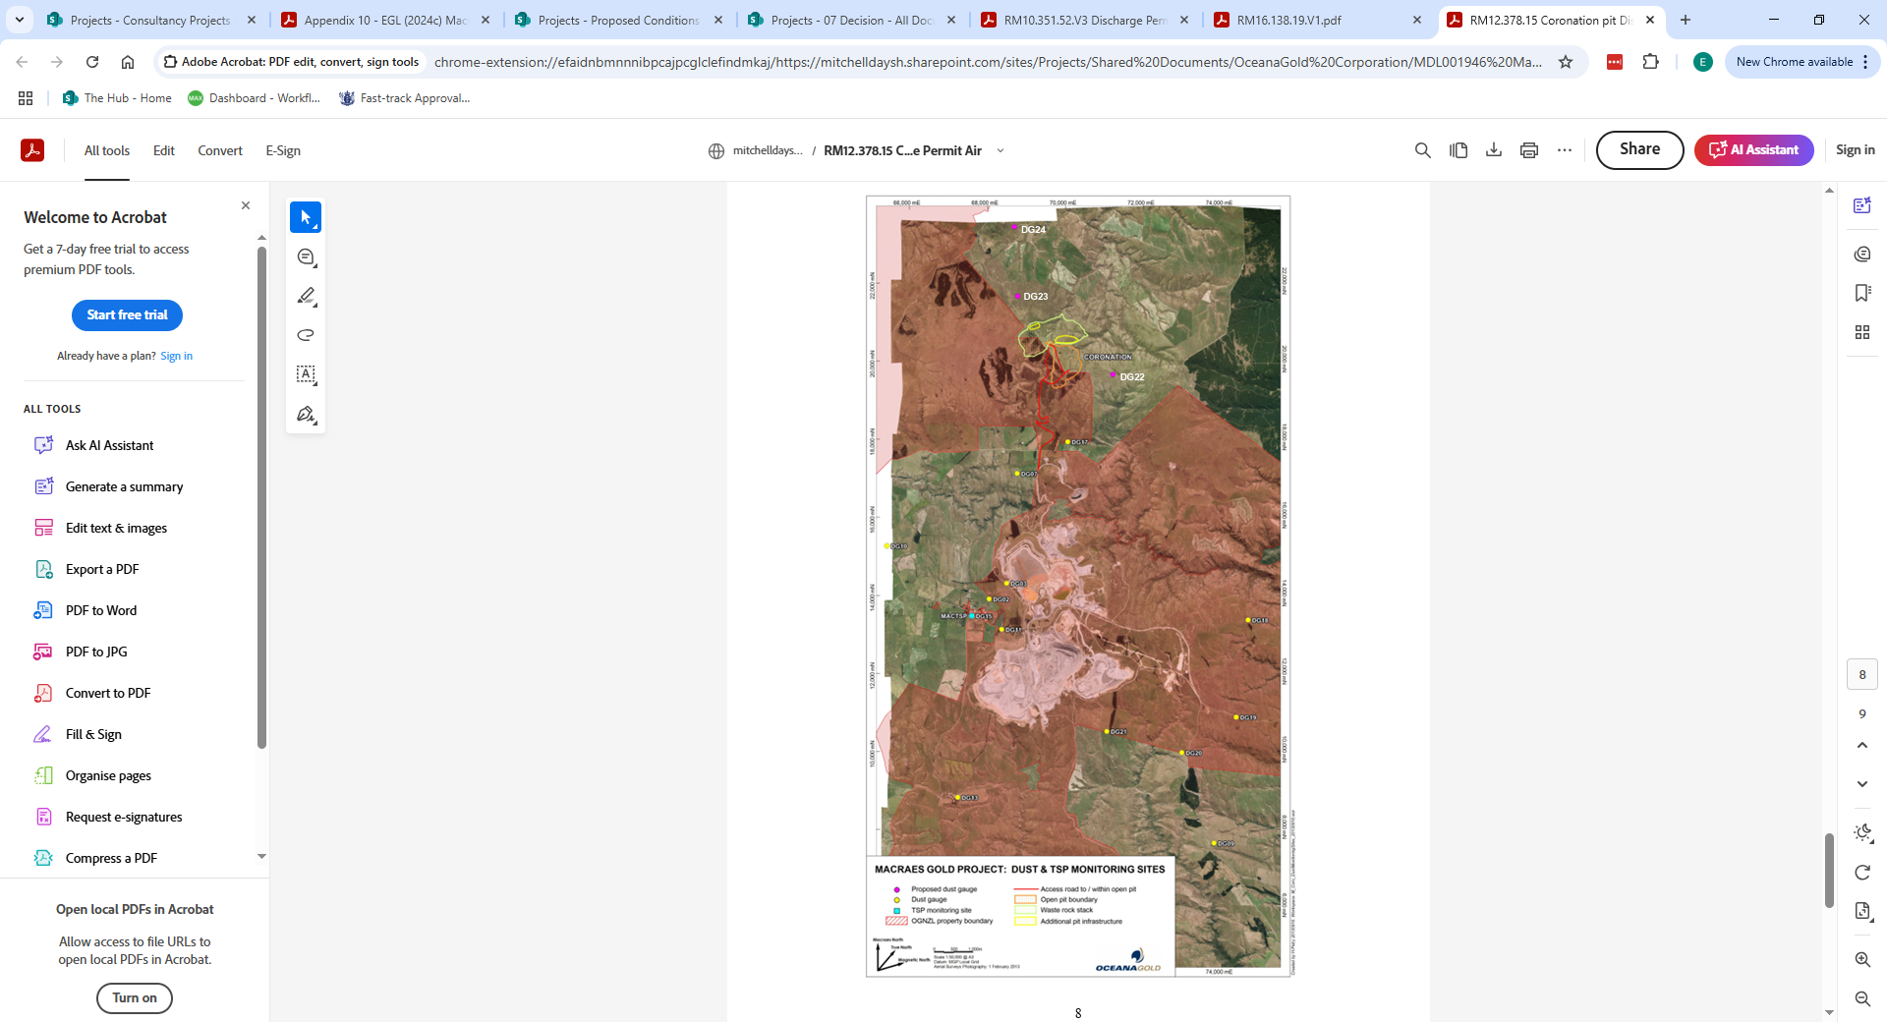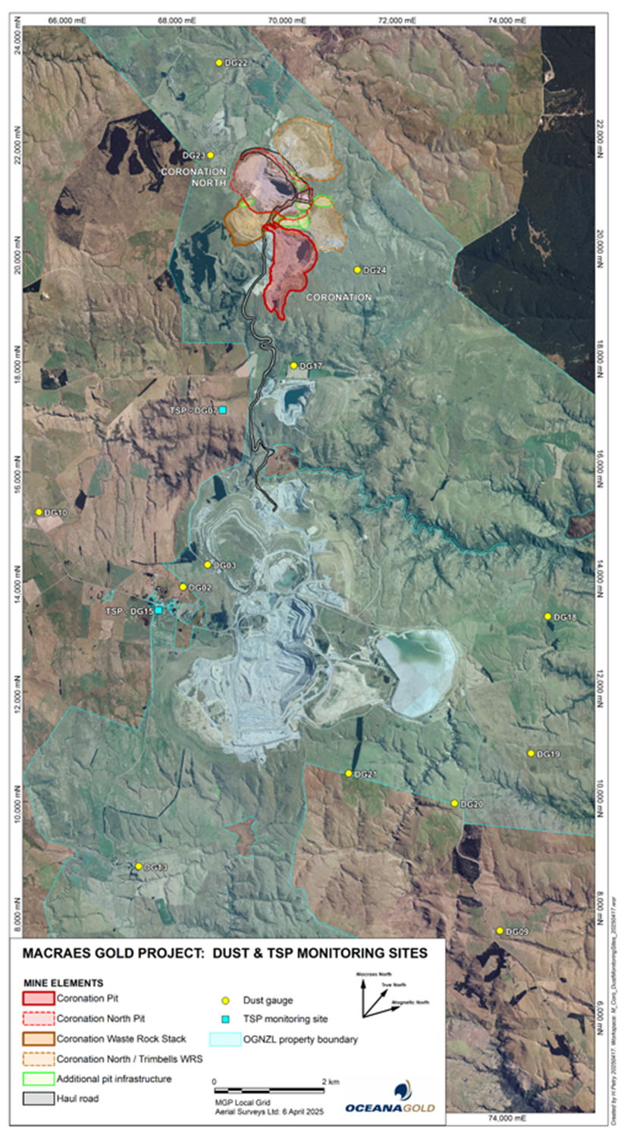

Appendix II – RM12.378.15
Delete Appendix II
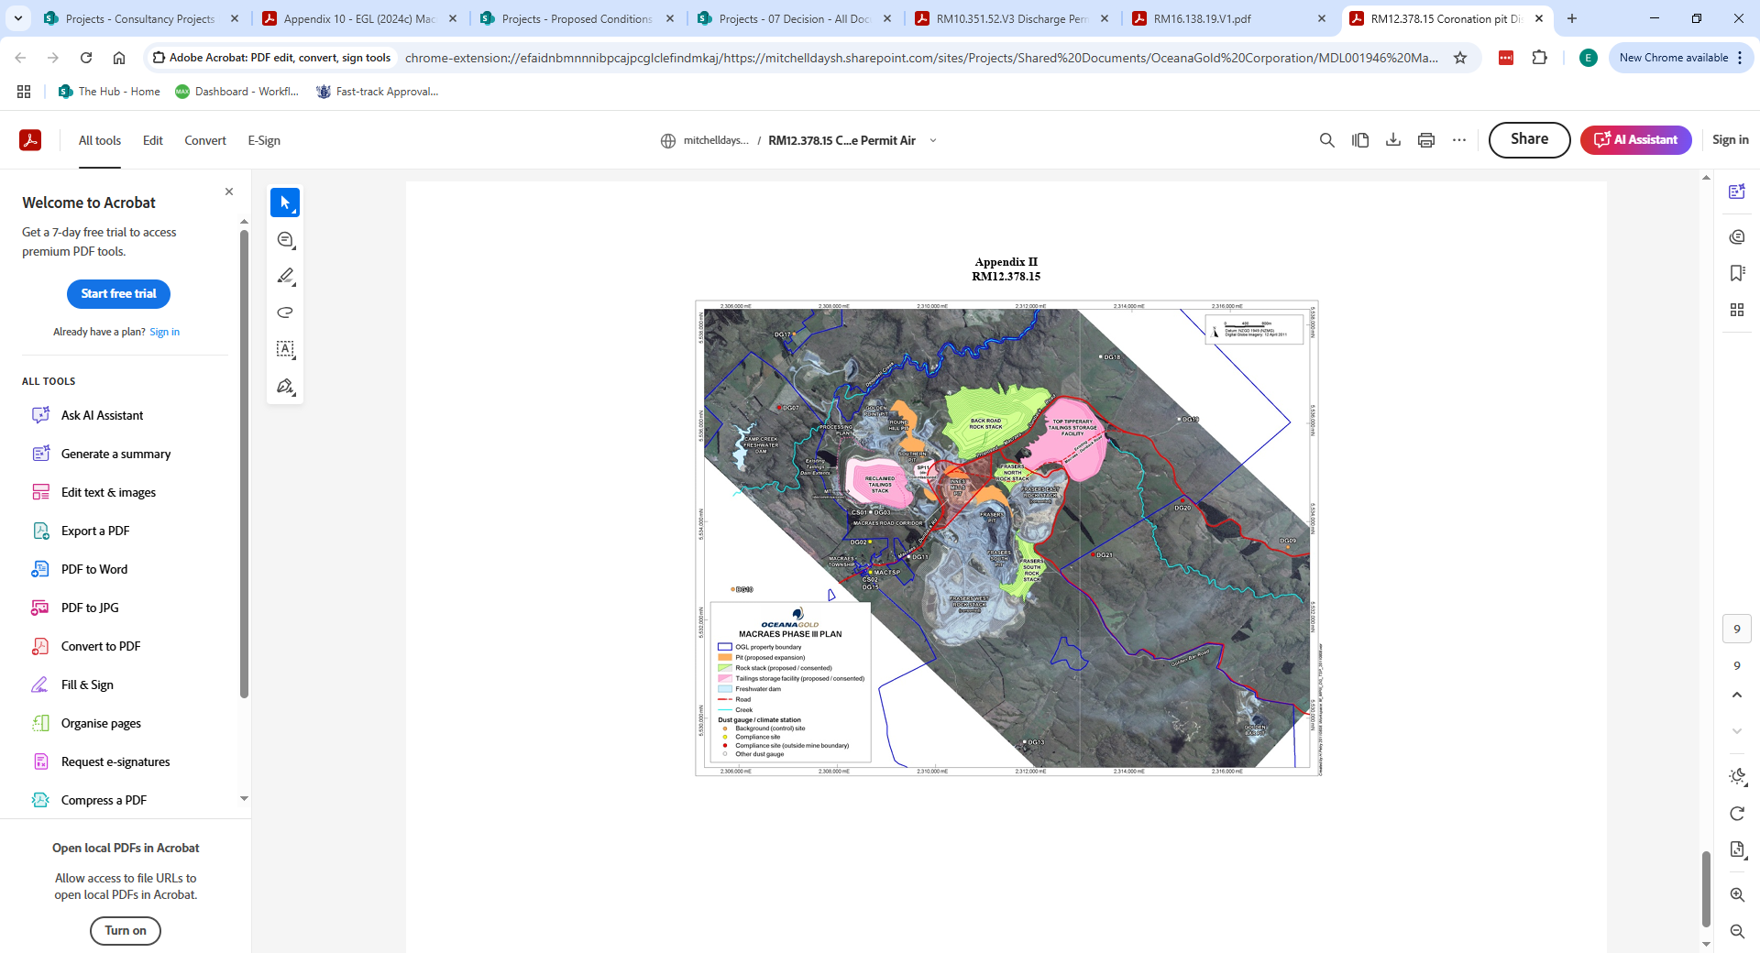

RM16.138.19.V2
Condition Number | Proposed Conditions
RM16.138.19.V2
Discharge Permit (to air)
To discharge contaminants from mining operations and post mining rehabilitation to air for the purpose of undertaking mining operations
For a term expiring 31 August 2032
Location of consent activity: Coronation North Project, approximately 7.5 kilometres to the northwest of the intersection of Macraes Road and Red Bank Road, Macraes Flat.
Legal description of consent location: Pt Section 2 Blk V Highlay SD, Pt Section 2 Blk VII Highlay SD, Lot 1 DP 465577, Pt Section 11 Block VII Highlay SD,
Map Reference: Within a 2.5 kilometre radius of NZTM 2000: E1395000 N4979000
Conditions
Specific
1 | This consent shall be exercised in conjunction with Discharge Permit 96785, Discharge Permit 2006.689, Discharge Permit RM10.351.52, Discharge Permit RM12.373.15, Discharge Permit RM24.184.30 and any subsequent variations to these permits.
2 | This consent authorises the discharge of contaminants to air from the Coronation North Waste Rock Stack, Trimbells Waste Rock Stack, Coronation Pit extension, Coronation North Pit, Coronation North Pit Extension and associated haul roads and working areas, as shown on Appendix I attached.
3 | There shall be no visible dust beyond the boundary of the Macraes Gold Project site that, in the opinion of an enforcement officer, is offensive or objectionable to such an extent that it has an adverse effect on the environment, including the human environment.
Performance Monitoring
4 | Insoluble dust deposition rates at sites DG07, DG20, DG21, DG22 and DG25, as shown on Appendices’ II-IV attached, must not exceed 3 grams per square metre per 30 days (g/m²/30 days) of insoluble dust above background more than twice in any calendar year. Compliance with this condition shall be demonstrated by the monitoring required in Condition 9 of this consent.
5 | Insoluble dust deposition rates at sites DG02 and DG15, as shown on Appendices’ II-IV attached, must not exceed 3 grams per square metre per 30 days (g/m²/30 days) of insoluble dust above background. Compliance with this condition will be demonstrated by the monitoring required in Condition 9 of this consent.
6 | Background concentrations will be calculated by averaging the insoluble dust deposition rates at sites DG09, DG10 and DG24 as shown on Appendices’ II-IV attached.
7 | Twenty-four hour average total suspended particulate at site DG15, as shown on Appendix I Appendix II attached, must not exceed 120μg/m3. Compliance with this condition will be demonstrated by the monitoring required in Condition 10 of this consent.
8 | In the event of any exceedance of those limits specified in Conditions 4, 5 and 7 of this consent, the Consent Holder must undertake an immediate review of the cause of the exceedance. A report detailing the findings of this review shall be provided to the Consent Authority within 1 month of the non-compliant result(s) being received. If it is shown that activities within the Macraes Gold Project site were the cause of the exceedance, then dust mitigation measures within the Macraes Gold Project shall be reviewed by an independent consultant engaged in consultation with the Consent Authority. The independent consultant shall provide a report summarising the cause of the exceedance and recommending measures to improve dust mitigation at the Macraes Gold Project site so that the exceedance does not occur again. This report shall be provided to the Consent Authority within 2 months of the non-compliant result(s) being received.
9 | The consent holder shall monitor dust deposition rates at monthly intervals in accordance with draft ISO Standard ISO/DIS 4222.2 (“Air Quality Measurement of Atmospheric Dustfall – Horizontal Deposit Gauge Method” 1980), or another method approved in writing by the Consent Authority. The monitoring shall be undertaken at the sites shown on Appendices’ II-IV attached
10 | - The consent holder shall monitor real time total suspended particulate concentrations at sites DG15 as shown on Appendix I attached. The monitoring shall be undertaken using a nephelometer, or other instrument as agreed in writing by the Consent Authority. The instrument shall be sited in accordance with AS/NZS 3580.1.1:2007 (Methods for Sampling and Analysis of Ambient Air – Guide to Siting Air Monitoring Equipment).  - The consent holder shall monitor total suspended particulate at monitoring site DG15 as shown on Appendix I Appendix II in accordance with Australian Standard AS/NZS3580.9.3:2003 (Determination of suspended particulate matter - Total Suspended Particulates [TSP] - High Volume Sampler Gravimetric Method), or another method approved by the Consent Authority. Twenty-four hour measurements must be taken every six days March to October inclusive, and every three days November to February inclusive, for a minimum period of twelve months or for however long is required to ensure that adequate data is collected to achieve the objectives of Condition 10(d).  - Parameters to be recorded shall include, but not be limited to:  - Hourly average TSP concentrations as measured by the instrument installed in accordance with Condition 10(a) of this consent;  - 24-hour average TSP concentrations as measured by the instruments installed in accordance with Conditions 10(a) and 10(b).  - The instruments installed in accordance with Conditions 10(a) and 10(b) shall be operated concurrently for a period of no less then twelve months to ensure that twelve months of coincident data is collected. A correlation between the data shall be established by an independent consultant engaged in consultation with the Consent Authority. A report detailing this investigation shall be provided to the Consent Authority within two months of the data being collected.
10A | - The consent holder must continuously monitor real time suspended particulate matter at the DG07 monitoring site shown in Appendix I or another site otherwise agreed in writing by the Consent Authority.  - The monitoring instrument must be a nephelometer with controlled heated inlet or similar equipment that provides continuous real-time data to a website with alerts sent to the consent holder when trigger levels are reached. The instrument must be regularly serviced and calibrated. The equipment design and operating specifications must be agreed in writing with the Consent Authority.  - The results of total suspended particulate matter monitoring undertaken in accordance with Condition 10A(a) must be compared to trigger levels of 250μg/m3 (1-hour average) and 80μg/m3 (24-hour average). Any exceedance of these levels that is deemed to be caused by dust from mining activities must result in a trigger alert message being immediately sent to the Consent Holder.  - The procedure for determining whether an exceedance of the trigger levels referred to in Condition 10A(c) is deemed to be caused by dust from mining activities must be set out in the Dust Management Plan required by Condition 14 of this consent and shall include consideration of wind speed, wind direction and humidity, as a means of filtering non-mining related exceedances.  - On receipt of a trigger alert message referred to in Condition 10A(c), the Consent Holder must implement additional dust control measures as set out in the Dust Management Plan required by Condition 14 of this consent.  - If a trigger alert message is received again within a 7-day period of a response being actioned in accordance with Condition 10A(e), the need for further dust management must be reviewed and if required must be specified in the Dust Management Plan via the review procedure outlined in Condition 15.  - A record of trigger alert messages and responses must be included in the annual report required by Condition 16 of this consent.
11 | - Meteorological conditions shall be continuously monitored and recorded at site DG03 as shown on Appendix I Appendix II attached. As a minimum, the meteorological data collected shall include wind speed, wind direction, temperature and rainfall. Sufficient information shall also be measured to allow an estimate of atmospheric stability. These estimates shall be obtained from measurements of solar radiation and temperature at two heights above ground level, or other parameters as approved by the Consent Authority.  - Meteorological conditions shall be continuously monitored and recorded at site DG15 as shown on Appendix I Appendix II attached. As a minimum, the meteorological data collected shall include wind speed, wind direction, humidity, temperature and rainfall.
12 | The consent holder shall keep a daily record of water used for dust suppression. These records shall be made available to the Consent Authority on request.
13 | Results of all monitoring undertaken in accordance with this consent shall be reported to the Consent Authority on a quarterly basis. The format of the report shall be agreed upon in consultation with the Consent Authority.
14 | Prior to the exercise of this consent, the consent holder shall submit a Dust Management Plan to the Consent Authority. The Dust Management Plan shall include, but not be limited to, the following:  - A description of potential dust sources and the factors influencing dust generation;  - Dust mitigation measures and procedures including, but not limited to:  - Minimising the areas of disturbed ground;  - Watering, with water trucks and fixed sprinklers;  - Avoiding as far as possible, ground disturbance when wind may cause dust nuisance;  - Taking wind conditions into account in planning and carrying out work to minimise dust dispersion;  - Ensuring materials being moved are kept in a coarse state;  - Covering materials; and  - Replanting disturbed ground as soon as possible, including temporary planting if necessary.  - A description of dust monitoring equipment and procedures, including methods of analysis and details of the method used for the calculation of background dust concentration should values from one or all of the background sites be unavailable;  - Procedures for managing and addressing air quality or odour related complaints; and  - Key responsibilities, consultation and reporting, including details of the annual review and independent consultant used as required by Condition 1816 of this consent.
15 | The consent holder shall review the Dust Management Plan annually taking into account the following:  - The outcomes of reviews completed in accordance with Conditions 8 and 16 of this consent; and  - Whether management practices are resulting in compliance with the conditions of this consent.  Confirmation of the review and any revisions will be included in the Project Overview and Annual Work and Rehabilitation Plan for the Macraes Gold Project site. The consent holder shall provide the Consent Authority with any updates of the Dust Management Plan within one month of any update occurring.
16 | An independent consultant, engaged by the Consent Holder in consultation with the Consent Authority, shall undertake an annual review and assessment of all dust monitoring data. The reviewer’s report shall include:  - The name, qualifications, and experience of the reviewer;  - The methods used and the investigations undertaken for the review;  - Interpretation of the monitoring data reviewed;  - An assessment of the quality of the monitoring data;  - An assessment of the monitoring regime;  - A description and evaluation of each of the dust mitigation measures used by the consent holder;  - Recommendations on whether:  - The monitoring of dust is adequate or should be changed, and if changed the changes that are recommended;  - The dust mitigation measures used by the consent holder are adequate, or should be changed, and the changes that are recommended; and  - Any changes should be made to the conditions of this consent; and  - Any other matters that the reviewer considers should be drawn to the attention of the consent holder or the Consent Authority.
17 | The annual report required by Condition 16 shall be provided to the Consent Authority by 30 April each year.
18 | In the event of any non compliance with the conditions of this consent, the consent holder shall notify the Consent Authority within 24 hours of the non compliance being detected. Within five working days the consent holder shall provide written notification to the Consent Authority providing details of the non-compliance. This notification will at a minimum include an explanation of the cause of the non compliance, the steps taken to remedy the situation and steps taken to mitigate any future occurrence of the non compliance.
19 | The consent holder shall maintain a record of any complaints received regarding their operation. The register shall include, but not be limited to:  - name and location of site where the problem is experienced;  - nature of the problem;  - date and time problem occurred, and when reported;  - action taken by consent holder to remedy the situation and any policies or methods put in place to avoid or mitigate the problem occurring again.  The register of complaints shall be incorporated into the Project Overview and Annual Work and Rehabilitation Plan.
General
20 | - The consent holder shall provide and maintain in favour of the Consent Authority one or more bonds to secure:  - The performance and completion of rehabilitation in accordance with the conditions of this consent; and  - The carrying out of the monitoring required by the conditions of this consent; and  - The remediation of any adverse effect on the environment that may arise from the exercise of this consent.  - Compliance with Conditions 20(m) to 20(q) of this consent.  - Before the first exercise of this consent, the consent holder shall provide to the Consent Authority one or more bonds required by Condition 20(a).  - Subject to the other provisions of this consent, any bond shall be in the form and on the terms and conditions approved by the Consent Authority.  - Any bond shall be given or guaranteed by a surety acceptable to the Consent Authority.  - The surety shall bind itself to pay for the carrying out and completion of the conditions of consent which are the subject of the bond on default by the consent holder or the occurrence of any adverse environment effect requiring remedy; during or after the expiry of this consent.  - The amount of each bond shall be fixed annually by the Consent Authority which will take into account any calculations and other matters submitted by the consent holder relevant to the determination of the amount to be bonded in the Project Overview and Annual Work and Rehabilitation Plan required for by condition 6 of RM16.138.05, condition 6 of RM16.138.10, condition 8 of RM16.138.17 and condition 10 of RM16.138.18.  - The amount of the bond(s) shall include:  - The estimated costs of complete rehabilitation in accordance with the conditions of consent on the completion of the mining operations proposed for the next year and described in the Project Overview and Annual Work and Rehabilitation Plan.  - The estimated costs of:  - Monitoring in accordance with the monitoring conditions of the consent;  - Monitoring for and of any adverse effect of the activity authorised by this consent which may become apparent during or after expiry of this consent;  - Monitoring any rehabilitation required by this consent.  - Any further sum which the Consent Authority considers necessary for monitoring and dealing with any adverse effect on the environment that may arise from the exercise of the consent whether during or after the expiry of this consent.  - The amount shall be calculated for the duration of this consent and for a period of 20 years after its expiry.  - If, on review, the total amount of bond to be provided by the consent holder is greater or less than the sum secured by the current bond(s), the consent holder, surety and the Consent Authority may, in writing, vary the amount of the bond(s).  - While the liability of the surety is limited to the amount of the bond(s), the liability of the consent holder is unlimited.  - Any bond may be varied, cancelled, or renewed at any time by written agreement between the consent holder, surety and Consent Authority.  - The costs (including the costs of the Consent Authority) of providing, maintaining, varying and reviewing any bond shall be paid by the consent holder.  - For a period of 20 years from the expiry or surrender of this consent the consent holder shall provide in favour of the Consent Authority one or more bonds.  - The amount of the bond to be provided under Condition 20(m) shall include the amount (if any) considered by the Consent Authority necessary for:  - Completing rehabilitation in accordance with the conditions of this consent.  - Monitoring for and of any adverse effect on the environment that may arise from the exercise of the consent.  - Monitoring any measures taken to prevent, remedy or mitigate any adverse effect on the environment that may arise from the exercise of this consent.  - Dealing with any adverse effect on the environment which may become apparent after the surrender or expiry of this consent.  - Contingencies.  - Without limitation, the amount secured by the bond given under Condition 20 (m) may include provision to deal with structural instability or failure, land and water contamination, and the failure of rehabilitation in terms of the rehabilitation objectives and conditions of this consent. Costs shall include costs of investigating, preventing, remedying or mitigating any adverse effect.  - The bond(s) required by Condition 20(m) must be provided on the earlier of:  - 12 months before the expiry of this consent.  - Three months before the surrender of this consent.  - Conditions 20(c), (d), (e), (h), (i), (j) and (k) apply to the bond(s) required by Condition 20(m).
Review
21 | The Consent Authority may, in accordance with Sections 128 and 129 of the Resource Management Act 1991, serve notice on the consent holder of its intention to review the conditions of this consent within three months of each anniversary of the commencement of this consent, for the purpose of:  - determining whether the conditions of this consent are adequate to deal with any adverse effect on the environment which may arise from the exercise of the consent and which it is appropriate to deal with at a later stage, or which become evident after the date of commencement of the consent; or  - ensuring the conditions of this consent are consistent with any National Environmental Standards; or  - requiring the consent holder to adopt the best practicable option, in order to remove or reduce any adverse effect on the environment arising as a result of the exercise of this consent.

Appendix I – RM16.138.19
[Replace the plan on left with the plan on right]
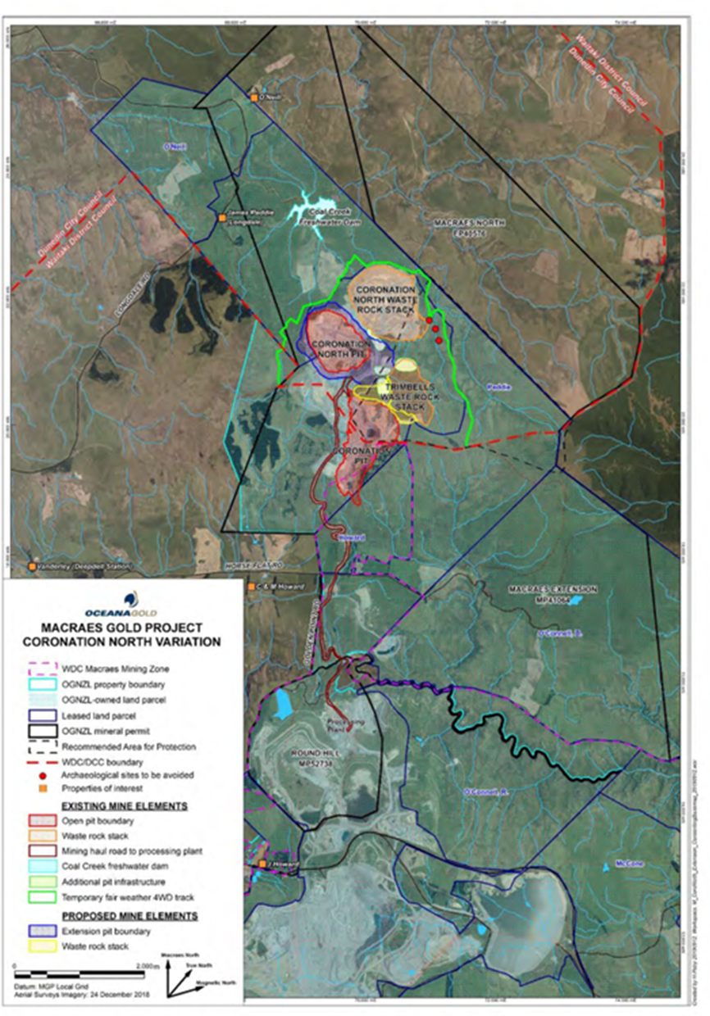

Appendix II – RM16.138.19
Delete Appendix II
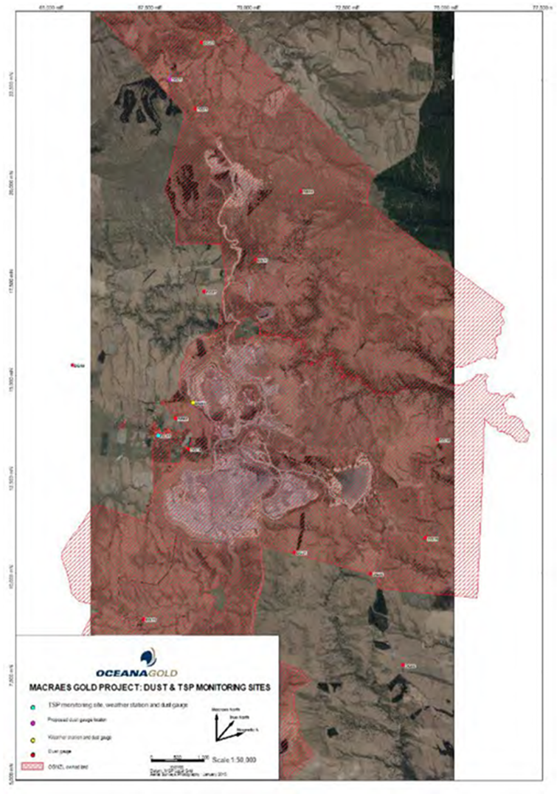

Appendix III – RM16.138.19
Delete Appendix III
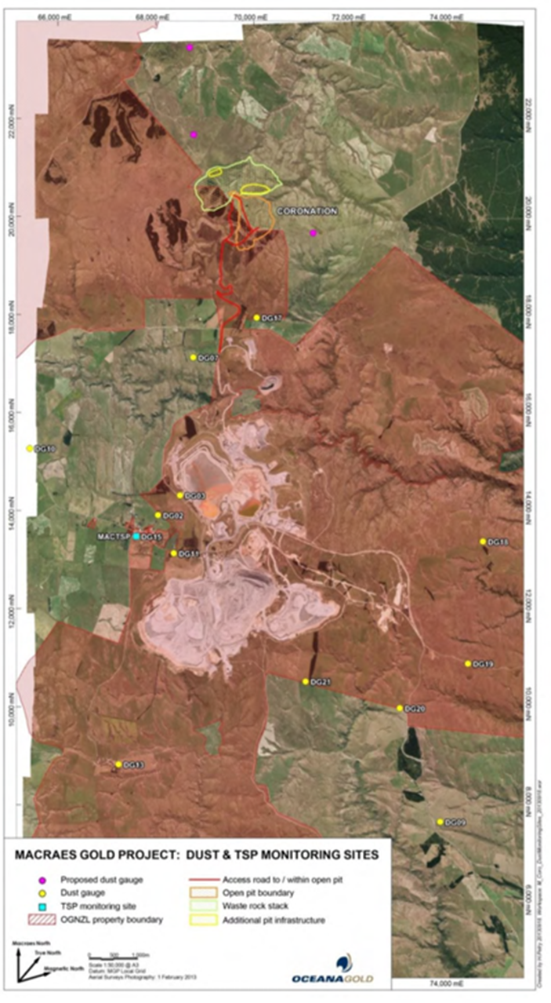

Appendix IV – RM16.138.19
Delete Appendix IV

RM24.184.30 - New Air Discharge Permit For Golden Bar
Condition Number | Proposed Conditions
RM24.184.30
Discharge Permit (to air)
To discharge contaminants to air for the purpose of carrying out mining activities and post mining rehabilitation.
Legal description: Sec 4 and Pt Sec 7 Blk VIII, Dunback SD
Map reference: NZMS 260 I43:167-298
Expiry of Consent: This consent shall expire on 30 November 2032 or on the completion of site rehabilitation to the satisfaction of the consent authority.
Conditions
1 | This consent must not commence until Discharge Permit 2007.511 has been surrendered or has expired.
2 | This consent shall be exercised in conjunction with Discharge Permit 96785, Discharge Permit 2006.689, Discharge Permit RM10.351.52, Discharge Permit RM12.373.15, Discharge Permit RM16.138.19 and any subsequent variations to these permits.
3 | The discharge of contaminants to air must be carried out in accordance with the plans and all information submitted with the application, detailed below, and all referenced by the Consent Authority as consent number RM24.184.  - Macraes Phase 4 Project Resource Consent Application and Assessment of Environmental Effects, including Appendices 1 – 33, prepared by Mitchell Daysh Limited, dated 28 March 2024 (Updated 18 February 2025);  - Response to s92(1) Request for Further Information, dated 15 October 2024; and  - Response to s92(1) Request for Further Information, dated 5 February 2025.  If there are any inconsistencies between the above information and the conditions of this consent, the conditions of this consent will prevail.
4 | There shall be no visible dust beyond the boundary of the Macraes Gold Project site that, in the opinion of an enforcement officer, is offensive or objectionable to such an extent that it has an adverse effect on the environment.
Performance Monitoring
5 | Insoluble dust deposition rates at sites DG20 and DG21, as shown on Appendix I attached, must not exceed 3 grams per square metre per 30 days (g/m²/30 days) of insoluble dust above background more than twice in any calendar year. Compliance with this condition shall be demonstrated by the monitoring required in Condition 10 of this consent.
6 | Insoluble dust deposition rates at sites DG02 and DG15, as shown on Appendix I attached, must not exceed 3 grams per square metre per 30 days (g/m²/30 days) of insoluble dust above background. Compliance with this condition will be demonstrated by the monitoring required in Condition 10 of this consent.
7 | Background concentrations will be calculated by averaging the insoluble dust deposition rates at sites DG09, DG10 and DG24 as shown on Appendix I attached.
8 | Twenty-four hour average total suspended particulate at site DG15, as shown on Appendix I attached, must not exceed 120μg/m³. Compliance with this condition will be demonstrated by the monitoring required in Condition 11 of this consent.
9 | In the event of any exceedance of those limits specified in Conditions 5, 6 and 8 of this consent, the Consent Holder must undertake an immediate review of the cause of the exceedance. A report detailing the findings of this review shall be provided to the Consent Authority within 30 working days of the non-compliant result(s) being received. If it is shown that activities within the Macraes Gold Project site were the cause of the exceedance, then dust mitigation measures within the Macraes Gold Project shall be reviewed by an independent consultant engaged in consultation with the Consent Authority. The independent consultant shall provide a report summarising the cause of the exceedance and recommending measures to improve dust mitigation at the Macraes Gold Project site so that the exceedance does not occur again. This report shall be provided to the Consent Authority within 60 working days of the non-compliant result(s) being received.
10 | The consent holder shall monitor dust deposition rates at monthly intervals in accordance with draft ISO Standard ISO/SIS 4222.2 (“Air Quality Measurement of Atmospheric Dustfall – Horizontal Deposit Gauge Method” 1980), or another method approved in writing by the Consent Authority. The monitoring shall be undertaken at the sites shown on Appendix I attached.
11 | - The Consent Holder must continuously monitor real time suspended particulate matter at the DG15 monitoring site shown in Appendix I.  - The monitoring instrument must be a nephelometer with controlled heated inlet or similar equipment that provides continuous real-time data to a website with alerts sent to the consent holder when trigger levels are reached. The instrument must be regularly serviced and calibrated. The equipment design and operating specifications must be agreed in writing with the Consent Authority.  - The results of total suspended particulate matter monitoring undertaken in accordance with Condition 11(a) must be compared to trigger levels of 250μg/m3 (1-hour average) and 80μg/m3 (24-hour average). Any exceedance of these levels that is deemed to be caused by dust from mining activities must result in a trigger alert message being immediately sent to the Consent Holder.  - The procedure for determining whether an exceedance of the trigger levels referred to in Condition 11(c) is deemed to be caused by dust from mining activities must be set out in the Dust Management Plan required by Condition 15 of this consent and shall include consideration of wind speed, wind direction and humidity, as a means of filtering non-mining related exceedances.  - On receipt of a trigger alert message referred to in Condition 11(c), the Consent Holder must implement additional dust control measures as set out in the Dust Management Plan required by Condition 15 of this consent.  - If a trigger alert message is received again within a 7-day period of a response being actioned in accordance with Condition 11(e), the need for further dust management must be reviewed and if required must be specified in the Dust Management Plan via the review procedure outlined in Condition 16.  - A record of trigger alert messages and responses must be included in the annual report required by Condition 17 of this consent.
12 | - Meteorological conditions shall be continuously monitored and recorded at site DG03 as shown on Appendix I attached. As a minimum, the meteorological data collected shall include wind speed, wind direction, temperature and rainfall. Sufficient information shall also be measured to allow an estimate of atmospheric stability. These estimates shall be obtained from measurements of solar radiation and temperature at two heights above ground level, or other parameters as approved by the Consent Authority.  - Meteorological conditions shall be continuously monitored and recorded at site DG15 as shown on Appendix I attached. As a minimum, the meteorological data collected shall include wind speed, wind direction, humidity, temperature and rainfall.
13 | The consent holder shall keep a daily record of water used for dust suppression. These records shall be made available to the Consent Authority on request.
14 | Results of all monitoring undertaken in accordance with this consent shall be reported to the Consent Authority on a quarterly basis. The format of the report shall be agreed upon in consultation with the Consent Authority.
15 | Prior to the exercise of this consent, the consent holder shall submit a Dust Management Plan to the Consent Authority. The Dust Management Plan shall include, but not be limited to, the following:  - A description of potential dust sources and the factors influencing dust generation;  - Dust mitigation measures and procedures including, but not limited to:  - Minimising the areas of disturbed ground;  - Watering, with water trucks and fixed sprinklers;  - Avoiding as far as possible, ground disturbance when wind may cause dust nuisance;  - Taking wind conditions into account in planning and carrying out work to minimise dust dispersion;  - Ensuring materials being moved are kept in a coarse state;  - Covering materials; and  - Replanting disturbed ground as soon as possible, including temporary planting if necessary.  - A description of dust monitoring equipment and procedures, including methods of analysis and details of the method used for the calculation of background dust concentration should values from one or all of the background sites be unavailable;  - Procedures for managing and addressing air quality or odour related complaints; and  - Key responsibilities, consultation and reporting, including details of the annual review and independent consultant used as required by Condition 17 of this consent.
16 | The consent holder shall review the Dust Management Plan annually taking into account the following:  - The outcomes of reviews completed in accordance with Condition 9, 11(f), and 17 of this consent; and  - Whether management practices are resulting in compliance with the conditions of this consent.  Confirmation of the review and any revisions will be included in the Project Overview and Annual Work and Rehabilitation Plan for the Macraes Gold Project site. The consent holder shall provide the Consent Authority with any updates of the Dust Management Plan within one month of any update occurring.
17 | An independent consultant, engaged by the Consent Holder in consultation with the Consent Authority, shall undertake an annual review and assessment of all dust monitoring data. The reviewer’s report shall include:  - The name, qualifications, and experience of the reviewer;  - The methods used and the investigations undertaken for the review;  - Interpretation of the monitoring data reviewed;  - An assessment of the quality of the monitoring data;  - An assessment of the monitoring regime;  - A description and evaluation of each of the dust mitigation measures used by the consent holder;  - Recommendations on whether:  - The monitoring of dust is adequate or should be changed, and if changed the changes that are recommended;  - The dust mitigation measures used by the consent holder are adequate, or should be changed, and the changes that are recommended; and  - Any changes should be made to the conditions of this consent; and  - Any other matters that the reviewer considers should be drawn to the attention of the consent holder or the Consent Authority.
18 | The annual report required by Condition 17 shall be provided to the Consent Authority by 30 April each year.
19 | In the event of any non compliance with the conditions of this consent, the consent holder shall notify the Consent Authority within 24 hours of the non compliance being detected. Within five working days the consent holder shall provide written notification to the Consent Authority providing details of the non-compliance. This notification will at a minimum include an explanation of the cause of the non compliance, the steps taken to remedy the situation and steps taken to mitigate any future occurrence of the non compliance.
20 | The consent holder shall pay to the Consent Authority, the costs for monitoring, enforcing and administering this consent as agreed upon between the consent holder and the Consent Authority pursuant to Section 36 of the Resource Management Act 1991.
21 | The consent holder shall maintain a record of any complaints received regarding their operation. The register shall include, but not be limited to:  - name and location of site where the problem is experienced;  - nature of the problem;  - date and time problem occurred, and when reported;  - action taken by consent holder to remedy the situation and any policies or methods put in place to avoid or mitigate the problem occurring again.  The register of complaints shall be incorporated into the Project Overview and Annual Work and Rehabilitation Plan.
General
22 | - The consent holder shall provide and maintain in favour of the Consent Authority one or more bonds to secure:  - The performance and completion of rehabilitation in accordance with the conditions of this consent; and  - The carrying out of the monitoring required by the conditions of this consent; and  - The remediation of any adverse effect on the environment that may arise from the exercise of this consent.  - Compliance with Conditions 22(m) to 22(q) of this consent.  - Before the first exercise of this consent, the consent holder shall provide to the Consent Authority one or more bonds required by Condition 22(a).  - Subject to the other provisions of this consent, any bond shall be in the form and on the terms and conditions approved by the Consent Authority.  - Any bond shall be given or guaranteed by a surety acceptable to the Consent Authority.  - The surety shall bind itself to pay for the carrying out and completion of the conditions of consent which are the subject of the bond on default by the consent holder or the occurrence of any adverse environment effect requiring remedy; during or after the expiry of this consent.  - The amount of each bond shall be fixed annually by the Consent Authority which will take into account any calculations and other matters submitted by the consent holder relevant to the determination of the amount to be bonded in the Project Overview and Annual Work and Rehabilitation Plan, or otherwise.  - The amount of the bond(s) shall include:  - The estimated costs of complete rehabilitation in accordance with the conditions of consent on the completion of the mining operations proposed for the next year and described in the Project Overview and Annual Work and Rehabilitation Plan.  - The estimated costs of:  - Monitoring in accordance with the monitoring conditions of the consent;  - Monitoring for and of any adverse effect of the activity authorised by this consent which may become apparent during or after expiry of this consent;  - Monitoring any rehabilitation required by this consent.  - Any further sum which the Consent Authority considers necessary for monitoring and dealing with any adverse effect on the environment that may arise from the exercise of the consent whether during or after the expiry of this consent.  - The amount shall be calculated for the duration of this consent and for a period of 20 years after its expiry.  - If, on review, the total amount of bond to be provided by the consent holder is greater or less than the sum secured by the current bond(s), the consent holder, surety and the Consent Authority may, in writing, vary the amount of the bond(s).  - While the liability of the surety is limited to the amount of the bond(s), the liability of the consent holder is unlimited.  - Any bond may be varied, cancelled, or renewed at any time by written agreement between the consent holder, surety and Consent Authority.  - The costs (including the costs of the Consent Authority) of providing, maintaining, varying and reviewing any bond shall be paid by the consent holder.  - For a period of 20 years from the expiry or surrender of this consent the consent holder shall provide in favour of the Consent Authority one or more bonds.  - The amount of the bond to be provided under Condition 22(m) shall include the amount (if any) considered by the Consent Authority necessary for:  - Completing rehabilitation in accordance with the conditions of this consent.  - Monitoring for and of any adverse effect on the environment that may arise from the exercise of the consent.  - Monitoring any measures taken to prevent, remedy or mitigate any adverse effect on the environment that may arise from the exercise of this consent.  - Dealing with any adverse effect on the environment which may become apparent after the surrender or expiry of this consent.  - Contingencies.  - Without limitation, the amount secured by the bond given under Condition 22(m) may include provision to deal with structural instability or failure, land and water contamination, and the failure of rehabilitation in terms of the rehabilitation objectives and conditions of this consent. Costs shall include costs of investigating, preventing, remedying or mitigating any adverse effect.  - The bond(s) required by Condition 22(m) must be provided on the earlier of:  - 12 months before the expiry of this consent.  - Three months before the surrender of this consent.  - Conditions 22(c), (d), (e), (h), (i), (j) and (k) apply to the bond(s) required by Condition 22(m).
23 | The Consent Authority may, in accordance with Sections 128 and 129 of the Resource Management Act 1991, serve notice on the Consent Holder of its intention to review the conditions of this consent during the period of three months either side of the date of granting of this consent each year, or within two months of any enforcement action taken by the Consent Authority in relation to the exercise of this consent, for the purpose of:  - Determining whether the conditions of this consent are adequate to deal with any adverse effect on the environment which may arise from the exercise of the consent and which it is appropriate to deal with at a later stage, or which becomes evident after the date of commencement of the consent;  - Ensuring the conditions of this consent are consistent with any National Environmental Standards or rules in a relevant regional plan;  - Reviewing the frequency of monitoring or reporting required under this consent;  - Amending the monitoring programme set out in accordance with Conditions 5 to 12 of this consent; or  - Requiring the Consent Holder to adopt the best practicable option, in order to prevent or minimise any adverse effect on the environment arising as a result of the exercise of this consent.

Appendix I – RM24.184.30

