SCHEDULE TWO
BENDIGO-OPHIR GOLD PROJECT
GENERAL CONDITIONS WHICH APPLY TO ALL OF THE
RESOURCE CONSENTS WITHIN THE JURISDICTION OF THE
OTAGO REGIONAL COUNCIL
Notes: The ‘comment’ column has been provided for guidance and interpretation purposes only and is not proposed to form part of the consent conditions.
Cross references to other conditions are highlighted in yellow wash for ease of finding and checking the accuracy of those cross references when the conditions are finalised. In some instances, a short description of the condition being cross referenced is also provided in square brackets.

Contents
EROSION AND SEDIMENT CONTROL 2
WATER MANAGEMENT PLAN 7
FRESHWATER ECOLOGY MANAGEMENT AND MONITORING PLAN 11
GEOTECHNICAL MANAGEMENT PLANS 14
DISCHARGE OF CONTAMINANTS TO AIR 32

EROSION AND SEDIMENT CONTROL
No. | Condition | Comment
 | General
All earthmoving machinery, and ancillary equipment must be operated in a manner which ensures spillages of fuel, oil and similar contaminants are prevented to the greatest extent practicable. Refuelling and lubrication activities must be set back at a distance of at least 10 m from any water body, ephemeral water body, or overland flow path, that is sufficient to ensure that any spillage can be contained and not enter surface water.
This condition does not apply to refuelling of generator sets within proximity waterbody where the area is suitably bunded to prevent any spill from entering any water bodies.
 | Erosion and Sediment Control
NEW 1 | All earthworks undertaken in the areas listed in this condition must be done in accordance with a site-specific Erosion and Sediment Control Plan (SSESCP) developed for that area  - Administration and work camp area, including the access road;  - Process Plant and Infrastructure Area;  - Rise and Shine Pit, Haul Road, Shepherds ELF, Shepherds Silt Pond, and Shepherds Tailings Storage Facility;  - Western ELF;  - Come in Time Pit and Backfill; and  - SRX Pit, SRE Pit, and SRX Engineered Landform. | ORC comment:  Condition to provide certainty about what plans need to be developed
NEW 2 | The SSESCP must contain, at a minimum, the following information:  - Administrative Requirements  - Daily inspections of specific erosion and sediment control measures as required by GD05 (such as sediment retention ponds)  - Weekly site inspections  - Monthly environmental reporting  - Pre and post rainfall inspections  - Independent audit by Suitably Qualified and Experienced Person  - Notification and management of environmental incidents  - Records and registers  - Environmental roles and responsibilities of personnel (including nomination of Principal Contractor)  - Site induction  - Operational Requirements  - Detailed of the erosion and sediment controls, including  - Detailed layout plans of the proposed erosion and sediment controls. Layout plans shall cover progressive construction, stabilisation and rehabilitation of each area;  - Detailed design of any specific diversion channels or bunds;  - Detailed design of any sediment retention ponds or decanting earth bunds;  - Details of any stabilisation works required; and  - Details of dust control approach (where site-specific approach is required)  - Water quality monitoring including sampling locations, frequencies, and triggers including site-specific relationship between turbidity and total suspended solids to enable real-time turbidity monitoring  - Chemical and fuel management  - Sufficient detail to address the following matters:  - Assessment of soil characteristics within earthworks catchments and the necessity for additional erosion and sediment control practices;  - Specific erosion and sediment control works (locations, dimensions, capacity etc);  - Catchment boundaries and contour information;  - Details of construction methods;  - Timing and duration of construction and operation of control works;  - Processes in place if unexpected contaminated land is encountered;  - Contingency measures for snow and/ or frost events (in relation to chemical treatment);  - Adaptive management processes if the controls are found to be  - Measures to avoid silt and/or sediment tracking onto roads and then to water for the duration of the earthworks  - Details relating to the management of exposed areas;  - Monitoring and maintenance requirements; and  - Details relating to the management of long-term stockpiling. | ORC comment:  Condition to specify the content of the SSESCP.  This wording is applied to all large earthworks sites in Otago (which are still substantially smaller than this site).  ORC has modified part (b)(i) from its standard wording to include the detailed design recommendations made by EGL in B.26.
The SSESCP, required by Condition NEW 1 must be prepared by a suitably qualified and experienced environmental practitioner, and must be submitted to Otago Regional Council for certification no less than 20 working days prior to the proposed commencement of the activities in the area subject to that SSESCP.
The purpose of the certification is to confirm that the SSESCP is in accordance with the requirements set out in Condition NEW 2.
 | Once it has been certified, the Consent Holder must undertake earthworks in accordance with any relevant SSESCP.
 | The Consent Holder must establish and maintain erosion and sediment control measures in a manner which is in accordance with any applicable certified SSESCP.
 | The Consent Holder must ensure that, clean water run-off from stabilised surfaces including catchment areas up gradient of the site is diverted away from the exposed areas via a stabilised system to prevent erosion. The Consent Holder must also ensure the outfall(s) of these systems is protected against erosion.
 | The Consent Holder must ensure thatsediment laden run-off from an area containing soil disturbance activities is treated by sediment retention structures prior to discharge. These structures are to be fully operational before bulk earthworks in the area commence.
 | Sediment retention devices and diversions must be sized and constructed in accordance with the Erosion and Sediment Control Management Plan and any relevant SSESCP as required in the Common Conditions in Schedule One. | ORC comment:  ORC does not agree that the Erosion and Sediment Control Report B.26 outlines appropriate sizing requirements for diversions or sediment retention devices.
NEW 3 | The concentration of total suspended solids in the discharge from any sediment retention device must not exceed XX mg/L except when the background total suspended solids in the waterbody is greater than XX mg/L.  The Consent Holder must monitor TSS on a monthly basis. | ORC comment:  As discussed at workshops, applicant to propose a TSS end-of-pipe limit.  Monthly sampling is suggested to align with other water quality monitoring; however, this frequency should be determined with input from water quality experts.
 | The works authorised by this consent must not cause:  - increases in upstream or downstream flows which cause flooding on adjacent land; or  - A conspicuous change in visual clarity in any river beyond the zone of reasonable mixing.  Advice note: For the purposes of this condition, the length of the zone of reasonable mixing downstream of the outlet of a sediment retention device is greater of:  - 50 metres  - XX times the wetted channel width of the receiving environment at the estimated seven day mean annual low flow | Narrative standard to be paired with end-of-pipe standard
NEW 4 | The Consent Holder must:  - Prior to commencing any bulk earthworks on site, establish a paired TSS–turbidity relationship using representative monitoring data, and calculate a turbidity trigger level based on:  - the TSS compliance limit,  - the regression relationship between turbidity and TSS, and  - the residual variability of that relationship. The trigger should incorporate a conservative buffer (e.g., set at a turbidity value corresponding to 85% of the TSS limit, adjusted for prediction error).  - Undertake ongoing turbidity monitoring, supplemented by monthly TSS sampling;  - Regularly update the TSS–turbidity regression and associated trigger level as additional data are collected;  - In the event that the turbidity trigger is exceeded:  - Immediately collect a confirmatory TSS sample; and  - Cease discharge or implement additional treatment until turbidity falls below the trigger level.  - Report the results of confirmatory TSS sampling to ORC Compliance; and  - If the TSS sample confirms non-compliance, implement the relevant corrective and reporting procedures.
 | All disturbed or cut vegetation, soil or debris must be placed in a position where it will not enter, nor cause erosion of, any water body.

WATER MANAGEMENT PLAN
No. | Condition | Comment
No less than two months prior to the first exercise of these consents, the Consent Holder must provide to Otago Regional Council for certification a Water Management Plan (“WMP”) that has been prepared by a suitably qualified and experienced person.
The primary objective of the BOGP WMP is to ensure that water is managed in a way that protects the environment, supports operational needs, and meets regulatory requirements.
The key objectives of the WMP are to:
- Identify roles and responsibilities for MGL personnel to ensure the management plan achieves its objectives.
- Protect the receiving environment by ensuring any water discharges do not cause adverse effects.
- Explain the water quality limits set out in resource consents and relevant guidelines.
- Manage water sustainably across all phases of the project, including construction, operations, closure, and post-closure.
- Classify and manage water appropriately based on its source and quality (e.g., clean water, mine impacted water (“MIW”), aquifer water).
- Design and implement infrastructure that supports effective water capture, diversion, treatment, and discharge.
- Monitor water quality and quantity to inform adaptive management processes and ensure compliance.
- Support closure outcomes by ensuring water management infrastructure and practices align with long-term rehabilitation goals.
- Identify and manage risks associated with water quality and quantity through a structured risk management framework.
The Consent Holder must implement the WMP.
Implementation of the WMP is intended to result in the following key outcomes:
- Reliable water supply to the processing plant;
- Effective water availability and distribution across the site to support mining and associated activities;
- Controlled movement and storage of various water classes;
- Water discharges within compliance limits;
- Proactive monitoring and adaptive management processes;
- Long-term sustainability of water use in a water-deficit environment;
- Zero release of untreated MIW from mine circuit water during operations and construction phases (except surficial MIW run-off from haul roads and engineered landforms); and
- Successful transition to closure, including active and passive water treatment systems that help achieve water quality objectives.
 | Monitoring and Compliance
 | Surface Water Monitoring and Compliance
The Consent Holder must undertake monthly surface water quality monitoring at the following locations, which are shown on the plan in Attachment 1 - Water Monitoring Locations, in relation to the parameters set out in Attachment 2 – Surface Water Compliance Parameters and Limits:
- SC01 – Shepherds Creek Compliance Site
- RS03 – Rise and Shine Creek Compliance Site: CC01 – Clearwater Creek Control Site
The Consent Holder must undertake continuous water monitoring at the two monitoring locations listed in Condition 12 as follows:
- Flow meter or water level;
- Electrical conductivity; and
- Turbidity (NTU).
The Consent Holder must comply with the Surface Water Quality Compliance Limits set out in Attachment 2 at:
- SC01 – Shepherds Creek Compliance Site; and
- RS03 – Rise and Shine Creek Compliance Site.
Advice Note: The Surface Water Quality Compliance Limits define the environmental outcomes that the operation of the BOGP must achieve in relation to surface water and are the subject of consent conditions as well as being set out in the WMP. In addition to the Surface Water Quality Compliance Limits, the WMP includes an extensive programme of ‘performance monitoring’. The latter is for internal management purposes to assist MGL in the achievement of the Surface Water Quality Compliance Limits and is not the subject of specific consent conditions (other than Common Condition C13 (Schedule One) requiring MGL to implement the WMP). Despite that, the results of the performance monitoring must form part of the Annual Surface Water and Groundwater Monitoring Report required by Condition 15.
NEW 5 | Insert surface water performance monitoring requirements here
NEW 6 | Volunteered Lindis River and Bendigo Creek surface water monitoring to be inserted here
 | Groundwater Monitoring and Compliance
The Consent Holder must undertake monthly groundwater quality monitoring at the following locations, which are shown on the plan in Attachment 1 – Water Monitoring Locations, in relation to the parameters set out in Attachment 3 - Groundwater Compliance Parameters and Limits:
- MW-101 – Compliance Bore (Ardgour Station)
- Base Bore – Production Bore (Abstraction Borefield)
The Consent Holder must undertake monthly monitoring of the groundwater level in the bores listed in Condition 15.
Advice Note: The Base Bore is also subject to conditions attached to the Water Take Consent [Insert Consent Number] including a requirement to record and telemeter the rate of take.
The Consent Holder must comply with the Groundwater Quality Compliance Limits set out in Attachment 3 at the groundwater quality monitoring locations listed in Condition 15.
Advice Note: The Groundwater Quality Compliance Limits define the environmental outcomes that the operation of the BOGP must achieve in relation to ground water and are the subject of consent conditions as well and being set out in the WMP. In addition to the Groundwater Quality Compliance Limits, the WMP includes an extensive programme of ‘performance monitoring’. The latter is for internal management purposes to assist MGL in the achievement of the Groundwater Quality Compliance Limits and is not the subject of specific consent conditions (other than Common Condition C13 (Schedule One) requiring MGL to implement the WMP). Despite that, the results of the performance monitoring must form part of the Annual Surface Water and Groundwater Monitoring Report required by Condition 19.
 | Accuracy of the Water Measuring Systems
 | As part of the design and implementation of any water measuring systems, and upon any subsequent request of the Otago Regional Council, the Consent Holder must undertake an assessment of the accuracy of the water measuring system(s). Each system must have a reliable calibration to water flow and must be maintained to an accuracy of +/- 5%. The assessment must be undertaken by an independent, qualified person and evidence documenting the assessment must be forwarded to the Otago Regional Council within one month of the assessment occurring.
 | Reporting
The Consent Holder must, as part of the Annual Monitoring and Compliance Report required by Condition C12 in the Common Conditions in Schedule One, provide to the Otago Regional Council a report (“Annual Surface Water and Groundwater Monitoring Report”) which includes:
- A summary all monitoring undertaken during the previous year, including compliance and performance monitoring (as set out in these conditions and/or the WMP as applicable), and the results of that monitoring including tables, graphs and summary data of water quality, flow and water level monitoring;
- A summary of compliance and / or non-compliance with resource consent conditions that specify surface water and groundwater compliance limits; and
- A summary of any works that have been, or are proposed to be, undertaken to improve environmental performance and/or compliance with consent limits.

FRESHWATER ECOLOGY MANAGEMENT AND MONITORING PLAN
No. | Condition | Comment
 | Freshwater Ecology Management and Monitoring Plan
The Consent Holder must implement the Freshwater Ecology Management and Monitoring Plan (“FEMMP”) certified as part of the approval of the BOGP pursuant to Section 81 of the Fast-track Approvals Act 2024 (or as amended in accordance with relevant conditions), and which forms part of the consents.
The objective of the FEMMP is to identify how the potential adverse effects of instream works on aquatic ecology values will be avoided, remedied, mitigated or offset, including on vegetation and habitats (including wetlands) and watercourses.
To achieve the objective set out in Condition 20, the FEMMPP must include:
- A summary of the aquatic ecological values within water bodies affected by the project and the potential effects of the project on these values;
- Details of the approach to be taken to manage adverse effects on aquatic ecology values within the affected water bodies including in riparian zones;
- Maps showing:
- The location and extent of streams to be diverted and artificial watercourses to be created; and
- The location and extent of stream reaches and artificial watercourses proposed for restoration works;
- Stream diversion design principles (in accordance with Condition 22 below);
- Details of monitoring and reporting to the Otago Regional Council prior to, during, and post construction and operation to determine if the FEMMPP objectives are being met (including the requirements in Condition 23); and
- Details of the roles and responsibilities of key staff responsible for implementing the FEMMP.
 | Stream Diversions
 | Stream diversions must be undertaken in accordance with the following high-level principles of design:  - As much as practicable, the diversion should be designed with an average width of no less than 0.8 m, and preferably 1 m for Shepherds Creek, and no less than 0.5 m for Rise and Shine Creek.  - As much as possible, the steam diversion channel must be a similar length and stream area than the channel to be reclaimed. This aims to ensure that there is no loss of extent and values of the watercourse.  - The channel design does not have to replicate the form of the channel to be reclaimed but would benefit from a low-flow (or baseflow) channel, a bank full channel and where available, a floodplain area.  - As much as possible, water flow should mimic the hydrology of the existing watercourse (i.e., flows intermittently or permanently same as existing channel).  - The design of the final diversions shall have a Stream Ecological Valuation (SEV) score equal to or greater than that measured in the corresponding diverted reaches prior to works beginning..  - The length and area of the final diversion at seven day mean annual low flow shall be equal to or greater than that measured in the corresponding diverted reaches prior to works beginning.  Advice note: The stream ecological values of the existing streams and final diversion designs are to be calculated by a suitably qualified and experienced person in accordance with the methodologies set out the “Stream Ecological Valuation (SEV): A User’s Guide (Auckland Council Report No. GD2011/001). Auckland Council, Auckland, New Zealand”.  The following functions are not considered when calculating the SEV:  - Fish fauna intact  - Invertebrate fauna intact | ORC comment:  This condition is written from the perspective of an ecologist looking at rehabilitation of the diversion channel following cessation of mining, and the changes tracked in by ORC relate to this aquatic ecology effects management.  The condition requires updating, or needs to work with other conditions, to reflect the operational-phase function of the diversion channels, which is to ensure that water is kept away from worked areas i.e. to provide for the matters discussed in the natural hazards section of the s53 comments.  Condition will also need to provide for certification of detailed design by ORC, both the construction detailed design (for flow management) and rehabilitation detailed design (for aquatic ecological enhancement proposal)
By 30 November each year, the Consent Holder must prepare an Annual Freshwater Ecology Monitoring Report as part of the Annual Monitoring and Compliance Report, required by Common Condition C12 in Schedule One, which covers activities for the previous year’s monitoring period. The monitoring report must include:
- A description of the stream works, riparian planting, and other related actions completed by the Consent Holder in the previous twelve months;
- Where aspects of the FEMMP have not been implemented in accordance with expected timeframes, the Report must include the reasons why, and the reasonably practicable measures that have been taken by the Consent Holder to address the failure to meet those timeframes.
- Whether there should be amendments made to the FEMMP which would better assist the Consent Holder and in meeting the objectives of the FEMMP.
 | Aquatic Ecological Monitoring
NEW 7 | Condition to be based on following framework  - Annual summer macroinvertebrate and periphyton monitoring should be undertaken in Shepherds Creek at sites located upstream and downstream of the treated seepage water discharge point;  - The frequency, location and methodology of this ecological monitoring should be explicitly specified in a consent condition;  - Macroinvertebrate monitoring should be undertaken in accordance with the quantitative hardbottom protocols described in Stark et al. (2001) (or any subsequent approved update);  - Periphyton biomass and cover monitoring should be undertaken in accordance with the relevant National Environmental Monitoring Standards (NEMS) protocols (MfE, 2022);  - If equivalence testing demonstrates a reduction in QMCI of greater than 20% between the upstream and downstream sites (indicative of potential significant adverse effects), a consent condition or management plan requirement should obligate the applicant to engage a suitably qualified and experienced person (SQEP) to investigate the cause of the degradation and implement appropriate remedial actions; and  If periphyton biomass exceeds 200 mg chlorophyll-a per m² and/or weighted composite periphyton cover exceeds 50% at the downstream site but not at the upstream site, a consent condition or management plan requirement should similarly require engagement of an SQEP to investigate causation and implement any necessary management responses. | ORC comment:  This condition should be proposed by the Applicant / derived during conditions conferencing / determined by the panel and should be based on the framework outlined here
NEW 8 | Sediment quality monitoring  Exceedance of the ANZG (2018) Guideline Value–High (GV-high) thresholds should trigger a management response requiring investigation of the source and ecological implications of elevated sediment concentrations, and implementation of any remedial actions necessary to address existing effects and prevent future significant adverse effects

GEOTECHNICAL MANAGEMENT PLANS
No. | Condition | Comment
 | All structures – landslide risk
NEW 9 | No less than two months prior to the commencement of construction of any open pit, underground mine, ELF, TSF, large dam, or processing plant (hereafter referred to in this condition as “infrastructure”), the Consent Holder must:  - engage a suitably qualified and experienced geotechnical engineer to investigate and identify active or potentially active landslides within in and around the proposed site of any infrastructure and assess the landslide risk to that infrastructure; and  - develop and implement a Landslide Monitoring and Management Plan (LMMP) the objective of which is to ensure that landslides are monitored and managed in a way that protects people and the environment throughout mine operations, active closure, and passive closure of the BOGP;  - engage a suitably qualified and experienced independent engineer to undertake a peer review of the LMMP;  - include the findings of the (a), the LMMP required by (b) and the peer-review required by (c) of this condition into any detailed design of any infrastructure; and  - Specifically for the Shepherds TSF, include the LMMP within the Dam Safety Management System required for compliance with the New Zealand Society on Large Dams Dam Safety Guidelines 2024.
 | Open pits
NEW 10 | The open pits must not materially exceed the following sizes:  - RAS pit: 64.3 ha, with a highest crest point of 700 m RL and base at 395 m RL;  - CIT pit: 23 ha, with a highest crest point …  - SRX pit: 15 ha, with a highest crest point …  - SRE pit: 1 ha, with a highest crest point …
NEW 11 | - No less than two months prior to the excavation of each open pit, the Consent Holder must provide to the Otago Regional Council for certification a Ground Control Management Plan (GCMP) prepared by suitably qualified and experienced geotechnical engineer.  - The objective of the GCMP is to provide for the systematic management of geotechnical risks associated with open pit mining, through monitoring, identification, modelling, assessment, and mitigation of hazards, to prevent ground related injuries and damage to infrastructure, and to ensure continuity of mining.  - The GCMP must, at a minimum, address all of the matters listed in the example table of contents shown in Attachment X of this consent, and also include all of the recommendations for pre-mining and during-mining monitoring and modelling (that are relevant to open pit mining) set out in Application Report B.28 Geotechnical Assessment Open Pit & Underground Mining Rise & Shine Deposit, by Peter O’Bryan & Associates, dated June 2025.  - The Consent Holder may elect to provide one combined GCMP for all four open pits, or it may provide a separate GCMP for each individual pit. | ORC comment:  Provision of GCMP as proposed in Peter O’Bryan RFI response 2 Feb 2026  Objectives of the GCMP, and any other required contents, should be refined by geotechnical experts.
NEW 12 | A minimum Factor of Safety of 1.5 must be maintained under static loading for all ground outside the project site as shown on Plan 2 of Common Conditions which apply to all of the resource consents within the jurisdiction of the Central Otago District Council and Otago Regional Council. | ORC comment:  To ensure appropriate stability of land outside the mining area. ORC is not sure what the appropriate definition of ‘site boundary’ should be in this context, as there is no one definition of ‘the site’ for this application. A conservative approach has been taken in suggesting the Project Site as per Plan 2. A less conservative option would be the BOGP consent area as shown on the same plan. This should be discussed by geotechnical experts.
NEW 13 | No less than two months prior to the excavation of each open pit, the Consent Holder must provide to the Otago Regional Council for certification a geotechnical stability assessment prepared by a suitably qualified and experienced geotechnical or mining engineer. This assessment must:  - Model potential failure surfaces and assess FoS for areas outside the project site as shown on Plan 2 of Common Conditions which apply to all of the common conditions which apply to all of the resource consents within the jurisdiction of the Central Otago District Council and Otago Regional Council.  - Identify any mitigation measures or monitoring required to maintain compliance with Condition NEW 12. | ORC site boundary comment as per condition X3.
NEW 14 | No less than 12 months prior to the cessation of mining operations, the Consent Holder must:  - Provide to Otago Regional Council for certification a geotechnical assessment, prepared by a suitably qualified and experienced geotechnical engineer which assesses residual stability risks and safety considerations for the purpose of designating an appropriate exclusion zone, within which it is necessary to prevent public access, around each of the RAS and SRX pits; and  - An Exclusion Zone and Public Safety Management Plan, prepared by a suitably qualified and experienced person or persons which must include at a minimum:  - The location and dimensions of the exclusion zone around each of RAS and SRX pits;  - The type and specification of physical barriers and signage that will be implemented;  - Long-term (in perpetuity) maintenance requirements for the barriers and signage;  - The legal and practical mechanisms that will secure the ongoing maintenance requirements of the barrier and signage are met.  Advice Note: The Consent Holder may elect to include this assessment within or alongside the Mine Closure Plan that must submitted to Otago Regional Council in accordance with Condition C48 Common Conditions which apply to all of the resource consents within the jurisdiction of the Central Otago District Council and Otago Regional Council. | ORC comment:  To determine an exclusion zone around those pits that will not be backfilled.
NEW 15 | Prior to first allowing public access to the site, the Consent Holder must implement the implement the Exclusion Zone and Public Safety Management Plan, including by constructing the barriers, installing signage, and securing any necessary legal mechanisms to ensure the ongoing requirements of the plan are met. | ORC comment:  The risk is to public safety hence ORC has suggested public access be the trigger for implementation of the plan. ORC would support earlier implementation if it is workable with the
 | Rise and Shine Underground Mine
NEW 16 | No less than two months prior to the commencement of any underground mining activities, the Consent Holder must engage a suitably qualified geotechnical or mining engineer to prepare and submit to Otago Regional Council for certification a Subsidence Assessment Report. The report must, at a minimum:  - Identify and evaluate the potential for ground subsidence resulting from the proposed mining operations, including predicted magnitude, extent, and timing of subsidence effects;  - Assess potential impacts on surface infrastructure, surface water features and land stability within the area of influence;  - Include a monitoring and management plan specifying:  - Baseline ground level measurements prior to mining;  - Ongoing monitoring methods and frequency during mining and post-closure of the underground mine;  - Trigger levels for subsidence and corresponding mitigation actions; and  - Be certified by a suitably qualified and experienced geotechnical or mining engineer and certified as meeting [insert appropriate industry standards]. | ORC comment:  Appropriate ‘industry standards’ should be agreed by geotechnical experts and specified in this condition.
NEW 17 | - No less than two months prior to the commencement of underground mining, the Consent Holder must provide to the Otago Regional Council for certification a Ground Control Management Plan (GCMP) prepared by suitably qualified and experienced geotechnical engineer.  - The objective of the GCMP is to provide for the systematic management of geotechnical risks associated with open pit mining, through monitoring, identification, modelling, assessment, and mitigation of hazards, to prevent ground related injuries and damage to infrastructure, and to ensure continuity of mining.  - The GCMP must, at a minimum, address all of the matters listed in the example table of contents shown in Attachment X of this consent, and also include all of the recommendations for pre-mining and during-mining monitoring and modelling (that are relevant to underground mining) set out in Application Report B.28 Geotechnical Assessment Open Pit & Underground Mining Rise & Shine Deposit, by Peter O’Bryan & Associates, dated June 2025.
 | Dam Structures
All dams forming ponds and reservoirs must be identified and recorded on a register and location plan. The register and location plan must be kept on file and be provided to the Otago Regional Council no less than one month prior to first exercise of these consents, at any time that the register is updated, and otherwise on request. The register must include:
- A unique identification;
- Location coordinates;
- Normal operating volume;
- Maximum stored volume;
- Dam height;
- Spillway design criteria; and
- Large Dam status, and Potential Impact Classification (“PIC”) (where required).
 | Large Dams
All artificial barriers (dams and associated structures) for the BOGP that are designed and constructed to hold back water to form a pond or reservoir and used for the storage, control or diversion of water must be assessed to determine whether they meet the definition of a Large Dam under the Building Act 2004.
Advice Note: A Large Dam is defined as a dam that has a height greater than or equal to 4 m and forms a reservoir that holds greater than or equal to 20,000 m³ of water or other fluid.
Advice Note: All dams forming part of the BOGP must comply with all relevant sections of the Building Act, and Large Dams must comply with the relevant requirements of the NZ SOLD New Zealand Dam Safety Guidelines (NZDSG) 2024 and Building (Dam Safety) Regulations 2022. On that basis, the requirements of the aforementioned guidelines and regulations, which are administered in another jurisdiction, are not repeated in the conditions of these consents.
 | Closure of each individual Large Dam must be integrated into the overall Mine Closure Plan and LERMP to ensure alignment of environmental, social, and land use outcomes.
 | Shepherds Tailings Storage Facility (TSF)
The TSF must be constructed, operated and maintained in accordance with the following design specifications:
- A design crest height of up to 690 mRL; and
- A minimum freeboard level sufficient to impound the surface water run-off arising from the Probable Maximum Precipitation (“PMP”) event without overtopping, plus a 1 metre freeboard.
Following significant rainfall or any other event that reduces freeboard, the pond level within the TSF must be drawn down as soon as practicable to restore minimum freeboard in accordance with the approved design (Building Consent).
NEW 18 | - No less than one month prior to the commencement of the construction of the Shepherds TSF, the Consent Holder must submit to Otago Regional Council an Operations, Maintenance and Surveillance (OMS) Manual for the Shepherds TSF prepared by a suitably qualified and experienced person in accordance with the requirements of the New Zealand Society on Large Dams Dam Safety Guidelines 2024.  - The Consent Holder must ensure that the OMS Manual is reviewed by an appropriately qualified and experienced independent engineer with suitable experience in tailings impoundment construction and operation, appointed in consultation with Otago Regional Council. A copy of the reviewer’s report must be provided to Otago Regional Council alongside the OMS Manual.  - The Consent Holder must construct, operate, and maintain the Shepherds TSF in accordance with the OMS Manual. The Consent Holder must review the OMS manual annually and if necessary, update it. Any updates must be reviewed by the appropriately qualified and experienced independent engineer with suitable experience in tailings impoundment construction and operation, appointed in consultation with Otago Regional Council under part (a) of this condition. Details of the review will be included in the Annual Monitoring and Compliance Report required by Condition C12 of the Common Conditions which apply to all of the resource consents within the jurisdiction of the Central Otago District Council and Otago Regional Council. The Consent Authority must be provided with any updates of the manual within one month of any update occurring.  - The results of annual dam safety inspections and comprehensive safety reviews that are required by the Building (Dam Safety) Regulations 2022 must be submitted to Otago Regional Council within three months of the inspection date.
 | The Consent Holder must install during construction of the TSF a primary seepage collection system for the TSF, which must be in general accordance with the ‘Subsurface Drain Layout Plan’ shown in Attachment Y, and include the following, at a minimum:  - Tailings underdrains;  - Embankment chimney drain;  - Upstream cutoff drain;  - Low permeability core; and  - Pipes to convey collected seepage to the Shepherds ELF seepage collection sump. | ORC comments:  Attachment Y is Figure 7 from EGL report B.21.  Minimum requirements are also taken from Seepage Collection Memo, HGG, dated 5 March 2026
 | The Consent Holder must ensure that the primary seepage collection system is in place prior to the first discharge of tailings to the Shepherds TSF.
 | If any groundwater or surface water compliance or performance monitoring, whether that monitoring is explicitly required by a condition of these consents or not, indicates [sulphate and nitrate triggers?] that seepage is bypassing the primary seepage collection systems, the Consent Holder must:  - Immediate [investigations] to determine likely source of seepage and seepage pathway [which geological layer] and [modelling] to determine likely contaminant migration rate;  - Implement any necessary remedial measures for damaged / poorly functioning components of the primary seepage collection system;  - [necessary peer reviews];  - [necessary notifications to Otago Regional Council];  - [necessary period of monitoring to determine efficacy of any remedial measures undertaken, and assess need for installation of secondary seepage collection infrastructure];  - [implementation of secondary seepage collection infrastructure which may include shallow rock-filled interception drains to intercept near-surface pathways, interception wells to intercept deeper groundwater pathways, low-permeability cut-off walls to enhance hydraulic control of seepage interception];  - [Necessary monitoring and reporting] | ORC comment:  Other highlighting is to recognise that this a preliminary layout of this condition and details will need to be discussed and agreed by geochemistry / hydrogeology / water quality experts.
 | The Consent Holder must construct a diversion channel around the hills surrounding the northern margins of the TSF impoundment area to intercept and divert run-on water to Shepherds Creek. The diversion channel must be sized to allow passage of a 1 in 10 year Annual Return Interval (“ARI”) 24 to 72 hour duration flood event during the operational life of the TSF. | ORC comment:  This condition will likely require update following provision of additional information in relation to stream diversions.
 | Tailings Management Plan
 | No less than two months prior to the commencement of the construction of the TSF, the Consent Holder must provide to Otago Regional Council for certification a Tailings Management Plan (“TMP”) that has been prepared by a suitably qualified and experienced person.  The objective of the Tailings Management Plan is to ensure the protection of people, the environment, and the integrity of the Shepherds TSF.  The Consent Holder must implement the TMP. | ORC comment:  As for other management plans, changes are made to reflect certification of plans by ORC rather than the Panel.
To achieve the objective in Condition 32 the TMP must include:
- An overview of the regulatory context and industry guidelines;
- Roles and responsibilities;
- Design, construction, operation, closure and post closure management procedures;
- Emergency response and risk management approaches;
- The process for change management; and
- Record keeping, reviewing and auditing requirements.
 | Decommissioning and rehabilitation of the TSF
 | Decommissioning and rehabilitation of the TSF must be integrated into the overall Mine Closure Plan to achieve the following objectives:  - Developing an acceptable and functional landform which integrates within the landscape;  - Providing acceptable, stable, post-closure landforms;  - Ensuring the secure storage of the tailings in a manner which minimises the risk of release of potential contaminants into the environment in the longer term;  - Describing the legal and practical mechanisms by which ongoing monitoring and maintenance requires will be ensured through the active and passive closure phases; and  - Reduce monitoring and maintenance procedures when environmental risks are assessed to be negligible. | ORC comment:  Clarification to minimise confusion associated with the term ‘closure’
NEW 19 | - Prior to the cessation of active mining and final discharge of tailings or other mine impacted water into the TSF, the Consent Holder must engage a suitably qualified and experienced mining or geotechnical engineer to determine the duration of the tailings settlement period, and to assess any consolidation of tailings that may occur, to inform the final capping requirements.  - As soon as practicable following the appropriate settlement / consolidation phase, the TSF must be capped with a minimum of 300 millimetres of weathered rock and 200 millimetres of site won topsoil material. | ORC comment:  ORC suggests a condition of this nature to ensure that the timing of capping is appropriate i.e. not too early which would risk excessive settling / deformation of the cap, but not so late that unnecessary seepage generation occurs or ecological rehabilitation timeframes are unduly constrained.
 | Once the TSF has been capped in accordance with Conditions X, the ongoing monitoring of and maintenance of the TSF must include:  - Seepage collection;  - Surface erosion and vegetation management;  - Water quality monitoring in downstream receptors; and  - Review of the structural integrity of the TSF, tailings capping, and outlet channel. | ORC comment:  It is unclear what is meant by ‘post-closure’ in the context of this condition. From Condition 34 closure of the TSF seems to refer to a time when the TSF is capped. This doesn’t align nicely with the concepts of active and passive closure of the mine. Suggestion is made for clarity.
 | Shepherds Seepage Collection Sump
 | Prior to commissioning the TSF and the construction of the Shepherds ELF, the Shepherds Seepage Collection Sump must be formed at the toe of the Shepherds Engineered Landform (“Shepherds ELF”) to manage seepage water reporting from the TSF and the Shepherds ELF underdrainage system.
 | The Shepherds Seepage Collection Sump must be internally lined with geomembrane and drains be installed below the lining. Water from the liner underdrain must be returned to the seepage collection sump.
 | Pipe outlets reporting to the seepage collection sump from both the TSF and Shepherds ELF underdrainage systems must be designed to prevent oxygen advection into the Shepherds ELF.
 | The seepage reporting to Shepherds Seepage Collection Sump must be conveyed for use at the processing plant during mine operations and the Water Treatment Plant during mine closure.
 | Shepherds Creek Silt Pond
 | The design of the Shepherds Creek Silt Pond (“Shepherds Silt Pond”) must provide sediment retention control for run off from Shepherds ELF in accordance with the sediment retention sizing requirements in the certified Erosion and Sediment Control Plan.
Shepherds Creek Silt Pond must be constructed, operated and maintained in accordance with the following design specifications:
- 5,500 m³ of dead storage for sediment retention;
- 30,000 m³ of water storage for back up process water; and
- A maximum volume at crest full of 90,000 m³ including the volumes of a) and b) above.
 | The Shepherds Creek Silt Pond auxiliary spillway must be designed to pass inflow design flood associated with a 1 in 1,000 year ARI flood event.
 | All captured sediment volumes within the Shepherds Silt Pond must be monitored and recorded. All sediment removed from the Shepherds Silt Pond must be placed into the bulk fill zone of any of the four engineered landforms within the Project Site.
 | The Consent Holder must ensure that safe and reliable access is maintained to the Shepherds Silt Pond to undertake all necessary inspections, maintenance, sediment removal and water management systems activities.
 | Pond and Reservoir Management Plan
 | No less than two months prior to the commencement of the construction of any pond or reservoir, the Consent Holder must submit to Otago Regional Council for certification a Pond and Reservoir Management Plan (“PRMP”) that has been prepared by a suitably qualified and experienced person.  The objective of the PRMP is to ensure the protection of people, the environment, and the integrity of the ponds and reservoirs that form part of the BOGP.  The Consent Holder must implement the PRMP. | ORC comment:  As for other management plans, changes are made to reflect certification of plans by ORC rather than the Panel.
To achieve the objective of the PRMP set out in Condition 45 the plan must include:
- An overview of the regulatory context and industry guidelines;
- Roles and responsibilities;
- Design, construction, operation, closure and post closure management procedures;
- Emergency response and risk management approaches;
- Continuous improvement measures;
- The process for change management; and
- Record keeping, reviewing and auditing requirements.
 | Engineered Landforms
 | Engineered Landforms (“ELFs”) must be located in general accordance with the footprints shown on Plan 1 – Project Overview Plan in Attachment 1 to the Common Conditions in Schedule One.
 | Engineered Landforms Management Plan
 | No less than two months prior to the commencement of the construction of any ELF, the Consent Holder must submit to Otago Regional Council for certification an Engineered Landform Management Plan (“ELFMP”) that has been prepared by a suitably qualified and experienced person.  The objective of the ELFMP is to set out the framework to ensure that Engineered Landforms (“ELFs”) are designed, constructed, and closed in a manner that is safe, stable, and environmentally responsible.  The Consent Holder must implement the ELFMP. | ORC comment:  As for other management plans, changes are made to reflect certification of plans by ORC rather than the Panel.
The key objectives of the ELFMP are to:
- Define roles and responsibilities for MGL personnel to ensure effective implementation.
- Define criteria used to classify waste material used in ELF construction.
- Define various construction elements of ELF design.
- Define ELF design criteria and design documentation.
- Define ELF construction sequencing.
- Provide details on required ELF construction and performance monitoring.
- Define ELF reporting requirements.
- Provide a high-level risk assessment of environmental aspects associated with ELF construction.
- Establish a change management process for ELFMP updates and recertification.
Implementation of the ELFMP is intended to result in the following outcomes:
- Identification and management of key risks associated with ELF construction and MIW that could impact water quality objectives during operation and closure.
- Development of a materials classification and management process to ensure correct placement of materials during ELF construction.
- Implementation of engineering design standards to minimise long-term geochemical risks and support closure water quality goals.
- Implementation of engineering design standards to ensure long-term geotechnical stability.
- Establishment of performance monitoring to validate ELF design and construction effectiveness.
- Facilitation of a successful transition to closure, including meeting BOGP ecological rehabilitation and water quality compliance objectives for completed ELF’s.
 | All individual ELFs must be subject to a specific detailed design documented within Detailed Design Report, Construction Drawings, Specifications, and Construction Monitoring and Inspection schedule. The detailed design and documentation for each individual ELF must be reviewed and approved by a Chartered Professional Engineer experienced in geotechnical and civil engineering and be provided to Otago Regional Council for certification no less than two months prior to the commencement of construction of any ELF.
 | The Consent Holder must keep construction monitoring and as-built records on file and provide them to Otago Regional Council on request.
NEW 20 | - Within [three months] of commencing bulk earthworks on the BOGP the Consent Holder must initiate ELF cover system field trials for the purpose of validating the net percolation rate of 20% that was assumed in the application. The trial must include / must be undertaken in the following way;  - [methodology]  - Following completion of trials the Consent Holder must”  - [report on trials];  - [ensure that sufficient stockpiles of rock and soil are available for use as ELF cover];  - … | ORC comment:  This condition is required to ensure that the critical cover system trials are undertaken in a timely manner (assuming trials can’t be completed sooner)  Input from relevant experts should inform the final wording of this condition.
The Consent Holder must summarise all work completed on each individual ELF for the past year in the Annual Monitoring and Compliance Report required by Condition C12 in the Common Conditions in Schedule One. This must include:
- A description of the completed works;
- The actual material volume and tonnage stored in each ELF;
- The balance of material volume and tonnage required and available for earthworks rehabilitation of the site; and
- Review of construction versus design for each individual ELF by a Chartered Professional Engineer, noting any non-compliance items and recommendations.
The Consent Holder must summarise the proposed work on each individual ELF for the year ahead in the Annual Work Programme required by Condition C11 in the Common Conditions in Schedule One. This must include:
- A description of the proposed works;
- The estimated material volume and tonnage in each ELF at the end of the year; and
- The estimated balance of material volume and tonnage required and available for earthworks rehabilitation of the project site at year end.
 | On closure of an individual ELF (completion of all design and rehabilitation earthworks), the Consent Holder must ensure the final construction is reviewed against the detailed design by a Chartered Professional Engineer experienced in geotechnical and civil engineering. Any remedial measures are to be recommended. A copy of the completion report must be submitted to the Otago Regional Council.
 | Shepherds Engineered Landform
 | The Shepherds ELF must not exceed a height of 775 m asl or a capacity of 85 million cubic metres.
 | The Consent Holder must install subsurface drainage beneath the downstream toe of Shepherds ELF to collect seepage water and discharge it to the Shepherds Seepage Collection Sump.
 | The toe of Shepherds ELF shall be detailed to limit oxygen ingress into the core of the ELF, in general accordance with Figure 9, BOGP Engineered Landform Technical Report, Engineering Geology Limited, 25 September 2025.
NEW 21 | The Consent Holder must construct and rehabilitate the Shepherds ELF to ensure that oxygen ingress into the ELF is < 5 % at a 20 m depth (measured horizontally from the ELF surface) and that oxygen profiles (from oxygen probe monitoring) demonstrate that oxygen ingress is diffusion controlled.  This must be achieved through, at a minimum:  - limiting tip heights in the bulk fill zones to [height];  - truck compaction of the outer fill zone [to a specific standard];  - [specific layer thickness near the ELF surface];  - [design of pipework to avoid oxygen advection]. | ORC comment:  Further to condition 58. ORC understands from the February water workshops that this is feasible. The condition should specify the specific methods by which this will be achieved. Hence, it should be conditioned as it is a key factor driver of seepage water quality.
 | Surface water run-off from the Shepherds ELF must be collected and diverted to the Shepherds Creek Silt Pond.
 | Western Engineered Landform
 | The Western ELF must not exceed a height of 725 m asl or capacity of 5.2 million cubic metres.
 | The Consent Holder must install subsurface drainage beneath the downstream toe of the Western ELF and divert and discharge seepage water collected from the Western ELF for use within the processing plant during mine operations and the water treatment plant (or passive treatment system) during mine closure.
NEW 22 | The toe of Western ELF shall be detailed to limit oxygen ingress into the core of the ELF, in general accordance with [applicant to specify appropriate reference]. | ORC notes:  Applicant agreed (outcome of water workshops, Appendix X) to including this condition for the WELF.
 | Surface water run-off from the Western ELF must be collected and diverted to the Western ELF Silt Pond.
NEW 23 | The Consent Holder must construct and rehabilitate the Western ELF to ensure that oxygen ingress into the ELF is < 5 % at a 20 m depth (measured horizontally from the ELF surface) and that oxygen profiles (from oxygen probe monitoring) demonstrate that oxygen ingress is diffusion controlled.  This must be achieved through, at a minimum:  - limiting tip heights in the bulk fill zones to [height];  - truck compaction of the outer fill zone [to a specific standard];  - [specific layer thickness near the ELF surface];  - [design of pipework to avoid oxygen advection]. | ORC comment:  As per NEW
 | Srex Engineered Landform
 | The SRX ELF must not exceed a height of 756 m asl or capacity of 4.2 million cubic metres.
 | Surface water run-on from upslope of the SRX ELF must be intercepted and diverted around the SRX ELF and discharged into the Rise and Shine Creek.
 | The Consent Holder must ensure that seepage water from the SRX ELF is collected and discharged to the SRX Open Pit void.
 | The Consent Holder must ensure that surface water run-off from the SRX ELF is collected and discharged to the SRX Open Pit void or an appropriately sized sediment retention pond in accordance with a Site-Specific Erosion & Sediment Control Plan as required by Condition 2.
 | Come-In-Time Backfill
 | Upon the completion of mining the Come-in-Time (“CIT”) Open Pit, the Consent Holder must backfill the pit void to establish a free draining surface that allows the rehabilitation of slopes similar to the pre-mining landform.
 | Seepage water and surface water run-off collected from the CIT Backfill must be diverted for use within the processing plant during mining operations and the water treatment plant (or passive treatment system) during mine closure.
 | Upslope diversion bunds or clean water diversion channels must be constructed during operation to prevent surface water run-on to the CIT Backfill.

DISCHARGE OF CONTAMINANTS TO AIR
No. | Condition | Comment
 | General Requirements
 | There must be no particulate matter or gaseous emissions in any discharge to air that gives rise to objectionable, noxious or dangerous adverse effects (as defined in Section 16.2.9 of the Regional Plan: Air for Otago as at the date of the commencement of this consent) at any location beyond the boundary of the BOGP Consent Area.
ORC comment:
Unclear what a ‘related company’ is.
Persons can’t provide approval for effects on the environment i.e. can’t approve air quality effects or provide approval on behalf of other persons, such as any occupiers of these sites.
The Consent Holder must provide a written report to the Otago Regional Council within five days of receiving a complaint from the public or of being notified by the Otago Regional Council that a discharge to air has resulted in an objectionable effect at or within any land beyond the boundary of BOGP Consent Area. The report must comply with the requirements of condition 14(k) and at a minimum include:
- The date, time, of the event;
- The incident that resulted in the event, if known, including if relevant the dust source and the location;
- Observations and photographs from a site inspection undertaken during the event or as soon as practical after the event;
- Review meteorological data from the on-site station for the period in the lead up to and during the event;
- The nature and timing of any measures implemented by the Consent Holder to avoid, remedy or mitigate any adverse effects; and
- The steps proposed to be taken in future to prevent recurrence of similar events.
 | The Consent Holder must implement the measures set out in Condition 72f, if any, as soon as practicable and no more than one month following the incident, to the satisfaction of the Otago Regional Council. | ORC comment:  Three months is too long to rectify an objectionable (etc.) discharge. Remedial / correction action should be undertaken as soon as practicable, with a time-based backstop of one month.
 | Meteorological Monitoring
Meteorological instruments must be installed, calibrated, maintained and operated by the Consent Holder for the duration of the consents in accordance with manufacturer recommendations to measure the following:
- Wind speed;
- Wind direction;
- Rainfall;
- Relative humidity; and
- Temperature.
 | Meteorological instruments must be sited, installed, operated, maintained and calibrated as far as practical in accordance with the requirements of AS/NZS 3580.14:2014 Methods for Sampling and Analysis of Ambient Air – Part 14: Meteorological Monitoring for Ambient Air Quality Monitoring Applications.
 | Particulate monitoring instruments must be installed, calibrated, maintained and operated by the Consent Holder for the duration of the consents in accordance with manufacturer recommendations to measure PM₁₀.
 | Particulate monitoring instruments must be sited, as far as practical in accordance with the requirements of AS/NZS 3580.14:2016 Methods for Sampling and Analysis of Ambient Air – Part 1.1 Guide to siting air monitoring equipment.
 | The meteorological and particulate data must be retained in the form of an electronic record for the duration of the consents.
 | All meteorological and particulate monitoring data must be made available to the Otago Regional Council on request.
 | Air Quality Monitoring
NEW 24 | The Consent Holder must undertake an Arsenic Ambient Air Sampling programme as described in this condition:  - Background concentration of arsenic in ambient air must be determined prior to the first exercise of these consents;  - Monitoring must commence– as soon as bulk  - Methodology – must utilise US EPA Method IO-3.1. Analysis must be done by IANZ accredited independent laboratory. Analysis requires sufficient mass of particulate matter to accumulate on filter. Frequency of monitoring must at a minimum occur monthly (max. likely time needed to accumulate sufficient mass on filter is 30 days) but may occur more frequently.  - Monitoring locations – downwind of the crushing plant (part of the main processing plant) and downwind of the arsenic soil stockpile. (Downwind means the monitoring site must be between the plant / stockpile and the receptors to the northwest).  - Interpretation of results – ideally would have a numerical threshold for comparison, rather than requiring SQEP interpretation.  - Process for review:  - This default position is that this monitoring programme must be undertaken for the duration of this consent.  - After 12 consecutive months of monitoring, the Consent Holder must engage a suitably qualified and experienced independent air quality expert chosen in consultation with Otago Regional Council to review and interpret the monitoring data and make recommendations as to the necessity of continued monitoring, taking into account the monitoring results, the actual or potential effects on sensitive receptors from arsenic, the nature, duration, and location of the upcoming mining operations.  - If the arsenic monitoring shows that is that arsenic concentrations in ambient are not above the limit of detection for the analytical method, or if the recommendation of the independent SQEP is that the monitoring is not required, the Consent Holder may:  - Advise Otago Regional Council of its intention to cease the monitoring, and the date by which it intends to do so; or  - Elect to continue monitoring. If this option is selected, the Consent Holder may choose to follow the review process in part (f)(ii) annually to determine if monitoring should continue for subsequent years. | ORC comment:  Framework of condition suggested. Applicant has agreed in writing to undertake this monitoring. Final wording should be discussed between air quality experts.
NEW 25 | The Consent Holder must undertake dust deposition monitoring, utilising dust deposition gauges to meet the requirements of ISO4222.2 at the following sites as shown in Attachment:  - Ardgour Flats (background site)  - CIT valley (impact site)  - CIT stamper (impact site)  - CIT valley north (impact site)  - RAS (impact site)  Insoluble dust deposition rates at the impact sites must not exceed 4 grams per square metre per 30 days (g/m²/30 days) of insoluble dust about background rates as measured at the Ardgour Flats background site. | ORC comment:  Applicant to please attach map with clearly labelled locations
NEW 26 | - The Consent Holder must undertake real-time total suspended particulate (TSP) and PM₁₀ monitoring at the following two sites as shown in Attachment:  - Lake Clearview  - CIT valley north  - The monitoring instrumentation must send an alert to the Consent Holder when the TSP or PM₁₀ concentrations at either site reach:  - 150 micrograms per cubic metre as a rolling 1-hour average concentration  - 300 micrograms per cubic metre as a rolling 1-hour average concentration  The TSP or PM₁₀ concentrations at either site must not exceed 300 µ/m³ as a rolling 1-hour average concentration at any time. If this concentration is reached, the Consent Holder must immediately cease all dust generating activities on site.  If the TSP or PM₁₀ concentrations at either site reaches 150 µ/m³ as a rolling 1-hour average concentration the Consent Holder must implement necessary dust mitigation measures until the concentration reduces below 150 µ/m³. | ORC comment:  Applicant to please attach map with clearly labelled locations (including the proposed new location for the Lake Clearview monitoring station)
 | Air Quality Management Plan
 | The Consent Holder must implement the Air Quality Management Plan (“AQMP”) certified as part of the approval of the BOGP pursuant to Section 81 of the Fast-track Approvals Act 2024 (or as amended in accordance with relevant conditions), and which forms part of the consents.
The overarching objective of the AQMP is to set out actions and measures to ensure that air discharges from the BOGP do not result in noxious, dangerous, objectionable, or offensive dust or gases within private land beyond the boundary of the BOGP Consent Area.
The key objectives of the AQMP are:
- Identify and categorise sources of air contaminants, including dust and gaseous emissions;
- Outline mitigation strategies for managing air quality impacts during the establishment, operation, and restoration phases of the project;
- Establish monitoring protocols for assessing the effectiveness of air quality controls; and
- Promote proactive and adaptive management of air quality risks; and
- Provide the management and monitoring framework to ensure compliance with Condition 70.
To achieve the objectives in Condition 82, the AQMP must include, as a minimum:
- Identification of the sources and characteristics of dust sources including haul and public roads, ore processing plant, tailings storage facility, the pits, stockpiles, and engineered landforms;
- Identification of the sources and characteristics of the gaseous pollutants discharged from the ore processing plant, machinery, and underground portals;
- The number and location of meteorological and particulate monitoring instruments;
- The dust mitigation measures proposed, including design measures, for haul and public roads, ore processing plant, the tailings storage facility, the pit, stockpiles, and engineered landforms;
- The procedure for visual dust monitoring as described in Attachment Z
- Mitigation measures to manage the discharge of gaseous pollutants;
- The water demand calculations, water supply requirements and methods for applying dust suppression water to the BOGP;
- The environmental monitoring methods, including visual monitoring, instrumental dust monitoring and triggers and response requirements;
- The monitoring programme activities and frequency of monitoring ;
- Monitoring of windspeed and wind direction, and total suspended particulate (“TSP”) at a minimum of two locations within the Project Site;
- The wind speed, TSP and PM₁₀ trigger levels to determine the circumstances where additional dust control measures, or if required, the cessation of work, is necessary to ensure Condition 70 is complied with;
- Procedure for the Arsenic Ambient Air Sampling Programme;
- Details of the key personnel responsible for ensuring that mining operations are carried out in accordance with the AQMP; and
- A process for investigating and reporting on any complaints about dust levels.
 | Record Keeping
The Consent Holder must keep daily logs that include:
- Date, time and results of the daily inspections of visible dust emissions;
- Likely source(s) of any observed dust travelling beyond the boundary;
- Weather conditions during the day;
- The frequency of use of dust suppression measures;
- Dust and ore processing plant emissions control equipment malfunctions and any remedial actions taken;
- Any unusual on-site activities; and
- Records of any complaints or other community feedback.
The Consent Holder must, as part of the Annual Monitoring and Compliance Report required by Condition C12 in the Common Conditions in Schedule One, submit an annual Air Quality Monitoring Report to the Otago Regional Council. The Air Quality Monitoring Report must, as a minimum include:
- A summary of the results of the visual and instrumental monitoring required by this consent;
- Reporting on compliance with condition 1 and condition 4.;
- Any reasons for non-compliance or difficulties in achieving compliance with the conditions of this resource consent; and
- Any works that have been undertaken to improve environmental performance or that are proposed to be undertaken in the upcoming year to improve environmental performance in relation to the activities included in this consent.
- A summary of any amendments made to the AQMP.

Attachment X – Contents of Ground Control Management Plan for Open Pit Mines
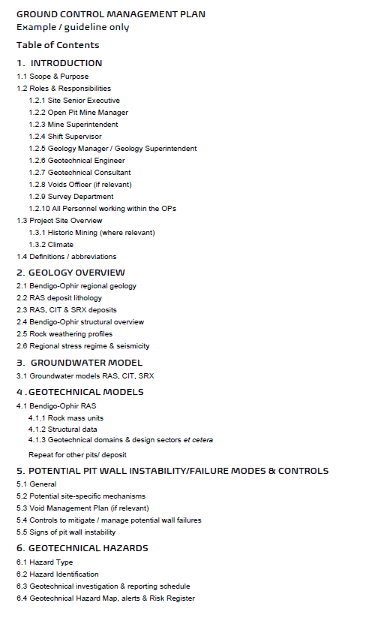
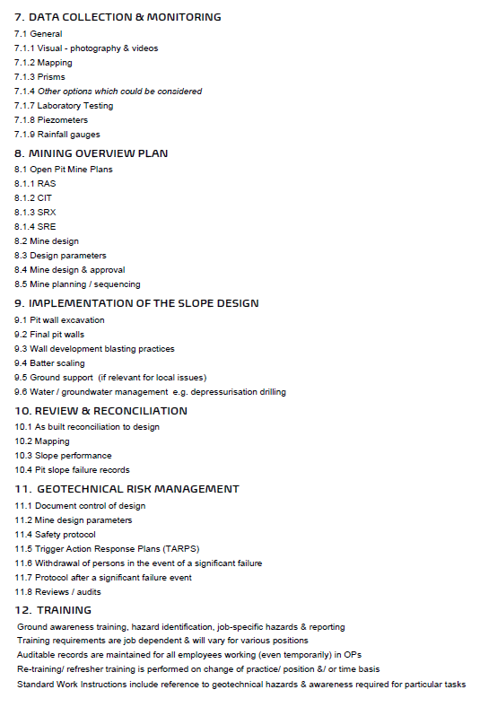
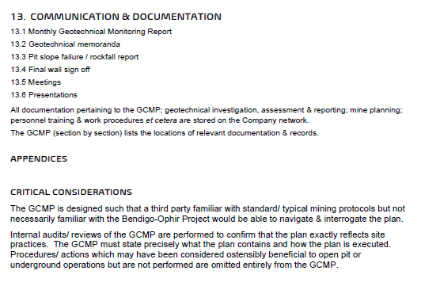
Attachment Y – Shepherds TSF Subsurface Drain Layout Plan
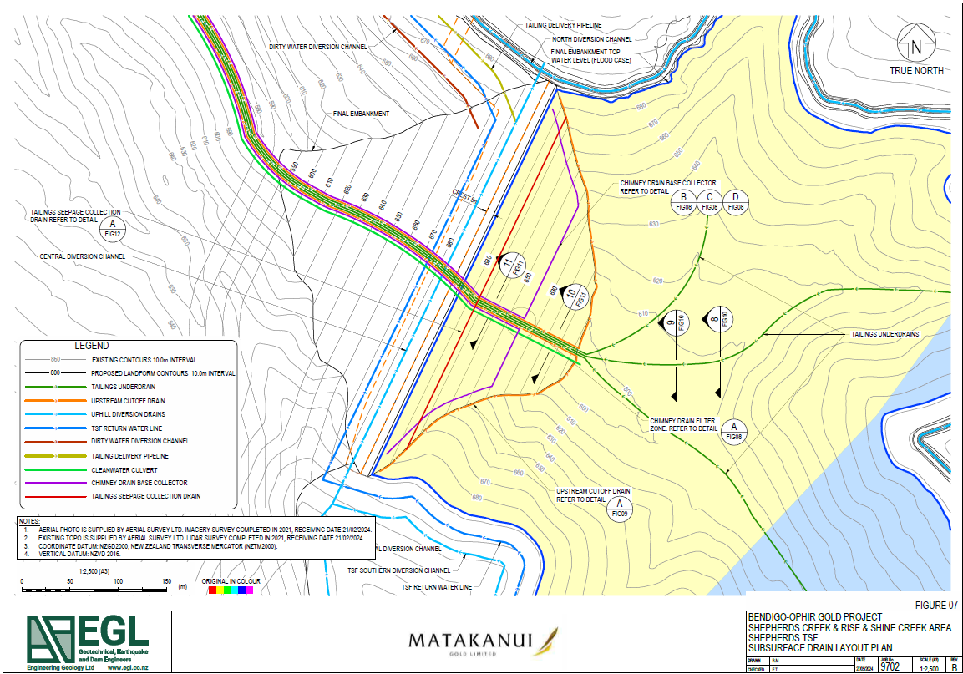
Attachment 1 - Water Monitoring Locations
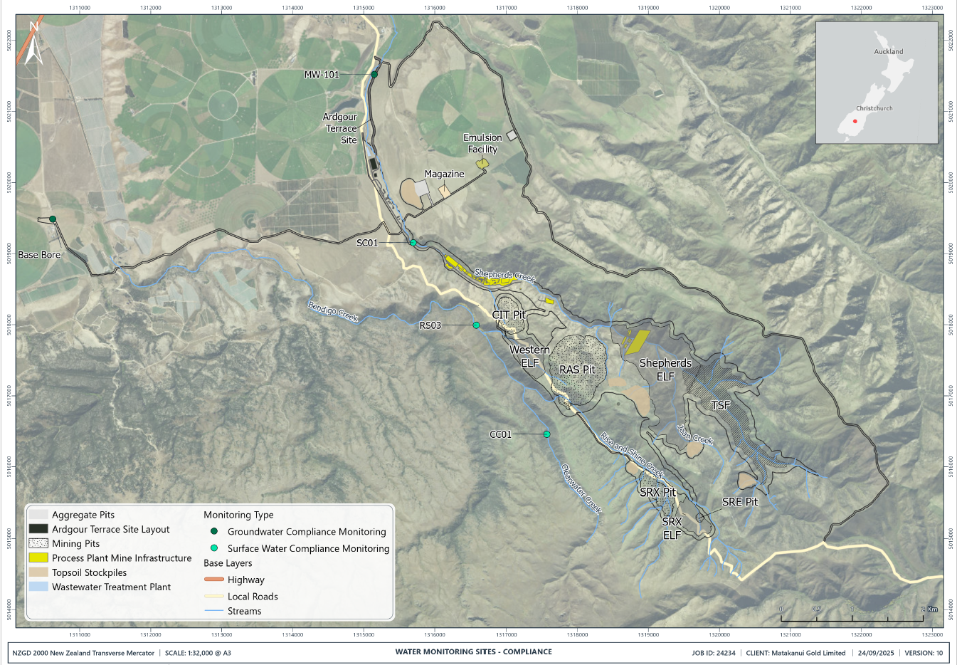
Attachment 2 - Surface Water Compliance Parameters and Limits
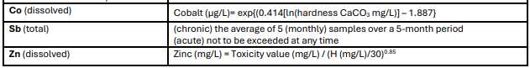
PARAMETER  (units are mg/L unless stated otherwise) | SURFACE WATER  Recommended compliance limit(s)
pH (unitless) | 6.5 - 9.0
Ammoniacal-nitrogen (NH3-N) | ≤0.24 (annual median)  <0.4 (annual 95th %)  See Appendix A for adjustments
Nitrate-nitrogen (NO3-N) | <2.4 (annual median)  <3.5 (annual 95th %)
Cyanide (CN) | 0.011 (un-ionised HCN, measured as [CN], ANZG 2018)  See Appendix A for adjustments
Sulfate (SO₄) | - If hardness is <100 mg/L (CaCO₃), the sulfate compliance limit = 500 mg/L.  - If chloride is <5 mg/L, the sulfate compliance limit = 500 mg/L  - If the hardness is 100–500 mg/L AND if chloride is 5–<25 mg/L, the sulfate compliance limit is (in mg/L):  [-57.478 + 5.79*(hardness mg/L CaCO₃) + 54.163*(chloride mg/L)] * 0.65  - If hardness is between 100 and 500 mg/L AND if chloride is between ≥25 and ≤500 mg/L, the sulfate limit is (in mg/L):  [1276.7+5.508*(hardness mg/L CaCO₃) +1.457*(chloride mg/L)] * 0.65  A minimum of 12 samples must be collected over any rolling 12-month period.  For compliance limits in A to D, no more than 20% of samples collected over a rolling 12-month period may exceed the relevant compliance limit.  - An acute compliance limit = 1,000 mg/L averaged over 4 days and not to be exceeded more than once in a one-year period, OR in more than 10% of samples over a one-year period.
Aluminium (Al) (dissolved) | ≤0.08
Antimony (Sb) (total) | 0.074 (chronic)  0.250 (acute)  See below
Arsenic (As(V)) (dissolved) | ≤0.042
Cadmium (Cd) (dissolved) | ≤0.0004  See below for adjustment algorithm
Chromium (Cr) (dissolved) | ≤0.0033 (CrIII)  ≤0.006 (CrVI)  See below for adjustment algorithm
Cobalt (Co) (dissolved) | 0.001 (chronic)  0.11 (acute, not to exceed)  See below for adjustment algorithm
Copper (Cu) (dissolved) | ≤0.0018
Molybdenum (dissolved) | ≤0.034
Zinc (Zn) (dissolved) | 0.015  See below for adjustment algorithm
Adjustments
Cd (dissolved) | HMTV = TV (H/30)^{0.89}, where hardness-modified trigger value (HMTV) = (µg/L), trigger value (TV) (µg/L) at a hardness of 30 mg/L as CaCO₃; H, measured hardness (mg/L as CaCO₃) of a fresh surface water.
Cr (dissolved) | HMTV = TV (H/30)^{0.82}, where hardness-modified trigger value (HMTV) = (µg/L), trigger value (TV) (µg/L) at a hardness of 30 mg/L as CaCO₃; H, measured hardness (mg/L as CaCO₃) of a fresh surface water.
Co (dissolved) | Cobalt (µg/L)= exp{(0.414[ln(hardness CaCO₃ mg/L)] – 1.887}
Sb (total) | (chronic) the average of 5 (monthly) samples over a 5-month period  (acute) not to be exceeded at any time
Zn (dissolved) | HMTV = TV (H/30)^{0.85}, where hardness-modified trigger value (HMTV) = (µg/L), trigger value (TV) (µg/L) at a hardness of 30 mg/L as CaCO₃; H, measured hardness (mg/L as CaCO₃) of a fresh surface water.

Attachment 3 - Groundwater Compliance Parameters and Limits
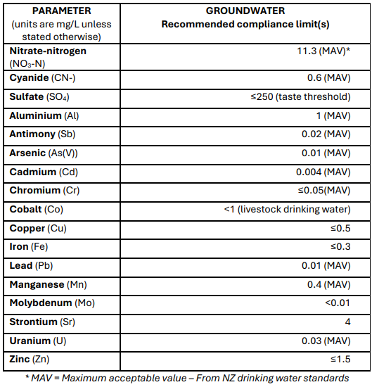

Attachment Z
