GOLDEN BAR PIT AND WASTE ROCK STACK

COMPLIANCE AND MONITORING SCHEDULE

**GENERAL PROVISIONS**

* 1. This schedule describes monitoring and sampling required pursuant to consent numbers RM24.184.18, RM24.184.23, RM24.184.28 and RM24.184.29 in addition to any monitoring specified in those consents.
  2. The design of all monitoring and sampling programmes shall be to the satisfaction of the Consent Authority. Where the consent to which the monitoring programme relates directs that an Operations and Management Plan shall be prepared, then the monitoring programme shall be incorporated into that plan.
  3. The parameters analysed, site locations and frequency of sampling shall be reviewed as part of the annual review of the management plan for the consent(s) to which this monitoring relates. New parameters, sites and frequencies may be approved by the Consent Authority under an application by the consent holder for a change of conditions for monitoring made pursuant to Section 127 of the Act.
  4. All sampling procedures, including collection, transportation of samples and laboratory analyses undertaken in accordance with this consent must be performed to IANZ registered standards, or otherwise as specifically approved by the Consent Authority.
  5. Reporting shall be quarterly unless specified otherwise. A quarterly consolidated report containing all sampling and monitoring results shall be submitted to the Consent Authority within one month of the end of the quarter being reported. This report shall highlight any particular features arising from monitoring and sampling and shall provide appropriate commentary on such features.
  6. Where a monitoring location is destroyed, engulfed, made redundant or unusable for any other reason, the consent holder shall, in consultation with the Consent Authority:

1. discuss and determine whether an alternative monitoring location is required and if so where it should be located; and
2. assign a timeframe for establishment of the new monitoring location.

**REPORTING OF NON-COMPLIANCE**

Any non-compliance with any compliance criteria shall be reported to the Consent Authority within 24 hours of the non-compliance first being detected.

**COMPLIANCE CRITERIA**

This following describes the compliance criteria pursuant to consent numbers RM24.184.18, RM24.184.23, RM24.184.28 and RM24.184.29.

|  |  |  |
| --- | --- | --- |
| **(a)** | **Narrative Standard for Receiving Waters** |  |

The waters of the North Branch of the Waikouaiti River, Murphys Creek, Golden Bar Creek, shall at all times be free of contaminants attributable to mineral processing and associated activities in concentrations which adversely affect directly or indirectly water uses or which adversely affect humans, animals, plants and/or aquatic life.

|  |  |  |
| --- | --- | --- |
| **(b)** | **Numerical Compliance Criteria** |  |

|  |  |
| --- | --- |
| ***(i)*** | ***Golden Bar Creek – (GB02)*** |

Surface water within Golden Bar Creek at GB02 (NZTM 1407089 4967911) shall not exceed the following water quality compliance criteria (where the metals standards are all soluble determinations), unless evidence can be provided that the level of a parameter is either naturally occurring or unrelated to mining activities:

|  |  |
| --- | --- |
| **Constituent** | **Standard (g/m3)** |
| Arsenic | 0.15 |
| CyanideWAD | 0.1 |
| Copper a | 0.009 |
| Iron | 1.0 |
| Lead a | 0.0025 |
| Zinc a  Sulphate | 0.12  1,000 |
| pH (range) | 6.0 - 9.5 |
| Nitrate Nitrogen (mg/L as an annual median) | = <2.4 |
| Nitrate Nitrogen (mg/L as 95th percentile) | <3.5 |

|  |  |  |
| --- | --- | --- |
| ***(ii)*** | ***Murphys Creek Compliance – (MC02)*** |  |

Surface water within Murphys Creek at MC02 (NZTM 1405418 4966923) shall not exceed the following water quality compliance criteria (where the metals standards are all soluble determinations), unless evidence can be provided that the level of a parameter is either naturally occurring or unrelated to mining activities:

|  |  |
| --- | --- |
| **Constituent** | **Standard (g/m3)** |
| Arsenic | 0.15 |
| CyanideWAD | 0.1 |
| Copper a | 0.009 |
| Iron | 1.0 |
| Lead a | 0.0025 |
| Zinc a  Sulphate | 0.12  1,000 |
| pH (range) | 6.0 - 9.5 |
| Nitrate Nitrogen (mg/L as an annual median) | = <2.4 |
| Nitrate Nitrogen (mg/L as 95th percentile) | <3.5 |

|  |  |  |
| --- | --- | --- |
| ***(iii)*** | ***North Branch Waikouaiti River Compliance Point 2 – (NB03)*** |  |

Surface water within the North Branch of the Waikouaiti River at NB03 (NZTM 1405803 4964562) shall not exceed the following water quality compliance criteria (where the metals standards are all soluble determinations), unless evidence can be provided that the level of a parameter is either naturally occurring or unrelated to mining activities:

|  |  |
| --- | --- |
| **Constituent** | **Standard (g/m3)** |
| Arsenic | 0.01 |
| CyanideWAD | 0.1 |
| Copper a | 0.009 |
| Iron | 0.2 |
| Lead a | 0.0025 |
| Zinc a  Sulphate | 0.12  250 |
| pH (range) | 6.0 - 9.5 |
| Nitrate Nitrogen (mg/L as an annual median) | = <2.4 |
| Nitrate Nitrogen (mg/L as 95th percentile) | <3.5 |

a Note: Copper, lead and zinc standards shall be hardness related limits in accordance with the following. Values given in the tables above assume a hardness of 100 g/m3 CaCO3.

Copper Limit (g/m3) = 0.96.e0.8545[ln (hardness)] - 1.702

1000

Lead Limit (g/m3) = (1.46203 – [ln(hardness)(0.145712)].e1.273[ln (hardness)] - 4.705

1000

Zinc Limit (g/m3) = = 0.986.e0.8473[ln (hardness)] + 0.884

1000

**(v) Waste Rock – ANC/MPA Ratio**

The acid neutralising capacity to maximum potential acidity (ANC:MPA) ratio, as referred to in California Administrative Code Article 7, 1992, shall be greater than 3:1 in rock discharged into the Waste Rock Stack.

**MONITORING**

1. **Surface Waters**

The consent holder shall collect monthly representative water samples from the following surface water sites (as shown on Figure 1):

1. Murphys Creek at MC02 (NZTM 1405418 4966923)
2. Clydesdale Creek at GB01 (NZTM 1405780 4968827)
3. Golden Bar Creek at GB02 (NZTM 1407089 4967911)
4. Golden Bar Creek at NB01 at (NZTM 1405830 4964619)
5. North Branch Waikouaiti River at NB02 (NZTM 1405805 4964676)
6. North Branch Waikouaiti River at NB03 (NZTM 1405803 4964562)

Surface water sampling shall occur in accordance with the following sampling schedule:

|  |  |  |
| --- | --- | --- |
| **Sampling Group** | **Sites** | **Schedule** |
| 1 | MC02, GB01 | Sites within the same sampling group must be sampled on the same day. |
| 2 | GB02, NB01 NB02, NB03 |

Samples shall be analysed for the following parameters:

|  |  |
| --- | --- |
| **Constituent** | **Monthly** |
| Major cations:  calcium  magnesium  potassium  sodium | ✓  ✓  ✓  ✓ |
| Major anions:  bicarbonate  carbonate  chloride  sulphate  pH | ✓  ✓  ✓  ✓  ✓ |
| Conductivity | ✓ |
| Arsenic | ✓ |
| Copper  Iron | ✓  ✓ |
| Lead  Zinc  Cyanide (WAD) | ✓  ✓  ✓ |

With the prior written approval of the Consent Authority, the consent holder may reduce the frequency of monitoring or the number of contaminants being monitoring in accordance with the table above where it is shown that maintenance of the original monitoring programme is not required. The Consent Authority may, by notice in writing at any time, require the consent holder to resume the monitoring programme as set out in the table above.

1. **Pit Water Quality**

The consent holder shall collect representative samples of water from the Golden Bar Pit Sump. Samples shall be analysed for the following parameters at the following intervals:

|  |  |  |
| --- | --- | --- |
| **Constituent** | **Quarterly** | **Annually** |
| pH | ✓ |  |
| Conductivity | ✓ |  |
| Arsenic | ✓ |  |
| Iron | ✓ |  |
| Sulphate | ✓ |  |
| Copper |  | ✓ |
| Lead  Total Inorganic Nitrogen |  | ✓  ✓ |

1. **Silt Ponds**

The consent holder shall collect representative samples of water from Clydesdale Silt Pond. Samples shall be analysed for the following parameters at the following intervals:

|  |  |  |
| --- | --- | --- |
| **Constituent** | **Quarterly** | **Annually** |
| pH | ✓ |  |
| Conductivity | ✓ |  |
| Arsenic | ✓ |  |
| Iron | ✓ |  |
| Sulphate | ✓ |  |
| Copper |  | ✓ |
| Lead  Total Inorganic Nitrogen |  | ✓  ✓ |
|  |  | | | |  |

1. **Surrounding Groundwater**
2. **Phreatic Surface**

The consent holder shall monitor the groundwater level in the surrounding groundwater bores at quarterly intervals.

The water level(s) shall be recorded prior to sampling.

1. **Surrounding Groundwater Bores**

Surrounding groundwater bores shall be those located at (as shown on Figure 2):

1. [*To be confirmed*]

The consent holder shall obtain representative samples of groundwater from the surrounding groundwater bores. Samples shall be analysed for the following parameters at the following intervals:

|  |  |  |
| --- | --- | --- |
| **Constituent** | **Quarterly** | **Annually** |
| Major cations:  calcium  magnesium  potassium  sodium | ✓  ✓  ✓  ✓ |  |
| Major anions:  bicarbonate  carbonate  chloride  sulphate  pH | ✓  ✓  ✓  ✓  ✓ |  |
| Conductivity | ✓ |  |
| Copper  Iron |  | ✓  ✓ |
| Lead  Total Inorganic Nitrogen  Arsenic |  | ✓  ✓  ✓  ✓ |

**(iv) Waste Rock ANC/MPA Ratio**

The consent holder shall, at monthly intervals collect representative samples of waste rock from the Golden Bar Waste Rock Stack.

**(v) Aquatic Biological Monitoring**

The consent holder shall engage a suitably qualified and experienced freshwater biologist to design and undertake an aquatic biological monitoring programme.

Biological monitoring shall be undertaken at the following sites (as shown on the attached Figure 3):

* Golden Bar Creek at GB02 (NZTM 1407089 4967911)
* Murphys Creek at MC02 (NZTM 1405418 4966923)

Note: Site names in parentheses relate to the original aquatic monitoring programme.

Monitoring of macro-invertebrates and periphyton shall be carried out at each of the sites on one occasion during each of the following periods each year:

* December to February inclusive;
* March to May inclusive;
* June to August inclusive; and
* September to November inclusive.

(unless there are insufficient flows to support any significant aquatic community). A flow reading shall be completed on each monitoring occasion.

An annual electric fishing survey shall be carried out at each of the sites (unless there are insufficient flows) during the period 1 February to 31 March inclusive. A flow reading shall be completed at each site. Within six months of the exercise of any of the consents to which this schedule is attached, a standard electric fish surveying method shall be developed in consultation with the Consent Authority and documented. This method shall be followed for every subsequent fish survey undertaken in accordance with this schedule.

All aquatic biology monitoring shall be undertaken during low or stable flows.

Components to be Monitored

1. Benthic macro-invertebrates - the taxonomic composition and abundances shall be monitored at all sites.
2. Fish - the taxonomic composition and abundances of fish shall be monitored by an electric-fishing survey at each of the sites.
3. Benthic Algae - a qualitative assessment of the height and percentage cover of dominant species of benthic algae shall be made at all sites.

**Figure 1 – Surface Water Quality Compliance Monitoring Sites in the**

**Murphys Creek and North Branch Waikouaiti River catchments**

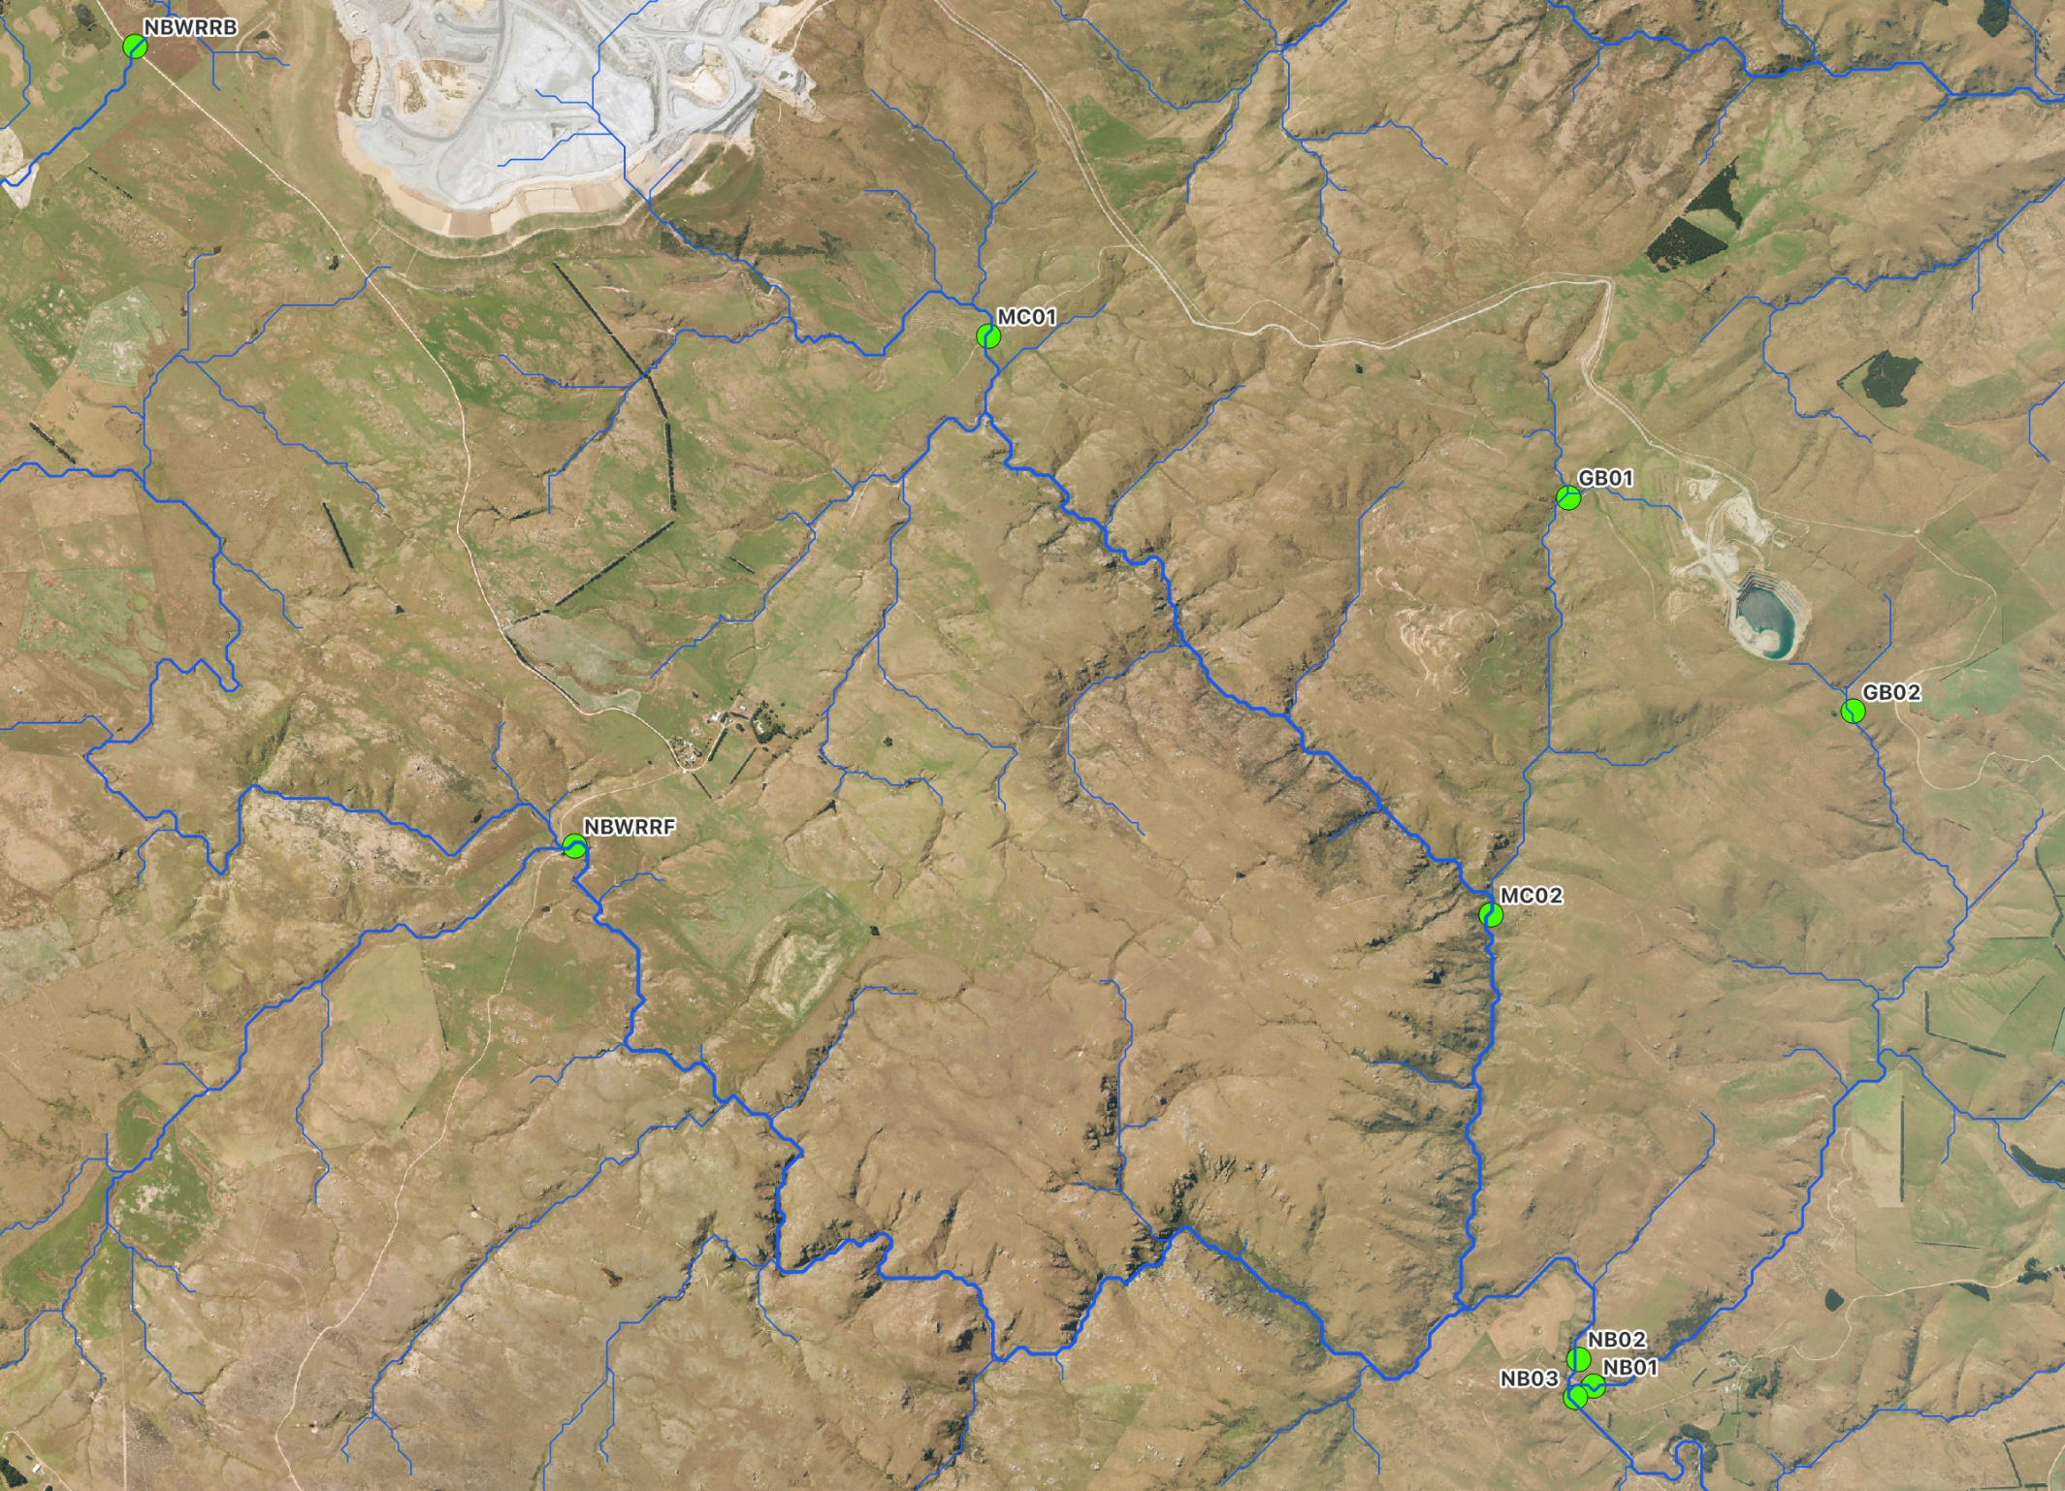

**Figure 2 – Surrounding Groundwater Monitoring Sites**

**[*To be confirmed*]**

**Figure 3 - Aquatic Biological Monitoring Sites**

