Bendigo-Ophir Gold Project

Proposed consents and Conditions For resource consents within the jurisdiction of the Otago Regional Council

Notes: All of the following consents are subject to compliance with:
- the Common Conditions between the Central Otago District Council and the Otago Regional Council in Schedule One; and
- the General Conditions in Schedule Two which apply to all Otago Regional Council consents.
Particular controls, limits, management of effects and monitoring required associated with the activities the subject of the consents below are controlled by way of the conditions in Schedules One and Two noted above. On that basis, and to avoid unnecessary repetition, most of the following consents have relatively few individual conditions.

The ‘comment’ column has been provided for guidance and interpretation purposes only and is not proposed to form part of the consent conditions.

Cross references to other conditions are highlighted in yellow wash for ease of finding and checking the accuracy of those cross references when the conditions are finalised. In some instances, a short description of the condition being cross referenced is also provided in square brackets.

Section 9 Permits
CONSENT TYPE AND ACTIVITY AUTHORISED | RMA S9 | A Land Use Consent to undertake earthworks, soil disturbance and vegetation clearance activities within the Project Site shown on Plan 1 - Project Overview Plan annexed as part of Attachment 1 – Plans to the Common Conditions for the purpose of mining development, mining operations, maintenance and ancillary activities, including locations within, or within a 10m or 100m setback from, natural inland wetlands within the catchments of Shepherds Creek, Rise and Shine Creek and an unnamed tributary of Clearwater Creek that result in, or will likely result in, the complete or partial drainage of all or part of a wetland.
TERM | 35 years
LAPSE PERIOD | 10 years

 | Condition | Comment
Schedule One – Common Conditions Which Apply to All Otago Regional Council and Central Otago District Council Consents
1 | The Consent Holder must comply with the Common Conditions in Schedule One (which apply to all of the consents for the BOGP within the jurisdiction of the Central Otago District Council and the Otago Regional Council) to the extent relevant to the management of activities authorised by this consent. | The Common Conditions in Schedule One include the requirement to implement the Erosion and Sediment Control Management Plan as well as the preparation and certification of Site-specific Erosion and Sediment Control Plans.  The Common Conditions also control the effects and direct the required mitigation of effects.
Schedule Two – General Conditions Which Apply to All Otago Regional Council Consents
2 | The Consent Holder must comply with the General Conditions in Schedule Two (which apply to all of the consents for the BOGP within the jurisdiction of the Otago Regional Council) to the extent relevant to the activities authorised by this consent.

CONSENT TYPE AND ACTIVITY AUTHORISED | RMA S9 | A Land Use Consent to drill bores and holes associated with mineral exploration, geotechnical investigations, establishment of underground mine declines and drives to access and mine an ore body, blasting, and dewatering activities and for the establishment of groundwater production and monitoring bores / piezometers within the area shown on Plan 2 – BOGP Consent Area annexed as part of Attachment 1 – Plans to the Common Conditions.
TERM | 35 years
LAPSE PERIOD | 10 years

 | Condition | Comment
Schedule One – Common Conditions Which Apply to All Otago Regional Council and Central Otago District Council Consents
1 | The Consent Holder must comply with the Common Conditions in Schedule One (which apply to all of the consents for the BOGP within the jurisdiction of the Central Otago District Council and the Otago Regional Council) to the extent relevant to the management of activities authorised by this consent.
Schedule Two – General Conditions Which Apply to All Otago Regional Council Consents
2 | The Consent Holder must comply with the General Conditions in Schedule Two (which apply to all of the consents for the BOGP within the jurisdiction of the Otago Regional Council) to the extent relevant to the activities authorised by this consent.
General Requirements – Bendigo Aquifer Borefield
Advice Note: The following conditions apply to bores associated with the taking of groundwater from the Bendigo Aquifer. They do not apply to holes drilled for blasting, geotechnical dewatering and mineral exploration purposes.
3 | The Otago Regional Council must be notified in writing at least 10 working days in advance of the installation of each bore, piezometer and groundwater monitoring bore.
4 | The bore must be constructed and maintained so that it will not cause cross contamination between hydraulic units (aquifers) in any water (including groundwater).
5 | All openings to the bore must be sealed or screened to prevent the entry of foreign matter or contaminants. The ground immediately surrounding the top of the bore casing must be sealed and graded to drain surface water away from the bore.
6 | Upon completion of the bore, any wastes introduced to the bore during drilling and construction must be removed.
7 | If artesian conditions are encountered, a conductor casing must be grout sealed to ensure control of potential flowing artesian groundwater and to prevent instability of the ground at the bore head. Bore head completion must be such that groundwater leakage under flowing artesian pressures is prevented.
8 | Discharge of wastewater from bore installation into or onto the ground is permitted provided that only non-hazardous and non-toxic drilling fluids and/or foams are used as approved by Otago Regional Council. Drilling must be undertaken in such a manner that there is no discharge of grease or oil, and wastewater does not directly enter surface water.
9 | Bores that are no longer operational must be decommissioned to prevent contamination, by grouting and capping.
10 | The Consent Holder must submit to the Otago Regional Council, as part of the Annual Monitoring and Compliance Report, a report which contains:  - A log for each bore drilled during that calendar year. Each log must show:  - The location of the bore; in NZTM2000 coordinates  - Date of completion;  - Duration of drilling;  - Depth and diameter of the bore;  - The method of drilling;  - Full construction details;  - The subsurface geology;  - Development information; and  - Installed instrumentation (pumps, loggers, flow meters, etc.).  - A list of any decommissioned bores, including their logs.

Section 13 Permits
CONSENT TYPE AND ACTIVITY AUTHORISED | RMA S13 | A Land Use Consent to place, use, maintain, upgrade and remove structures in the beds of watercourses and in natural inland wetlands within the catchments of Shepherds Creek, Rise and Shine Creek and an unnamed tributary of Clearwater Creek associated with mine development, operation, maintenance and closure activities within the Project Site shown on Plan 1 - Project Overview Plan annexed as part of Attachment 1 – Plans to the Common Conditions (Schedule One).
TERM | 35 years
LAPSE PERIOD | 10 years

 | Condition | Comment
Schedule One – Common Conditions Which Apply to All Otago Regional Council and Central Otago District Council Consents
1 | The Consent Holder must comply with the Common Conditions in Schedule One (which apply to all of the consents for the BOGP within the jurisdiction of the Central Otago District Council and the Otago Regional Council) to the extent relevant to the management of activities authorised by this consent.
Schedule Two – General Conditions Which Apply to All Otago Regional Council Consents
2 | The Consent Holder must comply with the General Conditions in Schedule Two (which apply to all of the consents for the BOGP within the jurisdiction of the Otago Regional Council) to the extent relevant to the activities authorised by this consent.
Design and Performance Requirements – all instream structures
NEW 1 | No less than 15 days prior to the commencement of works for the installation of any instream structure, the Consent Holder must advise Otago Regional Council of the intended works commencement date.  The pre-start notification for the culvert to be placed in Rise and Shine Creek must include detailed design plans, prepared by a suitably qualified and experienced person, that demonstrate compliance with Condition 3 of this consent. | ORC comment:  Condition added to ensure ORC is aware of exercise of this consent to enable any auditing or monitoring required to ensure compliance with conditions.  The culvert design should be peer-reviewed by a SQEP and provided to ORC for records.
3 | The culvert in the Rise and Shine Creek must be located in general accordance with the plan in Attachment 1 to this consent and be constructed and operated to convey the runoff resulting from at least a 5% Annual Exceedance Probability (AEP) design storm for all durations.
4 | The Consent Holder must ensure that the area of disturbance during placement/construction of all instream structures is kept to a practical minimum, and is undertaken in accordance with a site-specific erosion and sediment control plan as required by Condition 2 of the Scheule 2 General Conditions which apply to all of the Resource Consents within the jurisdiction of the Otago Regional Council. | ORC comment:  Changes for enforceability and to recognise that structures other than the single culvert in Rise and Shine Creek will be installed e.g. coffer dams in Shepherds Creek to effect the diversion of flows and infilling of Shepherds Valley, or flow monitoring devices.
NEW 2 | The Consent Holder must undertake routine monitoring and maintenance of the culvert (once placed), as detailed below:  - Engage a suitably qualified and experienced person to visually inspect each culvert within five days of any event that may cause damage that could affect the culvert’s stability, provision for fish passage, ability to convey the design flows, or cause erosion or scour;  - If any of the visual inspections in clause (a) identify that the culvert is damaged, undertake maintenance works as soon as practicable to remedy the issues identified.  - Following any maintenance works undertaken in accordance with part (b) of this condition, provide to the Consent Holder an updated version of the information relating to the structure as set out in Condition 5 of this consent. | ORC comment:  Reasonable monitoring and maintenance requirements to ensure culvert continues to convey design flows, does not lead to erosion or scour, and that fish passage does not deteriorate over time (as required by NES-FW regulation 69).
5 | Consent Holder must provide the Otago Regional Council with the information required under Regulations 62(3) and 63(3) of the Resource Management (National Environmental Standards for Freshwater) Regulations 2020 (NESF) no more than 20 working days following completion of the installation of the culvert within Rise and Shine Creek. | ORC comment:  Changes to correctly reflect the requirements of the regulations. Also serves as a completion of works notification to ORC.

Attachment 1 – Location of Culvert in the Rise and Shine Creek

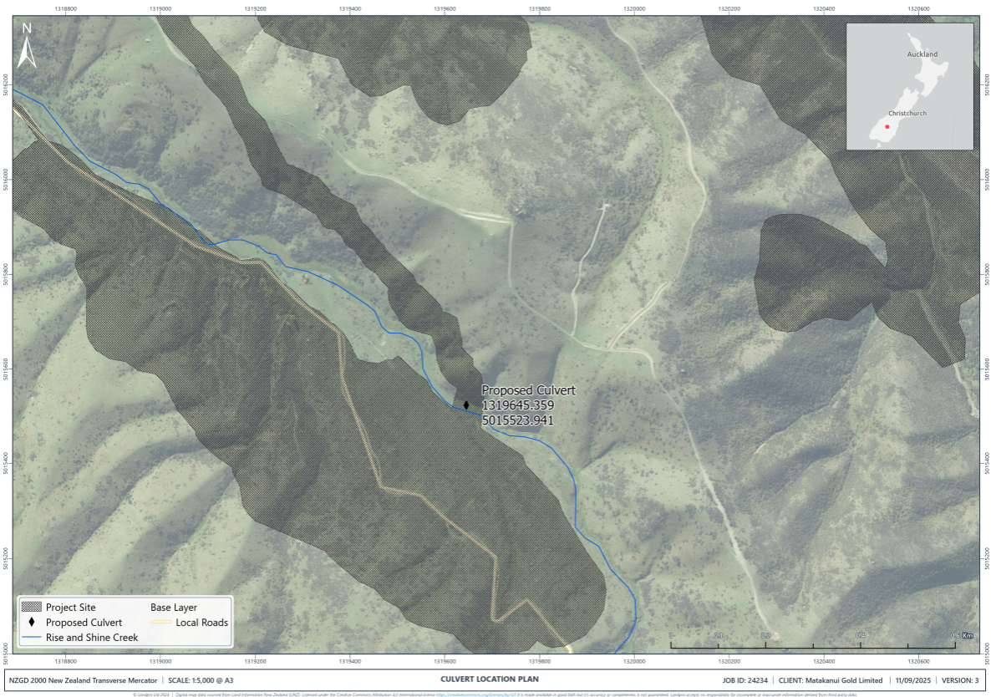

CONSENT TYPE AND ACTIVITY AUTHORISED | RMA S13 | A Land Use Consent to alter, disturb and reclaim the beds of the Shepherds Creek, Rise and Shine Creek, Jean Creek and an unnamed tributary of Clearwater Creek, including associated tributaries and connected natural inland wetlands within the Project Site shown on Plan 1 - Project Overview Plan annexed as part of Attachment 1 – Plans to the Common Conditions (Schedule One).
TERM | 35 years
LAPSE PERIOD | 10 years

 | Condition | Comment
Schedule One – Common Conditions Which Apply to All Otago Regional Council and Central Otago District Council Consents
1 | The Consent Holder must comply with the Common Conditions in Schedule One (which apply to all of the consents for the BOGP within the jurisdiction of the Central Otago District Council and the Otago Regional Council) to the extent relevant to the management of activities authorised by this consent.
Schedule Two – General Conditions Which Apply to All Otago Regional Council Consents
2 | The Consent Holder must comply with the General Conditions in Schedule Two (which apply to all of the consents for the BOGP within the jurisdiction of the Otago Regional Council) to the extent relevant to the activities authorised by this consent. | The General Conditions in Schedule Two include a requirement for an Aquatic Ecology Management Plan which sets out how stream diversions are to be undertaken.

Section 14 Permits
CONSENT TYPE AND ACTIVITY AUTHORISED | RMA S14 | A Water Permit to:  - Take and use groundwater from the Bendigo Aquifer for the purposes of supplying water to support all mining construction, operation, maintenance and ancillary activities (including ecological rehabilitation and enhancement) and for augmenting flows within Shepherds Creek, Rise and Shine Creek and natural inland wetlands; and
- Take groundwater for dewatering purposes associated with open pit and underground mining operations;
within the Project Site shown on Plan 1 - Project Overview Plan and the BOGP Consent Area shown on Plan 2 – BOGP Consent Area annexed as part of Attachment 1 – Plans to the Common Conditions (Schedule One).
TERM | 35 years
LAPSE PERIOD | 10 years

 | Condition | Comment
Schedule One – Common Conditions Which Apply to All Otago Regional Council and Central Otago District Council Consents
1 | The Consent Holder must comply with the Common Conditions in Schedule One (which apply to all of the consents for the BOGP within the jurisdiction of the Central Otago District Council and the Otago Regional Council) to the extent relevant to the management of activities authorised by this consent.
Schedule Two – General Conditions Which Apply to All Otago Regional Council Consents
2 | The Consent Holder must comply with the General Conditions in Schedule Two (which apply to all of the consents for the BOGP within the jurisdiction of the Otago Regional Council) to the extent relevant to the activities authorised by this consent.
Water Take from the Bendigo Aquifer
3 | The maximum instantaneous rate of take from the production bores must not exceed 110 litres per second. | ORC comment:  This condition needs to include a maximum daily rate of extraction that reflects the maximum efficient daily volume.  Further information is needed to determine whether 110 L/s is required for 35 years.
NEW 3 | Prior to commencing operational use of the bores, the Consent Holder must  - undertake an aquifer test in accordance with the Otago Regional Council Aquifer Test Guidelines, as detailed in Attachment 1;  - engage a suitably qualified and experienced hydrogeologist to interpret the aquifer test data to predict the extent of drawdown at other bores (that are used for abstractive purposes) within the aquifer; and  - if the findings of (b) are that the drawdown is of a magnitude that is likely to interfere with that bore operation, the Consent Holder must implement the process described in Condition NEW 3. | ORC comment:  This condition would benefit from expert (hydrogeologist / groundwater scientist) input
4 | The Consent Holder must install a system to measure on a continuous basis the volume taken via the bore. The system must have a reliable calibration and must be maintained to an accuracy of +/- 5 percent. The water use must be measured at the point of take. | ORC comment:  If the applicant does not want to / cannot measure the water use at the point of take then an exemption would need to be applied for under Regulation 10 of the Resource Management (Measuring and Reporting of Water Takes) Regulations 2010.
5 | Within one month of installation of the system required by Condition 4, the Consent Holder must provide Otago Regional Council:  - a copy of any relevant manufacturer calibration certificate; and  - evidence from a suitably qualified person showing that the system required by condition 4 is verified as accurate to +/- 5 percent.
6 | The Consent Holder must engage a suitably qualified person to undertake additional verification of the accuracy of the system required by Condition 4:  - at the written request of Otago Regional Council; and  - at a frequency of no less than five yearly from the date of the first verification required by Condition 4; and  - to the satisfaction of Otago Regional Council.  Evidence documenting each additional verification must be forwarded to Otago Regional Council within one month of the verification being completed.
7 | The Consent Holder must telemeter – via a telemetry system developed after liaison with Otago Regional Council to ensure that the telemetry system is compatible with Otago Regional Council telemetry system standards and data protocols - continuous 15-minute values of take volume (in units of cubic metres). The data must be reported once daily to Otago Regional Council via the telemetry system and there must be 96 values per parameter per daily report. When no groundwater is being taken the data must specify the take volume as zero.
NEW 4 | - The Consent Holder must ensure the full operation of the water measuring system and telemetry unit at all times during the exercise of this consent. All malfunctions of the water measuring or telemetry unit during the exercise of this consent must be reported to the Otago Regional Council within 5 working days of observation. Appropriate repairs must be performed within 30 working days of observation of the malfunction or within a timeframe agreed with the Otago Regional Council.  - Once the malfunction has been remedied, a copy of the calibration record, Water Measuring Device Verification form (Form RS1) with photographic evidence and any non-transferred data must be submitted to the Otago Regional Council within 5 working days of the completion of repairs. Photographs must be in colour and be no smaller than 200 X 150 millimetres in size and be in JPEG form.  Advice Note: The water meter, data logger and telemetry unit should be safely accessible by the Otago Regional Council and its contractors at all times. The Water Measuring Device Verification Form and Calibration Form are available on the Otago Regional Council’s website. | ORC comment:  Requirement to maintain system
8 | The Consent Holder must submit a report in electronic spreadsheet format, as part of the Annual Monitoring and Compliance Report required by Common Condition C12 (Schedule One), to Otago Regional Council by 30 November each year that contains daily values – actual or estimated, as the case may be, and for the immediately preceding year ending 31 August – of the volume of groundwater taken pursuant to this consent.  For the avoidance of doubt, only the take volume data telemetered pursuant to Condition 7 can be used to assess compliance with Condition 3. | ORC is not sure that this condition is necessary. Daily provision of water use records in 15-minute increments is sufficient to understand rate and volume of abstraction.  If the Applicant wants to include this condition, ORC does not consider that there is any value in providing an ‘estimated’ volume when actual measured volume data is collected as per Condition 7.
NEW 5 | In the event that the cumulative drawdown assessment required by Condition NEW 1 indicates a vulnerability to project-induced drawdown and difficulties to the pumping operation of a surrounding water bore, the Consent Holder must:  - Undertake a follow-up consultation and a request to investigate remedial actions with the affected bore owner;  - Undertake investigations which may include:  - Detailed measurements of the affected bore(s):  - Reference to bore log, bore construction and drilling records  - Pulling the pump unit and making essential measurements, and  - Measuring the internal decline in bore water level during pumping of the subject bore (specific capacity or step rate testing)  - Investigate potential remedial actions, which may include:  - Lowering of the pump unit within the original bore (where feasible)  - Re-drilling of the bore and setting a deeper, larger diameter screen so as to allow lower setting of the pump unit and higher screen loss efficiency  - Provision of a replacement, high reliability water supply of equal or better water quality in the case of elevated risk of bore water supply interruption that cannot be remedied by any other means; and  - Consult the affected bore owner and implement the most practicable and effective remedial option to ensure that the bore owner can continue to access and abstract water at the rate and volume that that they were abstracting prior to the commencement of the BOGP, taking into account any preferences of the bore owner about the solution to be implemented.  Advice note: if the affected bore owner is abstracting water in accordance with a permitted activity rule that has a fixed limit, the Consent Holder must ensure that the full volume allowed for by that permitted activity rule is accessible by the affected bore owner. | ORC comment:  ORC’s intention for this condition is captured, but the wording could be revised to ensure that it is unambiguous and enforceable.

CONSENT TYPE AND ACTIVITY AUTHORISED | RMA S14 | A Water Permit to dam, divert, take and use surface water from the Shepherds Creek, Rise and Shine Creek, Jean Creek and associated tributaries and an unnamed tributary of Clearwater Creek, and from the RAS, CIT, SRX and SRE Open Pits, for the purposes of mining construction, operation, maintenance and ancillary activities including locations within, or within a 10m or 100m setback from, natural inland wetlands that results in, or is likely to result in, the complete or partial drainage of all or part of the wetland within the Project Site shown on Plan 1 - Project Overview Plan annexed as part of Attachment 1 – Plans to the Common Conditions (Schedule One)..
TERM | 35 years
LAPSE PERIOD | 10 years

 | Condition | Comment
Schedule One – Common Conditions Which Apply to All Otago Regional Council and Central Otago District Council Consents
1 | The Consent Holder must comply with the Common Conditions in Schedule One (which apply to all of the consents for the BOGP within the jurisdiction of the Central Otago District Council and the Otago Regional Council) to the extent relevant to the management of activities authorised by this consent.
Schedule Two – General Conditions Which Apply to All Otago Regional Council Consents
2 | The Consent Holder must comply with the General Conditions in Schedule Two (which apply to all of the consents for the BOGP within the jurisdiction of the Otago Regional Council) to the extent relevant to the activities authorised by this consent. | The General Conditions in Schedule Two include a requirement for a Freshwater Ecology Management and Monitoring Plan which sets out how stream diversions are to be undertaken.

Section 15 Permits
CONSENT TYPE AND ACTIVITY AUTHORISED | RMA S15 | A Discharge Permit to discharge water and associated contaminants to water associated with:  - The discharge of water (taken from the Bendigo Aquifer) into Shepherds Creek and Rise and Shine Creek for the purpose of augmenting flows;  - The discharge of water and associated contaminants from the SRX Open Pit, SRX ELF and portions of the Western ELF and RAS Open Pit into Rise and Shine Creek;  - The discharge of water and associated contaminants from the Western ELF into an unnamed tributary of Clearwater Creek;  - The discharge of water and associated contaminants from the Shepherds Silt Pond to Shepherds Creek (in the form of the Shepherds Stream Diversion);  - The discharge of water and contaminants from erosion and sediment control structures in accordance with certified Site-Specific Erosion and Sediment Control Plans; and  - The discharge of treated mine water from the water treatment plant (or passive treatment system) and associated contaminants to Shepherds Creek during mine closure;  within the Project Site shown on Plan 1 - Project Overview Plan annexed as part of Attachment 1 – Plans to the Common Conditions (Schedule One).
TERM | 35 years
LAPSE PERIOD | 10 years

 | Condition | Comment
Schedule One – Common Conditions Which Apply to All Otago Regional Council and Central Otago District Council Consents
1 | The Consent Holder must comply with the Common Conditions in Schedule One (which apply to all of the consents for the BOGP within the jurisdiction of the Central Otago District Council and the Otago Regional Council) to the extent relevant to the management of activities authorised by this consent. | The Common Conditions in Schedule One include the requirement to implement the Erosion and Sediment Control Management Plan as well as the preparation and certification of Site-specific Erosion and Sediment Control Plans.
Schedule Two – General Conditions Which Apply to All Otago Regional Council Consents
2 | The Consent Holder must comply with the General Conditions in Schedule Two (which apply to all of the consents for the BOGP within the jurisdiction of the Otago Regional Council) to the extent relevant to the activities authorised by this consent. | The General Conditions in Schedule Two include a requirement for a Water Management Plan which includes water quality discharge limits and associated monitoring requirements.
Augmentation of Flows in the Shepherds Creek and Rise and Shine Creek
3 | - Within six months of the commencement of these consents the Consent Holder must maintain the mean monthly surface water flow rates at Rise and Shine Creek and Shepherds Creek at the estimated pre-mining influenced mean monthly surface flow rates detailed below by augmenting flows in Shepherds Creek and Rise and Shine Creek using water taken from the Bendigo Aquifer under Water Permit [insert consent number].  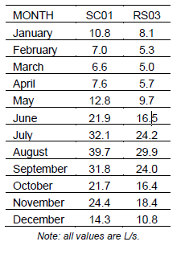  - Augmentation must be undertaken in general accordance with the Flow Augmentation Strategy Memorandum prepared by Hydro Geochem Group Limited dated 20 October 2025 (HGG 2025b), included in the application as Report B.43. Subject to adjustments as described in condition 3c below, the augmentation shall require as a minimum surface water augmentation at the following rates:  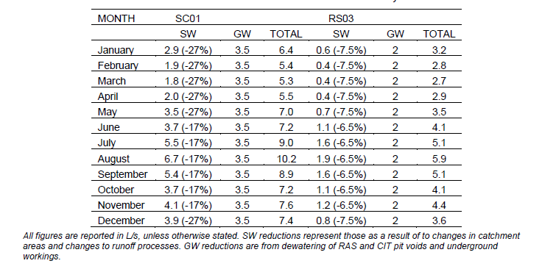  - Subject to adjustments as described in condition 3f. below, the Consent Holder must increase augmentation flow rates in addition to those required in Condition 3b above upon the commencement of the below identified mine domains:  - For Shepherds Creek (SC01):  - 10.0 L/s for all months once the RAS Underground commences; and  - 1.7 L/s for all months once the CIT Pit commences.  - For Clearwater/Rise and Shine Creek (RS03):  - 15.3 L/s for all months once the SRX Pit commences.  - The discharge sites for augmented flows must be located upstream of all water takes associated with the BOGP, in general accordance with Sites 1, 2, and 3 as described in HGG 2026, and as shown in Attachment 1 of this consent.  - The Consent Holder will implement the following performance monitoring methods to ensure the rate of augmentation is appropriate to ensure surface creek flows are maintained at the estimated pre-mining influenced mean monthly surface flow rates identified in Condition 3a above:  - Record volumes and flow rates of water discharged for flow augmentation.  - Install automated creek flow gauging sites at:  - RS03 on Clearwater Creek to monitor flow changes in Clearwater Creek and Rise and Shine Creek.  - An additional site on Clearwater Creek upstream of the confluence with Rise and Shine Creek to distinguish natural flow variability from mine influence.  - SC01 to monitor flow changes in Shepherds Creek.  - Install groundwater level monitoring at selected locations to provide early warning of creek flow losses due to drawdown.  - If performance monitoring data shows augmentation flow rates are too high, or too low, relative the minimum mean monthly flow rates specified in Condition 3a above, the Consent Holder must adjust the augmentation flow rates accordingly in order to maintain the mean monthly surface flow rates at Rise and Shine Creek and Shepherds Creek as set out in Condition 3a above.  - This condition does not apply in the post-closure phase once performance monitoring demonstrates creek flows exceed pre-mining flows without any augmentation. | ORC comment:  Reference to application document numbering for ease of compliance officer reference.
 | Active Water Treatment Plant
NEW 6 | Within [timeframe] the Consent Holder must commission [water treatment studies] which utilise representative mine impacted waters to inform the detailed design of the active water treatment plant.  The water treatment studies must include, at a minimum:  - Bench testing - simulation of each step in the treatment train;  - Scaled-up testing / pilot trials as necessary to ensure the process works at the required scale;  - Must be informed by the results of the cover system trials required by Condition X;and  - Must be informed by the water load and balance modelling required by conditions to ensure that the active water treatment plant is designed with adequate capacity.  The Consent Holder must include the results (and any associated analysis or interpretation) of all testing that is carried out in accordance with this condition, and details on work proposed for the next 12 months within the Annual Work Programme required by Condition C11 of the Common Conditions which apply to all of the resource consents within the jurisdiction of the Central Otago District Council and Otago Regional Council. | ORC comment:  This is a placeholder condition which should require all required testing require to inform the detailed design of the active WTP.  Expert input to this condition is suggested.
NEW 7 | No less than three months prior to commencing construction of the active water treatment plant, the Consent Holder must submit to Otago Regional Council for certification the detailed design for the active water treatment plant.  Criteria – must be prepared by a SQEP, must be informed by outcomes of testing condition | ORC comment:  Placeholder condition – intention is that ORC will certify the detailed design due to the critical importance of this WTP.  Expert input to this condition is suggested.
NEW 8 | The Consent Holder must construct and commission the active water treatment plant no less than [12 months] prior to the earlier of:  - Cessation of active mining; or  - Development of a water surplus condition, as predicted by water balancing monitoring. | ORC comment:  Another placeholder condition to ensure that the WTP is commissioned before it is needed  Expert input to this condition is suggested.
NEW 9 | The water discharged from the active water treatment plant must at all times comply with the surface water compliance limits shown in Attachment 2 of the General Conditions which apply to all of the resource consents within the jurisdiction of the Otago Regional Council. | ORC comment:  End-of-pipe limits should achieve the surface water quality compliance limits to avoid reliance on dilution water from Shepherds Creek to achieve water quality standard at SC01
NEW 10 | Sampling frequency  Testing requirements (methods, IANZ-accredited lab, etc.)  Reporting  Adaptive management / contingency actions if results are unexpected | ORC comment:  Placeholder condition
NEW 11 | Maintenance requirements for plant | ORC comment:  Placeholder condition to specify maintenance requirements and reporting requiremetns

Attachment 1 – Flow augmentation sites

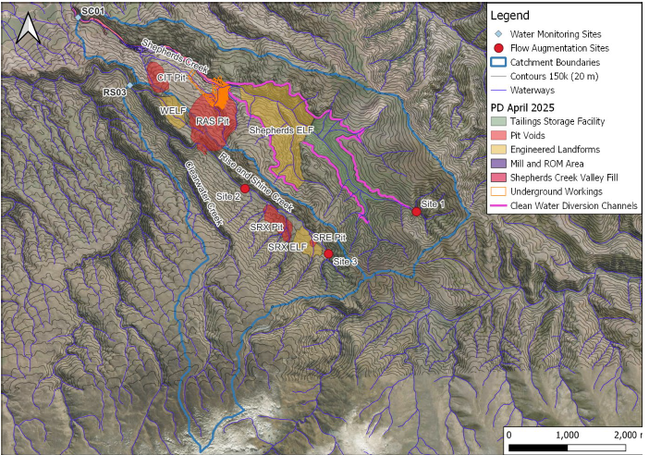
CONSENT TYPE AND ACTIVITY AUTHORISED | RMA S15 | A Discharge Permit to discharge water and contaminants to land, including in circumstances where contaminants may enter water, associated with:  - The discharge of soil and rock material to create the various topsoil and brown rock stockpiles, the TSF, various ELFs, the Shepherds Service Corridor, haul roads, erosion and sediment control structures and treatment devices, two aggregate pits, and to support the construction of any ancillary mining development, operation and maintenance activities;  - The discharge of water and contaminants, via seepage or surface runoff, from topsoil and brown rock stockpiles, the TSF, various ELFs, the Shepherds Service Corridor, haul roads, erosion and sediment control structures and treatment devices, two aggregate pits and other ancillary mining development, operation and maintenance activities;  - The discharge of water and contaminants from erosion and sediment control structures in accordance with certified Site-Specific Erosion and Sediment Control Plans;  - The discharge of water and contaminants within a 100 m setback from natural inland wetlands, including where the discharge may enter a wetland and change its water level range or hydrological function; and  - The discharge of water for dust suppression purposes;  within the Project Site shown on Plan 1 - Project Overview Plan annexed as part of Attachment 1 – Plans to the Common Conditions (Schedule One).
TERM | 35 years
LAPSE PERIOD | 10 years

 | Condition | Comment
Schedule One – Common Conditions Which Apply to All Otago Regional Council and Central Otago District Council Consents
1 | The Consent Holder must comply with the Common Conditions in Schedule One (which apply to all of the consents for the BOGP within the jurisdiction of the Central Otago District Council and the Otago Regional Council) to the extent relevant to the management of activities authorised by this consent. | The Common Conditions in Schedule One include the requirement to implement the Erosion and Sediment Control Management Plan as well as the preparation and certification of Site-specific Erosion and Sediment Control Plans.
Schedule Two – General Conditions Which Apply to All Otago Regional Council Consents
2 | The Consent Holder must comply with the General Conditions in Schedule Two (which apply to all of the consents for the BOGP within the jurisdiction of the Otago Regional Council) to the extent relevant to the activities authorised by this consent. | The General Conditions in Schedule Two include a requirement for a Water Management Plan which includes water quality discharge limits and associated monitoring requirements.
General
3 | All roofs and potentially small, impervious car parking areas within the Project Site associated with offices and administration buildings and vehicle servicing and repair areas shall be connected to a reticulated stormwater system. | Permitted activity condition in the Regional Water Plan.

CONSENT TYPE AND ACTIVITY AUTHORISED | RMA S15 | A Discharge Permit to discharge contaminants into or onto land, including in circumstances where it may enter water, associated with the discharge of tailings into the TSF within the Project Site shown on Plan 1 - Project Overview Plan annexed as part of Attachment 1 – Plans to the Common Conditions (Schedule One).
TERM | 35 years
LAPSE PERIOD | 10 years

 | Condition | Comment
Schedule One – Common Conditions Which Apply to All Otago Regional Council and Central Otago District Council Consents
1 | The Consent Holder must comply with the Common Conditions in Schedule One (which apply to all of the consents for the BOGP within the jurisdiction of the Central Otago District Council and the Otago Regional Council) to the extent relevant to the management of activities authorised by this consent.
Schedule Two – General Conditions Which Apply to All Otago Regional Council Consents
2 | The Consent Holder must comply with the General Conditions in Schedule Two (which apply to all of the consents for the BOGP within the jurisdiction of the Otago Regional Council) to the extent relevant to the activities authorised by this consent. | The General Conditions in Schedule Two include a requirement to implement a certified Tailings Management Plan.

CONSENT TYPE AND ACTIVITY AUTHORISED | RMA S15 | A Discharge Permit to discharge contaminants to air from the crushing and screening of aggregates, and mining operations (including mineral extraction and processing activities) associated with the BOGP within the Project Site shown on Plan 1 - Project Overview Plan annexed as part of Attachment 1 – Plans to the Common Conditions (Schedule One).
TERM | 35 years
LAPSE PERIOD | 10 years

 | Condition | Comment
Schedule One – Common Conditions Which Apply to All Otago Regional Council and Central Otago District Council Consents
1 | The Consent Holder must comply with the Common Conditions in Schedule One (which apply to all of the consents for the BOGP within the jurisdiction of the Central Otago District Council and the Otago Regional Council) to the extent relevant to the management of activities authorised by this consent.
Schedule Two – General Conditions Which Apply to All Otago Regional Council Consents
2 | The Consent Holder must comply with the General Conditions in Schedule Two (which apply to all of the consents for the BOGP within the jurisdiction of the Otago Regional Council) to the extent relevant to the activities authorised by this consent. | The General Conditions in Schedule Two include a requirement to implement the certified Air Quality Management Plan.

Attachment 1 – Otago Regional Council Aquifer Test Guidelines

To be attached to final version:
https://www.orc.govt.nz/media/14441/aquifer-test-guidelines.pdf
SCHEDULE ONE
BENDIGO-OPHIR GOLD PROJECT - COMMON CONDITIONS WHICH APPLY TO ALL OF THE RESOURCE CONSENTS WITHIN THE JURISDICTION OF THE CENTRAL OTAGO DISTRICT COUNCIL AND OTAGO REGIONAL COUNCIL

SCHEDULE TWO
BENDIGO-OPHIR GOLD PROJECT - GENERAL CONDITIONS WHICH APPLY TO ALL OF THE RESOURCE CONSENTS WITHIN THE JURISDICTION OF THE OTAGO REGIONAL COUNCIL

