Residential Lead Paint Contaminated Soil Management Plan

INTRODUCTION

Purpose
The Resource Management (National Environmental Standard for Assessing and Managing Contaminants in Soil to Protect Human Health) Regulations 2011 (the NESCS) provides a framework for identifying and managing contaminated soils.
Lead-based paint is a well-known source of potential soil contamination, particularly for older homes with weatherboard or roughcast cladding.
This Residential Lead Paint Contaminated Soil Management Plan (CSMP) outlines controls for minor renovation/redevelopment of residential properties to manage risks to human health from soils potentially impacted by lead-based paint.

Health Effects of Lead
Lead can be harmful to health (Te Whatu Ora - Health New Zealand, 2024). In adults, it may cause high blood pressure, heart problems, and kidney damage. Children are especially vulnerable; children absorb lead more easily than adults do, and their developing brains and nervous systems are highly sensitive. Contact with lead or a lead contaminated environment can therefore lead to learning, behavioural, and growth problems. Pregnant individuals can transfer lead stored in their bones to the foetus during pregnancy, increasing risks of miscarriage, premature birth, low birth weight, and long-term developmental issues. Even very small amounts of lead can cause lasting harm, making prevention critical.

When CSMP Applies
This CSMP can only be used on sites with confirmed or suspected lead-based paint contamination under the following specific conditions:
- Lead is the only contaminant of concern, due to pre-1945 buildings (e.g., houses and ancillary buildings larger than 35m²) being present on the site. This CSMP does not address the presence or potential presence of other contaminants, including but not limited to asbestos.
- Suspected contamination is limited to within 2m (herein called the ‘halo’) of existing pre-1945 building/s.
- Demolition has not yet occurred, and any demolition proposed as part of the project must:
- Be small scale (involve a maximum combined length of 10 m of the external building walls for each project), and
- Adhere to the responsible demolition guidelines outlined in this CSMP.
- Duration of the soil disturbance must not exceed 2 months.
- Soil must be reinstated to an erosion resistant state within one month of completing the works.
- If disturbed soil from within the halo is to be kept on site after completion of the works, then the extent of the deposit location must be recorded on a site plan and submitted to DCC (rcmonitoring@dcc.govt.nz).
- If there is a structure in place designed to contain contaminated soil (such as, but not limited to, a deck or terrace), the integrity of the structure must not be compromised.
- No change of use (as defined in the NESCS) or subdivision is proposed, i.e., site must remain residential.
Use of this CSMP outside of the above conditions will not comply with regulatory requirements, and a site specific CSMP would then be required.

Further Considerations
- Erosion and sediment control are not covered by this CSMP and must be addressed separately in accordance with relevant regulatory requirements and best practice guidelines.
- An asbestos survey is not required under the NESCS, but it is strongly recommended. See the Health and Safety at Work (Asbestos) Regulations 2016 and WorkSafe New Zealand’s Approved Code of Practice for requirements when working with asbestos.

Contamination Area - Building Halo Soils
This CSMP helps guide safe soil handling and/or removal, so that the site can be used safely in the future. The main concern is that people—especially children—could come into contact with this soil during gardening, digging, or construction work. To manage this risk, the contaminated soil needs to be safely removed or managed before any further work happens.
The diagram below shows a typical residential site and the areas of lead contaminated soil on a pre-1945 painted building:
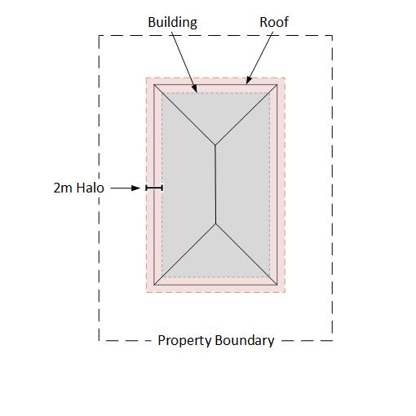
Figure 1: Typical residential site showing the potentially contaminated halo soils.
The halo has been identified as being contaminated (potentially or confirmed) caused by old lead-based paint flaking or washing off buildings over time. The contamination is:
- Only found in the top layer of soil (up to 300 mm deep),
- Only present within 2 m of existing buildings (like houses, garages, or sheds),
- Not found in deeper soil or further away from buildings, and
- Not mixed with other contaminants (like asbestos, hydrocarbons, or heavy metals).

SITE MANAGEMENT PROCEDURES

Responsibilities
The following procedures must be followed by everyone carrying out works on the site.

Health & Safety Measures
- Avoid direct contact with soil.
- Wear personal protective equipment (PPE): long sleeves/pants, safety footwear, gloves, safety glasses, hi-vis vest, hard hat (if near machinery), N95/P2 respirator mask if dust may be generated.
- No eating, drinking, smoking or vaping in the work area.
- Wash hands and face prior to breaks and when leaving site.

Paint Removal and Building Demolition Guidelines
If part demolition is proposed, demolition of any painted surfaces (cladding, windows, etc.) should be completed prior to soil disposal whenever possible. The following guidelines should be followed during any demolition activities:
- Prevent unauthorised people and pets from entering the work area.
- Cover the ground with appropriate plastic sheeting a minimum of 3m in all directions where the demolition will occur.
- Close all windows and doors within 6 m of the demolition, including on upper storeys.
- Avoid working in high winds if possible.
- Don’t track dust out of the work area. Vacuum/wipe down shoes and tools prior to leaving the work area.
- If preparing an area of the existing dwelling for re-painting:
  - Use wet methods to remove old paint whenever possible.
  - Mist areas before sanding, scraping, drilling or cutting to minimise generating dust.
  - Do NOT sand the paint with dry sandpaper, use heat guns, or use power tools (unless equipped with high-efficiency particulate (HEPA) exhaust control).
  - Score paint with a utility knife before separating pieces.
  - If possible, pry and pull apart components instead of pounding or hammering.
  - Clean up the area at the end of each workday and at the end of the demolition.
  - Collect all paint chips and debris and seal in a heavy-duty bag.
  - Remove the protective sheeting. Mist the sheeting before folding it dirty side inward, and either tape shut or seal in heavy-duty bags.

Pre-Excavation Steps
- Contact one of the approved landfills for approval to send contaminated soil to the landfill and obtain a special waste application number. The following are authorised facilities in Dunedin:
  - Nash and Ross (formerly Burnside) Landfill (https://www.nashandross.co.nz/)
- Green Island Landfill (https://www.dunedin.govt.nz/services/rubbish-and-recycling/green-island-landfill-and-transfer-stations).
- Other options outside of the Dunedin City boundary may also be available
- Note: The landfill operator may require the soil to be tested for lead and potentially other contaminants before approving the soil for disposal. Samples may be collected before potentially contaminated soils are excavated or from stockpiled soils. Contact the landfill early for advice around testing requirements.
- If the earthworks contractor is unfamiliar with soil sampling/testing, engage a suitably qualified and experienced contaminated land practitioner.
- Cordon the work area and install erosion and sediment controls (e.g., silt fences, stormwater diversions, etc.).

Preventing Soil Spread
- Clean equipment, including wheelbarrows including the tyre/s, and excavator and truck wheels before leaving site.
- Use rumble strips or wheel wash stations.
- Limit vehicle movements across the site.

Dust Control
- Keep an eye on the weather forecast and conduct dusty operations (excavation etc.) during conditions that will not cause the spread of dust whenever possible.
- Have water available onsite for dust control.
- Apply water to work areas and stockpiles as needed to prevent dust generation without resulting in runoff from the site.

Excavation and Soil Handling
- Remove the top 300 mm of soil from the portion of the halo scheduled for disturbance.
- If soil is to be removed from the site, load soil directly into trucks for transport to one of the authorised facilities listed in section 2.4 of this CSMP. The load must be covered during transport.
- Disposal at alternative landfills/managed fills is not permitted unless a resource consent is obtained.
- Include the special waste application number issued by the landfill with each load.

Stockpiling Soil Onsite
- Avoid stockpiling if possible.
- If needed, place soil on a plastic liner or within a lined skip bin. If that isn’t possible, excavate the top 100 mm of soil beneath the stockpile once it has been removed and dispose off-site as potentially contaminated soil.
- Keep stockpiles bunded or covered to prevent runoff.
- Keep contaminated soil separated from other excavated soil.

Stormwater Management
- Keep an eye on the weather forecast (rain and wind), and do not conduct earthworks during periods of heavy rain and/or wind whenever possible.
- After heavy rain, check stormwater controls and repair them if needed.
- If rainwater collects in excavated areas, allow it to soak into the ground. Do not discharge to stormwater drains or sewers.

Unexpected Contamination Procedures
- If you find buried waste, stained soil, asbestos, or soil that smells like fuel or chemicals:
  - Stop work immediately and notify the site supervisor.
- A Suitably Qualified and Experienced Professional (SQEP) must inspect the area and take soil samples if needed.
- Tell DCC and/or Otago Regional Council.
- If the SQEP confirms contamination is significant:
- Stop work until a remediation plan is prepared and approved by the relevant council.
- This may require resource consent or a variation if consent already granted.
- If the contamination is not significant:
  - Store material in a sealed, bunded area or in sealed skip bins until tested and approved for disposal.
  - The SQEP will direct validation sampling after removal.
- Examples of potential contamination are shown below:
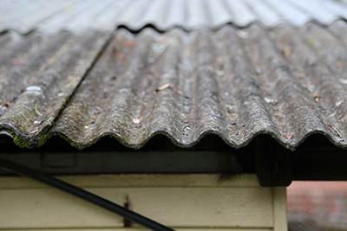 | 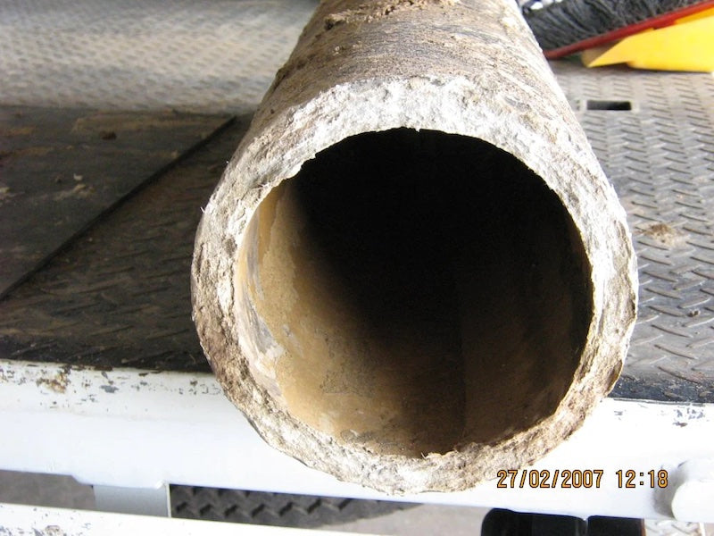
“Super Six” asbestos roof sheets | Asbestos containing cement pipe
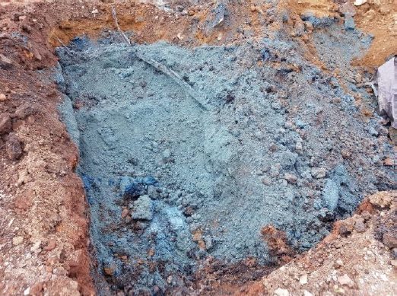 | 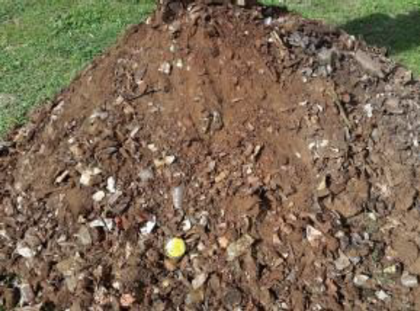
Unusual soil colour / odour, e.g. “billy blue” | Man made waste incorporated into soil

SITE SPECIFIC INFORMATION

Date of CSMP Preparation
click to insert date of preparation

Site Address
click to insert site address

Relevant Consent Numbers
click to insert any relevant building consent and/or resource consent numbers

Contacts
- Site Manager / Owner: click to insert site manager/owner name(s) and number(s)
- Earthworks Contractor: click to insert earthworks contractor name(s) and number(s)
- Otago Regional Council Pollution Hotline: 0800 800 033
- Dunedin City Council Contact: Resource Consent Monitoring team: rcmonitoring@dcc.govt.nz.
- Name of landfill contact (cross out those which do not apply):
- Nash and Ross (Burnside): 03 488 1146
- Green Island Landfill: 03 477 4000
- Other: if another landfill being used, click to insert other details
- Name & number of SQEP: click to insert SQEP name and number

Additional Information / Reports Provided
Information about HAIL and legacy lead from paint can be found here: https://www.dunedin.govt.nz/services/resource-consents/hail-and-lead-from-paint.
click to insert references to any relevant additional information or reports, these should be kept with the CSMP and be available on-site
Source: Te Whatu Ora – Health New Zealand. 2024. The Environmental Case Management of Lead-Exposed Persons: Guidelines for Public Health Officers. Wellington: Te Whatu Ora – Health New Zealand.

