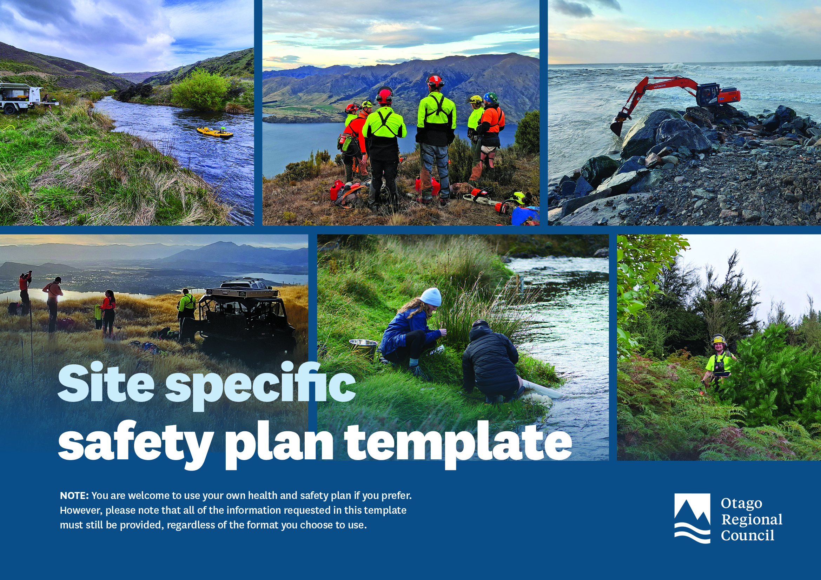

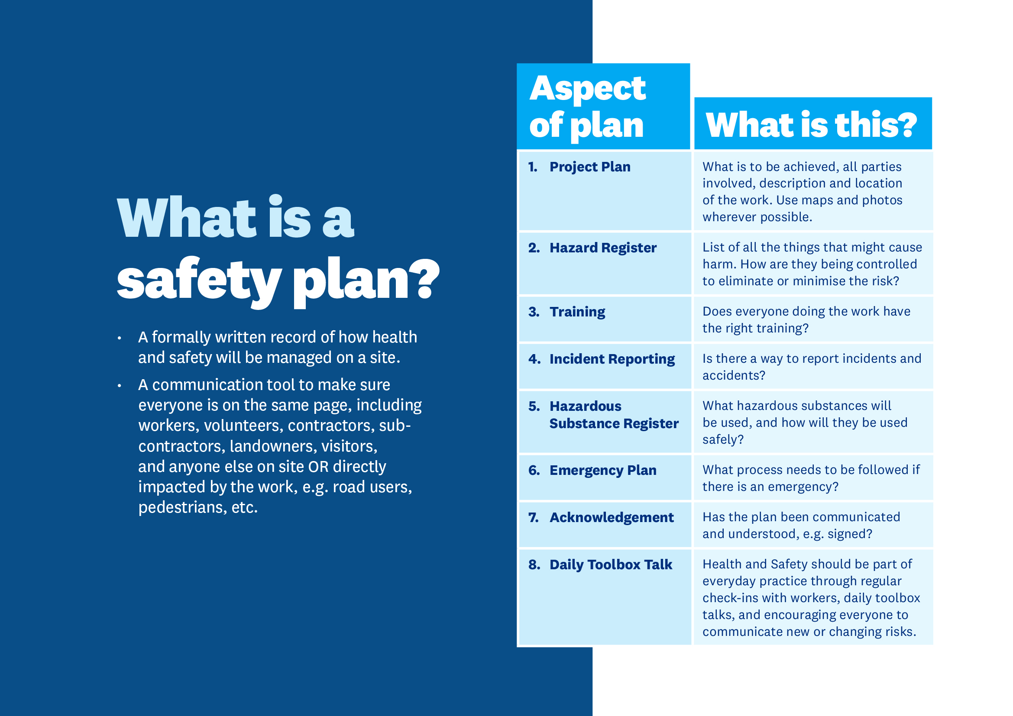

PROJECT PLAN

Project details
Project name
Location(s)
Add extra pages if needed for maps and photos.
Start and End dates
Organisation creating this plan
Project leader | Name:  Mobile:  Email:

Description of the project
Aim of the work

Number of people participating

Equipment to be used when/where and by whom?

Working days and times, e.g. Monday to Friday 9-5

Stakeholder contacts, e.g. subcontractors, landowners, government agencies
Trade Name / Agency Name  State your relationship to this project. | Contact Name | Contact phone and email

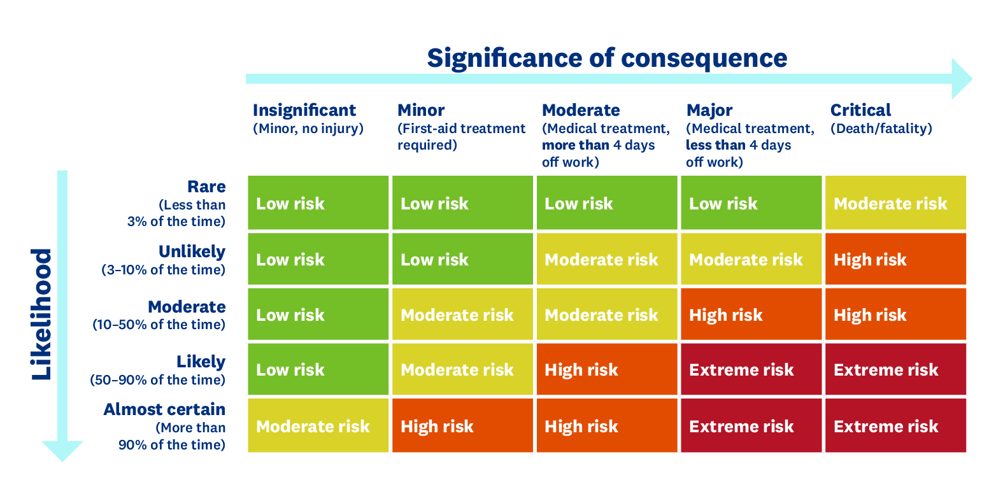
HAZARD REGISTER
What is the worst realistic outcome?
How likely is that worst outcome to happen?

- Tasks and associated hazards (list each task)
- Initial Risk - score without any health and safety controls?
- Controls – actions or equipment used to eliminate or minimise the risks?
- Residual Risk – new score with health and safety controls applied.
NOTE: Consequence rarely changes (other than PPE use), usually the likelihood is reduced.

 | Task  List each task needed to deliver the project outcome. | Hazards  How could undertaking the task on this specific site cause harm?  What type of harm could be done? | Initial  Risk | Controls  How are you removing or minimising the risk? | Residual  Risk
1
2
3
4
5
6
7
8

HAZARDOUS SUBSTANCE REGISTER

What hazardous substances will be used, and how will they be used safely?
Name of Substance | Volume held on site | Storage location and conditions | PPE requirements and controls for use | Safety Data Sheet provided
 |  |  |  | ☐
 |  |  |  | ☐
 |  |  |  | ☐
 |  |  |  | ☐

TRAINING

Does everyone doing the work have the right training?
Have you identified training or Standard Operating Procedures as controls in your hazards register?
Use the table below to record what training is relevant to this work. Record which workers have completed
this and check that the training has not expired.

 | Industry or NZQA evidence required for plant equipment / chainsaw and weed spraying
Worker’s name | Plant equipment  (evidence of license) | Powered hand-held equipment  Years of experience | Chainsaw  (e.g. U/S 6917) | Weed spraying (e.g. GrowSafe) | Off-road vehicle / ATV / Motorbike  (evidence of license) | Other | Worker’s signature
 | ☐ |  | ☐ | ☐ | ☐
 | ☐ |  | ☐ | ☐ | ☐
 | ☐ |  | ☐ | ☐ | ☐
 | ☐ |  | ☐ | ☐ | ☐
 | ☐ |  | ☐ | ☐ | ☐
 | ☐ |  | ☐ | ☐ | ☐
 | ☐ |  | ☐ | ☐ | ☐

Please describe how untrained or partially trained workers will be managed to ensure safety?
- Who are they? What activity needs to be supervised? Who is responsible for their supervision?

INCIDENT RESPONSE AND REPORTING

- If an incident occurs, the area must be made safe.
- If the incident is a WorkSafe notifiable event, WorkSafe must be notified immediately.
- If (2) applies, after the site is made safe, it must be ‘frozen’ awaiting WorkSafe inspection. Power down machinery and leave everything where it is. All staff on site must be recorded so that WorkSafe can talk to them later.
- No later than the next business day, report the incident to your ORC contact or email health.safety@orc.govt.nz

Stop Work Authority
All workers, contractors, sub-contractors, volunteers, and others involved in a work activity have the right and responsibility to stop work if conditions are unsafe.
If any team member identifies an immediate, uncontrolled risk of injury or illness, they must seek to resolve the issue without delay. If the risk cannot be immediately mitigated, the team member is authorised to stop work. This decision is binding on all affected contractors and sub-contractors.
Upon stopping work, the team member must notify the Site Manager and/or the person or group that’s has engaged the work and request support in implementing corrective actions to ensure a safe resumption of work. The decision to resume work following corrective action must be made by the primary site controller.
The authority to stop work also applies in situations involving excessive work hours, adverse weather, fatigue, and stress.

Describe the process and instructions for workers to report incidents, accidents, near misses, and hazards.

NOTE: The report template or system access details of any electronic system reporting system must be included with this document.

EMERGENCY PLAN

The people working on site will communicate if there is an emergency by:

e.g. three blasts of a vehicle horn or air horn. Note: this may need to be adapted if site noise prevents the use of an audible alarm.

Evacuation Plan
Note: you will need a separate evacuation plan for each site you are working on. Include as a minimum:
- A safe and easily identified assembly point for all workers on site. Consider using a work vehicle or paddock gate.
- Turn off and make safe any mechanical or powered equipment.
- Ensure all hazardous substances are safely secured.
- Consider the weather implications and take appropriate action to make the site safe, e.g. securing material during high-wind events.
- How to move from the site to the assembly point in the safest possible manner.
- Staff are to be recorded at the assembly point to ensure everybody is safe.

Document the emergency plan here or add it to this document as a separate sheet.

Locations of key equipment
First Aid Kit(s) | Fire Extinguisher(s) | Other

Key Contacts
 | Name | Contact Phone Number
Site Manager
First Aider
Nearest medical facility
Nearest hospital
WorkSafe |  | 0800 030 040
Poison Centre |  | 0800 764 766

ACKNOWLEDGMENT — (To be signed by all parties working, controlling or owning the site)
☐ I have read, understood, and will follow this safety plan and any associated safety procedures
Name | Date | Employer | Signature

DAILY TOOLBOX TALK
Health and safety is an all day, everyday responsibility for everyone on site.
Regular check-ins and ongoing risk awareness help ensure that controls are working and that new risks are identified early.

Complete this toolbox talk daily with everyone on-site.
Date
Time
Location
Facilitator

Discuss
What are today’s work tasks?
What are the site conditions today?
What are the known hazards and controls?
Did we have any incidents, near misses, or hazards reported yesterday that we can learn from?
Is everyone feeling good and fit for work?
Does everyone have the tools, skills, and training to complete their work safely today?

Anything else to discuss?

Attendance
Name | Date | Employer | Signature

