OTAGO REGIONAL COUNCIL
NAVIGATION SAFETY BYLAW
2026

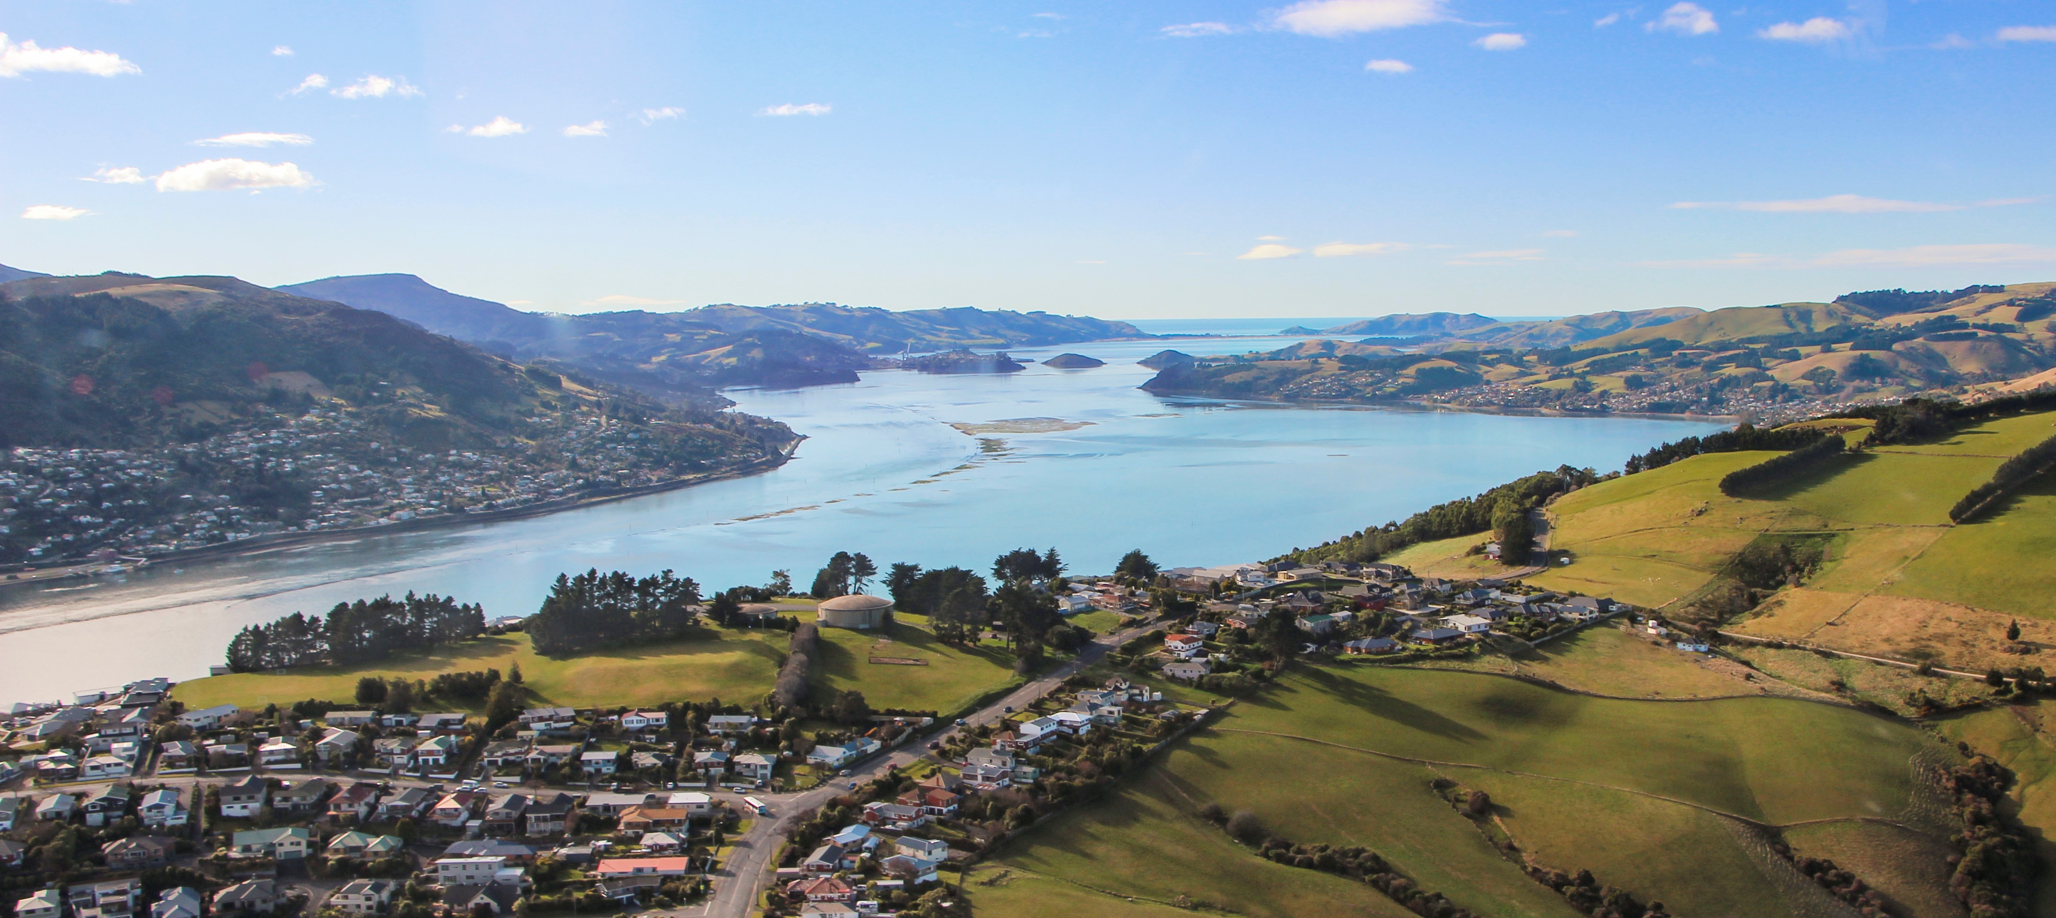

That pursuant to section 33M of the Maritime Transport Act 1994 and the Local Government Act 2002, the Otago Regional Council resolves that the Navigation Safety Bylaw 2026 adopted on TBC, is hereby confirmed, and shall come into force TBC
The common seal of the Otago Regional Council was hereunto affixed on TBC in the presence of:

__________________________
Councillor

__________________________
Councillor

Table of Contents

Part 1. Preliminary Provisions 1
1. Title and commencement 1
2. Application 1
3. Interpretation 1-7
4. Revocation 7
Part 2. General Navigation Safety Requirements 8
5. Notification of maritime accidents, incidents and mishaps 8
6. Person in charge of the vessel 8
7. Carriage of personal flotation devices 8
8. Exemptions to the compulsory carriage of personal flotation devices 9
9. Wearing of personal flotation devices on vessels 10
10. Minimum age for operating power-driven vessels 10

11. Navigation on rivers 10
12. Fishing or swimming or diving around landing places 11
13. Obstructions that may constitute or become a danger to maritime safety 11
14. Vessels to be seaworthy 11
15. Vessels to be identified 11-12
16. Navigational aids 12
Part 3. Speed Limits, Reserved Areas and Access Lanes 13
17. General speed limits 13
18. Special Speed Zone (SSZ) 14
19. Reserved Areas and Access Lanes 14
20. Water Skiing, Parasailing, Paragliding and Towing 15
21. Divers to Display Flag Alpha 16
22. Special events 16
23. Conduct near marine mammals 16
Part 4. Anchoring and Mooring 17
24. Anchoring 17
25. Vessels to be adequately secured 17
26. Moorings 17
Part 5. Special Controls on Activities in Otago Harbour 18
27. Communication requirements for vessels in the Otago Harbour Shipping Channel 18
28. Moving Prohibited Zone (MPZ) 18
29. Vessel movements in proximity to ships 18
30. Fishing in Otago Harbour Shipping Channel 19
Part 6. Special Provisions for Lake Dunstan Area 20
31. Lake Dunstan Reserved Areas 20
32. Lake Dunstan Area Speed Limits 21
Part 7. Maritime Safety Administrative Matters 21
33. Written approvals 21
34. Offences and penalties 22
Part 8. Appendices 22
Appendix A. Otago Region 23
Appendix B. Commercial Port Areas of Otago Harbour 24
Appendix C. Otago Harbour Shipping Channel 25
Appendix D. Lake Dunstan – Including Reserved Areas 26
Appendix E. Special Speed Zones for Otago Inland Waters 27-33
Appendix F. Halfway Islands Safety Zone 34
Appendix G. Oamaru Harbour 35
Appendix H Lake Waihola Reserved Areas and Access Lanes 36

- Preliminary Provisions
- Title and commencement
This Bylaw is the Otago Regional Council Navigation Safety Bylaw 2026.
This Bylaw comes into force onTBC
- Application
- This Bylaw applies to all waters in the Otago Region including the territorial sea and all inland waters apart from:
- The navigable waters in the Queenstown Lakes District Council area, which are administered by that council as shown in Appendix A.
- Interpretation
- In this Bylaw, unless the context otherwise requires:

“Act” means the Maritime Transport Act 1994.

“Council” means the Otago Regional Council.
“Commercial Port Area” means areas defined as a Coastal Development Area or a Coastal Harbourside Area in the Regional Coastal Plan for the Otago and Oamaru Harbours as shown in the maps in Appendix B and G.
“Competent Person” when used in relation to the inspection and/or maintenance of moorings means a person or organisation who has demonstrated to the satisfaction of the Harbourmaster that they are suitably experienced and/or qualified to undertake inspections and/or maintenance of moorings.

“Dunedin Wharves” means the Commercial Port Area of Otago Harbour at Dunedin located west of beacon 67.
“Halfway Islands Safety Zone” means the area identified in Appendix F.
“Harbour Area” means Otago Harbour or Oamaru Harbour.
“Harbour Control” means the Otago Harbour vessel traffic control centre operated by Port Otago Limited.
Explanatory note: Harbour Control is staffed at all times and may be contacted on VHF Channel 14. Alternative contact information for Harbour Control; Telephone: 472 9882; Email: harbourcontrol@portotago.co.nz.
“Harbourmaster” has the same meaning as in section 2 of the Act.

“Lake Waihola” means the lake area shown in Appendix H.
“Landing Place” means a wharf, jetty, dock, quay, landing, pile mooring, pier, pontoon, boat ramp, slipway or other facility, where vessels can be or may be moored, launched or retrieved, but does not include a mooring.
“Large Vessel” means any vessel 40 metres or greater in Length Overall, or 500 gross tonnage or greater. If a tug and tow or composite vessel, gross tonnage shall be the sum of gross tonnage for all of the connected vessels.

“Local Notice to Mariners” means a notice related to maritime safety in Otago which is available to the public from the Council website.

“Medium Vessel” means any vessel more than 15 metres but less than 40 metres in Length Overall and under 500 gross tonnage.

“Mooring Area” means an area, where vessel moorings may be placed, identified by the Council as a mooring area in the Regional Coastal Plan.
“Moving Prohibited Zone (MPZ)” means the space of water in the Otago Harbour Shipping Channel extending:
  - For a Large Vessel, 100 metres astern and 100 metres to each side of the vessel, and continued at such width to 1,000 metres ahead when that vessel is underway.
  - For a tug in attendance of a large vessel, 100 metres all around the tug, in addition to the MPZ around the large vessel.
“Navigable” means able to be navigated by a vessel on, through, over or under the water.
“Navigational Channel” means the Otago Harbour Shipping Channel, or the principal access to any other harbour area, or the principal navigational channel of an inland water.
“Oamaru Harbour” means the Commercial Port Area located at Oamaru as shown in Appendix G.
“Otago Harbour” means the area comprising all waters enclosed by a line from Trig at Heyward Point then bearing 20 degrees for three nautical miles then bearing 126 degrees for 1.75 nautical miles then bearing 200 degrees for 3 nautical miles to Howletts Point, as published in the New Zealand Gazette Vol II July 1930 p.2233 and p.2234.
“Otago Harbour Shipping Channel (OHSC)” means the marked channel extending through Otago Harbour from the Fairway Beacon at the Channel Entrance through the gap between the Halfway Islands (Goat Island and Quarantine Island) to a line extending due south of Beacon 67 at the Dunedin Wharves as shown in Appendix C.

“Owner”:
  - when used in relation to any vessel, has the same meaning as in the Act
- when used in relation to any landing place, means the person holding a coastal permit under the Resource Management Act 1991 for the landing place and shall include a lessee of the landing place
- when used in relation to Port Areas of Otago Harbour means Port Otago Limited
- when used in relation to Commercial Port Areas of Oamaru Harbour means the Waitaki District Council, or a port company established by the Waitaki District Council.
“Parasailing” “Parakiting” or “Paragliding” means any flying or gliding by use of a parachute or kite when being towed by a vessel

“Reserved Area” means an area declared as being reserved for a specified maritime safety purpose under Maritime Rules Part 91 or clause 19 of this Bylaw.
Explanatory note: For the avoidance of doubt the only reserved areas in the Otago Region having legal status are those authorised under this Bylaw. All reserved areas authorised by previous bylaws, rules, or regulations made under any act have been revoked by this bylaw (or a previous bylaw) and have no effect or legal status.

“Sailboard” means any type of board including a windsurfer or kiteboard that is propelled by any type of sail and intended to be navigated by a person on the board.
.
“Shore” when referring to distance from shore, means distance from the water's edge.
“Speed” means
- On the sea or lakes the speed through the water; or
- On rivers and estuaries, the speed through the water if travelling with the current, or speed over the ground if travelling against the current.
“Small Vessel” means any vessel 15 metres or less in Length Overall.
“Special Speed Zone (SSZ)” means an area of water where the speed limit has been set under clause 18 or clause 32 of this Bylaw.
Explanatory note: Under Maritime Rule Part 91 speed limits are generally 5 knots within 200m of shore or a structure, and within 50m of a person in the water.
“Specified MPZ” means a Moving Prohibited Zone specified for any vessel by the Harbourmaster in accordance with clause 28(4) of this bylaw.
“Support Vessel” means any vessel used for coaching, marshalling and rescue attendance for training, regattas and competitions.
Explanatory note: For the sake of clarity, this definition relates to recreational and sporting activities and does not include port company vessels engaged in normal port operations.
“Surfboard” means any type of board that is used for surf riding.

“Unseaworthy” means, in the opinion of the Harbourmaster not being in a fit condition or readiness to navigate safely on the water.
“Vessel” means every description of ship, boat or craft used in navigation, whether or not is has any means of propulsion; and includes—
  - a barge, lighter, or other like vessel:
  - a hovercraft or other thing deriving full or partial support in the atmosphere from the reaction of air against the surface of the water over which it operates:
  - a submarine or other submersible:
  - a seaplane while it is on the surface of the water.
- and shall include but is not limited to, a sledge, surfboard, sailboard, stand-up paddle board, raft, personal water craft or any other object intended or used to carry or support a person in or on the water.

“Waters” means
- all the sea area including in estuaries, inlets or harbours and coastal waters, the outer boundary being the seaward limit of the territorial sea and the inner boundary being the water’s edge; and
- all inland waters of the Region.
Explanatory note: The seaward limit of the territorial sea is approximately 12 nautical miles from shore, the exact limits may be found on the Land Information New Zealand (LINZ) website. Inland waters includes all rivers lakes and ponds regardless of whether or not they are accessible to the general public.
“Water Skiing” means- being towed barefoot or on an object of any kind other than a vessel.

NOTE
To avoid doubt, compliance with this Bylaw does not remove the need to comply with all other applicable Acts, regulations, bylaws, Maritime Rules, rules in any District or Regional Plan and rules of law.
Unless the context requires another meaning, a term or expression that is defined in the Act or a Maritime Rule and used in this Bylaw, but not defined, has the meaning given by the Act or Maritime Rule.
Any explanatory notes are for information purposes only and do not form part of this Bylaw, and may be made, amended and revoked without formality.

- Revocation
- This Bylaw revokes all existing speed uplifts or increases and restricted areas in the Otago Region previously authorised by the Otago Regional Council or its predecessors.

- General Navigation Safety Requirements
- Notification of maritime accidents, incidents and mishaps
- The person owning or having responsibility for, or in charge of, or having conduct of any vessel, Port Company property, other maritime facility, structure or object that:
  - has been involved in any accident, incident, or mishap involving a vessel; or
  - in any manner gives rise to a navigational hazard;
Shall, as well as complying with any accident reporting requirements of Maritime Rules and the Act, as soon as practicable report the occurrence to the Harbourmaster.

- For other accidents incidents or mishaps the Harbourmaster shall be contacted as soon as practicable within 24 hours of the incident by phone call or by email, or reported though the Hazman link - https://go.hazman.org/incident/kssFWb8RO90pwZkFhnrRsuULW4uF1D3KNIjMMtrQ
Explanatory note: Harbourmaster email address is harbourmaster@orc.govt.nz
- Persons reporting accidents under the Maritime Rules and the Maritime Transport Act should provide to the Harbourmaster a copy of the appropriate Maritime New Zealand report form within 24 hours of submission to Maritime New Zealand. https://services.maritimenz.govt.nz/incident/

- Wearing of personal flotation devices on vessels
Every person on board vessels 6 metres or less length overall must wear a properly secured personal flotation device of an appropriate size for that person at all times.
Subclause 9(1) does not apply if the person in charge of the vessel, after assessing all circumstances and determining there would be no reduction in safety, expressly authorises any person on board to not wear a personal flotation device.
- Subclause 9(1) does not apply to a person who is below deck of the vessel unless expressly instructed to wear a personal flotation device by the person in charge of the vessel.
- Subclause 9(1) does not apply to a person training or participating in or for any trick water skiing/wake boarding element of a sporting event supervised in accordance with the safety system of a national sporting organisation approved by the Director of Maritime New Zealand pursuant to part 91 of the Maritime Rules.

- All persons must wear a properly secured personal flotation device of an appropriate size for that person when:
  - in circumstances where tides, river flows, visibility, rough seas, adverse weather, when crossing a bar, in emergencies, or other situations that may cause danger or a risk to the safety of persons on board, or;
  - being towed by a vessel.
Explanatory note: circumstances and activities that could result in people inadvertently being in the water includes the activity being undertaken by a person, the type of vessel, the activity the vessel is engaged in, adverse weather or sea conditions, and other nearby vessel activity that could result in collision. A person must wear and secure a suitable personal flotation device whilst on a vessel if instructed to do so by the Harbourmaster.
- Minimum age for operating power-driven vessels
- No person under the age of 15 years shall be in charge of, or navigate, a power-driven vessel that is capable of a speed exceeding 10 knots unless he or she is under the direct supervision of a person over the age of 15 years who is in immediate reach of the controls.
- The person in charge of a power-driven vessel that is capable of a speed exceeding 10 knots must not allow any person who is under the age of 15 years to navigate that vessel in contravention of subclause 10(1).
- Subclause 10(1) does not apply to any person who has a written approval from the Harbourmaster. Written approvals may be given for training, competitions or other sporting events, and the Harbourmaster, when considering whether or not to grant such an approval, shall have regard to the competence of the person, the level of supervision, and awareness of other relevant navigation safety matters.
- Navigation on rivers
- A person in charge of a vessel on a river must:
  - Ensure that the vessel keeps to the starboard side of the navigable channel where safe and practicable; and
  - When going upstream, give way to any vessel coming downstream; and
  - Not navigate the vessel unless it is safe to do so and weather conditions are considered to permit safe navigation of the vessel; and
  - Not exceed a speed of 5 knots on any river unless in an area designated as a SSZ, or a Reserved Area or an Access Lane.
Explanatory note for subclause 1)c): For example, not navigate immediately downstream of dams that are spilling.

- Fishing or swimming or diving around landing places
- No person shall fish, jump, dive or swim:
  - From, or within 50 metres from, a landing place in a manner that interferes with the berthing or departure of any vessel, or
  - In Commercial Port Areas without the permission of the owner and shall comply with all conditions of that permission, or
- Subclause 12(1) does not apply to activities conducted by, on behalf of, or approved by a marine facility owner within the relevant Commercial Port Area.
- Obstructions that may constitute or become a danger to maritime safety
- No person may place any obstruction, including any fishing apparatus, in any waters that is likely to—
- restrict navigation; or
- cause injury or death to any person; or
- cause damage to any vessel or any property.
- Vessels to be seaworthy
- No person shall navigate any vessel in circumstances where the vessel is unseaworthy, except to remove the vessel from the water or to move it to a safe area.
No person shall operate any vessel in circumstances where persons on board have been advised by the Harbourmaster or an enforcement officer that the vessel is unseaworthy, except to comply with the directions of the Harbourmaster or enforcement officer to proceed to a safe area.
- Vessels to be identified
- No person shall navigate a vessel unless it displays an identifying name or number displayed above the waterline on each side of the vessel.
- The identifying name or number shall;
  - consist of letters of the Roman alphabet or numbers that are not the vessel’s brand, make or model; and
- be unique to that vessel; and

- unless complying with the requirements of an organisation listed in subclause 15(3)(a), be a minimum height of 90 millimetres and be readable to the naked eye by day from a distance of at least 50 metres.
- The identifying name or number referred to in subclause 15(1) shall be:
  - a registration or identification approved by and conforming to the requirements
of:
    - Maritime New Zealand (MNZ) or an equivalent foreign authority (e.g. a MNZ number or vessel’s registered name); or
    - A sporting body as may be approved from time to time by the Harbourmaster and listed on the Council’s website; or
  - the vessel’s radio call sign; or
- for any trailer borne vessel without a registration or identification listed in subclauses (a) or (b), the registration number of its trailer; or a unique identification name or number or,
  - for non-trailer borne vessels, an identifying name or number otherwise complying with the requirements of subclause 15(1), or
  - for sail vessels the identifying name or number may be the vessel’s sail number.
4 Other non powered vessels under 6m length shall be marked with the current owner’s name and contact details somewhere on the vessel.
- Subject to subclause (4), subclauses (1), (2) and (3) do not apply to:
(a) non-powered vessels of six metres or less in length;
(b) paddle craft;
(c) vessels powered solely by oars;
(d) a vessel which is temporarily being operated on Otago waters and which displays markings which meet an identification requirement within the Navigation Safety Bylaws of the region in which the vessel normally operates.

Explanatory note: For the sake of clarity, “trailer borne vessel” refers to a vessel transported on a road-going trailer that is, or is required to be, registered. It does not include vessels stored on/launched from haul-out trailers – such vessels fall into the “non-trailer borne vessel” category.
- Navigational aids
- No person shall erect, maintain or display any sign, beacon, light, mark, buoy or other device that has the characteristics of a navigational aid and/or which may be used or mistaken as a navigational aid or warning, without the prior written approval from the Harbourmaster.

Explanatory note: Approval from the Director of Maritime New Zealand may be required as well.

- Speed Limits, Reserved Areas and Access Lanes

Exemption:
- Vessels shall be exempt from compliance with the general speed limit specified in Clause 17 (1)b) provided that navigation is conducted in a safe manner and is authorised by
  - an approval to use SSZs pursuant to clause 18 (2) or clause 32 of this Bylaw provided that the vessel speed does not exceed the specified maximum speed for the vessel concerned in that SSZ; or
  - a Reserved Area or Access Lane pursuant to clause 19 or Part 6 of this Bylaw; or

Requirement for safe and considerate navigation:
- No person is permitted by any provision of this Bylaw or any Maritime Rule to navigate a vessel in a manner that is likely to endanger any person or vessel.
Wake and Draw off:
No person may operate a power-driven vessel at a speed or in a manner that any wake or draw-off endangers persons or property. . This clause does not apply to a vessel over 500 gross tonnage, if the vessel cannot be safely navigated in compliance with this subclause
Speed over bars
The person in charge of a vessel may navigate a vessel at any speed required to enable the safe crossing of a river mouth bar.
- Special Speed Zone (SSZ)
Each of the waters shown in appendix D is declared under this bylaw as a Special Speed Zone (SSZ).
- An approval to use an SSZ identified in any controls specified by the Harbourmaster under this Bylaw, is approved for all persons from the date of commencement of the Bylaw for the period in which the Bylaw remains in force except where approval is restricted or revoked under either subclause 18(3) or subclause 18(4).
Ability to restrict or revoke approval to use SSZs
- The Harbourmaster may at any time restrict or revoke an approval given under subclause (2) in relation to any person if that person is, in the opinion of the Harbourmaster:
  - Using the SSZs in an unsafe manner;
  - In breach of the Bylaw in a manner that justifies restriction or revocation of the person’s approval to use the SSZs.
Harbourmaster may restrict use of SSZ
- The Harbourmaster may at any time restrict the use of an SSZ to any degree the Harbourmaster sees fit, for a period of up to one year, if the Harbourmaster is of the opinion that the SSZ is not safe or that such restriction is necessary for a special event.
Explanatory note: Changes to the extent and permitted use of any SSZ will be posted on the ORC website in advance of any change.
- Reserved Areas and Access Lanes
- Locations of Reserved Areas and Access Lanes are identified in Appendix D and H.
- Any other waters may be reserved for an Access Lane or other specified maritime safety purpose or activity either:
  - by the Council issuing a written approval; or
  - by the Harbourmaster,
- The Harbourmaster may specify controls and suspension of the use of the Reserved Area by issue of a Local Notice to Mariners.
Explanatory note: The controls made under the Otago Regional Council Navigation Safety Bylaw 2020 contain maps showing areas of navigable water permanently reserved by Council for specified purposes and use. Local Notices to Mariners will be posted on the Council web site.
- No person may operate a vessel in a reserved area other than in accordance with any condition imposed by the Harbourmaster for the reserved area.
No person may enter a reserved area for any other purpose than that specified by the Harbourmaster.
While a reserved area is in use for the purpose specified by the Harbourmaster, no person may obstruct that use, or be in the specified area for any other purpose without prior approval of the Harbourmaster.

- Special events
- A person that intends to conduct a sporting event, training activity, ceremonial or customary event or any other organised water activity on navigable water must obtain approval from the Harbourmaster if the activity is likely to affect normal operation of another vessel or any other user of the water, or:
  - requires temporary suspension of the relevant speed clause(s) and any other relevant clause of the Maritime Rules or this Bylaw;
  - requires an area to be temporarily reserved for a specific area for the purpose of the event; or
  - requires the temporary suspension of a reserved area or access lane; or
  - requires temporary installation of course markers or similar such structures in the water.
An application to temporarily reserve an area of navigable water may be approved or refused at the discretion of the Harbourmaster, upon such terms and conditions as the Harbourmaster thinks fit. Such conditions may include temporary suspension of use of defined waters by all other users, if reasonably required for maritime safety purposes in the opinion of the Harbourmaster.
Explanatory note: Temporary Reservations will be published by Local Notice to Mariners on the Council’s website.

- Conduct near marine mammals
- In the vicinity of marine mammals, the person in charge of each vessel shall;
- travel no faster than idle or ‘no wake’ speed within 300m of any marine mammal
- approach whales and dolphins from behind and to the side
- not circle them, obstruct their path or cut through any group.
- keep at least 50m from whales (or 200m from any large whale mother and calf or calves).
- idle slowly away. Speeds may be gradually increased to out-distance dolphins and should not exceed 10 knots within 300m of any dolphin.
Explanatory note: the presence of marine mammals tends to attract vessels into a small area of water for viewing purposes. It is important for maritime safety that vessels operate in a consistent and predictable manner.
- Masters of large vessels are not obliged to comply with Clause 23 (1) if necessary for navigationsafety reasons.
Explanatory note: Masters of Large Vessels should slow down as much as conditions allow while keeping sufficient speed for control of the vessel to maintain navigational safety within the confines of the navigable waters.
- Anchoring and Mooring
- Anchoring
No vessel shall anchor in a Navigational Channel without approval from the Harbourmaster. A large vessel may anchor in a Navigational Channel at the direction of the Pilot.
- No vessel shall anchor in a manner that obstructs moorings or moored vessels.
No vessel shall remain anchored within the Otago Harbour for longer than 14 days in any six month period without the prior approval of the Harbourmaster.
- An anchored vessel may not be left unattended for more than 24 hours without the owner, or their representative checking that the vessel remains secure.
Vessels are permitted to anchor in Oamaru Harbour in the area shown in Appendix G provided that clauses (2) to (4) above are complied with.
- Vessels to be adequately secured
- The person in charge of a vessel must ensure that it is securely anchored or moored, and secured while left unattended.
- In securing the vessel, the person in charge of the vessel must only use rope, chain or other means of anchoring or mooring a vessel that is fit for purpose.
- No person shall secure a vessel to any post, wharf, ring, fender, buoy or any other structure not fit for that purpose.
- No person shall leave any vessel or other property in a place where it may create a navigation hazard or nuisance where it may interfere with the normal use of the waters by other persons.
No person shall set a vessel adrift or interfere with a mooring or fastening.

- Moorings
- No person shall lay, or move, a mooring unless:
- that person holds a coastal permit for that mooring from Council; or
- the mooring is a permitted activity in the Regional Coastal Plan.
- No person shall secure a vessel to a mooring that exceeds the length, displacement, or draught specified in the coastal permit or in licencing arrangements with the coastal permit owner.
- If at in any time in the opinion of the Harbourmaster any mooring is or may be in an insufficient state of repair the Harbourmaster may require the mooring to be:
- inspected by a competent person approved by the Harbourmaster; and
- repaired to a standard specified by the Harbourmaster.
within a period specified by the Harbourmaster.
- Special Provisions on Activities in Otago Harbour
- Communication requirements for vessels in the Otago Harbour Shipping Channel
- All vessels over 6m in length shall carry an operational marine VHF radio and maintain a radio watch on Channel 14 whilst navigating along the Otago Harbour Shipping Channel.
- Between sunset and sunrise, or in conditions of restricted visibility, all vessels shall contact Harbour Control before entering or transiting along the Otago Harbour Shipping Channel.
The person in charge of all Medium Vessels and Large Vessels must contact Harbour Control before navigating along the Otago Harbour Shipping Channel.

22 Transmission of Automatic Identification System (AIS) in Otago Harbour

The following categories of vessels operating within Otago Harbour shall be required to transmit an accurate AIS signal;

(a) All commercial vessels of 300 gross tons or more;

(b) Tugs and barges together measuring 40 metres length overall (LOA) or greater;

(c) Commercial vessels of over 18 metres LOA;

(d) Commercial vessels licenced to carry 12 or more passengers;

(e) Commercial vessels operating with passengers during the hours of darkness or in restricted visibility; and

(f) Commercial vessels licenced as a commercial charter vessel to carry up to 12 passengers.

The owner or person in charge of every vessel required to transmit an AIS signal under this Bylaw must ensure that:

(a) The AIS transmits such information in accordance with the standards and requirements specified by the Harbourmaster and in accordance with the manufacturer's specifications; and

(b) The AIS operates continuously when the vessel is navigating within Otago Harbour.

- Moving Prohibited Zone (MPZ)
- No person shall navigate a vessel so as to be within an MPZ without the approval of the Harbourmaster.
- Subclause 28(1) shall not apply to tugs or pilot vessels while they are carrying out towage or pilotage duties in relation to a vessel for which a MPZ applies.
Explanatory note: The MPZ is defined to only apply to waters within the Otago Harbour Shipping Channel. Small Vessels may pass a Large Vessel transiting the Otago Harbour Shipping Channel provided that they pass outside the channel. Provided it is safe to do so,
- bclauses 28(1) and 28(2) shall not apply where the approval of the Harbourmaster has been obtained for a vessel to be within a MPZ or to pass another vessel in the Otago Harbour Shipping Channel.
- A Specified MPZ may be declared by the Harbourmaster by Local Notice to Mariners to apply to any vessel for such times and duration as the Harbourmaster considers necessary.
- Vessel movements in proximity to ships

- Vessels may come within 200 metres of a berthed tanker showing Flag B when necessary to navigate past provided they maintain the largest separation that can be safely achieved.
Explanatory note: There is insufficient room for vessels using the Otago Harbour Shipping Channel to maintain the minimum 200m separation required under Maritime Rules for tankers berthed at the Dunedin Oil Jetty or LPG terminal.

.

No vessel shall approach or manoeuvre within 25 metres of a berthed large vessel without the prior permission of the large vessel or the Harbourmaster.
Explanatory note: Being in the vicinity of a Large Vessel will be unsafe at times due to the lack of visibility of vessels in close and due to activities such as cargo loading, release of mooring lines, and operation of the ship’s propulsion systems.

- Fishing in Otago Harbour Shipping Channel
- Drift fishing and trolling using handheld rods or lines, either held in hand or placed in rod holders is permitted in the Otago Harbour Shipping Channel except when an MPZ applies in accordance with clause 28. Special restrictions apply in the vicinity of Halfway Islands in accordance with subclause 30(2).
- The Halfway Islands Safety Zone is established as a Reserved Area for the area shown in 0. The person in charge of any vessel that is fishing in the Halfway Islands Safety Zone must:
  - if intending to fish in the Halfway Islands Safety Zone, call Harbour Control on VHF Channel 14 prior to entry into the Zone, and
  - call Harbour Control on VHF Channel 14 upon exit from the Halfway Islands Safety Zone, or upon the cessation of fishing activity, and
  - maintain a radio watch on VHF Channel 14 while fishing in the Halfway Islands Safety Zone and immediately vacate the channel if:
    - a large vessel approaches the Safety Zone; or
    - a long blast is given from a ship’s whistle; or
    - the vessel indicates that it requires sea room by means of 5 short blasts on the ship’s whistle, or a light signal of 5 rapid flashes, or call via VHF; or
    - if advised by Harbour Control; or
    - if directed by the Harbourmaster.
- Commercial Vessels Transiting the Victoria Channel

Non Piloted Medium sized commercial vessels are not to transit the Victoria Channel whilst a large vessel is in transit or about to transit the Victoria Channel inward or outward.

- Special Provisions for Lake Dunstan Area

Note:

The following access lanes are specified in accordance with Clause 19 for the purpose of landing or launching vessels and landing or launching persons towed by those vessels on water skis or other objects:

No areas currently identified.

The following reserved areas are specified under Clause 19. Notwithstanding the reservation of areas for a particular purpose or type of vessel, the safety of the vessel, toboggan, windsurfer, sailboard and its occupants, or any person being towed, when operating within or in the vicinity of any reserved area is the responsibility of the master of the vessel, toboggan, windsurfer or sailboard.
The following areas are set out on the map of Lake Dunstan in Appendix D
31. Lake Dunstan - Reserved Areas

1) All watersports prohibited except use by anglers or waterfowl hunters–

Bendigo Wildlife Area being the area shown as shaded on the map in Appendix D being the area north of a line extending across Lake Dunstan from Rocky Point and marked by black posts with white horizontal bands.

2) Areas reserved for swimming and within which no person shall navigate a powered vessel –

Weatherall Creek

Dairy Creek Swimming Area

Sander’s Inlet

Bannockburn Inlet (Part)

Lowburn Inlet (Part)

Lowburn Raft

Pisa Moorings

Old Cromwell

Fernbrook area

Deadmans Point to first pier of Bridge (True Right side of lake)

The areas are marked by black posts with white horizontal bands and yellow buoys and are bound by lines extending from the shore as marked by the posts and buoys at the positions denoted on the map in Appendix D

3) Areas reserved for wildlife and within which no person shall navigate a powered vessel –

Pisa Moorings

The areas are marked by black posts with white horizontal bands and yellow buoys and are bound by lines extending from the shore as marked by the posts and buoys at the positions denoted on the map in Appendix D
  - Lake Dunstan Area – Special Speed Zones
- For the following areas the speed limits specified in Clause 17.1(a) and Clause 20.1(a) shall not apply, and subject to Clause 31, the following proper speed limits shall apply –

- Clutha Arm - From Deadmans Bridge to northern point of Pisa Moorings – 5 knots within 50 metres of any vessel, raft or person in the water otherwise no speed limit.
- Dunstan Arm – 5 knots within 50 metres of any vessel, raft or person in the water otherwise no speed limit.

- Kawarau Arm – Roaring Meg 5 knots within 50m of any other vessel, raft or person in the water otherwise no speed limit.

- From the northern point of Pisa Moorings to the Bendigo Wildlife area 5 knots within 200 metres of shore.
- That part of the Lowburn Inlet that does not comprise the area within which no person shall operate a powered vessel as set out in Clause 9.1 – 5 knots.

- Bendigo Wildlife Area – 5 knots within the reserve being the area shown as shaded on the map in Schedule 1 being the area north of a line extending across Lake Dunstan from Rocky Point and marked by black posts with white horizontal bands. Notwithstanding the stated speed limit of 5 knots in this area vessels may access the Clutha River via the main river channel at a speed greater than 5 knots subject only to any other provision of this bylaw stipulating a maximum speed.
- McNulty Inlet – 5 knots.

These areas are set out on the map of Lake Dunstan in Appendix D
- Maritime Safety Administrative Matters

- Written approvals
- Any person may make application to the Harbourmaster for written approval as allowed under this bylaw. Applications must be:
  - in a form and manner prescribed by the Harbourmaster; and
- be accompanied by any required fee.
- Written approval may be granted or refused and if granted subject to conditions.
- Any written approval required by this Bylaw shall be displayed as required by its terms and conditions and must be produced forthwith on request by the Harbourmaster, an Enforcement Officer or a Constable.
- No written approval, required by this Bylaw shall have effect until any fee required for it has been paid.
- Offences and penalties
- .
Offences
- Every person commits an offence against this bylaw who contravenes or permits a contravention of this bylaw.

Penalties
2) Every person who:
(a) commits an offence against this bylaw will be liable under the Act;
(b) commits an infringement offence, set out in any applicable regulations created under the Act is liable to an infringement fee prescribed in the regulations made under the Act.

- Appendices

- Otago Region
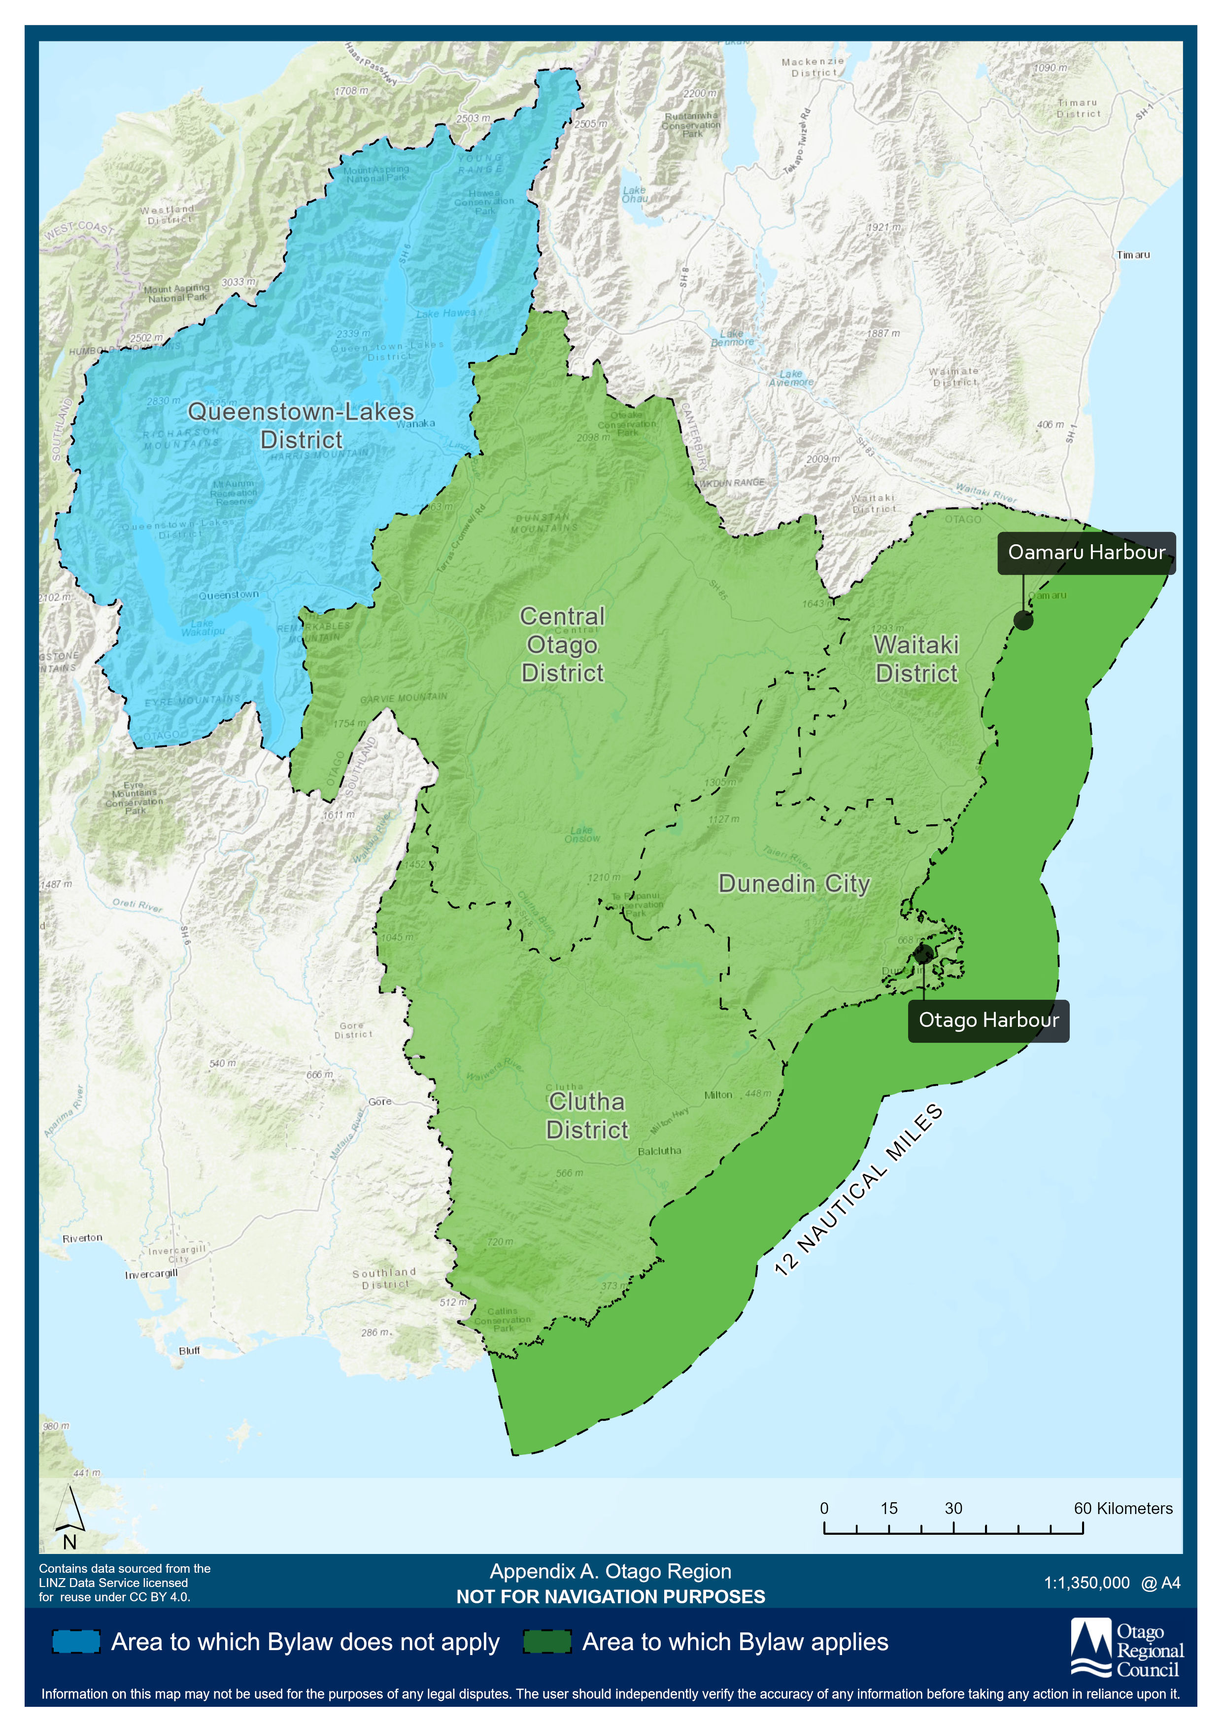

- Commercial Port Areas of Otago Harbour
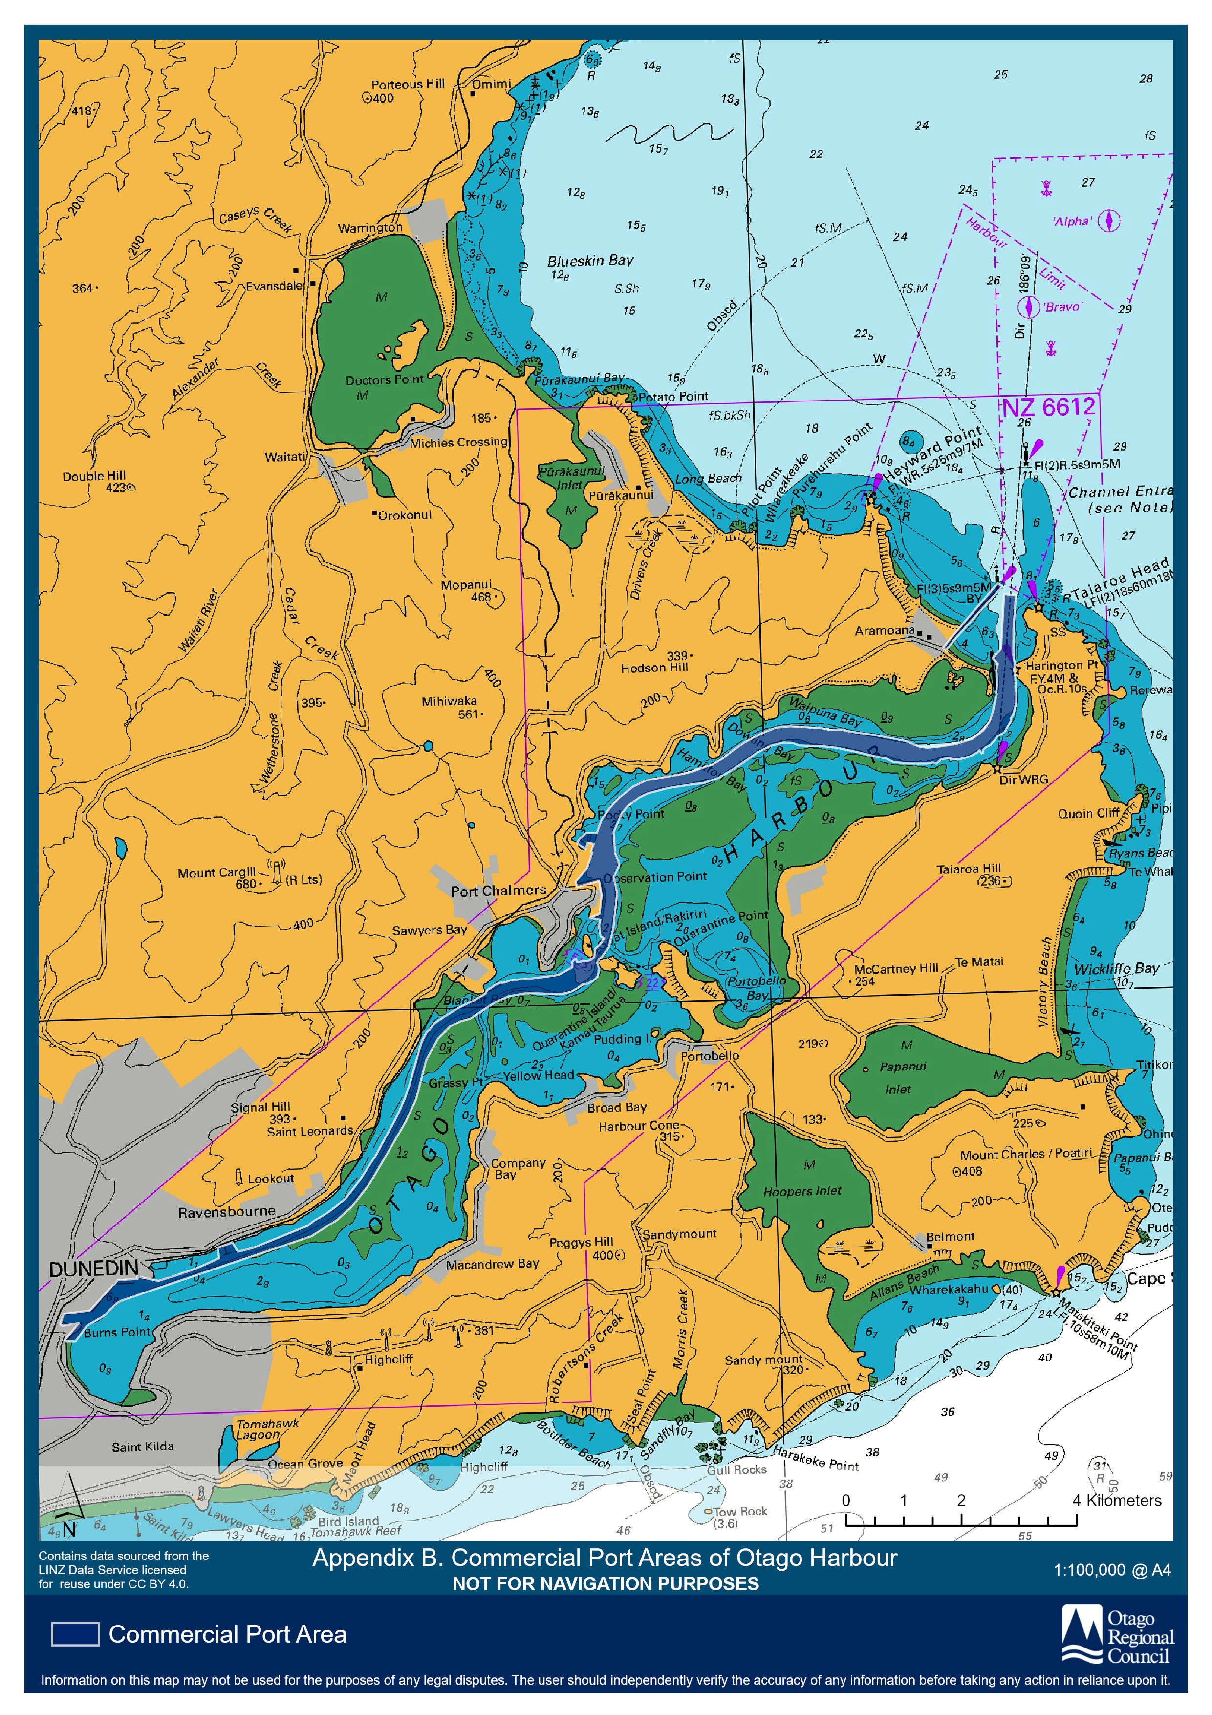

- Otago Harbour Shipping Channel
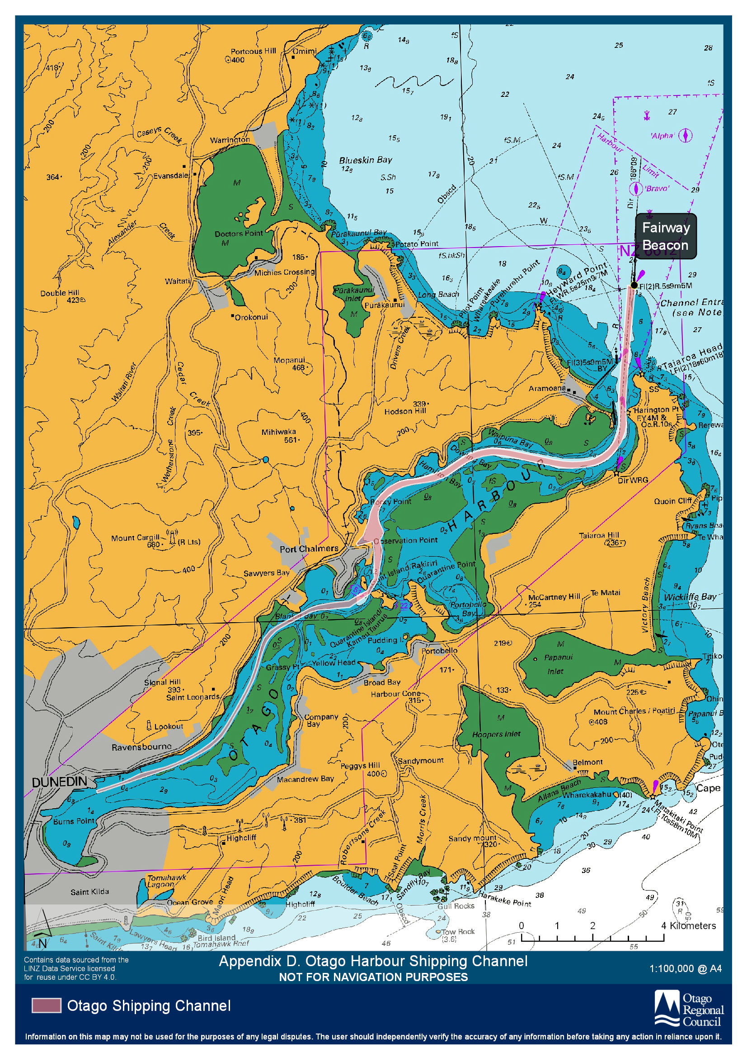

Appendix D Lake Dunstan and Reserved Areas
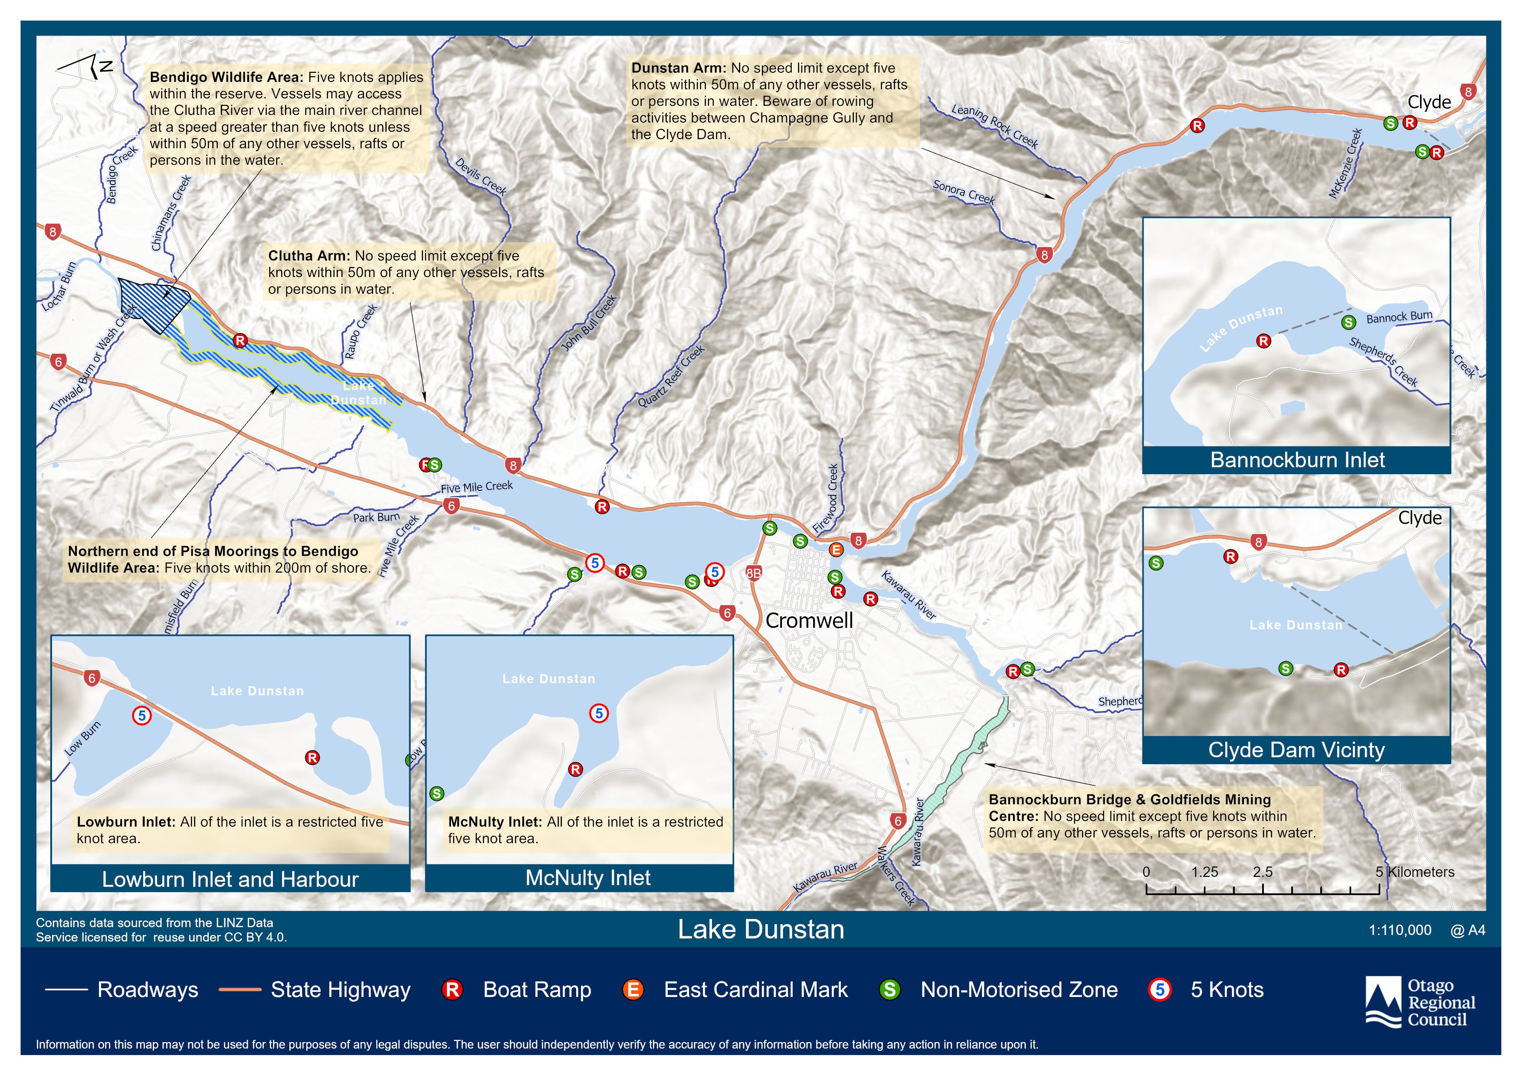

Appendix E Special Speed Zones for Otago Inland Waters
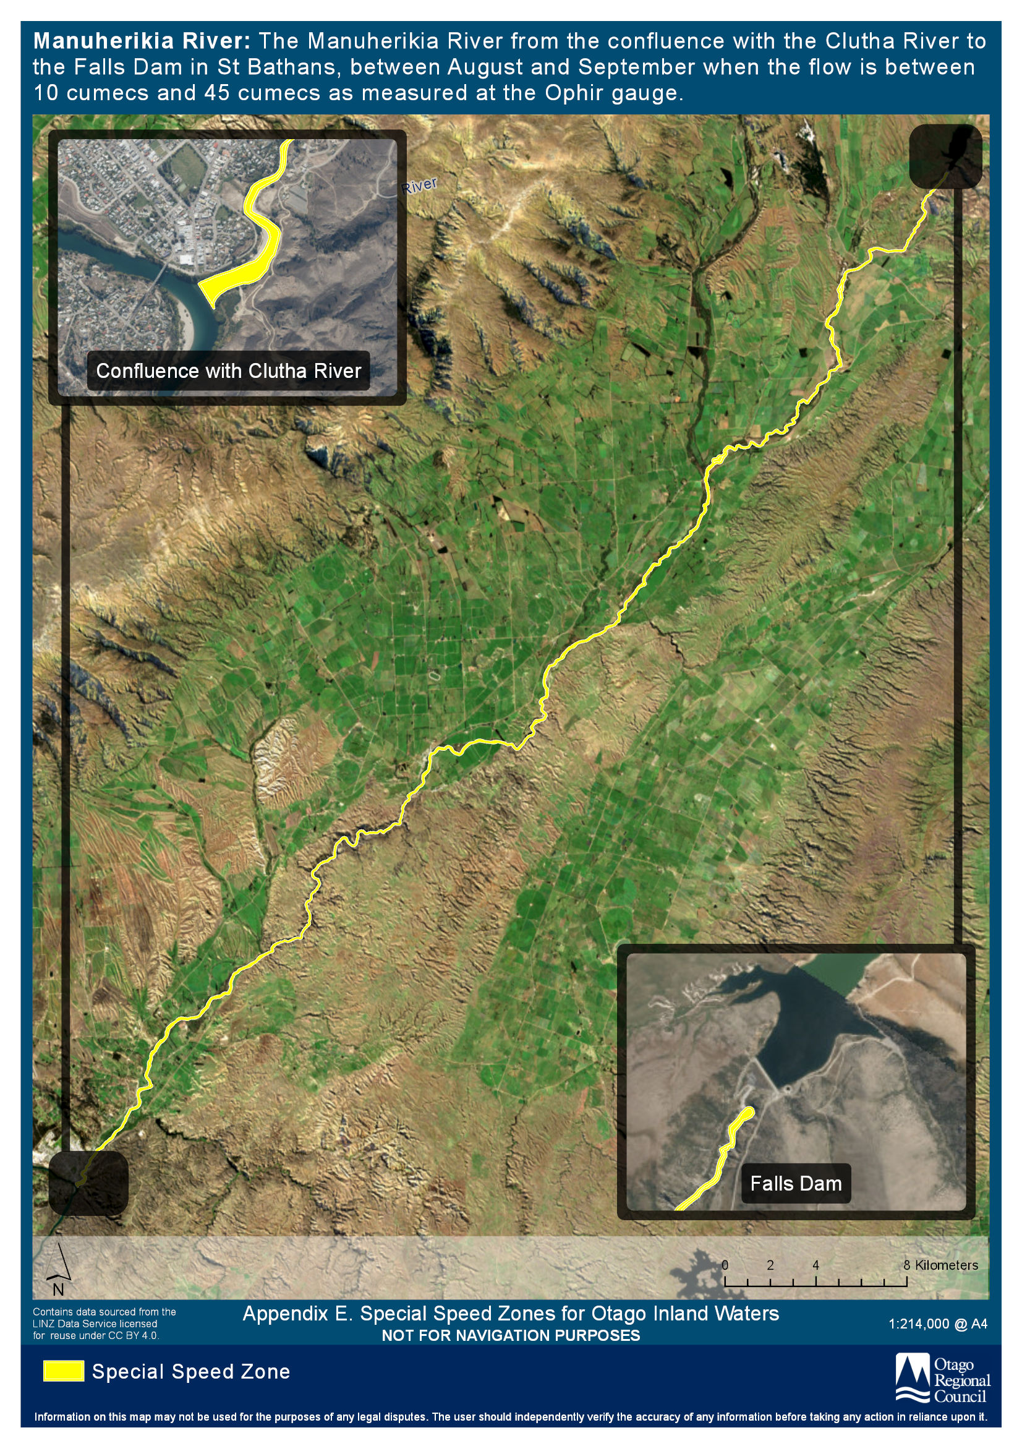
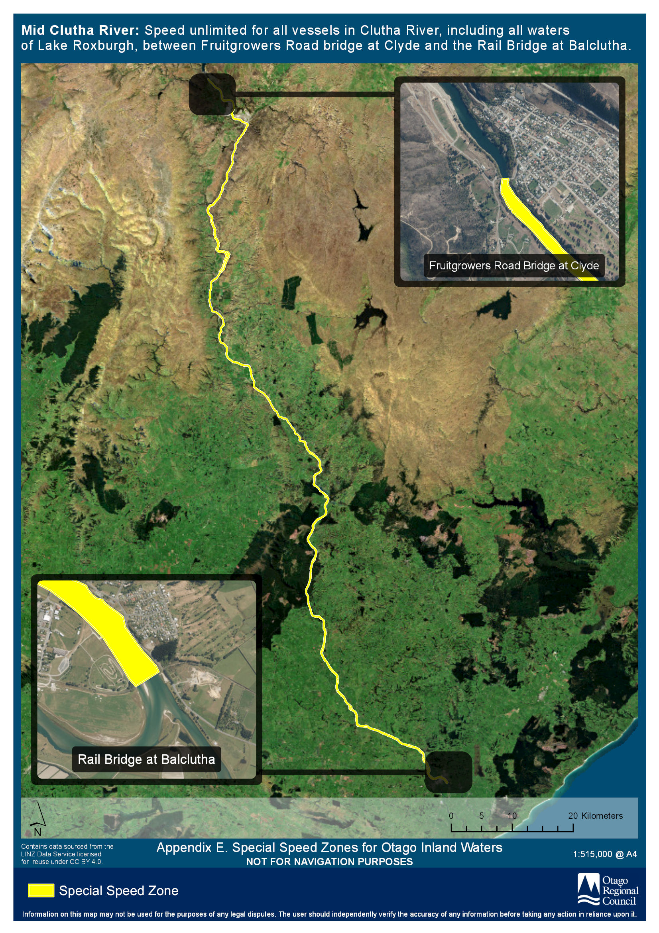

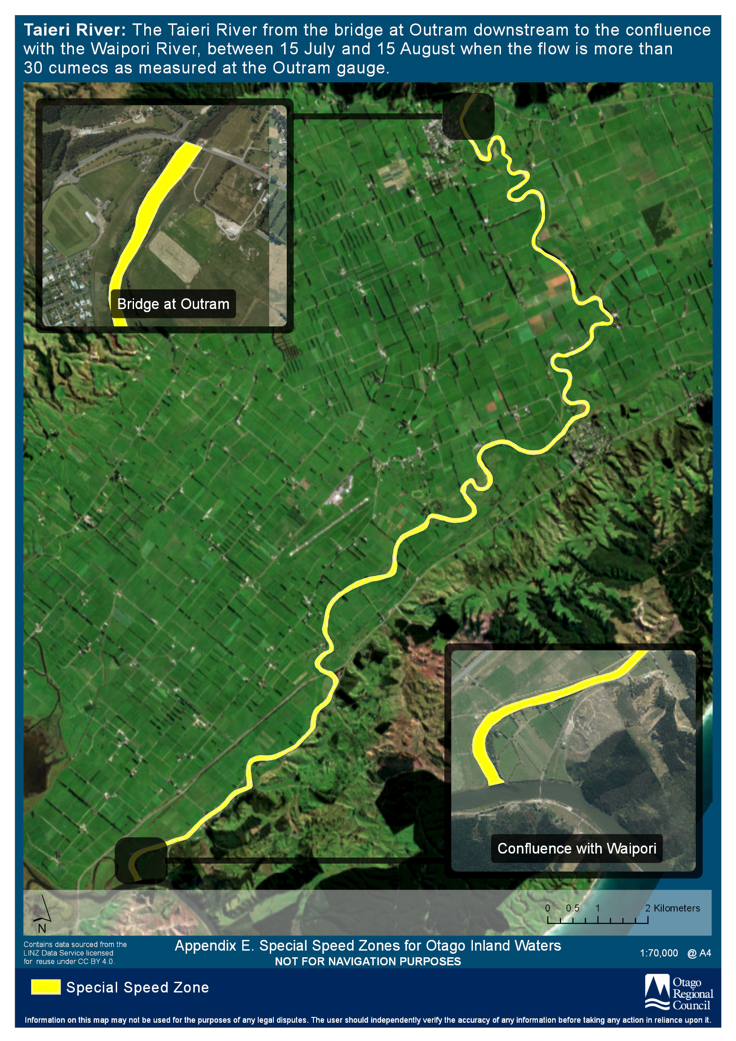

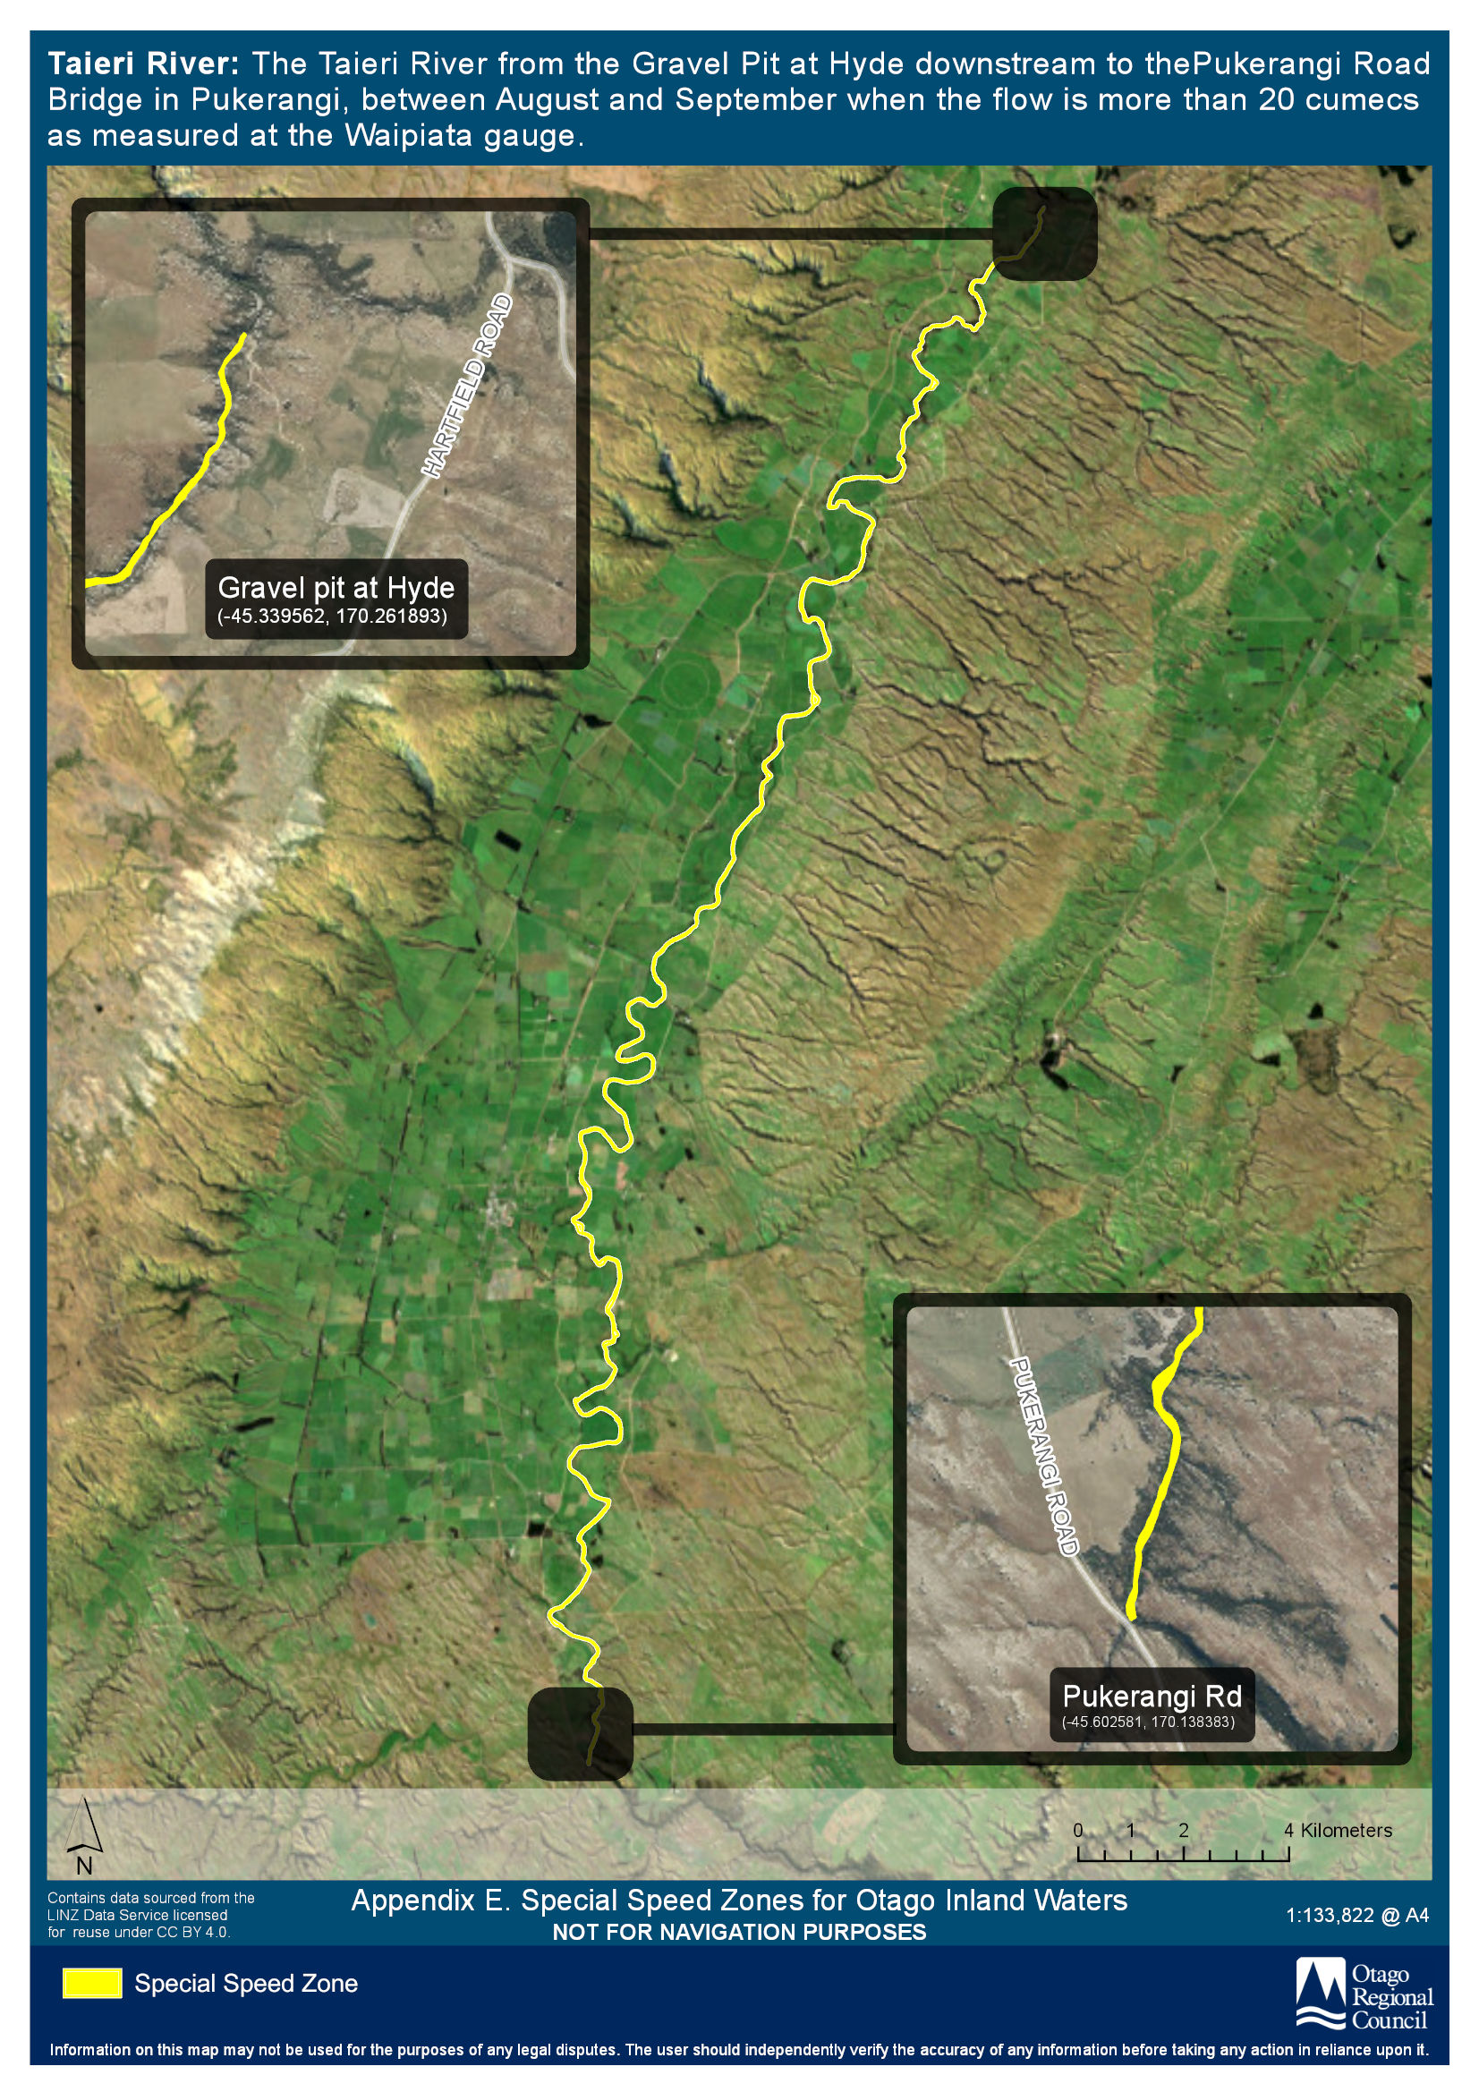

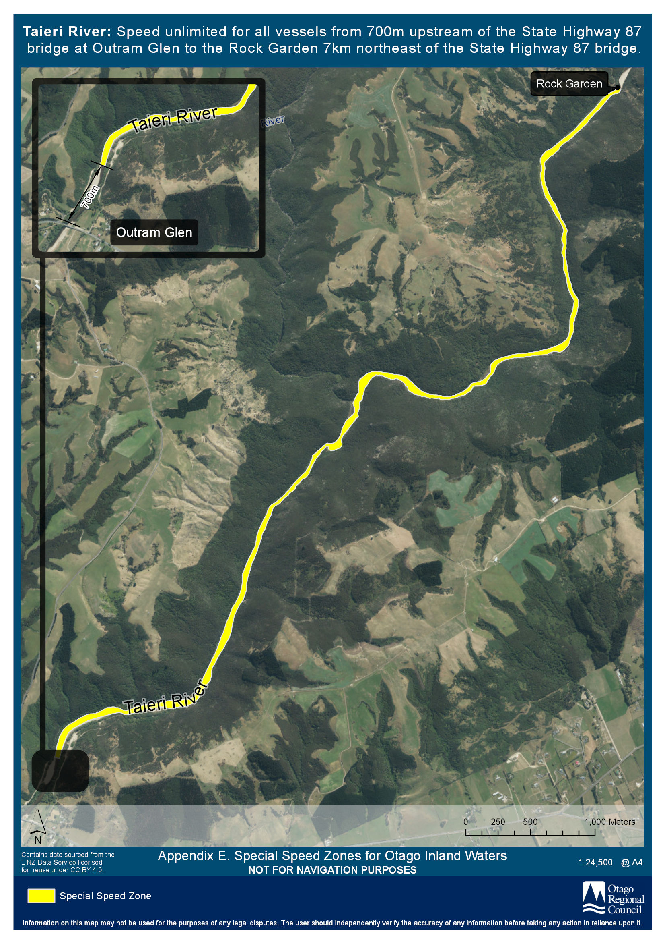

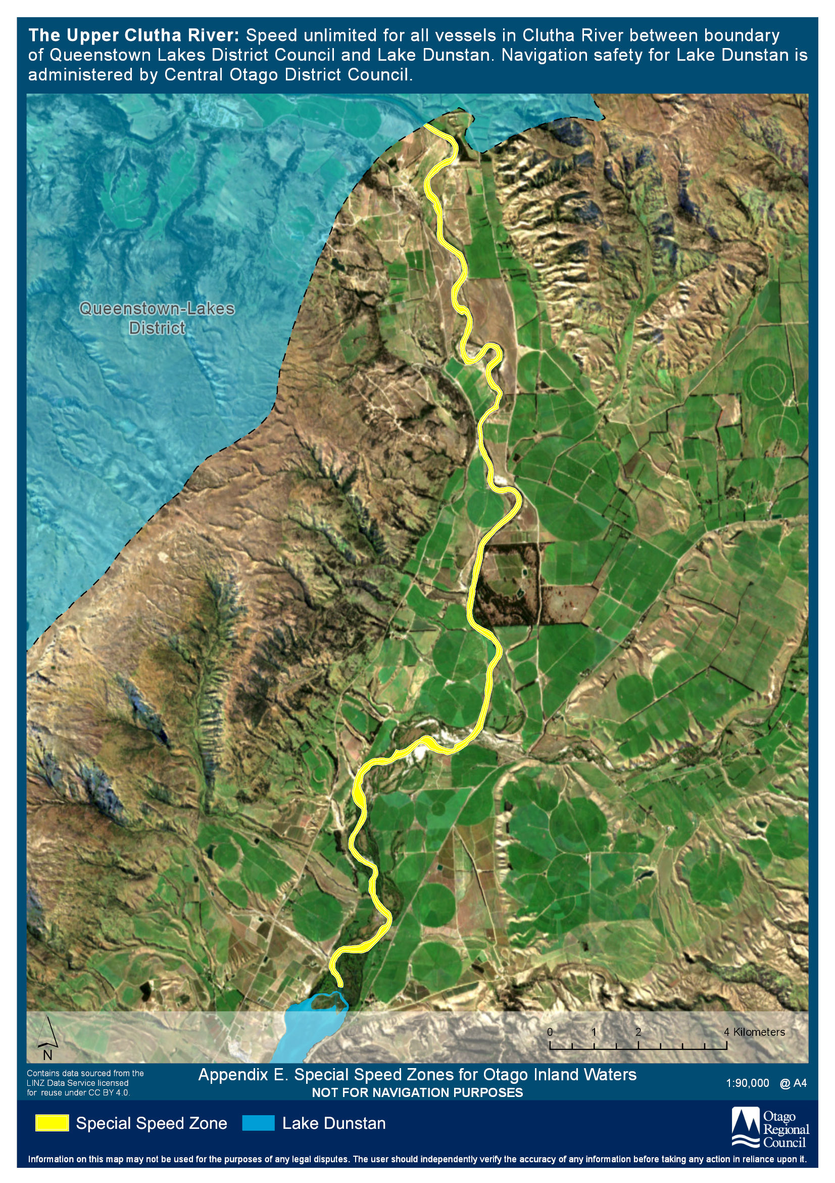

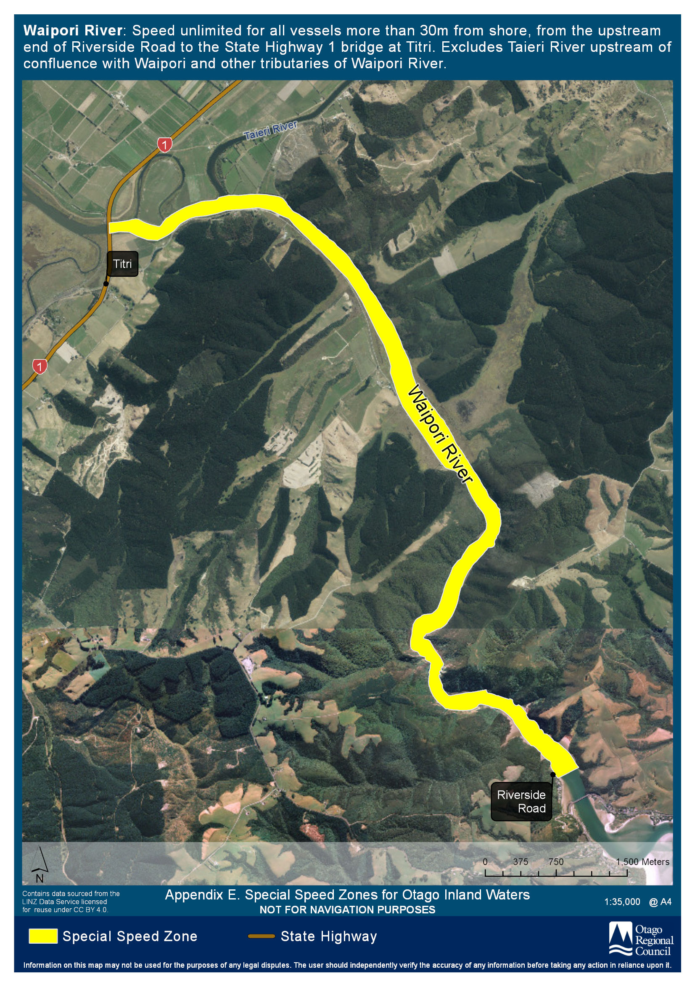

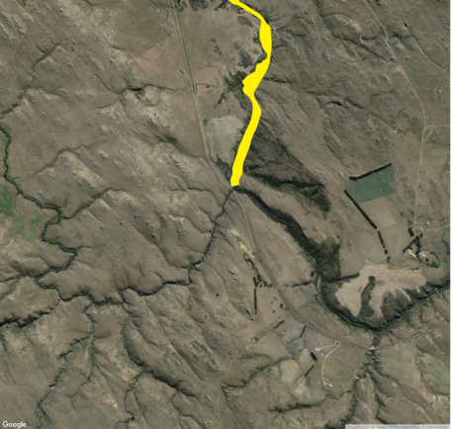
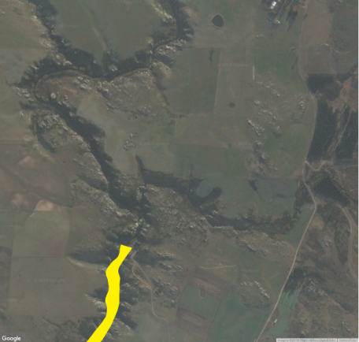
Appendix F Halfway Islands Safety Zone
Gravel pit at Hyde
(-45.339562°, 170.261893°)
Pukerangi Road
Hyde-Macraes Rd
Pukerangi Road Bridge
(-45.602581°, 170.138383°)
NOT FOR NAVIGATION PURPOSES
Key: Special Speed Zone

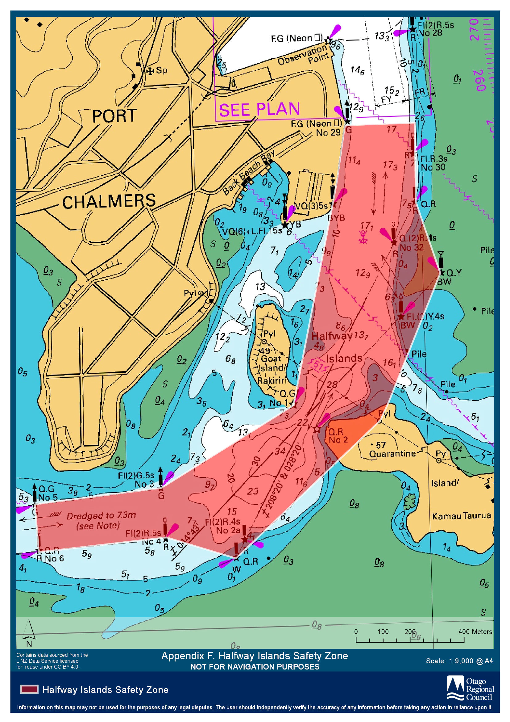

Appendix G Oamaru Harbour
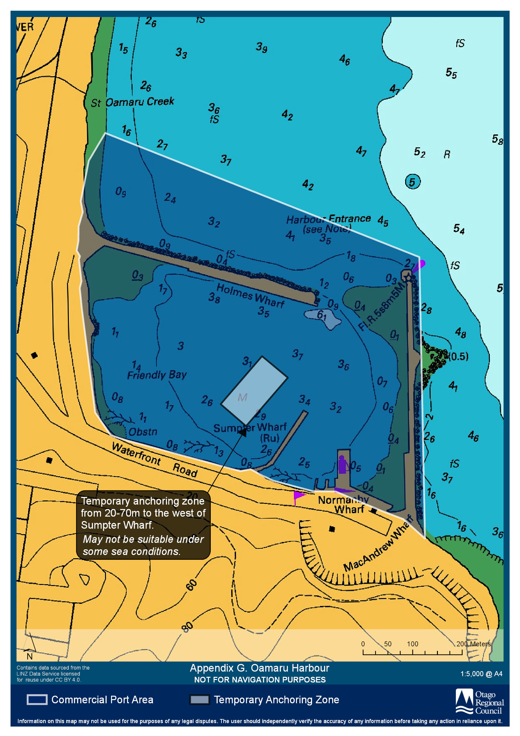

Apenndix H Lake Waihola Reserved Areas and Access Lanes
